Instructions: Use this form to submit a request for a Pretreatment Permit determination to the Pretreatment Section of the Vermont Department of Environmental Conservation (DEC) Watershed Management Division’s Wastewater Management Program.
The Pretreatment Section of the Wastewater Program will review the information submitted via this form to determine if the business or facility requires a state Pretreatment Permit to connect and/or discharge to the POTW.
The Wastewater Program requires the owner of a business or facility that generates and discharges or hauls process wastewater to a publicly owned treatment works (POTW) (municipal wastewater treatment facility), to request a Pretreatment Permit determination prior to:
- Discharging or hauling any process or industrial wastewater to a POTW; or
- Increasing the volume, pollutant loading, or changing the wastewater characteristics of an existing process wastewater discharge to a POTW.
Permit: A Pretreatment Permit regulates the discharge of process wastewater from industrial and commercial activities to POTWs and their collection systems. Process wastewater does not include sanitary or domestic wastewater, non-contact cooling water, or boiler blowdown.
Permit Criteria: The Wastewater Program will use the information submitted via this form to determine if the facility requires a Pretreatment Permit using the following criteria:
- If the facility is subject to the Environmental Protection Agency’s (EPA) National Categorical Pretreatment Standards (see 40 Code of Federal Regulations (C.F.R.) Subchapter N);
- If the discharge of process wastewater is ≥ 25,000 gallons per day (gpd);
- If the discharge has the potential to exceed ≥ 5% of the designed hydraulic capacity of the receiving POTW;
- If the discharge has the potential to exceed ≥ 5% of the designed organic (BOD₅) treatment capacity of the receiving POTW;
- If the discharge has the reasonable potential to adversely impact the proper operation of the POTW’s wastewater treatment facility or collection system;
- If the discharge has the reasonable potential to interfere with, pass through without treatment, or is otherwise incompatible with the receiving POTW; and/or
- If the discharge would have a substantial adverse effect on the POTW or on water quality.
Relevant Statutes and Rules:
- 10 V.S.A. 1259(a)
- 10 V.S.A. 1263(a)
- Vermont Water Pollution Control Regulations: https://dec.vermont.gov/content/vermont-water-pollution-control-permit-regulations
- 40 C.F.R. 403.3(v)
- 40 C.F.R. 403.8(f)(1)(iii)
Contact:
Pretreatment Section of the Wastewater Program: https://dec.vermont.gov/watershed/wastewater/contacts

1. Facility Contact Information
Facility Name:
Physical Address:
 | Street Number and Name |  | City/Town | State | ZIP
Owner Name: |  | Email:
Primary Contact/Consultant: |  | Title:
Primary Contact Phone: |  | Email:

2. POTW and Connection Information
Name of Receiving POTW:
Is this determination for a newly proposed discharge or an existing unpermitted discharge?
What is the anticipated start-up or expansion date?
Has the facility received authorization from the municipality to connect and discharge to the POTW:
Attach authorization and/or wastewater allocation from the municipality: |  | Attached: ☐
Primary POTW Contact: | Title:

3. Facility Information
Describe the general type of manufacturing, production and/or service(s) conducted at the site (i.e. electroplating, printing, painting, food and beverage manufacturing, warehousing, meat packing, machine shop, groundwater treatment, dairy products, septage receiving, anaerobic digestion, etc.):

NAICS Code(s): | SIC Code(s) (if applicable):
# of employees:
Identify EPA Effluent Limit Guidelines subject to the facility:
List other environmental permits held by the facility:
Is this facility a small quantity, large quantity, or conditionally exempt Hazardous Waste Generator?

4. Process Information
Provide an attachment with a detailed narrative description of the manufacturing/production process. | Attached: ☐
The narrative shall include:
- A detailed description of each step of the manufacturing, production, packaging, and cleaning process.
- A description of the product(s) produced;
- Average and maximum amount of product(s) produced per week and per year;
- Projection of future facility growth during the next five years;
- A description of the production and cleaning schedule, including:
  - Number of production days per week;
  - Operating hours and/or shifts per day;
  - Description of activities and operations performed each day of the week (for example: brewing days per week, packaging days per week, cleaning days per week, etc.);
  - Description of any seasonal variation in production.
Provide a process map, schematic, or flow diagram of the manufacturing/production process. | Attached: ☐
Provide a process-map, schematic, flow-chart, or flow-diagram of the manufacturing/production process. The diagram should depict each step within the process, and the flow of product, process wastewater, and byproducts. This schematic can be in the form of an engineering plan(s) or a simple flow-chart or line drawing. An example schematic is enclosed.
Provide a site layout drawing or map that depicts the location of the facility on the POTW’s collection system. | Attached: ☐

5. Wastewater Flow and Characteristics
Wastewater Flow
Flow Summary | Source | Average (gpd) | Maximum (gpd)
Current (proposed): | Sanitary
 | Process
Future (5-years): | Sanitary
 | Process
Wastewater Characteristics Detail |  |  |  | Attached: ☐
Provide an attachment that details the volume and characteristics of the process wastewater discharge. Include the following:
- List the sources and associated volumes of process wastewater generated at the facility.
- Identify the average and maximum daily volume of process wastewater generated in gallons per day. Include a projection of future wastewater flows based projected business growth. Provide calculations and/or documentation to support the basis of the process wastewater flow rates.
- Describe the characteristics of the process wastewater discharge, which you know or have reason to believe are present. Provide average and maximum concentrations of constituents prior to and following pretreatment and/or wastewater management practices (if applicable). If a constituent is present in unknown or uncertain amount, describe the circumstances relating to its presence, including amounts of known constituents. Provide supporting sample analyses, including the number of samples, sample location(s), and/or documentation on the estimates of pollutant concentrations. At the minimum, address the following constituents:
  - Biochemical Oxygen Demand (BOD₅)
  - Total Suspended Solids (TSS)
  - pH
  - Total Phosphorus
  - Total Nitrogen
    - Total Kjeldahl Nitrogen
    - Nitrate as Nitrogen
    - Nitrite as Nitrogen
  - Total Ammonia-Nitrogen
  - Fats, Oils, and Grease
  - Total Metals
  - Priority Pollutants (see: https://www.epa.gov/sites/production/files/2015-09/documents/priority-pollutant-list-epa.pdf)

- Identify all products used at the facility that will or could enter the process wastewater discharge, such as production chemicals, additives, cleaning chemicals, degreasers, solvents, etc. Attach safety data sheets (SDS) for each product.
- Provide any known information about toxicity or treatability associated with constituents within the process wastewater discharge for non-conventional pollutants such as biocides, pesticides, toxic organics, etc.

6. Waste Management and Wastewater Treatment
Waste Management | Attached: ☐
Provide an attachment with a description of the byproducts and waste products generated from the manufacturing/production process. Include:
- A description and approximate volume of the byproducts, solid waste products, liquid waste products, residual materials, spent materials, and hazardous wastes generated from the manufacturing process; and
- Identify the disposal or management method for each product.
Pollution Prevention, Source Reduction, Best Management Practices | Attached: ☐
Provide an attachment with a detailed description of the best management practices, source reduction practices, pollution prevention practices, and/or waste management practices that will be used or designed into the operation of the facility to limit pollutants within the wastewater discharge. Address:
- Waste separation or side streaming procedures to segregate high-strength wastes from the wastewater discharge, including side streaming of spent products, capturing first rinses, managing bad or spoiled batches or product, capturing product overflow, etc.
- Procedures (other than treatment) to manage low and high pH wastewaters (outside of the range of 5.5 to 9.5 standard units);
- Procedures to limit or prevent the discharge of hazardous or toxic pollutants;
- Procedures to prevent discharge of spills or releases, including inspection and maintenance of storage areas, handling and transfer of materials, loading and unloading operations, control of plant site runoff, worker training, containment structures or spill diversion equipment, measures for containing toxic organic pollutants, and measures and equipment for emergency response; and
- Other spill response, slug control, source reduction, pollution prevention, or wastewater management procedures implemented by the facility.
Wastewater Treatment, Flow Measurement, and Wastewater Sampling | Attached: ☐
Provide an attachment with a detailed description of the current and proposed wastewater treatment processes installed or being designed into the facility (if applicable). Include the following:
- Detailed description of the wastewater treatment process, including a description of all treatment units. Address spill diversion or spill protection systems, wastewater equalization tanks, pH adjustment systems, biological treatment, dissolved air floatation (DAF), grease traps, oil and grease removal, solids separation, activated carbon, ion exchange, chemical precipitation, or any other wastewater treatment process;
- Description of the process wastewater flow measurement method and associated equipment; and
- Description of the process wastewater grab and composite sampling method and associated equipment.
Provide a schematic or flow-diagram of the wastewater treatment process. | Attached: ☐
Provide a schematic, flow-chart, or diagram of the wastewater treatment process, if applicable. The diagram should depict the flow of wastewater through each treatment unit, the wastewater effluent sampling point representative of the entire process wastewater flow, and the location of the flow measurement device (if applicable). This flow chart may be combined with the process schematic (see Section 4. above).

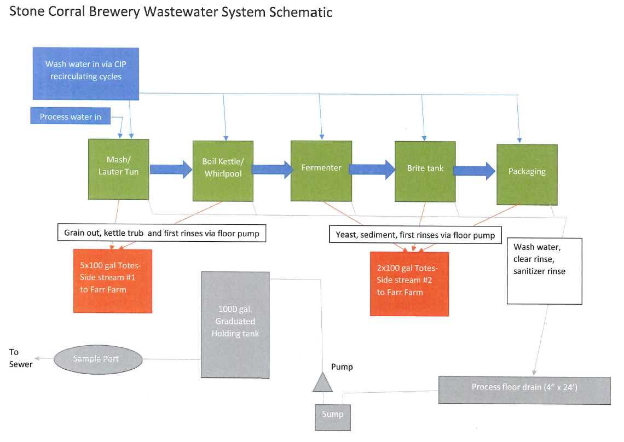
Process Schematic Example:

