Vermont Cyanobacteria Monitors

We’re looking to learn more about conditions on Vermont’s lakes – You can help!

cyano Volunteer resources

Cyanobacteria are common in water around the world and we expect them to be in Vermont lakes. Because contact with large amounts of cyanobacteria can lead to illness (for more information see our factsheet), we are collecting information on these organisms around the state. Reports are shared with the public through the Department of Health’s CyanoTracker and added to our long-term records. Staff at the VT DEC and the Department of Health work together with volunteers recruited and trained by the Lake Champlain Committee or the VT DEC to monitor on lakes around the state, including Lake Champlain.

We ask volunteers to
- Take an annual training to learn about cyanobacteria and how to monitor for them.
- Provide weekly reports during the summer from a lake location.
  - In 2017, we’ll monitor from June 19 to September 8.
- Upload the weekly report to the Department of Health’s CyanoTracker
- Take photos if high levels of cyanobacteria are observed.

Interested in becoming a monitor?
Email us at anr.lakesvolmonitoring@vermont.gov or contact Angela Shambaugh at (802) 490-6130. Thanks!
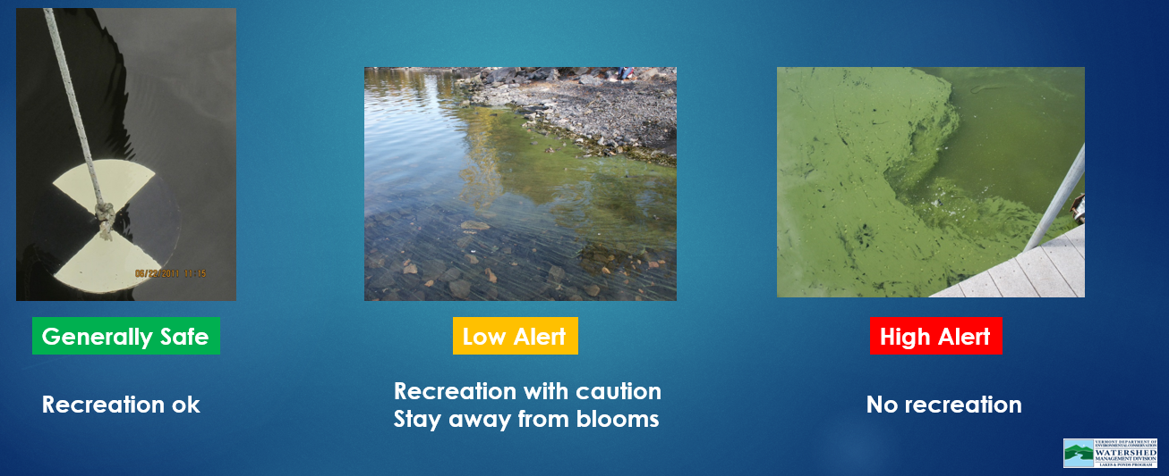

Volunteer Resources (should be linked to the box above)

Videos
- Introduction to Cyanobacteria
- How to Monitor for Cyanobacteria in Vermont
- Uploading Your Report to the CyanoTracker

Lake Champlain Committee Volunteer Resources
- Cyanobacteria Bloom Intensity
- Instructions for Photographing Cyanobacteria Blooms and Taking Samples

Having Trouble Uploading Your Report to CyanoTracker?
Complete this form and send it to 2017 Cyano Reports

Contact us!
Angela Shambaugh: angela.shambaugh@vermont.gov (802)490-6130
Alison (Ali) Davis: alison.davis@vermont.gov (802)798-2142

Cyanobacteria Reporting Form for Volunteers (Pete, can you turn this into a fillable PDF and link it to the red text above?)

Please complete ALL the fields below – Thanks!

*Lake (Lake Champlain, Lake Carmi, etc):
Region (for Lake Champlain only, if you know it):
- Champlain – Inland Sea
- Champlain - Main Lake Central
- Champlain - Main Lake North
- Champlain - Main Lake South
- Champlain - Malletts Bay
- Champlain - Missisquoi Bay
- Champlain - South Lake
- Champlain - St. Albans Bay
Municipality of Observation:
Site Number (Required for all routinely monitoring sites):
*Site Name or precise description:
*Type of Report
- Routine weekly
- Supplemental
*Date of Observation:
*Time of Observation (Military Time):
*Please choose the category that best describes the conditions and intensity of any bloom present:
- 1a – no cyanobacteria present – clear water
- 1b – no cyanobacteria present – brown and turbid conditions
- 1c – no cyanobacteria present – other plant material
- 1d – Little cyanobacteria present – generally safe conditions
- 2 – cyanobacteria present at less than ‘bloom’ levels – low alert conditions (include photos)
- 3 – cyanobacteria ‘bloom’ in progress – high alert conditions (include photos)
Additional details (required for supplemental reports and useful for categories 2 and 3):
*Photos (required for categories 2 and 3): Please attach to the email along with this form.
- water surface close-up
- water surface broad view
- water surface in clear container
*Extent of area covered by the bloom (evaluate the lake within 100 yards of where you are):
- No bloom
- Very Limited
- Less than 50% coverage
- Between 50 and 75% coverage
- Coverage greater than 75%
Cyanobacteria color:
- None
- Green
- Turquoise
- Reddish
- Yellow
- Other (please add details)
Water Temperature:
*Water surface:
- Calm
- Rolling
- Whitecaps
*I am using this form because:
- I am a first time monitor
- This is the only reporting form I am aware of
- I had problems using the Dept of Health web page
- I didn’t have access to my user name and password
- The form is more convenient
Please describe the problems you experienced with the Dept of Health Tracker. Include the device you used, your internet browser, screen size and resolution:
*Full name:
*Email:
Address
telephone

