- Lake Champlain Economic Value Assessments
  - Quantifying the social benefits and costs of reducing phosphorus pollution under climate change: https://www.sciencedirect.com/science/article/pii/S0301479721009002
  - An Assessment of the Economic Value of Clean Water in Lake Champlain. Technical Report #81:
https://www.lcbp.org/publications/assessment-economic-value-clean-water-lake-champlain/
- Financial loss estimates from the Curtis Pond Dam Exploratory Group for removal of dam rated “Significant” hazard ratings by Vermont’s Agency of Natural Resources (ANR):
  - Property values around the pond are conservatively estimated to be reduced by 25% with an estimated loss to the Town of $86,000 per year in tax revenue, with $2.3 million loss over the next 20 years.
  - The Maple Corner Community Store would not survive the loss of revenue without the recreational opportunities to draw the public.
- Act 138 Report (Vermont Shoreland Protection Act): 2013 Legislative Report on Shoreland Management Options, see PART 2, page 109
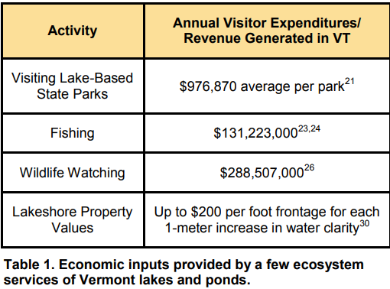
- Economic value of lake-based tourism and recreation
- Pollution or habitat degradation can threaten the fee-based services that lakes provide, such as revenue from state parks fees and fishing licenses
- Including the money spent surrounding tourist visiting lake, such as gas, food and lodging, the total visitor expenditure is significant. A study from Gilbert and Manning in 2002 outlines “The average annual total visitor expenditures for lake-based state parks ($976,870) is nearly three times the amount of that of non-lake based state parks ($367,122)” for VT State Park visitors.
- Economic value of lake-based fishing and wildlife tourism
- The average total fishing license sales amount to about $3,000,000 each year
- FPR-FY21-Budget.pdf (vermont.gov)
“The State Park system includes 55 developed Parks that received 1,013,433 visits in 2019. Those visits contribute an estimated $94 million annually to Vermontʹs economy through related consumer spending in addition to significant receipts contributing to Parks operations.”
- https://vtfishandwildlife.com/vt-fishing-report-june-11-2021
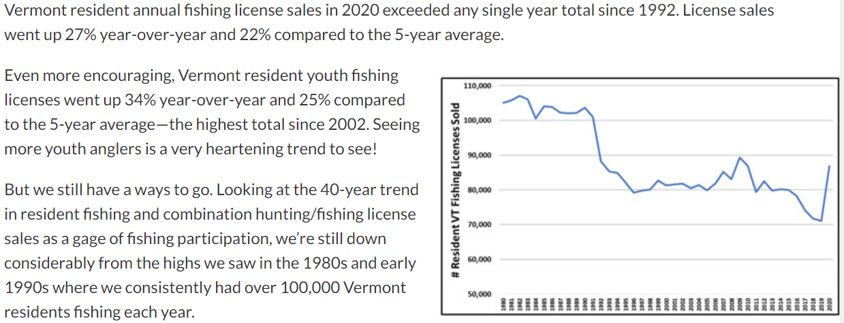

- VERMONT FISH & WILDLIFE DEPARTMENT FISHING ACCESS AREA PROGRAM 2020
“In calendar year 2020, the Fishing Access Area Program maintained 196 developed fishing access areas on 130 unique waterbodies. Targeted user groups are anglers, recreational boaters, waterfowl hunters, and trappers. In 2020, there were 136,006 licensed anglers, waterfowl hunters, and trappers and approximately 27,300 registered Vermont motorboats that potentially used Department Fishing Access Areas, along with the tens of thousands of unregistered non-motorized paddlecraft and motorboats registered in other states. The Fishing Access Area Program is funded primarily by Vermont motorboat registration fees and Federal Aid in Sport Fish Restoration funds (SFR). The Department received $430,001 in FY20 from motorboat registration fees per 23 V.S.A. § 3319, which directs 34% of the fees to the Fishing Access Area Program. This was nearly a $32,000 increase over FY19. These state funds are used to match SFR funds which are generated from a federal excise tax on fishing tackle, boats, motors, and marine fuels. In FY20, the SFR apportionment for Vermont fishing access areas was $554,588, which is a decrease of $1,008 from last year.”
- FY2018-Fish-and-Wildlife-Budget-Preformance-Report_FINAL.pdf (vermont.gov)
“The economic impact of sport fishing in Vermont is estimated to be $147.1 million, providing 2,420 jobs and $16.0 million in state and local tax revenues.”
- Rockville Institute. 2020. Bridging the 50-State Surveys of Fishing, Hunting, and Wildlife-Associated Recreation with Previous National Survey of Fishing, Hunting, and Wildlife-Associated Recreation Trends. Final Methodology Overview: Vermont. (Vermont Fish & Wildlife Department Disclaimer: The hunter and angler estimates in this report are well below actual 2016 license sales. Actual resident and nonresident license sales for Vermont in 2016 were 119,576 for anglers and 66,920 for hunters.)
