Ecosystem Restoration Grant Application Troubleshooting
The Clean Water Initiative Program (CWIP) has been contacted with questions regarding the use of the ERP Application form. Please see the information below.
Contact Allison Lewis if you have further questions. Allison.Lewis@vermont.gov, 802-490-6124.
Can I fill out the application online?
No. The application must be downloaded from the website and populated as a local version on your computer or within your organization’s filing system. Instructions:
- Click the link to the ERP Application. It will open in an internet browser window.
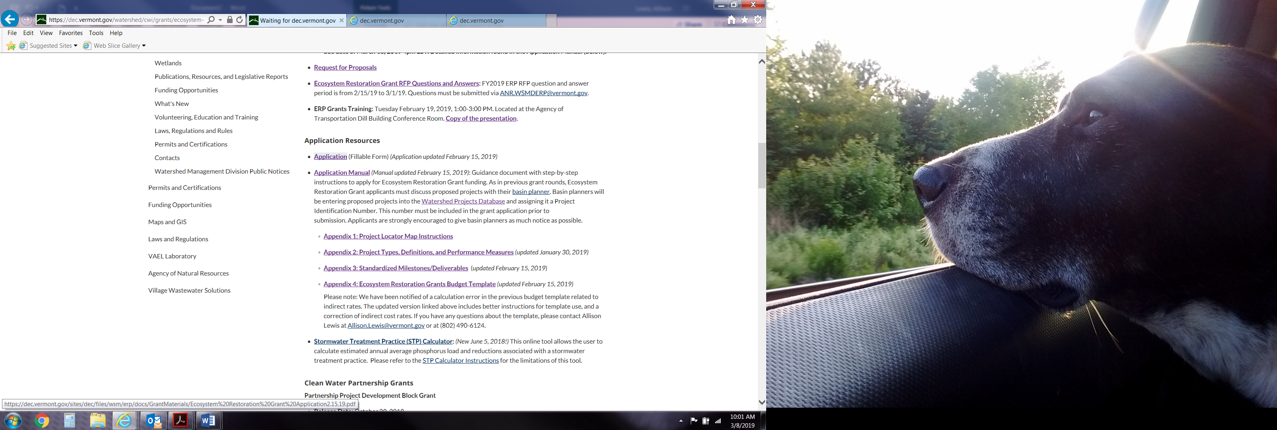
- Save the application to your desktop or other location that you can access as a local copy to work from. We recommend changing the file name to be specific to the project you are applying for. (See next page for screen shot examples).
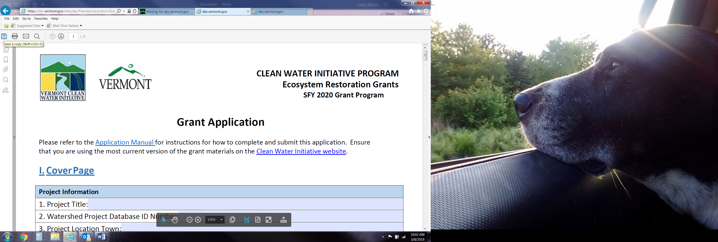
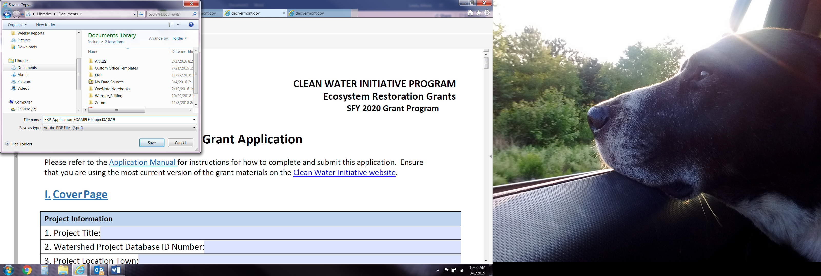
- Fill out the application utilizing guidance in the ERP Application Manual and Appendices found on the ERP Grants Webpage.
- Be sure to save as you go!
When I fill out the application, save and then reopen, the drop downs are blank even though when I saved previously, they had been selected. How do I save the form so that the drop downs display?
We apologize that you’re having this issue- it may have something to do with the version of Adobe that you have. Please see the instructions below on how to save as a non-fillable .pdf.
- When you have completed all editing for the application, save as you usually would. Do not close the document.
- Ensuring the drop downs are still selected appropriately and displaying in the application, select ‘File Print’
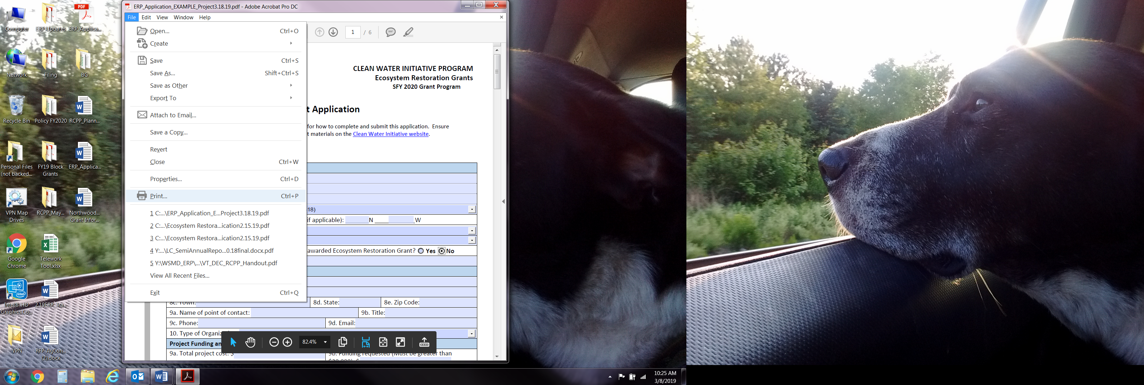

- The print window will open on your desktop. Select the ‘Printer:’ drop down. Select ‘Adobe PDF’.

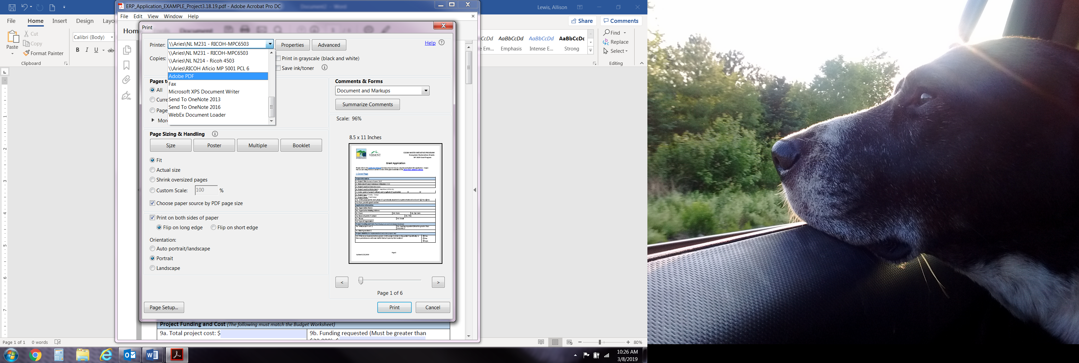

- Select ‘Print’.

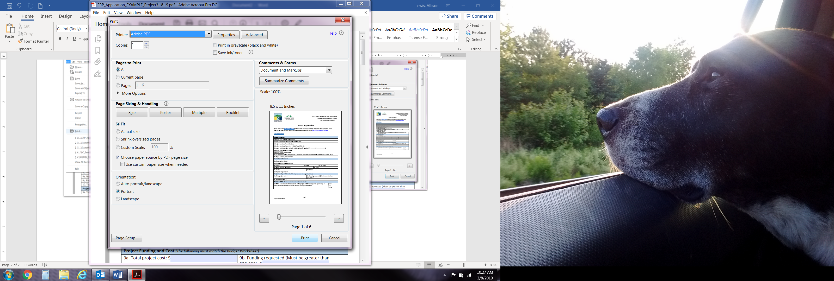

- It will process briefly and then a ‘Save PDF File As’ window will open. Save to your preferred location with a project specific application name.

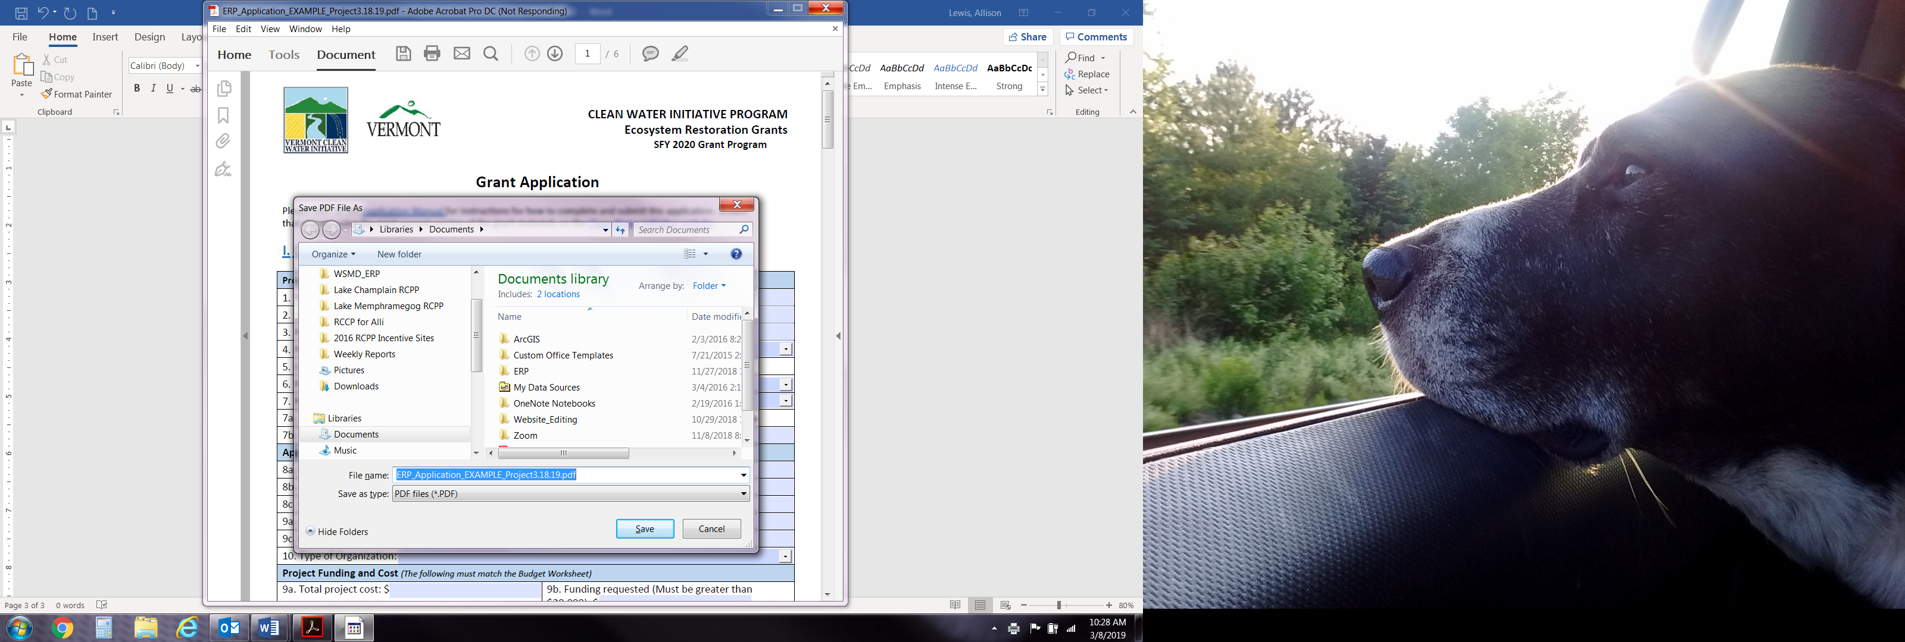
- When you’re ready to submit your application and supporting materials to ANR.WSMDERP@vermont.gov, include in the body of the email a notification that you had technical difficulties with the application and had to use the ‘Print to PDF’ format.

