Vermont’s Universal Recycling (UR) Law bans food waste from the trash. Food waste includes leftovers, food scraps, and excess food. To help prevent food waste and put these resources to good use, ANR has developed the following guidance on the Food Recovery Hierarchy.

Food Recovery Hierarchy Guidance

Section 6605k of the UR Law outlines Vermont’s priorities for managing food waste through the Food Recovery Hierarchy. The first priority is waste reduction, followed by feeding people, feeding animals, composting, and anaerobic digestion. Energy recovery refers to the burning of clean wood and won’t be discussed in this Guidance. To support a statewide organics recycling system that includes feeding people and animals, de-packaging technology, resource recovery, anerobic digestion, composting, energy production through anaerobic digestion, vermiculture, and more, ANR has developed the following guidance on the food recovery hierarchy.
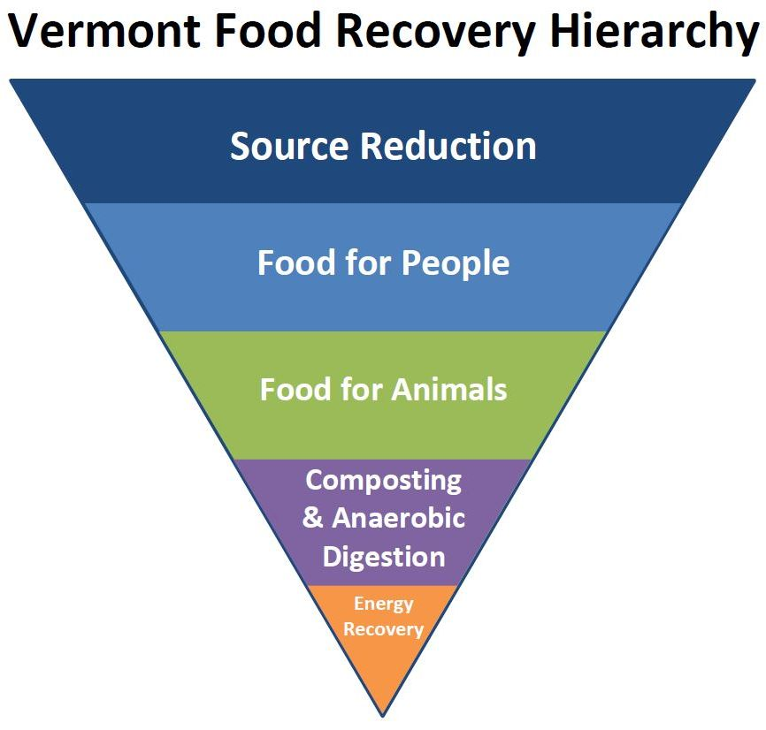
Food waste must be managed according to the following order of priority uses:
(1) Reduction of the amount generated at the source,
(2) Diversion for food consumption by humans,
(3) Diversion for agricultural use, including consumption by animals,
(4) Composting, land application, and anaerobic digestion, and
(5) Energy recovery.

Businesses and institutions, such as colleges, hospitals, supermarkets, convenience stores, restaurants, and food manufacturers, who generate food scraps must manage them according to the hierarchy as outlined:

(1) Reduce the amount of food scraps generated. Identify all the areas of your facility or business where food scraps are produced and conduct a waste audit to learn about your food scrap baseline. Keeping track of what and how much food is wasted will help identify the greatest opportunities for savings, and help you plan the right number of collection bins and pickup frequency. Once you figure out your biggest sources of food waste, you can target those areas. Spoiled food? Modify your purchasing habits or storage procedures. Table scraps? Reduce portion sizes or change menus according to customer preferences. For more tips, consult our resources to reduce food waste for businesses.

(2) Donate edible food to help feed people in need through food donation and hunger relief organizations. Large grocers should have a system for donating excess, quality, edible food. The Vermont Foodbank can connect you with a recipient organization that will get your surplus food to those in need. Resources on Food donation and Food Donation guidance.

(3) Explore options for animal consumption.
The Agency of Agriculture allows providing food scraps to chickens, at a small scale. Some food scraps from food manufacturing, such as spent brewery grain and whey, can be fed to animals. Many food manufacturers and some grocers have formed beneficial relationships with farmers and animal feed companies. Find a hauler who works with a farm on the statewide list of food scrap haulers.
To prevent the spread of diseases, the Agency of Agriculture prohibits feeding pigs food scraps that have touched meat or fish, including their organs, bones, and juices. To learn more, consult Feeding Food Scraps to Pigs and the Agency of Agriculture's Guidance on Feeding Food Scraps to Pigs.

(4) Separate food scraps for compost or anaerobic digestion
Send what cannot be donated for human consumption or used for animal feed to compost or anaerobic digestion. Keep your food scraps free of trash (PLU stickers, plastic bags, twist ties, ketchup packets, etc.).

To get started, ask if your hauler provides food scrap collection services or find a food scrap hauler at VTrecycles.com. You may haul your own food scraps to a farm, transfer station, compost facility, or digester if they are willing to accept them. Ask what is accepted—facilities may not accept napkins, and many do not accept compostable service ware. Connect your local solid waste management entity or the Solid Waste Program for no-cost assistance and resources or explore the Solid Waste Program’s FAQ for Businesses.

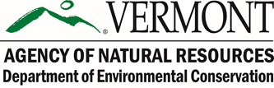
If you have questions, please contact the DEC Solid Waste Program at anr.scrapfoodwaste@vermont.gov or 802-828-1138.

Food scraps are 1) parts of food that are typically discarded rather than eaten: peels, rinds, cores, eggshells, seeds, pits, bones, shells, coffee grounds and filters, loose-leaf tea, and fats/oils/ grease, and 2) food that was not finished: "plate scraps" or leftovers that went bad. Any type of food can become food scraps—bread, pasta, soup, vegetables, fruit, sauces, meat, fish, dairy, sweets, etc. Make sure there are no produce stickers, butter packets, plastic bags, twist ties, or other non-compostable items in your food scraps. Ask your composter or hauler if they accept other organic materials, such as residual animal feed, wooden stir sticks, or compostable paper.

