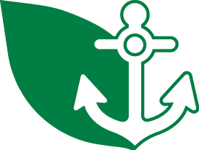
VERMONT CLEAN MARINA

CHECKLIST

Marinas receiving the VERMONT CLEAN MARINA designation must complete and check off each of the following three items.

-  The Achievement Form for marinas has been completed and is attached, or has been previously submitted to the DEC’s Environmental Assistance Office, signifying that the standards have been satisfied.

-  Our marina is in good regulatory standing with the Vermont Department of Environmental Conservation (DEC) and is in compliance with all applicable DEC regulations. We have had an onsite assessment for environmental compliance performed by a specialist from the DECs Environmental Assistance Office and have corrected any issues identified during that process.

-  We have a system in place to properly manage hazardous waste generated by customers.

In addition, we agree to:

- ensure that the standards for the program as documented continue to be met and, as feasible, improved upon;

- complete and return the Annual Survey which is necessary for continued designation in the program;

- continue to make a good faith effort to comply with all state and federal environmental regulations;

- notify the program representative of any change in our situation, such that we are no longer able to meet program standards; and

- promote the Vermont Business Environmental Partnership by placing the marina logo on our website with a link to the marina home page, and through other publicity.

Name (Owner, Manager, or other Authorized Representative) Date

