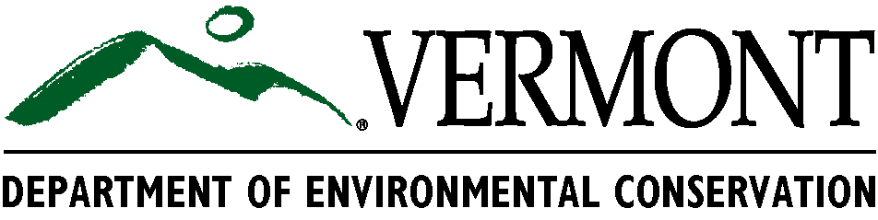
Environmental Fact Sheet

On-site Distillation to Recycle Solvents

Autobody shops use a significant amount of paint thinner and solvent for cleaning spray equipment. Up to 80 percent of used solvent can be reprocessed for reuse through an on-site recycling system. Distillation is the most common method of solvent recycling. On-site distillation will save money resulting from reduced purchases of virgin material as well as lowering disposal costs. Regulatory requirements may also be lessened. Other factors when considering a distillation unit include fire and electrical safety concerns and recycled product quality.

How does on-site distillation equipment work?
Simple units operate by vaporizing solvent within a closed system, leaving behind paint residue and other contaminants in a sludge or solid material called “still bottoms”. The vaporized solvent is captured when it condenses on a refrigerated heat exchanger and is then collected in a separate container. Small stills can process batch runs of five gallons or less and can be very cost effective - especially when used in combination with gun washing equipment. Gun washers reuse solvent for successive cleanings. When the solvent is no longer effective it can be reclaimed using distillation equipment.

Do the still bottoms have to be managed as a hazardous waste?
Still bottoms (solid still bottoms are often called a “puck”) generally must be managed as hazardous waste because most solvents being used and recycled in autobody shops are specifically “listed” as hazardous waste or are ignitable. Some common solvents used by autobody shops are identified by the following “F-listing” hazardous waste codes:
F003: xylene, acetone, methyl isobutyl ketone and methanol
F005: toluene, methyl ethyl ketone and isobutanol

Although less common, some shops may use petroleum mineral spirits, stoddard solvent or naptha to clean spray equipment. When spent, these solvents or the still bottoms resulting from distillation of these solvents, are hazardous waste if they are greater than 5 % by weight petroleum distillate - identified by the VT02 hazardous waste code- or are ignitable.

To determine if a still bottom (or spent solvent) is regulated as hazardous waste, compare the constituents identified on the material data safety sheets (MSDS) for the solvent being used to see if any F-listed or petroleum-based solvents are identified. For a complete list of F-listed wastes, see section 7-210 of Vermont’s Hazardous Waste Management Regulations.

Does recycled solvent “count” as hazardous waste when determining my generator status?
The weight of waste solvent destined for on-site recycling is counted only the “first time through” the recycling process when calculating monthly hazardous waste generation totals used to determine a facility’s “generator status”. Simply put, generator status determines the level of regulation that a facility is subject to. For example, if the weight of all hazardous waste generated at a facility changes from more than 220 lbs. in a month to less than that amount, the facility’s generator status changes from small quantity (“SQG”) to conditionally exempt (“CEG”) and it has fewer regulatory requirements to comply with.

Since recycled solvent is processed again and again, after the first time through the recycling process its weight should not be added to the weight of other hazardous waste generated by the facility during the month. This is important as it can make the difference in keeping the facility in a lower status category.

How must used solvent awaiting distillation be managed?
It is important to note that solvent that is partially used, and will be used again prior to recycling, is not considered a waste because it is still being used for its intended purpose. However, once solvent can no longer be used, it is a waste and must either be transferred directly to the still for reclamation or managed according to hazardous waste container management (and potentially other) requirements.

Do other requirements apply?
Because on-site distillation is a generator treatment activity, the facility must provide written notification of the activity to the DEC’s Hazardous Waste Program. The notification must provide the following information:

a) a simple description of the process;
b) an estimate of the frequency that the distillation process will be used;
c) the type and quantity of solvents to be distilled; and
d) how the still bottoms will be managed.

