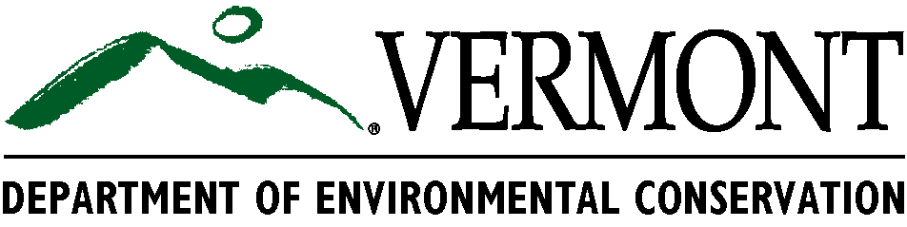
Environmental Fact Sheet

For Food & Beverage Manufacturers

This fact sheet gives a brief introduction to Act 148, Biochemical Oxygen Demand (BOD), and Hazardous Waste Management. The information provided is tailored to food and beverage processors and manufacturers in Vermont.
What is Act 148?
Act 148, Vermont’s universal recycling law, was unanimously passed by the Vermont legislature in 2012. This law requires residents and businesses to divert all recyclables, yard debris, and food scraps from landfills by July 1, 2020. Each year, there are more stringent regulations for what is banned from landfills.
Who is required to comply with Act 148?
As of July 1, 2016, all businesses that generate 26 tons/year (1/2 ton per week) or more of food scraps are required by law to separately collect and properly manage food scraps. You are exempt from composting food scraps if you do not have a compost facility within 20 miles of your facility. If your business generates less than ½ ton of food scraps per week, you are not yet required to separately collect food scraps; however, you will be required to do so in the near future.

July 1 | Food Scrap Generation
2014 | 104 tons/year (2 tons/week)
2015 | 52 tons/year (1 ton/week)
2016 | 26 tons/year (1/2 ton/week)
2017 | 18 tons/year (1/3 ton/week)
2018 | All food scraps banned from landfills

Could food that is “too good to waste” be donated to the food bank instead of being composted?
Yes! If possible, it is preferred that food scraps are donated to the food bank or to farmers for animal feed instead of being composted. Donation guidelines can be found at www.vermontfoodbank.org or on the Act 148 webpage.
For more information, contact Celia Riechel by email, celia.riechel@vermont.gov, or by phone, 802-477-2669. www.dec.vermont.gov/waste-management/solid/universal-recycling

What is Biochemical Oxygen Demand (BOD)?
BOD is the amount of dissolved oxygen in water that is required for micro-organisms to live and breakdown waste. It is important for septic and wastewater treatment facilities to maintain a certain level of dissolved oxygen in the water in order to function properly.
How does BOD affect food processors/manufacturers?
Depending on the nature of your business, you may be sending high strength wastewater into your water treatment system. High strength wastewater contains a high concentration of spent liquid or solid waste, which can deplete dissolved oxygen levels. Depending on the volume of high strength wastewater that is produced as well as the capacity of the wastewater treatment facility, your business may need a wastewater pretreatment permit.
Do I need a pretreatment permit for my wastewater discharge?
According to federal and Vermont regulations, you need to obtain a pretreatment permit if:
- Total wastewater discharge exceeds 25,000 gallons per day
- Total wastewater discharge is greater than 5% of wastewater treatment facility’s designed hydraulic capacity
- BOD of the discharge is greater than 5% of the designed organic treatment capacity of your wastewater treatment facility
- Discharge can impact proper operation of treatment process

As my business grows, will I need to apply for a pretreatment permit?
When you first open your business, your initial production levels may not necessitate a pretreatment permit. However, as your business grows, if you generate a larger quantity of high strength wastewater, you may be required to obtain a pretreatment permit.

Why is it important to use pollution prevention strategies for my facility’s wastewater discharge?
Good wastewater pollution prevention = preventing high strength materials (liquid and solid) from entering the discharge. Septic and wastewater treatment facilities are not designed to handle large quantities of solid or liquid food waste. Disposing of food and drink down the drain can lead to plugging pumps/pipes, septic system failure, increased need for system maintenance, and potential fines.

For more information, contact Eamon Twohig by email, eamon.twohig@vermont.gov, or by phone, 802-490-6189. www.dec.vermont.gov/watershed/wastewater

Do food processors need to be concerned about producing hazardous waste?
While you may not be generating a lot of hazardous waste, it is possible that you have certain chemicals onsite that are used for machinery, cleaning, testing, printing, painting or maintenance that qualify as hazardous waste when disposed.
What are the regulatory requirements for facilities that produce hazardous waste?
Facilities must identify all hazardous waste, quantify how much hazardous waste is generated each month and how much is stored onsite to determine your “generator status,” register with the VTDEC Hazardous Waste Management Program, and manage hazardous waste according to the Vermont Hazardous Waste Management Regulations (Regulations).
Though each operation is unique and must determine their amounts of waste individually, small businesses and those that deal primarily with non-hazardous materials like food most often fall into the least-regulated generator status of Conditionally Exempt Generator (CEG).

To determine if you have hazardous waste, check with Vermont’s Hazardous Waste Management Regulations at www.dec.vermont.gov/waste-management/hazardous. For more information, contact Lynn Metcalf by emalynn.metcalf@vermont.gov, or by phone, 802-522-0469.

