Notification of Presumptive Isolation Zone
During the Course of a Review of an Application
(Notification Form 2)

Dear Neighboring Property Owner, Click or tap here to enter text.,
I, Click or tap here to enter text., own the property at, Click or tap here to enter text.. I am working with a licensed Vermont Water Supply and Wastewater Designer on a submitted application to the Drinking Water and Groundwater Protection Division of the Vermont Department of Environmental Conservation (DWGPD). The application includes the proposal to construct a new potable water supply and/or wastewater system on my property. The DWGPD is reviewing my application to determine if the design of the proposed potable water supply and/or wastewater system complies with the standards in the Vermont Wastewater System and Potable Water Supply Rules (Rules), which are in place to protect human health and the environment.
The application now includes a revised site plan, a copy of which is included with this letter. The site plan includes the locations of all relevant water supplies and wastewater systems, including what is proposed in this project. Around each water supply and wastewater system is a “presumptive isolation zone” (zone). These zones, when drawn around a well, show the areas where a leachfield should not be located, and when drawn around a leachfield, show the areas where a well should not be located. The zones are established by the DWGPD to protect human health by preventing contamination of a well. Please see the included informational sheet on presumptive isolation zones if you are interested in learning more.
I am reaching out to you today, so that you may let my designer and I know if there is a water supply or wastewater system component that is missing or incorrectly located from the plan that is included. It is important that we are accurate in our application. Please note that due to changes in my application during the course of the DWGPD’s review, this notification to ascertain the accuracy of the site plan is a requirement of the Rules.
Please contact my designer at: Click or tap here to enter text.
Designer’s Name: Click or tap here to enter text.
Designer’s Phone Number: Click or tap here to enter text.
Designer’s Email: Click or tap here to enter text.
Thank you for your assistance with this matter.
Sincerely,
Applicant’s signature (optional):
Printed Name of Applicant: Click or tap here to enter text.
Applicant’s Address: Click or tap here to enter text.
Applicant’s Phone Number: Click or tap here to enter text.
Applicant’s Email: Click or tap here to enter text.
Enclosed: Site plan that will be submitted with my application and that accurately depicts the presumptive isolation zone(s)
Informational sheet on presumptive isolation zones

Presumptive Isolation Zones: A Quick Reference Guide
The State of Vermont began reviewing and permitting private water supplies and wastewater systems in 1969. It did not take jurisdiction of all water supplies and wastewater systems in the State until 2007. Due to the relatively new nature of the water supply and wastewater program, there are many preexisting water supplies and wastewater systems in Vermont. All water supplies and wastewater systems that were installed or permitted prior to January 1st, 2007 (when the State implemented ‘Clean Slate’) are allowed to continue until such time as they fail and need to be replaced. All those existing systems and any newly permitted systems are surrounded by areas referred to as Presumptive Isolation Zones. These presumptive isolation zones are established to protect drinking water quality in water supplies. This is accomplished by not allowing a wastewater system (commonly called a septic system) to be placed in the presumptive isolation zone of a water supply and subsequently, not allowing a water supply to be placed in the presumptive isolation zone of a wastewater system. This is true for all legally existing water and wastewater systems and systems that are permitted but not yet installed.
 |  | The proposed wastewater systems have been sited and designed to treat wastewater and safely recharge the groundwater. The presumptive isolation zones provide physical separation for the protection of nearby drinking water supplies. In the State of Vermont’s permitting process, designers using the Drinking Water and Groundwater Protection Division’s rules ensure that the conditions for treatment are met for a particular site. Since all the processes are occurring subsurface, you are free to utilize the area in a presumptive isolation zone to work, play, or construct homes, garages, driveways, businesses, playgrounds, and garden beds. Thus, presumptive isolation zones frequently extend onto a neighboring property, and the presumptive isolation zones for your property likely extends onto your neighbor’s. They exist only to help optimally site future water supplies and wastewater systems to allow nature the time and space needed to properly recharge our groundwater supply.
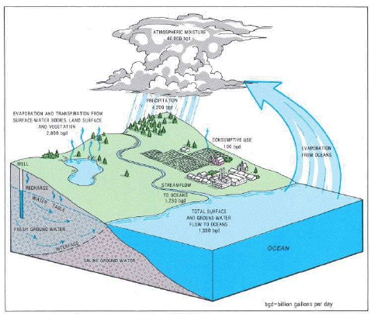
Ground Water and the Rural Homeowner, USGS
Above is an example of a presumptive isolation zone around a proposed wastewater dispersal area, otherwise known as a leachfield. No well will be permitted to be drilled inside the area. The area is not finalized until it has been reviewed and approved by one of VT DEC’s Regional Engineers.
If you are interested in learning more about water supplies and wastewater systems in the State of Vermont, please check out the Drinking Water and Groundwater Protection Division’s Informational website at:
https://dec.vermont.gov/water/programs/ww-systems/program-education

Also find us on social media at:
 | the Vermont Department of Environmental Conservation |  |  | thevermontdec

