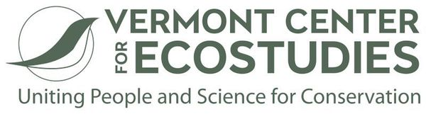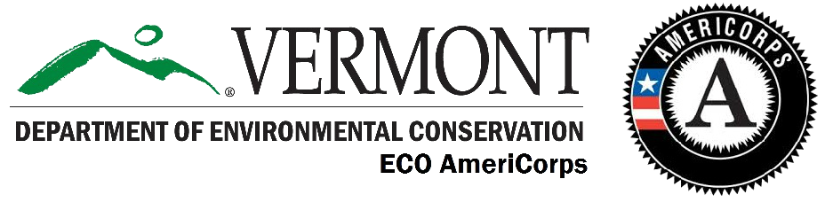

*September 2019- August 2020 Service Year*

Position Description

Position Title

Vernal Pool Monitor/Grassland Bird Outreach Coordinator

Sponsoring Organization

Vermont Center for Ecostudies

Norwich, VT

Sponsoring Organization’s Mission

The Vermont Center for Ecostudies advances wildlife conservation across the Americas through research, monitoring, and citizen engagement. With a reach extending from Canada and northern New England through the Caribbean and South America, our work unites people and science for conservation.

Goals for the ECO AmeriCorps Position

**Vernal Pool Monitoring Coordinator (50%)**

This position involves coordinating a statewide, citizen science-based program which is designed to engage trained volunteers in the collection of data that will monitor the breeding phenology, status, and trends of vernal pool amphibian and invertebrate populations, as well as abiotic variables such as water quality and hydroperiod.

**Grassland Birds Landowner Outreach (50%)**

Promote bird-friendly haying practices to landowners in Vermont. Locate and communicate with owners of identified properties that support grassland habitat about their options for managing their lands for grassland birds. Coordinate and promote bird monitoring on private lands by landowners and citizen scientists, including helping to develop, promote, and conduct bird monitoring workshops.

Essential Functions. Functions that the applicant must be able to perform

**Vernal Pool Monitoring Coordinator**

Responsibilities include:

-Recruit, steward, train, and generally support the volunteer participants in VPMon. This will involve extensive communication (in-person, phone, email) with current, new, and prospective volunteers;

-Develop and conduct volunteer training workshops to educate new participants about project protocols and background information;

-Conduct field visits to assist volunteers with field equipment set-up;

-Assist Project Biologist and Software Developer in the development of an online database for vernal pool mapping and monitoring data;

-Assist Project Biologist with monitoring at one (or more) vernal pools;

-Summarize results of previous field season data;

-Contribute to VCE publications and outreach trough blog posts, newsletter articles, etc.

**Grassland Birds Landowner Outreach**

-Recruit landowners to participate in bird monitoring, recruit citizen scientists to assist in training landowners in bird monitoring protocols.

-Visit with participating landowners, assess needs for successful follow-through, and assist as needed.

-Research opportunities to provide grassland bird management information to foresters assisting with Current Use Program landowners.

-Communicate and collaborate with NRCS, NH Land Stewardship, UNH Cooperative Extension, VDFW, NH Fish and Game, UVM Extension, Coverts, and other entities with overlapping objectives. -Provide calendars and brochures to those willing to distribute them at their own events.

-Send spring reminder to participating landowners about grassland habitat management for the upcoming season.

-Promote and help conduct at least one workshop to train landowners to monitor birds on their land.

-Provide management guidelines, incentives program information, and bird identification/monitoring protocols to interested landowners through printed materials, on-site discussion, phone and emails.

Marginal Functions. These are secondary to Essential Functions, may be negotiable, and can be completed as time allows.

-Write engaging and educational blogs and other articles to be used in VCE's outreach materials  
-Participate in a variety of VCE projects not directly related to assigned work, for the benefit of professional growth and breadth of experience of the AmeriCorps member and to be a fully participating member of the VCE team.

Projects May Include

For the Vernal Pool Monitoring Project, the member will measure the impact of their service by tracking the number of vernal pools field-verified, assessed, and monitored, the number of citizen scientists trained and participating in monitoring, and the number of attendees at educational presentations and training sessions.

For the Grasslands Project, measures of success will be: 1) the number of landowners monitoring birds on their land; and 2) the percentage of landowners who submit their bird observations to eBird. Our intermediate measures of success will include: 1) the number of landowners trained in bird monitoring; 2) the number of citizen scientists engaged in the process; and 3) the number of acres on which grassland management and active monitoring occurs. We will begin in 2019 by training up to 12 landowners, with the help of 2-3 citizen scientists. We will solicit feedback from landowners to determine any improvements needed. In 2020, the AmeriCorps Member will continue to expand this model to other landowners and develop partnerships with like-minded organizations and agencies.

Desired Qualifications

• Have a BS in wildlife biology or a related field.  
• Have experience successfully conducting field work in wildlife biology or a related field.  
• Be able to efficiently learn new things about VCE projects and about biodiversity, in order to get up to speed quickly on a topic and be able to teach/present it to the public. Present public programs in "draft" form to the VCE science staff and integrate their feedback to improve presentation style, format, and content. Be open to feedback and eager to grow professionally.  
• Have experience working with volunteers or managing others.  
• Be a strong, engaging public speaker and clear writer.  
• Have the ability to organize and manage a project from start to finish, seeking and integrating the input of experts, recruiting and training volunteers, and managing the time line and project work flow to be completed on time and within budget.  
• Maintain a positive attitude.  
• Be comfortable working as a team and independently, in the field and in the office.  
• Be willing and able to transport oneself to field sites, and flexible enough to conduct field work at odd hours and in all kinds of weather.  
• Be physically able to carry out the field work required in this position, including but not limited to carrying a backpack with necessary equipment, using a GPS to hike off-trail across uneven terrain to access field sites, navigating via GPS to predetermined sampling locations, camping overnight in remote areas.

Networking Opportunities

VCE has extensive partnerships with colleagues in academia, state and federal agencies, and NGOs, and we encourage networking opportunities among mentees. The member will be coordinating and collaborating with several conservation partners with overlapping objectives as appropriate. Partners in past years include the USDA Natural Resources Conservation Service, USDA Forest Service, Vermont Department of Fish and Wildlife, Vermont Department of Environmental Conservation, University of Vermont Extension, Vermont Coverts, The Trust for Public Land, Upper Valley Land Trust, and Audubon Vermont. In addition, service members will be encouraged to participate in other VCE field projects as time allows in order to fully experience the depth and breadth of our programs.

Service Conditions

Service will be performed indoors and in the field, with VCE staff biologists, constituents, members of the public, volunteers, and citizen scientists. During certain seasons (e.g., summer) there may be periods of extended outdoor field service (ranging from leading bird walks to conducting multi-day excursions to remote mountain ridges to conduct or map out routes for bird surveys or bee surveys).

Minimum Qualifications:

* Be a US citizen, a national, or legal permanent resident alien of the U.S.;
* Be at least 18 years of age upon entering the Pre-Service Orientation (there is no upper age limit);
* Be a high school graduate or have a GED certificate, or be willing to work towards their GED as part of their service-year successful completion requirement. A member cannot have dropped out of high school to join AmeriCorps. If a member has a documented medical reason/professional opinion why they cannot finish high school, they might be eligible; call in this case;
* Has not been convicted of murder or sexual assault and is willing to undergo a National Service Criminal History Check;
* Must submit to Agency of Human Services checks, i.e. Adult Abuse and Child Abuse Prevention;
* Be committed to the ECO AmeriCorps program, and its ethic of service and personal and professional development of its participants;
* Have the ability and enthusiasm to drive to, attend, and participate in required trainings and events, and be prepared to drive up to 2-3 hours each way.