Upper Otter Creek Watershed Council (UOCWC)
Summer 2016

Water Quality Monitoring Program

Report prepared by Christina O’Brien

Introduction
Monitoring stream water quality is imperative to understanding natural conditions that support aquatic habitat, and food for many plants and animals. Even small streams can attenuate floodwater from heavy rainfall. Some streams provide drinking water, and many contribute to recreational and commercial uses farther downstream. There are many factors that contribute to the quality of a stream. The four factors analyzed in this study are the levels of Escherichia coli (E. coli), turbidity, total phosphorus, and chloride in multiple areas of four streams in Rutland County that either comprise or contribute to the Otter Creek.

E. coli, or fecal coliform, is a common bacteria found in the digestive systems of humans and animals. It usually enters a stream ecosystem by means of agricultural runoff, wastewater runoff, and other runoff of fecal matter from animals near the stream. The presence of E. coli in recreational water is not usually cause for alarm. However, at high levels, there are human health concerns regarding contact recreation, where such incidental contact can cause cramps, diarrhea, nausea, vomiting, and fever in humans. E. coli is measured by the number of organisms (coliforms) per 100 mL of water or most probable number of organisms (MPN) per 100 mL of water. For Class B Waters, the EPA sets the recommended limit for E. coli at a geometric mean of 126 organisms per 100mL of water over a period of 60 days and at 235 MPN/100mL for a single sample.

Turbidity is a measure of relative clarity of the stream. If a sample of water has a high level of turbidity it means that the water is cloudy or even opaque. Causes of high turbidity include high concentrations of clay, silt, algae, plankton, and/or other microscopic inorganic and organic matter. Heavy rainfall increases turbidity because it is generally accompanied with an increased amount of runoff into the stream which can cause higher flows and more erosive power, thereby eroding stream banks and river beds. Turbidity is often an indicator of runoff into a stream system. Turbidity is measured by shining a light through a sample; the scattered light is measured in nephelometric turbidity units (NTU). The State of Vermont has established a turbidity criterion of 10 NTU for cold-water and 25 NTU for warm-water surface waters (2016 Vermont Water Quality Standards).

Phosphorus is the essential nutrient for plant life and produced naturally from decaying plants and animals, and as mineralized compounds in soil, rocks, and sediment. When phosphorus gets to excessive levels, usually due to fertilizer runoff, manure, and runoff from other organic waste like sewage, it encourages eutrophication and algae growth. As the limiting nutrient in fresh waters, excessive nutrient enrichment can upset the balance of production vs. consumption in the ecosystem if nutrient loading exceeds the assimilative capacity of that system. This can affect aquatic life in a waterbody if the excessive nutrients and biological oxygen demand creates anaerobic conditions. In addition, ingestion of water with high levels of phosphorus can lead to digestive problems in humans. Phosphorus is measured in units of micrograms of phosphorus per liter. The criterion for phosphorus in streams in Vermont is 15 µg/L.

Low levels of chloride are present in almost all water sources due to the dissociation of salts (sodium chloride) in water from natural minerals. In some cases, the predominant source of chloride in surface waters is road use. With the addition of these man-made salts, chloride levels can rise to palpable levels in drinking water, giving it a salty taste. Too much chloride in water also affects the animals that live there. Smaller organisms like plankton are impacted to a greater degree than larger organisms like fish, but these plankton are also important food sources for the fish and help control the algae that contribute to eutrophication. The EPA recommends a maximum concentration of 250 mg/L of chloride ions in secondary drinking water.
Method
Samples were collected from the following ten locations on seven dates throughout the summer (every other Tuesday morning from June 7th to August 30th). All samples were collected and analyzed on every date with the exception of samples from moon3.2 on August 30th.

Table 1: Sample names and locations
Site | Description
Tenn1.0 | Lincoln Avenue (Rotary Park) – Rutland
Tenn0.8 | Baxter Street at Confluence with East Creek – Rutland
East0.2 | Off of Meadow Street at recreation area – Rutland
East2.1 | Giorgetti Park – Rutland
Moon0.3 | At Forest Street Bridge – Rutland
Moon0.9 | At Porter Place – Above Porter Street Bridge to Howe Center – Rutland
Moon1.5 | At White’s Playground – Rutland
Moon3.2 | At Charter Hill or RHS (Headwaters) – Rutland
Mussey0.1 | At Park Street Bridge – Rutland
Mussey0.8 | At Mussey Street Bridge near VT Sport & Fitness

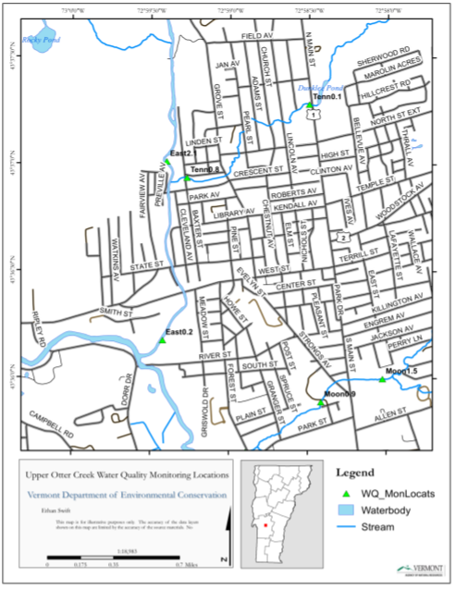
Figure 1: Locations of sampling sites
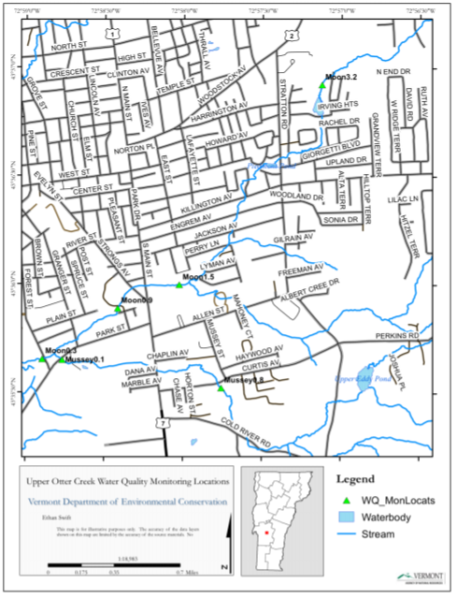
Figure 2: Location of sampling sites
Map source: Ethan Swift, VT DEC
Results

Figure 3: Tenney Brook E. coli Results

Figure 4: Tenney Brook Turbidity Results

Figure 5: Tenney Brook Total Phosphorus Results

Figure 6: Tenney Brook Chloride Results

Figure 7: East Creek E. coli Results

Figure 8: East Creek Turbidity Results

Figure 9: East Creek Total Phosphorus Results

Figure 10: East Creek Chloride Results

Figure 11: Mussey Brook E. coli Results

Figure 12: Mussey Brook Turbidity Results

Figure 13: Mussey Brook Total Phosphorus Results

Figure 14: Mussey Brook Chloride Results

Figure 15: Moon Brook E. coli Results

Figure 16: Moon Brook Turbidity Results

Figure 17: Moon Brook Total Phosphorus Results

Figure 18: Moon Brook Chloride Results
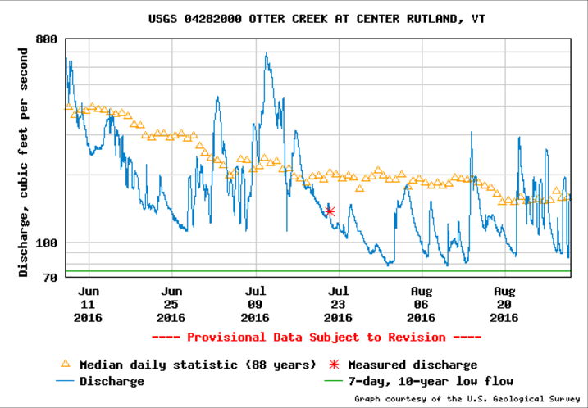
Figure 19: Otter Creek Discharge for summer 2016 - a measure of rate of flow of water

Figure 20: Summer 2016 Precipitation Data for Rutland, VT; courtesy of US Climate Data
Figures 3-6 show the results of tests from Tenney Brook. The E. coli levels at the two sites in Tenney Brook are similar and relatively stable except for the two spikes in tenn0.8 on 6/21 and 8/2. The average levels were 288.28 MPN/100mL in tenn1.0 and 925.17 MPN/100mL in tenn.8, which is significantly higher than the standard limit of 235 MPN/100mL. Turbidity levels, on the other hand, were consistently below the limit recommended by the EPA at both sites throughout the summer. Minimum levels at both sites occurred on 6/7 and maximum levels of turbidity at tenn1.0 occurred on 7/19 and at tenn0.8 on 8/16. The phosphorus data from the two sites on Tenney Brook followed similar trends with a collective average value of 44.09 µg/L, almost three times the suggested limit of 15 µg/L. Chloride levels were consistently below the limit at the two sites with maximums on 7/5 at only 77.8 mg/L in tenn1.0 and 88.9 mg/L in tenn0.8.

Figures 7-10 show the results of tests from East Creek. E. coli levels in East Creek were below the standard limit set by the EPA at only the site farthest upstream, east2.1. Farther down the stream, at east0.2, the average E. coli level was 841.73 MPN/100mL. East0.2 reached a max level of E. coli on 8/16 at 2419.6 MPN/100mL (the max detectable level by the lab), more than ten times the limit of 235 MPN/100mL. Turbidity was again consistently below the limit with similar trends in the two sites throughout the summer. Average phosphorus levels for the summer were about the recommended 15 µg/L at 14.74 µg/L in east2.1 and 16.06 µg/L in east0.2. Phosphorus levels were relatively stable throughout the summer at both sites in East Creek. Chloride levels at the two sites were also consistent and well below the limit of 250 mg/L. There was slightly more chloride at east0.2 than at east2.1, but the two sites followed similar trends as the levels decreased and increased throughout the summer.

Figures 11-14 show the results of tests from Mussey Brook. The two sites sampled on Mussey Brook followed similar trends in E. coli levels throughout the summer with averages significantly greater than the recommended limit. Levels where highest on 6/21, 8/2, and 8/16. Mussey Brook was the only stream sampled to go over the limit in turbidity levels. Mussey0.8 reached a max of 58.1 NTU on 8/16, and then returned to its average level of 1.13 NTU by the following sample date. This level of turbidity is exceptionally high but can be rationalized by the peak in precipitation around 8/16 (see Figures 19 and 20). Phosphorus levels were slightly greater than the recommended limit with averages of 18.91 mg/L in mussey0.8 and 27.08 mg/L in mussey0.1. Phosphorus levels in mussey0.8 were relatively consistent, while they varied more downstream in mussey0.1. As in the other streams, chloride levels in Mussey Brook where below the limit. The two sites followed similar trends throughout the summer with mussey0.1 having slightly higher values than mussey0.8.

Figures 15-18 show the results of tests from Moon Brook. Farthest upstream in Moon Brook at moon3.2, E. coli levels were generally consistent and below the recommended limit. E. coli levels increased downstream and varied throughout the summer with a peak in moon1.5, moon0.9, and moon0.3 on 6/21 at around 2419.6 (the lab’s upper detectable limit). The average at these three sites for the summer was significantly above the recommended limit. Turbidity started off very low and increased downstream, but averages at all sites were below 10 NTU. With the exception of 6/21 where levels peaked, phosphorus in the four sites on Moon Brook were consistent with an overall average of 28.51 µg/L. Chloride levels at the four sites were consistent, as well, and below the limit.

Conclusion
Often, once nutrients enter a stream by means of runoff of any sort, they will be carried downstream with the flow of the water. In all four streams, E. coli concentration increased steadily downstream throughout the summer. Chloride levels also followed this pattern as did phosphorus levels, though not as consistently. Turbidity didn’t depend on a sample site’s location in a particular stream and varied at sites independently. Overall, the four streams sampled have high levels of E. coli and phosphorus, and low levels of turbidity and chloride. Most of the streams sampled are in urban areas, so it is expected to have higher levels of pollutants due to various runoff. Moon Brook had the highest levels of E. coli, turbidity, and chloride. Mussey Brook also had some of the highest levels of turbidity and Tenney Brook had some of the highest levels of phosphorus. East Creek had regularly the lowest levels of turbidity.

Nearly all of the sites where samples were taken are in urban areas. This suggests high potential for fertilizer, salt, and other urban and storm water runoff into the streams. It is expected that levels of all four factors tested that contribute to water quality will increase during rainy periods because the nutrients and pollutants are carried into the streams at a faster rate and at larger quantities. The Rutland area experienced rain on or just before the following sample collection dates: 6/21, 8/2, and 8/16 (See Figure 20). These three dates saw the highest levels of E. coli, phosphorus, and turbidity at most of the sample locations, especially on 8/16 when it was actively raining while samples were collected. Trends in chloride concentrations didn’t seem to depend as closely to weather conditions and stayed relatively low and consistent throughout the summer.

Sources
- https://www.epa.gov/sites/production/files/2014-12/documents/vtwqs.pdf
- https://thewaterproject.org/water-scarcity/health-implications-of-e-coli
- https://water.usgs.gov/edu/turbidity.html
- https://water.usgs.gov/edu/phosphorus.html
- http://www.water-research.net/index.php/phosphate-in-water
- http://www.ruf.rice.edu/~cbensa/Salinity/
- http://cels.uri.edu/docslink/ww/water-quality-factsheets/Chlorides.pdf
- https://archive.epa.gov/water/archive/web/html/index-17.html
- https://www.vacd.org/rcd/images/UOCWC_WQ_Monitoring_Report_2015_FINAL_1-2.pdf
- https://nwis.waterdata.usgs.gov/usa/nwis/uv/?cb_00060=on&cb_00065=on&format=gif_stats&site_no=04282000&period=&begin_date=2016-06-07&end_date=2016-08-30
- http://www.usclimatedata.com/climate/rutland/vermont/united-states/usvt0205/2016/8

