Water Quality Monitoring Training
Vermont Agriculture and Environmental Laboratory

Introduction:
The tradition of volunteer water monitoring in Vermont began over 30 years ago. Concerned citizens, environmentalists, and stewards of the state provide samples to the Vermont Agriculture and Environmental Laboratory. This guide will help to guide samplers through the steps required to obtain sample bottles, go into the field for sampling, and return the sample containers to the laboratory while allowing for the best possible sample quality.

Water Quality Monitoring: Sampling and analysis of water constituents, which may include introduced (oils, pesticides, metals) or naturally occurring (nutrients, bacteria, dissolved oxygen) parameters. The results that are obtained from these samplings can show trends in water quality, help to identify sources of pollution, and to ensure that pollutants are not exceeding allowable values. To guarantee that the most representative, consistent, and accurate samples are obtained, all field samplers should be thoroughly trained on proper sampling techniques.

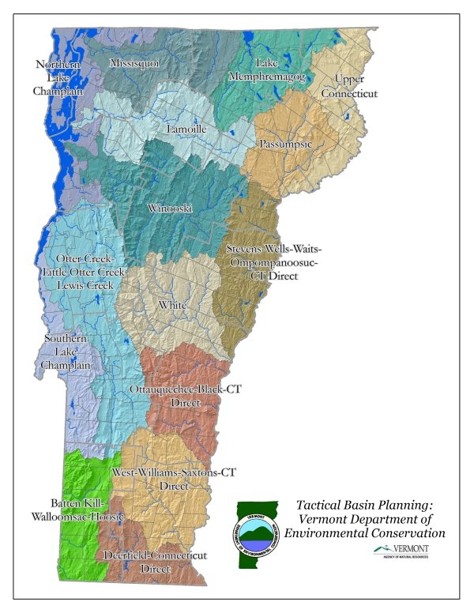
Picking Up Bottle Orders/Pre-Logs:
- Sample site identification and selection of parameters will most likely be determined by project coordinators, which will send “bottle orders” to the laboratory for each sampling session. Bottle orders contain empty sample containers, sample labels, as well as a “pre-log” packet of paperwork.
- Bottle orders should be placed at least 2 weeks prior to scheduled sampling. Planning should be done so that when a cooler full of samples is being dropped off, the cooler of empty containers is being picked up.
- The empty containers are placed into a cooler, these are what volunteer samplers will be filling in the field.
- “Pre-Log” paperwork is a packet of papers that show all of the information about the sites where sampling is to take place, including the laboratory number associated with those sites, the site location, and which parameters are supposed to be sampled.
- The stickers/labels included with empty containers contain the same information as the pre-log paper work, each sticker will have the laboratory sample number, the site, and a single parameter listed on it.
- When the containers are filled on the sample collection day, the labels should be adhered to the corresponding sample container to allow for easy sorting and organization upon arrival to the laboratory.
- For best results, stickers/labels should be adhered to the sample containers prior to sampling, this reduces the ability to incorrectly label samples.
Sample Containers
Sample containers play an extremely important role in sample quality. Certain parameters require certain bottles. Some containers are able to be re-used, and some are disposed of after analysis. In the field, it is important to use the correct containers for the correct parameters, and to correctly label all containers to prohibit confusion when the samples are brought to the laboratory.
Bacteria Sample Containers – 125mL or 290mL round IDEXX bottles with plastic seal, sterile – one use.
Conductivity, Turbidity, and Alkalinity – 250mL square plastic bottle – reusable.
Total Phosphorus/Dissolved Phosphorus (TP / TDP) – 50mL glass tube with white cap – one use.
Chloride, Silica, Anions – 50mL plastic centrifuge tubes – PURPLE cap – one use.
Total Nitrogen/Filtered Nitrogen (TN / TDN) – 50mL plastic centrifuge tubes – BLUE cap – one use.
Total Suspended Solids (TSS) – 1 liter round plastic bottle – reusable.
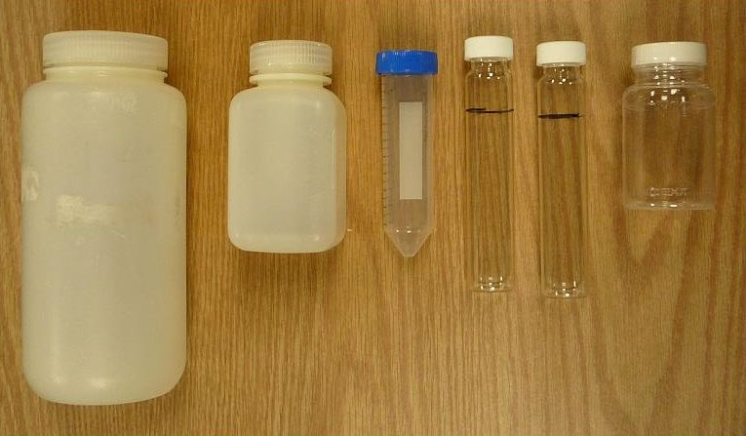
E. coli
Total Phosphorus
Dissolved P
Total Nitrogen
Dissolved N
Alk
Turb
Cond
TSS
General Sampling Instructions:
- Collecting a representative sample requires that samplers are aware of the conditions of the water they are sampling.
- All sampling should begin with verifying (and/or writing down) on pre-log paperwork:
  - the correct sample site/bottle label
  - date of sampling
  - time of sampling
  - sampler name
This information is 100% required by the laboratory, samples that are missing ANY of this information may be rejected by the laboratory.
All writing should be done in blue or black pen – NO PENCIL.

Wading Samples:
Before sampling, labels should be adhered to sample containers.

- Samples should be taken toward the centers of streams when possible, avoiding sampling water near the bank, or in stagnant pools.
- When wading to a sample site, care should be taken not to disturb the bottom. If bottom is disturbed, prevent any bottom sediment from being sampled.
- Samplers should always stand facing UPSTREAM (See Figure 1).
Figure 1
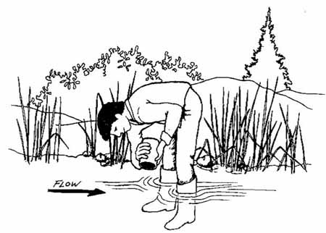
- Fingers should be near the bottom of the sample container to avoid contamination. Care should be taken to avoid touching bottle openings or caps.
- Open sample containers should be placed upside down over water, and water should be sampled in a “U” shape against the flow of water, away from the body (Figure 2). This process should be done at a swift (but not disturbing of the site) pace to allow for the most representative sample.

Figure 2
1
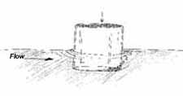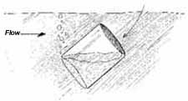
2
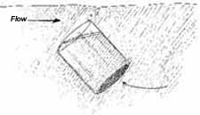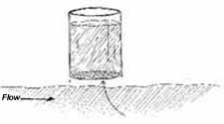
4
3

- Samples should be taken at a depth of at least 8 inches, or mid-way between the surface and bottom if a stream is shallow.
- Once the full sample container is out of the water, water should be poured off to the required volume in the field before capping. Bringing samples to the lab at the wrong volumes requires lab personnel to adjust volumes in house which leads to unnecessary contamination risks.
All Samples
- After samples are collected and capped, they should be placed into a cooler with frozen ice packs/water frozen into bottles. Using free ice in a cooler should be avoided. Sample containers and tubes are not guaranteed to be leak-free, therefore, samples that are floating around in cooler of melted ice are at risk of unnecessary contamination.
- When racks are provided, samples should be organized numerically by parameter (all phosphorus in order, all dissolved phosphorus in order, all chlorides in order, etc.)
- ALL LABELS NOT USED SHOULD BE IMMEDIATELY DISCARDED TO PREVENT ACCIDENTAL RE-USE IN FUTURE SAMPLINGS.
- All labels are unique to every bottle order, sample labels should never be exchanged or re-used from one site to the next – if you need to add/change a site but do not have a specified label, use masking tape (or write on the bottle) to note which site it is and new labels can be added when samples are dropped off at lab, do not use labels from another site, even if that site’s labels were not used.
**********************************************************************
Quality Control Samples:
Field Duplicates
- Groups should include duplicate site sampling into their bottle order requests, these duplicate samples would have a laboratory label with a separate number than the original “parent” sample. (ex: sample 12345-01 and 12345-17 are from the same location).
- These are not the same as the extra duplicate containers labeled with a “duplicate/spike” sticker that are provided by the laboratory on some parameters (dissolved and total phosphorus, and E. coli).
Phosphorus/Dissolved Phosphorus Duplicate Sampling (glass tubes):
- If a bottle order has been filled that contains phosphorus samples, the lab will include extra glass tubes for 10% of the total sampling (if there are 30 phosphorus samples, there would be 3 extra tubes) labeled with the following sticker:
COLLECT SAMPLE FOR DUPLICATE/SPIKE

Lab Sample ID #

- Samplers may choose ANY site(s) at which to take an extra sample – not the blank!
For example – you may choose to duplicate the first site being sampled: 12345-01, write the lab number on the “Collect Sample For Duplicate/Spike” sticker, and fill with sample as normal from the corresponding site, at the same time as taking the original sample.
COLLECT SAMPLE FOR DUPLICATE/SPIKE

Lab Sample ID # 12345-01 Dup

Labeling the tube: the only thing that needs to be written on the duplicate label is the laboratory number. (For site 12345-01, on the duplicate label write 12345-01 Dup).

E. coli Duplicate Sampling (290mL plastic IDEXX bottles):
- If a bottle order has been filled that contains bacteriological samples (E. coli), 10% of the bottles will be larger than the normal sample containers – they are 290mL containers instead of 125mL containers.
- It does not matter which site the duplicate bottle is filled from (not the blank!) simply apply the label that corresponds to that site to the bottle (ex: 12345-08) and fill the bottle to the 200mL line. This sample will be aseptically split into 2 separate samples at the laboratory.
Why are some parameters duplicated in extra containers while others are not?
To help the laboratory guarantee accurate results, parameters are run in duplicate 10% of the time (one in ten samples is run twice to ensure laboratory accuracy). Most parameters analyzed in the lab are brought in with sample containers that provide the laboratory with enough extra sample that it can be analyzed twice using the original bottle. Phosphorus and E. coli samples, however, require the use of the ENTIRE sample for analysis, duplicates cannot be run unless another bottle or extra sample is provided. This is why you will find extra glass tubes and bigger E. coli bottles for these parameters.
Blank Samples:
Groups should also include “blank” site sampling into their bottle order requests, these samples would have laboratory labels.
- Equipment/Field Blanks – Blanks are samples of deionized water that are taken in the same way samples are. These samples will potentially show field sampling errors involved with proper rinsing and equipment cleaning between sample sites, and are used to determine if there is contamination from one site to the next. They can also show potential laboratory errors in dish washing, or laboratory analysis.

- Laboratory Blanks – Laboratory blanks are samples of deionized water that are analyzed the same way samples are for any given parameter. These samples will potentially show laboratory errors involved with the de-ionization system, laboratory preparations, or laboratory analysis.

***************************************************************************

Returning Samples to the Laboratory:
- After all sample sites have been collected, along with the required quality control samples, samplers should bring their coolers back to the VAEL Laboratory as soon as possible.
- All sample parameters have a “hold time” – a maximum time allowed before parameters are required to be run, without compromising the quality of the data.

- Samples should be delivered to:

Hills Agriculture Building, Room 015
105 Carrigan Drive, Burlington, VT
Between the hours of 8-4:30
For after hours sample drop-off coordination, please contact the lab.

** E. coli samples can only be delivered Monday through Thursday before 3pm **

Parameter | Hold Time | Sample Preservation at Lab
E. coli / Bacteria | 8 hours/same day analysis | Refrigeration
Turbidity | 48 hours | Refrigeration
Total Suspended Solids | 7 days | Refrigeration
Alkalinity | 14 days | Refrigeration
Total/Dissolved Nitrogen | 28 days (must be acidified within 48 hours of sampling) | Acidification/Refrigeration
Total/Dissolved Phosphorus | 28 days | Room Temperature
Conductivity | 28 days | Refrigeration

- All hold times are determined using the date and time of SAMPLING, not the date and time of RECEIPT at the laboratory.
- It is very important that regardless of hold times, all samples are returned as quickly as possible to the laboratory. If samples are “held” and not brought to the laboratory quickly, it only increases the chances of samples being run outside of their hold time.

Checking Samples into the Laboratory:
- Once coolers are returned to the laboratory with filled samples, samplers (or whomever is dropping the samples off) should take the time to again go through the pre-log paperwork and make hand-written changes as needed.
  - Cross out any samples or parameters that were not sampled.
  - Add any new sites that were sampled but weren’t included in original pre-log.
  - Verify that a date and time of sampling is noted for each sample site.
  - Alert personnel of samples with short hold times that have arrived (E. coli).
- After checking through the paperwork, all samples should remain in the cooler with the paperwork – someone from the laboratory will complete sample check in by again comparing the paperwork to what samples are received and verifying that everything that should have arrived – did arrive.
- Once samples have been verified by someone from the lab staff, the new samples/parameters are entered into the LIMS system, which shows lab personnel that new samples are available for analysis.
What Next?
- Laboratory personnel will begin analysis of samples and results are provided within 30 business days of sample drop off.

Safety While Sampling:
• Carry a cell phone while sampling, sample with a partner, and always let someone else know where you are, when you intend to return, and what to do if you do not return on time.
• Honor private property rights. Never cross a landowner’s property without permission.
• Never wade in swift or high water. Do not wade if depth is greater than knee-deep. Do not monitor if the stream is at flood stage.
• If possible, have a first aid kit on hand. Preferably, at least one team member should have first aid/CPR training. Have a medical form for each volunteer monitor including emergency contacts, insurance, and pertinent health information such as allergies or other health conditions.
• Be aware of the nearest hospital and how to get there from the sampling area.
• Listen to weather reports. Never monitor if severe weather is predicted or if a storm occurs.
• Do not walk on unstable stream banks. Disturbing these bank may accelerate erosion and lead to a collapse.
• Be aware of animals and plants: watch for dogs, farm animals, wildlife, and insects such as ticks, mosquitoes, and hornets. Watch for poison ivy, poison parsnip, and other skin-irritating vegetation.

Disclaimer: In putting together this guide, several documents written by the EPA, the Vermont DEC, the USGS, and other state and government entities were referenced. In several cases, information was copied for the use of producing this guide. Generally, this information is in no way referenced besides in the links below. The VAEL Laboratory in no way claims rights to any of this information and is simply trying to provide useful information for Vermont’s Volunteer Water Monitors.
For more information:
http://water.epa.gov/type/rsl/monitoring/vms50.cfm
http://water.usgs.gov/owq/FieldManual/chapter4/pdf/Archive/chapter4.pdf
http://water.epa.gov/type/rsl/monitoring/upload/2002_08_13_volunteer_stream_stream.pdf
http://www.watershedmanagement.vt.gov/lakes/docs/monitoringguide/lp_vmg-sec1.pdf#zoom=100
http://www.in.gov/idem/riverwatch/files/volunteer_monitoring_manual.pdf
http://www.vtwaterquality.org/bass/docs/bs_fieldmethodsmanual.pdf

