Analysis of Temporal Trends in Water Quality

at Sentinel Stations in the Lewis Creek watershed

31 October 2017

Prepared by:

Kristen L. Underwood, PG

South Mountain Research & Consulting

Bristol, VT

Prepared under contract to:

VT Agency of Natural Resources

Watershed Management Division

Montpelier, VT

Table of Contents

Acknowledgements i

Executive Summary ii

1.0 Introduction 1

2.0 Background 1

2.1 Description of Watershed 1

2.2 Description of Sentinel Stations 2

2.3 Discharge Measurement 3

2.4 History of Water Quality Monitoring at Sentinel Stations 4

2.5 Summary of River Corridor Planning Activities 6

3.0 Methods 8

3.1 Assign Flow Condition to Sample Dates 8

3.2 Examine Flow Record for Stationarity 8

3.3 Trend Analysis (Monotonic) 8

4.0 Results and Discussion 9

4.1 Trends in Discharge 10

4.2 Trends in Concentration 11

5.0 Conclusion 12

6.0 References 13

Appendix A.

Table A-1. Monitoring History for Sentinel Stations, Lewis Creek watershed

Table A-2. Trend Analysis Results

# Acknowledgements

This document is one of five templates or guidance documents generated by the VT Department of Environmental Conservation (VTDEC) to support watershed groups engaged in ambient water quality monitoring under the LaRosa Partnership Program. These templates provide examples of data reduction and visualization, as well as statistical analysis, that enable more effective communication of the data – to constituents of Partnership groups; to local, state and federal partners in project implementation; and to the VT Agency of Natural Resources for meeting a variety of needs (e.g., listing / delisting of waters, basin planning, prioritization of resources to groups for project implementation). This template has been prepared by South Mountain Research & Consulting of Bristol, VT, under contract to VTDEC.   
  
This template relies on water quality data from the Lewis Creek watershed, where sampling is carried out by a network of trained volunteers operating under the Addison County River Watch Collaborative (fiscal agent, Lewis Creek Association), with logistical and technical support provided by the VTDEC Monitoring, Assessment and Planning Program, the Addison County Regional Planning Commission and South Mountain Research & Consulting. Analytical services are provided by the Vermont Agricultural & Environmental Laboratory (<http://agriculture.vermont.gov/vael>) in Burlington, VT, through an analytical services partnership grant.

# Executive Summary

Historic water quality at two water quality stations in the Lewis Creek watershed was evaluated to discern possible longterm, gradual changes in sediment, pathogen and nutrient concentrations in response to progressive implementation of restoration and conservation projects and practices. Statistical trend analysis was carried out for these two sentinel stations (LCR3.7 and LCR14) which have been monitored in spring and summer for *E.coli* (since 1992), Total Phosphorus (since 1997) and Turbidity (since 2006). No significant trends in monthly water quality data were evident over the respective monitoring periods at either sentinel station. While gradual improvements in water quality are to be expected as a result of these restoration projects, an increased magnitude and frequency of high flows may be complicating the water quality response. A statistically-significant, positive trend in daily mean flow over the 24-year period from 1992 through 2015, and a significant positive trend in the number of High Flow days per year over the same period were detected. These results underscore the importance of continued implementation of Best Management Practices and riparian conservation measures in the face of increasing climate change.

# 1.0 Introduction

The Lewis Creek Association, through the Addison County River Watch Collaborative (ACRWC), has been monitoring water quality at several stations in the Lewis Creek since 1992. Phosphorus, suspended sediments, and *E. coli* are impacting the Creek as a result of channel erosion, land erosion, and non-erosion-related nutrient and pathogen loading (VTDEC, 2012; SMRC, 2010, 2013). Two sentinel stations have been established (Figure 1) to track long-term (annual-scale) variations in water quality resulting from naturally fluctuating weather and vegetation, but also human-influenced factors such as shifting land use or changes in management practices.

These two sentinel stations complement 20 additional monitoring stations in the watershed sampled less frequently in support of other monitoring objectives, such as spatial trend monitoring, bracketing monitoring to discern effectiveness of treatment practices, health and safety monitoring at recreational sites, and evaluation of instream biological health and reference-reach status. This report examines historic water quality at these two sentinel stations to discern possible longterm, gradual changes in sediment, pathogen and nutrient concentrations over time.

# 2.0 Background

## 2.1 Description of Watershed

The Lewis Creek watershed is an 81-square-mile basin located in Addison and Chittenden Counties, Vermont, and drains directly into Lake Champlain at Hawkins Bay near Long Point and Gardner Island. The watershed spans two major geologic provinces. Approximately 30% of the watershed occupies the till-blanketed bedrock slopes of the Northern Green Mountain province within the steep headwaters of the Lewis Creek main stem, High Knob tributary and Hollow Brook in eastern Starksboro and Hinesburg. The remaining 70% of the Lewis Creek watershed, including the Pond Brook tributary, is positioned in the broad Champlain Valley province (Stewart, 1973; Capen, 1998).

Lewis Creek is a largely rural watershed, dominated by agricultural and forested land uses, with lesser percentages of urbanized land cover associated with roads and driveways, sparse development, and the village centers of Starksboro and North Ferrisburgh. Land cover in the Lewis Creek watershed has remained fairly consistent over the monitoring period from water year 1991 through 2015. Population centers (e.g., Starksboro village, North Ferrisburgh village) have not grown appreciably in the last 25 years.

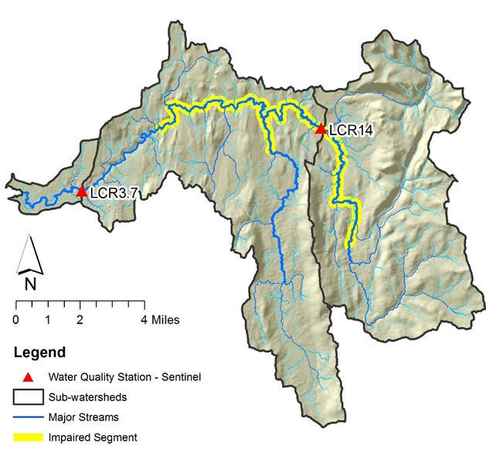

*Figure 1. Location of sentinel stations in Lewis Creek Watershed*

## 2.2 Description of Sentinel Stations

Sentinel station, LCR14, is located at the Tyler Bridge Road crossing of Lewis Creek approximately 1,500 feet downstream of the confluence of Hollow Brook tributary in the town of Monkton. This station has an upstream drainage area of 36.0 square miles (mi2).

* Soils: Upland slopes in the eastern extent of the watershed draining to LCR14 are dominated by soils derived from glacial till and glacial outwash deposits including kame terraces that run north-south along the flanks of the Northern Green Mountains. These soils are a mix of sediment sizes and permeabilities, ranging from higher infiltration capacities of the outwash deposits and ablation tills to lower infiltration capacities of soils formed on the dense till and glacial lake deposits.
* Land cover / land use: The sub-watershed draining to LCR14 is largely forested (79%) but contains significant agricultural (13%) and developed uses (6%), particularly along the main stem through the Starksboro valley (Troy *et al*., 2007; source date 2001). Station LCR14 is located 1,500 feet downstream of the confluence with Hollow Brook tributary which flows through wetlands populated by beavers. This station is also located one mile downstream of a pasture where for several decades dairy cows have had direct access to the stream along a mile of pasture. Since 2007, a second farm located 0.3 mile upstream of LCR14 has excluded dairy cows along 3,600 feet the Lewis Creek via fencing, and reduced access to a single stabilized crossing.

Sentinel station, LCR3.7, is located at the former Route 7 bridge crossing, approximately 1,000 feet downstream of the current US Route 7 bridge crossing and 1,500 feet downstream of the USGS streamflow gaging station in the town of Ferrisburgh. The total upstream drainage area to this station is 77.3 mi2, representing an incremental drainage area of 41.3 mi2 downstream of station LCR14.

* Soils: The central and western portions of the watershed draining to LCR3.7 are dominated by silt loams originating from silty-clay deposits of marine and freshwater lake environments. These deposits tend to be less permeable and have lower infiltration rates, and are more prone to runoff (Stewart, 1973; Stewart & MacClintock, 1969; USDA 2013, 2011).
* Land cover / land use: The incremental drainage area to LCR3.7 is composed of 50% forested, 32% agricultural and 10% developed uses (Troy *et al*., 2007; source date 2001). This station is located 1.5 miles downstream from North Ferrisburgh village, where homes and commercial properties are serviced by onsite wastewater systems.

## 2.3 Discharge Measurement

The United States Geological Survey (USGS) maintains a streamflow gaging station on the Lewis Creek just upstream from LCR3.7. Station #04282780 is located near the US Route 7 crossing and measures flow from an approximate drainage area of 77.2 square miles, or 95% of the watershed (USGS, 2017). ACRWC assigns a discharge for each sampling date based on reference to the daily mean flow (DMF) recorded at this gage, applying a correction factor for the proportional drainage area at each sampling station.

Figure 2 presents a flow duration curve computed on daily mean flows recorded for water years 1991 through 2015. Flows have been categorized following VTDEC *Guidance on Streamflow Observations at time of Water Quality Sampling of Rivers and Streams*. High flows are defined as those flow conditions which are equaled or exceeded only 25% of the time, and low flow levels are those equaled or exceeded more than 75% of the time, while those flows occurring between 25 and 75% of the time are classified as moderate.

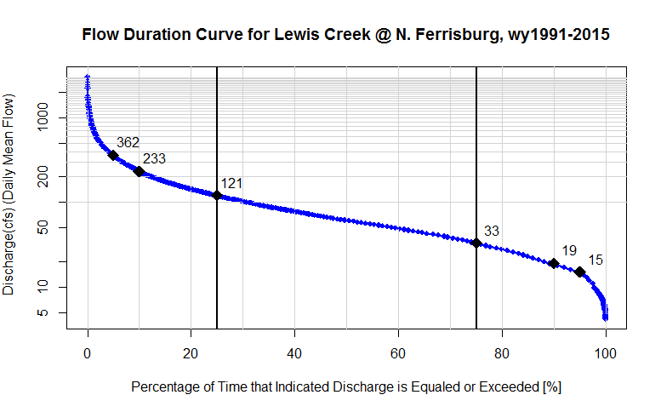  
*Figure 2. Flow Duration Curve for Lewis Creek at Ferrisburgh, VT.  
Black diamonds mark the discharge at the 95th, 90th, 75th, 25th, 10th, and 5th quantiles.   
(Approved record for water years: 1991 – 2015; USGS Stn# 04282780; 77.2 sq mi).*

High Flows

Moderate Flows

Low Flows

The twenty-five-year trend analysis period represents a range of hydrologic conditions, from very wet years (1996, 2006, and 2011) to drier-than-normal years (1995, 2002, and 2012), based on cumulative annual flows developed on the DMF record for this streamflow gage.

## 2.4 History of Water Quality Monitoring at Sentinel Stations

Water quality sampling in the Lewis Creek watershed is carried out by a network of trained volunteers operating under an EPA-approved Quality Assurance Project Plan. Analytical services are provided by the Vermont Agricultural & Environmental Laboratory in Burlington, VT. In earlier years, analytical services were provided by Endyne, Inc. (2000-2002), and for select years *E. coli* was analyzed at the Middlebury Union High School (1998-1999) and CVU High School (1992 – 1997).

Aside from a hiatus in 2009, sampling has been conducted annually since 1992. Available data for the two sentinel stations include monthly grab samples collected on pre-determined dates in summer months (June, July, August and September). Beginning in 2004, two monthly spring events (April, May) were also added to the annual schedule. Additionally, wet-weather high-flow sampling was conducted at station LCR14 in October and December of 2012 as part of a spatial trend monitoring effort in the Pond Brook tributary. The maximum flow recorded during these high-flow sample dates was a daily mean flow of 843 cfs, a flow that is exceeded only about 0.8% of the time according to the flow duration curve (Figure 2). This flow magnitude represents approximately one half of the two-year recurrence interval peak flow (Q2 = 1,750 cfs; Table 1).

Scheduled monthly samples have been analyzed for *E. coli* (since 1992), Total Phosphorus (since 1997), and Turbidity (since 2006) with some years omitted as detailed in Appendix A, Table A-1. In select years, analyses have also been conducted for Dissolved Phosphorus, Total Nitrogen, and Total Suspended Solids. This report focuses on *E. coli*, TP, and Turbidity records, as they are of sufficient length to examine for monotonic trends. Historic monitoring results at the two sentinel stations are summarized in Figure 3.

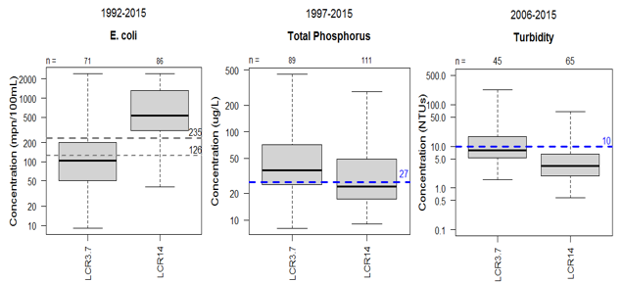

*Figure 3. Summary of historic monitoring results for Sentinel Stations, LCR3.7 and LCR14, Lewis Creek watershed. Whiskers extend to the maximum and minimum values, while the gray-shaded box represents the interquartile range of values. The median value is marked by the solid horizontal line. The number of samples (n) represented by each box-and-whisker is displayed across the top of the chart. Horizontal dashed lines mark the relevant values for VT Water Quality Standards as detailed in the text below*.

***E. coli*** counts on summer sampling dates in the Lewis Creek at the two sentinel stations have ranged from 9 to >2420 MPN/100 mL (Figure 4A). Vermont Water Quality Criteria (VTDEC, 2016) state that *E. coli* is not to exceed a geometric mean of 126 MPN/100mL obtained over a representative period of 60 days, and no more than 10% of samples should be above 235 MPN/100 mL. Chronic exceedances of the water quality standard for *E. coli* are evident at LCR14. Station LCR14 is located downstream of a dairy pasture where livestock have direct access to the stream. This station is also located downstream of the confluence with Hollow Brook which flows through wetlands populated by beavers.

**Phosphorus** was detected at low to moderate concentrations during spring and summer sampling dates from 1997 to 2015, ranging from 8 to 448 µg/L (Figure 4B). The instream phosphorus criterion of 27 µg/L for warm-water medium gradient (WWMG) wadeable stream ecotypes in Class B waters is applicable at low median monthly (LMM) flow conditions during June through October. Historic results for both sentinel and rotational sites have shown an increasing trend in phosphorus concentration with distance downstream, as well as a tendency for elevated phosphorus concentrations during high flows.  
  
**Turbidity** levels in the Lewis Creek at the two sentinel stations ranged from 0.6 to 223 NTUs on spring and summer sample dates from 2006 through 2015. The box-and-whisker plot in Figure 4C shows the full distribution of Turbidity results reported over that time frame. The Vermont state standard of 10 NTUs (for Class B cold-water fisheries) is applicable during dry-weather, baseflow conditions. Turbidity can be elevated at times of increased flow – during a summer thunderstorm, or during spring runoff conditions – especially in the lower reaches of the Lewis Creek (vicinity of LCR3.7). Based on additional stations, an increasing trend in turbidity with distance downstream is generally observed during all flow conditions (SMRC, 2010, 2013) – coincident with increasing density of glaciolacustrine soils (ACRWC & SMRC, 2016).

Based in part on ACRWC historic water quality monitoring data, the State of Vermont has listed the following Lewis Creek segments as impaired for contact recreation use due to *E. coli* impacts resulting from agricultural runoff (VTDEC WQD, 2016):

* Lewis Creek main stem, 12.3 miles from Quinlan Covered Bridge upstream to footbridge at LCR19.5 (yellow highlighted river segment in Figure 1), and
* Pond Brook from confluence with Lewis Creek upstream approximately 1.5 miles.

A *Vermont Statewide Total Maximum Daily Load (TMDL) for Bacteria-impaired Waters* was issued by the VTDEC in 2011 and addresses these Lewis Creek segments in Appendix 5 (VTDEC, 2011).

## 2.5 Summary of River Corridor Planning Activities

River corridor planning activities carried out by Lewis Creek Association have identified that mobilization of fine sediments, phosphorus and *E. coli* to the Lewis Creek is occurring, related to: (1) fall-tilling, manure applications, and cropping practices in close proximity to unbuffered swales, road ditches and other locations of concentrated runoff to surface waters; (2) occasional inundation of fields beyond minimum buffer widths required by Required Agricultural Practices; (3) maintenance of drainage ditches in agricultural fields; (4) livestock pastured with direct access to surface waters; and (5) stormwater and sediment runoff from forested and developed lands and road and driveway networks (SMRC, 2013; 2010).

Several riparian and floodplain conservation and restoration projects have been implemented along the main stem and major tributaries over the past twenty-five years, resulting in gradual expansion of vegetated riparian buffers, increased setbacks of crop fields and pasture areas, and enhanced floodplain connection (Table 1).

*Table 1. Notable river corridor conservation / restoration projects, Lewis Creek watershed.*

|  |  |  |  |  |  |
| --- | --- | --- | --- | --- | --- |
| Sentinel Subshed | Reach* | ID | Description | Year(s) | Acres / Miles |
| LCR14 | M22 | Wagner | Buffer plantings, streambank stabilization |  |  |
| LCR14 | M20 | Rublee Farm | Livestock exclusion, riparian buffer plantings | 1998 |  |
| LCR14 | M19 | Starksboro Ball Fields, Cota lands | Conservation, lands out of agricultural production, riparian buffer plantings |  |  |
| LCR14 | M17 | Cota lands | Conservation, lands out of agricultural production |  |  |
| LCR14 | M16 | Clifford Farm | Cedar revetments, waddles, tree planting  Livestock exclusion, stabilized crossing, increased setbacks for crop fields | 2001-2005  2007 | 8.8 ac, 1000 ft channel, 35 – 100 ft width |
| LCR14 | M15-B | Cobble Creek Nursery | Gully stabilization |  |  |
| LCR3.7 | M15-B | Mainer / VFW | Conservation |  |  |
| LCR3.7 | Mxx | VFW | Conservation, Silver St |  |  |
| LCR3.7 | Mxx | Baldwin Farm | Conservation, riparian buffer plantings |  |  |
| LCR3.7 | M06 |  | Conservation (VRC) |  |  |
| LCR3.7 | T3.xx | Last Resort Farm | Gully stabilization |  |  |
| LCR3.7 | T3.01 | Russell Farm | Conservation, riparian buffer plantings, conversion from conventional dairy to grass-fed beef |  |  |

*Reach numbers assigned through stream geomorphic assessment, viewable on the VT Natural Resource Atlas via http://anrmaps.vermont.gov/websites/anra/

# 3.0 Methods

Progressive implementation of restoration and conservation projects over time is expected to result in gradual improvements in water quality. Statistical analyses were performed to examine for possible temporal trends. Available water quality data for each sentinel station were examined for monotonic trends, by regressing concentration data on time, while adjusting for variable flow conditions on the sample dates. Of the historic parameters tested at these two sentinel stations, *E. coli*, TP and Turbidity had sufficient length of record to analyze for monotonic trends (at least 5 years - Hirsh, 1998; Helsel & Hirsch, 2002). As detailed below, certain exploratory data steps were completed prior to trend analysis, including examining data for outliers or large data gaps and transforming data to fulfill assumptions for equal variances of residuals about the trend line.

## 3.1 Assign Flow Condition to Sample Dates

Flow conditions were assigned for each sample date, following VTDEC *Guidance on Streamflow Observations at time of Water Quality Sampling of Rivers and Streams*, with reference to the flow duration curve (Figure 2). This flow condition was then used to subset samples for further analysis in some cases. Recorded daily mean flows on sample dates were further classified by category, as those exhibiting base-flow characteristics (i.e., relatively stable flow stage, not significantly rising or falling in response to a rainfall or snowmelt event) versus a “freshet flow”, per VTDEC guidance (only for most recent years: 2010 – 2015).

## 3.2 Examine Flow Record for Stationarity

One of the underlying assumptions in trend analysis of concentration data is that the overall mean of discharge remains constant – or stationary – throughout the examined monitoring record. Otherwise, patterns in concentration with time may be resulting from larger-scale increases or decreases in average flow conditions attributed to decadal-scale climate fluctuations (such as the North Atlantic Oscillation) or global climate change. To evaluate this assumption, trends in daily mean flows in Lewis Creek were examined for three different time spans, representing the record of years over which *E. coli*, TP and Turbidity were each monitored.

## 3.3 Trend Analysis (Monotonic)

Trend testing was performed using nonparametric methods (Helsel & Hirsch, 2002), because assumptions of the linear regression methods – namely, that residuals belong to a normal distribution – could not be met in all cases. The nonparametric Mann-Kendall (MK) test (Mann 1945, Kendall 1975, Helsel & Hirsch, 2002) is applied to determine if there is a steady, gradual increasing or decreasing trend in a given variable over a specified period of time. This method provides more flexibility than linear regression methods, where the trend may or may not be linear, and since there is no requirement that residuals from that trend be normally distributed. The MK method is also more robust to missing data, small data gaps in the record, outliers, and censored data (i.e, data below [or above] a minimum [or maximum] detection limit) (Meals *et al.,* 2013).

In the MK method, the rank-based correlation between concentration and time is evaluated. A Kendall S statistic is calculated and tested to see if it is significantly different from zero. If S > 0, then observations made later in time tend to be larger than observations made earlier in time, indicating a positive (increasing) trend in concentration. If S < 0, then a decreasing trend in concentration is evident. The MK method performs a test of the null hypothesis that there is no trend. A small p value rejects this hypothesis, and it can be concluded that there is a statistically-significant trend. A p value greater than the established level of significance (α ) fails to reject the null hypothesis and the data are insufficient to conclude whether there is a trend. The trend can be visualized by fitting a smoothing line to the plot of concentration versus time, using LOcally WEighted Scatterplot Smoothing (Cleveland, 1979).

When adjusting for flow using nonparametric methods, a smoothing line is fit to the plot of concentration versus discharge, using LOWESS, The LOWESS-estimated value of concentration is then compared to the observed value of concentration, to generate a residual value for each sample date on the time axis. The residuals are then subjected to the MK trend test.

Discharge and concentration data were log10 transformed to maximize the chances of meeting the requirement for equal variance of residuals about the trend line. Early *E. coli* results (from 1992 – 1999) were truncated at >2420, in order to be reported in a manner consistent with more recent data analyzed by Standard Methods 9223-B (2000 – 2015).

# 4.0 Results and Discussion

Trend analysis results are presented below for each parameter, and summarized in Appendix A, Table A2. Results reflect adjustment for flow, since correcting for flow conditions on the sample date, and regressing the residuals (or flow-adjusted concentrations) on time, allows one to make inferences about factors other than daily-to-seasonally-varying flow that may be influencing concentration trends over time, such as:

* Fluctuating strength of contaminant sources (e.g., number of cows, length of channel with direct livestock access), or
* Changing influence of groundwater sources (e.g., failing septic systems), or
* Incremental changes in aggregate land use in the upstream catchment (e.g., gradual development of buffer vegetation, or staged implementation of BMPs).

When plotting log10 transformed concentration versus discharge data to facilitate flow adjustment, a linear model did not always provide the best fit – particularly where threshold responses were evident (e.g., Figure 4). This provided further justification for application of nonparametric methods.

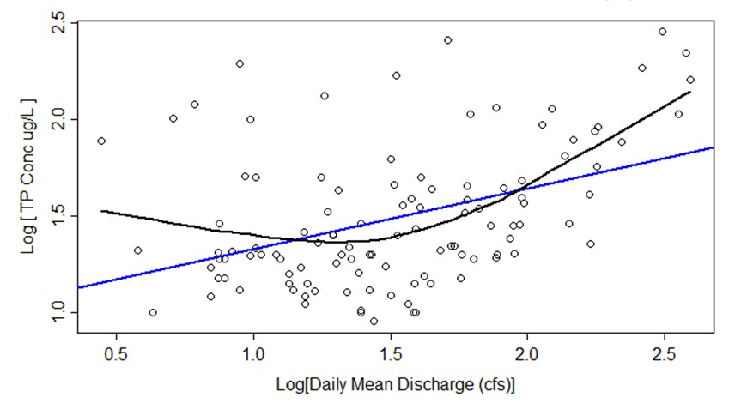

*Figure 4. Comparison of simple linear regression fit (blue line) and LOWESS fit (black line) to plot of log10 TP vs log10 Discharge data for LCR14 over the available record from 1997 -2015 (n = 111). Slope of linear regression line (0.313) is significantly different from zero (r2 = 0.17, p < 0.05); however, residuals are not normally distributed (p < 0.05). LOWESS line uses smoothing factor = 0.8.*

## 4.1 Trends in Discharge

Mann-Kendall analysis confirmed a significant positive trend in daily mean flows over time for *E. coli* (years 1992 through 2015) and for TP (years 1997 – 2015). A significant negative trend in daily mean flows is evident for the most recent decade (2006 – 2015) during which Turbidity has been sampled (Table 2).

Yearly average trends (upward) for the 29-year and 19-year records of *E. coli* and TP concentration data are relatively minor, representing less than 1% of the annual mean of daily mean flows recorded for Lewis Creek for water years 1990 through 2015 (i.e., 108.7 cfs; USGS, 2016). A somewhat more substantial trend (downward) in DMF is evident for the most recent decade, wherein flows are decreasing on average by 3.2 cfs per year. However, this length of record (10 yrs) may be too short to reflect longterm changes, and could instead reflect serial correlation of DMF values. A separate test of the full DMF record for Lewis Creek revealed that values are autocorrelated out to about 60 days, or two months.

Table 2. Trend Analysis Results for Daily Mean Flows, Lewis Creek at North Ferrisburgh



The DMF records for each monitoring period were also examined for trends in the number of days per year where flow exceeded the 95th, 90th, 75th, and 50th percentiles. A significant positive trend in days per year exceeding both the 75th and 50th percentiles (α = 0.10) was noted for the 24-year period from 1992 through 2015 (Table 6). This finding is consistent with regional patterns of increased magnitude, frequency and persistence of precipitation over recent decades (Guilbert, *et al*., 2015; Guilbert *et al*., 2014).

## 4.2 Trends in Concentration

Table 3 presents trend data for flow-adjusted *E. coli*, TP, and Turbidity concentrations over the length of available record for Lewis Creek sentinel stations LCR3.7 and LCR14. Record lengths varied for the constituents (*E. coli* for TP, for Turbidity). Two options are presented for *E. coli* and TP, wherein “All” available data and data stratified to select only those observations made during “Low Flow” conditions (i.e., DMF recorded at the USGS gage was below 33 cfs). In each case, the trend is not significant over the indicated time period. This response was apparent despite slight, statistically-significant upward trends in DMF over the relevant time periods for *E. coli* and TP, and despite statistically-significant increasing trends in DMF equaling or exceeding the 75th percentile for the period from 1992 through 2015.

Table 3. Monotonic Trend Results for Sentinel Stations, Lewis Creek watershed



# 5.0 Conclusion

Trend analysis has been undertaken for two sentinel stations (LCR3.7 and LCR14) in the Lewis Creek watershed which have been monitored in spring and summer for *E.coli* (since 1992), Total Phosphorus (since 1997) and Turbidity (since 2006). No significant trends in monthly water quality data were evident over the respective monitoring periods at either sentinel station. Restoration and conservation projects have been progressively implemented over time in the watershed. While gradual improvements in water quality are to be expected as a result of these projects, an increased magnitude and frequency of high flows may be complicating the water quality response. A statistically-significant, positive trend in daily mean flow over the 24-year period from 1992 through 2015, and a significant positive trend in the number of High Flow days per year over the same period were detected. These results underscore the importance of continued implementation of Best Management Practices and riparian conservation measures in the face of increasing climate change.

# 6.0 References

Addison County River Watch Collaborative and South Mountain Research & Consulting, 2016, *Workshops and Analysis to Enhance Flood Resiliency of Headwater Forests*, Final Grant Summary Report, Grant Award #: WG224-16.

Capen, David E., 1998, Biophysical regions of Vermont from the VT Biodiversity Project (GeologicOther_BIOPHYSRG), downloaded from Vermont Center for Geographic Information [<http://www.vcgi.org/>](http://www.vcgi.org/).

Cleveland, W.S., 1979, Robust Locally Weighted Regression and Smoothing Scatterplots: *J. Am. Stat. Assoc. 74*, 829-836.

Guilbert, J., A. K. Betts, D. M. Rizzo, B. Beckage, and A. Bomblies. 2015. Characterization of increased persistence and intensity of precipitation in the Northeastern United States. Geophysical Research Letters. DOI: 10.1002/2015GL063124.

Guilbert, J., B. Beckage, J. M. Winter, R. M. Horton, T. Perkins, and A. Bomblies. 2014. Impacts of projected climate change over the Lake Champlain Basin in Vermont. Journal of Applied Meteorology and Climatology 53: 1861-1875.

Helsel, D.R., and R.M. Hirsch. 2002. Statistical Methods in Water Resources. Book 4, Chapter A3 in *Techniques of Water-Resources Investigations*. U.S. Geological Survey, Reston, VA. Accessed February 10, 2016. http://pubs.usgs.gov/twri/twri4a3/.

Hirsch, R.M. 1988. Statistical methods and sampling design for estimating step trends in surface water quality. *Water Resources Research* 24:493-503.

Hirsch, R.M., J.R. Slack, and R.A. Smith. 1982. *Techniques of trend analysis for monthly water quality data* , Water Resources Research 18(1):107-121.

Illick, Marty, 2017, personal communication, Executive Director of Lewis Creek Association.

Kendall, M.G. 1975. *Rank Correlation Methods*, 4th edition, Charles Griffin, London.

Mann, H.B. 1945. *Non-parametric tests against trend*, Econometrica 13:163-171.

Meals, D. W., J. Spooner, S. A. Dressing, J. B. Harcum, 2013, Statistical analysis for monotonic trends, Tech Notes 6, Developed for U.S. Environmental Protection Agency by Tetra Tech, Inc., Fairfax, VA, 23 p. Available online at: https://www.epa.gov/sites/production/files/201605/documents/  
tech_notes_6_dec2013_trend.pdf

Olson, S.A., 2014, Estimation of flood discharges at selected annual exceedance probabilities for unregulated, rural streams in Vermont, *with a section on* Vermont regional skew regression, by Veilleux, A.G.: U.S. Geological Survey Scientific Investigations Report 2014–5078, 27 p. plus appendixes, [*http://dx.doi.org/10.3133/sir20145078*](http://dx.doi.org/10.3133/sir20145078)*.*

South Mountain Research & Consulting, 2013, Water Quality Management Plan: Pond Brook Tributary, Lewis Creek Watershed, prepared under contract to Lewis Creek Association.

South Mountain Research & Consulting, 2010, Lewis Creek Watershed: River Corridor Conservation & Management Plan, Addison & Chittenden Counties, Vermont, prepared under contract to Lewis Creek Association.

Stewart, David P., 1973. *Geology for Environmental Planning in the Burlington-Middlebury Region, Vermont*. Vermont Geological Survey, Environmental Geology No. 3. Montpelier, Vermont: Water Resources Department.

Stewart, David P. and Paul MacClintock, 1969, *The Surficial Geology and Pleistocene History of Vermont*. Vermont Geological Survey Bulletin No. 31.

Troy, Austin, Deane Wang, & David Capen, 2007. Updating the Lake Champlain Basin Land Use Data to Improve Prediction of Phosphorus Loading, Lake Champlain Basin Program, Technical Report No. 54.

USGS, 2017, on-line surface water data, <<http://waterdata.usgs.gov/vt/nwis>>.

USGS, 2015 Water Year Summary for Site USGS 04282780, available at https://waterdata.usgs.gov/nwis/wys_rpt/?site_no=04282780&agency_cd=USGS

VTDEC, 2011, *Vermont Statewide Total Maximum Daily Load (TMDL) for Bacteria Impaired Waters*, prepared by FB Environmental Associates, Inc., Portland, ME. and Appendix 5. Available at: http://dec.vermont.gov/sites/dec/files/wsm/mapp/docs/mp_bacteriatmdl.pdf http://dec.vermont.gov/sites/dec/files/documents/WSMD_mapp_5lewiscreekpondbrook.pdf

VTDEC, 2012, *Otter Creek Basin Water Quality Management Plan*, including appendices. Available at: http://dec.vermont.gov/sites/dec/files/wsm/mapp/docs/mp_ottercreekplan.pdf http://dec.vermont.gov/sites/dec/files/wsm/mapp/docs/mp_ottercreekappendix.pdf

VT DEC Water Quality Division, 2016, *State of Vermont 2016 303(d) List of Waters*: *Part D – Impaired Surface Waters in Need of TMDL*.

VT DEC Water Quality Division, 2010b, *State of Vermont 2008 List of Priority Surface Waters Outside the Scope of Clean Water Act Section 303(d)*: *Part C – Surface Waters in Need of Further Assessment*.

Vermont Watershed Management Division, 2016. *Vermont Water Quality Standards*.   
Effective 15 January 2017. Montpelier, VT. Available at: http://dec.vermont.gov/sites/dec/files/documents/wsmd_water_quality_standards_2016.pdf

Appendix A.

Table A-1. Monitoring History for Sentinel Stations, Lewis Creek watershed



Table A-2. Trend Analysis Results

