LaRosa Partnership Guidance Document for   
Coarse-level Estimation of Pollutant Loads

31 October 2017

Prepared by:

Kristen L. Underwood, PG

South Mountain Research & Consulting

Bristol, VT

Prepared under contract to:

VT Agency of Natural Resources

Watershed Management Division

Montpelier, VT

Table of Contents

1.0 Introduction 1

2.0 Discharge Estimation 2

2.1 Estimates from a USGS streamflow gaging station 2

2.1.1 Within-basin USGS gage 2

2.1.2 Near-basin USGS gage 5

2.2 Field Estimation 5

3.0 Qualitative Loading Estimates 8

3.1 Base-flow “Hot Spots” 9

3.2 High-flow Concentration Data as a Proxy for Loading 10

4.0 Quantitative Loading Estimates (Coarse-level) 11

5.0 References 12

Attachment 1 – VTDEC *Guidance on Streamflow Observations at time of Water Quality Sampling of Rivers and Streams*

Attachment 2 – Example field data sheet

Attachment 3 – Example photographic log for Flow Level and Flow Category

Acknowledgements

This document is one of five templates or guidance documents generated by the VT Department of Environmental Conservation (VTDEC) to support watershed groups engaged in ambient water quality monitoring under the LaRosa Partnership Program. These templates provide examples of data reduction and visualization, as well as statistical analysis, that enable more effective communication of the data – to constituents of Partnership groups; to local, state and federal partners in project implementation; and to the VT Agency of Natural Resources for meeting a variety of needs (e.g., listing / delisting of waters, basin planning, prioritization of resources to groups for project implementation). This guidance document has been prepared by South Mountain Research & Consulting of Bristol, VT, under contract to VTDEC.   
  
This template relies on water quality data from the New Haven River and Lewis Creek watersheds, where sampling is carried out by a network of trained volunteers operating under the Addison County River Watch Collaborative (fiscal agent, Lewis Creek Association), with logistical and technical support provided by the VTDEC Monitoring, Assessment and Planning Program, the Addison County Regional Planning Commission and South Mountain Research & Consulting. Analytical services are provided by the Vermont Agricultural & Environmental Laboratory (<http://agriculture.vermont.gov/vael>) in Burlington, VT, through an analytical services partnership grant.

# 1.0 Introduction

The LaRosa Volunteer Water Quality Monitoring Analytical Services Partnership[1] is comprised of more the nineteen separate groups around the state of Vermont engaged in ambient water quality monitoring. LaRosa Partnership groups may be interested in the estimation of pollutant loads to downstream waters for at least a couple of reasons:

* Groups may be motivated to estimate loading as a way to more effectively communicate the magnitude of pollution problems and to compel mitigation or restoration actions on the part of landowners or towns (e.g., Tons of sediment lost, percent of total watershed load phosphorus coming from one sub-region); or
* Load estimates may be used as a way to identify locations (“hot spots”) of pollutant flux within their watersheds, to rank or prioritize subwatershed areas for implementation projects.

The second objective is applicable to lake watersheds where loading on an annual basis is the focus of a Total Maximum Daily Load (TMDL) plan or pollutant reduction effort, and is expected to be less important for evaluating stream conditions where concentrations of pollutants under base-flow conditions tend to drive impacts to biological communities or human health risks.

Load estimates might also be desired to quantify effectiveness of a treatment area in terms of a load reduction (e.g., compare pollutant influx and outflux from a constructed wetland), or evaluate exceedances of loading targets in the context of a watershed restoration plan or TMDL plan. However, these objectives require data of high accuracy and precision, supported by robust estimation of discharge. A particular challenge for many groups seeking to estimate loading is the relative lack of discharge data on waters that they monitor. Not all rivers are gaged, and even if a gage is present in the watershed, topography and hydrology in the catchment may be sufficiently variable that a gage located near the catchment outlet may not adequately represent flow conditions at a site of interest, particularly if it is remote from the gage or has a drainage area that is much smaller. Techniques are available to develop high-accuracy discharge estimates to support loading studies, involving installation of temporary gaging stations. But these gages require significant resources to establish, calibrate, and maintain; and development of discharge estimates involves advanced calculation methods. Some groups may choose to secure technical and financial resources to support load monitoring studies involving the deployment of temporary flow gaging stations, but the expectation is that these more complex projects would be addressed through customized design, data analysis and reporting methods.

Therefore, this guidance document focuses on less robust, but equally useful, methods for generating coarse-level loading estimates for pollutants affecting downstream waters. Data generated in this manner will usually not be of sufficient accuracy and precision to compare to regulatory target loads (e.g., in a TMDL context) or load-reduction targets for BMP effectiveness. Nevertheless, coarse-level loading estimates can be used to focus further investigation and remedies to “hot spots” of greater loading. A discussion of available methods to estimate discharge is provided in the sections below, followed by both qualitative and quantitative methods to estimate loading.

2.0 Discharge Estimation

River discharge is estimated for at least two reasons: (1) to assign a Flow Level (low, moderate, high, or flood flow) and Flow Category (freshet, baseflow, or hydro-affected) at the time of sampling following the VTDEC *Guidance on Streamflow Observations at time of Water Quality Sampling of Rivers and Streams* (Attachment 1); and (2) to support the coarse-level calculation of pollutant loads. Depending upon the sampling location, different resources will be available to groups for the estimation of discharge. Some sites will be located on streams that have an automated streamflow gage. Other sites will be located on ungaged basins, but near to a gaged basin that is similar in character to the study basin. In all cases, samplers should conduct a field estimate of Flow Level and Flow Category, since local conditions may not be well captured by a distant or hydrologically-variable streamflow gage. For instance, flow stage at a sampling site may rise suddenly in response to an upstream, localized thunderstorm. However, due to the isolated nature of this storm event, it may not cause flow levels at a distant downstream gage to fluctuate significantly.

## 2.1 Estimates from a USGS streamflow gaging station

US Geological Survey (USGS) maintains several streamflow gaging stations throughout Vermont[2]. Near real-time discharge data can be viewed at or downloaded from their web site for a given station, and used to estimate discharge at an upstream or nearby sampling site.

### 2.1.1 Within-basin USGS gage

To determine Flow Level and Flow Category on the sample date, groups can refer to a within-basin USGS streamflow gaging station. For example, Figure 1a depicts the Lewis Creek watershed and the location of sentinel station, LCR14, relative to a USGS gaging station located just upstream from the US Route 7 bridge crossing. This station measures flow from an approximate drainage area of 77.2 square miles (USGS, 2017). Station LCR14 has an upstream drainage area of 36.0 square miles. A discharge is assigned for each sampling date at LCR14

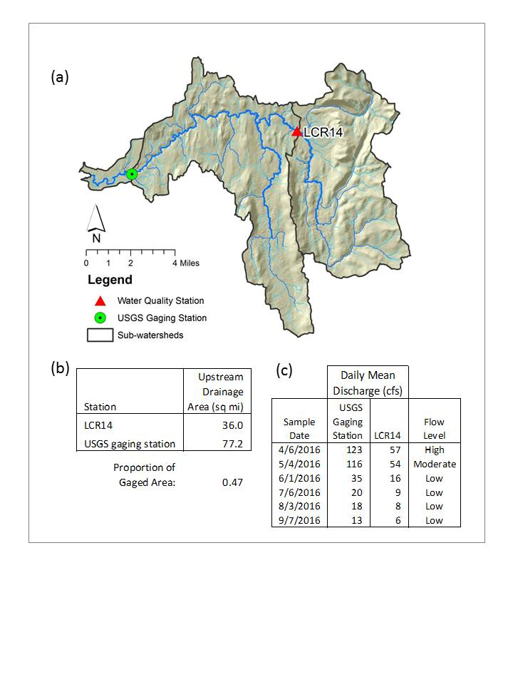

*Figure 1. Discharge estimate for station LCR14 in (a) Lewis Creek watershed which monitors  
 (b) 47% of the gaged drainage area. Daily mean flows recorded at the gage on six sample dates in 2016 are (c) adjusted by this proportional area to estimate daily mean flow at LCR14. Flow levels are assigned with reference to the Flow Duration Curve (Figure 2).*

based on reference to the daily mean flow (DMF) recorded at the gage, applying a correction factor for the proportional drainage area of station LCR14 (Fig 1b and 1c). It is important to note that this method approximates discharge at the sample station, but may over- or under- estimate the actual flow value, due to natural variability in precipitation and river flow patterns across the watershed.

Gaging records can also be used to categorize Flow Level in accordance with VTDEC guidance. Figure 2 presents a flow duration curve computed on daily mean flows recorded for water years 1991 through 2015 for the USGS streamflow gaging station on Lewis Creek. Flows have been categorized following VTDEC *Guidance on Streamflow Observations at time of Water Quality Sampling of Rivers and Streams*. High flows are defined as those flow conditions which are equaled or exceeded only 25% of the time, and low flow levels are those equaled or exceeded more than 75% of the time, while those flows occurring between 25 and 75% of the time are classified as medium.

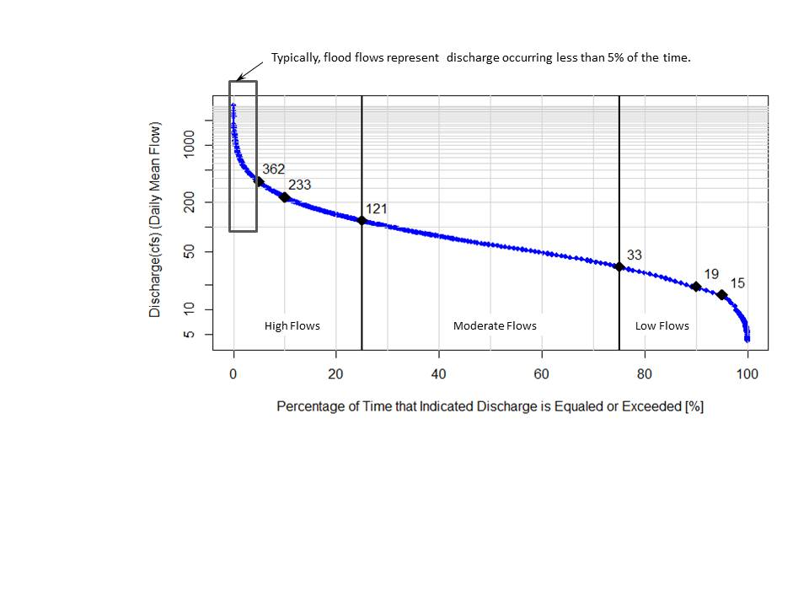  
 *Figure 2. Flow Duration Curve for Lewis Creek at Ferrisburgh, VT (USGS Stn# 04282780). Indicated values (black diamonds) correspond to the discharge that is exceeded 5%, 10%, 25%, 75%, 90% and 95% of the time (reading from left to right). Based on approved daily mean flow record for water years: 1991 – 2015.*

### 2.1.2 Near-basin USGS gage

Many groups will be sampling on rivers that are not gaged by USGS, or at locations within a gaged basin that are quite distant from the gage, and may exhibit very different hydrology patterns (e.g., more flashy). There are approaches that can be used in these ungaged locations to approximate discharge, by looking to a nearby watershed that is gaged. Ideally, this nearby watershed should be of similar size, land cover, elevation and runoff pattern. The instantaneous and daily mean flow records for this nearby gage can be obtained and adjusted by proportional area (see Section 2.1) to estimate flows in the monitored river. Groups should seek help from technical consultants or VTDEC basin planners to use this approach.

## 2.2 Field Estimation

Samplers are instructed to use their best judgement and site-specific knowledge to assign a **Flow Level** (Low, Moderate, High, or Flood) and **Flow Category** (Base Flow, Freshet Flow or Hydro Flow) for a given site on a given sample date following VTDEC guidance (Attachment 1). Data should be recorded at the time of sampling on a field data sheet. An example data sheet is included as Attachment 2. If no within-basin or nearby-basin flow gages are available, this field estimation of Flow Level and Flow Category may be the only means of characterizing flow conditions. This local site information may replace estimates of flow condition developed from nearby USGS streamflow gages, if site conditions identify that localized weather patterns have influenced flow conditions, or if the nearby gage for some other reason does not reflect characteristics at the site. Therefore, this local flow condition information is very valuable. The following sections describe a few techniques that may be used to ensure that local flow information is reasonably accurate and representative.

Flow Level

A field estimate of Flow Level can be challenging, and requires familiarity with the site under a variety of flow conditions. The goal is to describe the flow through the cross-sectional area of the channel at your specific site in terms of a stage, or height, above the channel bed – relative to the full range of flows possible at that site. Pictures taken from the same reference point at several different times during different Flow Levels can provide a useful frame of reference to ensure continuity of discharge estimates over multiple years of sampling and across different volunteer samplers. For example, a game camera programmed to take a picture at the same time daily for several months is likely to capture images that can later be related to a Low, Moderate or High flow stage, with reference to a nearby USGS gage. Photos can then be selected from that record to generate a photo log similar to the one in Attachment 3.

Groups may opt to install a staff gage (Figure 3a) at an adjacent structure such as a bridge pier or culvert headwall, to provide a consistent reference point for measuring the fluctuating water stage at their sampling station.  
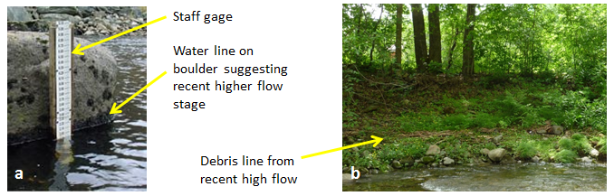

*Figure 3. Features at a site can be relied on to discriminate between Flow Levels – such as a staff gage (a) – and to infer Flow Condition – including water lines (a) and debris lines (b) that suggest falling stage.*

Low flow stages are readily recognizable, since much of the channel bed may be exposed above the water surface. Flow velocities are low, water is typically clear, and the river is more easily wadeable. In fact, the sampling location may need to be shifted to access the deepest part of the channel for sampling. Similarly, flood flows are obvious due to their association with large volumes (and perhaps great intensity) of rain fall – sometimes coincident with snow melt. Waters are typically turbid (muddy), swift-moving (unsafe for wading), and turbulent, and standing waves may be evident (Attachment 3). High versus Moderate flow levels may be more difficult to discern at the time of sampling, since there is not always a substantial difference in flow stage between a High flow (that occurs less than 25% of the time) and a Moderate flow (that occurs between 25 and 75% of the time). Multiple observations over a long term at a given site, and relation of flows to a nearby USGS gage (where available), will help to improve Flow Level estimates.

Flow Category

Discharge at a site on the sample date should also be described in terms of a Flow Category from Base Flow to Freshet Flow or Hydro Flow. Hydro Flow only applies to those stream sites that are downstream from a dam where flows are regulated for production of hydropower. Local knowledge, or reference to the VTANR Natural Resource Atlas, will identify if a hydro dam is located above your station (Attachment 1). Discharge that is increasing or decreasing in response to a planned release from the upstream dam (and not resulting from precipitation or snowmelt) is categorized as a Hydro Flow. Otherwise, discharge will be classified as either Freshet Flow (significantly rising or falling in response to a rainfall or snowmelt event) or Base Flow (not significantly rising or falling).

Careful observation of the streamside vegetation, boulders, or bridge crossing can reveal a fluctuating water stage. Matted streamside vegetation, debris marking a recent high water line (Figure 1b), or saturation lines on boulders (Figure 1a) or bridge piers may suggest that water levels were recently higher than at the time of sampling (i.e., a falling stage). Similarly, a rising water level can be identified where features become progressively submerged during the time it takes to collect the sample. Often water is muddy (or “turbid”) and opaque during a Freshet Flow, especially when water levels are on the rise or just past peak flows. This information, combined with samplers’ observations of precipitation on the sample date or within the previous day(s), can be combined to suggest that water levels are declining (or still rising) significantly in response to a recent rain event, suggesting Freshet Flow conditions.

For sites well represented by a nearby USGS streamflow gage, the gaging record can be observed after the fact to confirm Freshet versus Base Flow conditions. For example, the hydrograph in Figure 4 displays the discharge over time for the gaging site on the New Haven River. Freshet Flows are characterized by a steep rise to a peak, followed by a more gradual decline. Generally speaking, Base Flow conditions begin where the discharge values return to pre-storm levels (although the hydrograph can be much more complicated (and Base Flow harder to define) if multiple storm events occur one after the other).

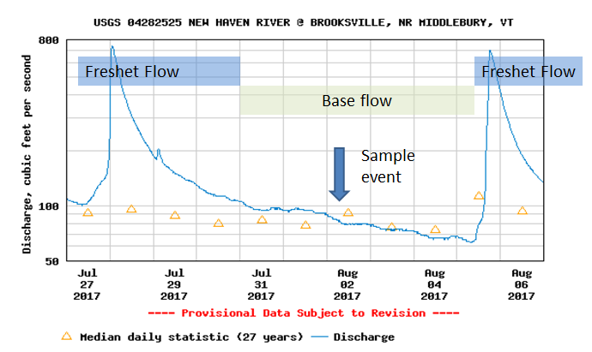

*Figure 4. Instantaneous discharge record for the New Haven River (Station #04282525) and distinction between Freshet Flow and Base Flow conditions.*

Base Flow conditions represent a time when the great majority of water flowing in the river is being supplied by groundwater (through subsurface flow paths), and there is no appreciable increase or decrease in water level over several hours. Some rivers exhibit a pattern of small daily fluctuations in water stage – especially noticeable at base-flow conditions. This pattern – called “diurnal fluctuation” - can be due to daily cycles of heating and evapotranspiration from wetlands and instream reservoirs. This daily cycling usually accounts for a small change in water level and can be ignored in the determination of Flow Category (e.g., Figure 5).

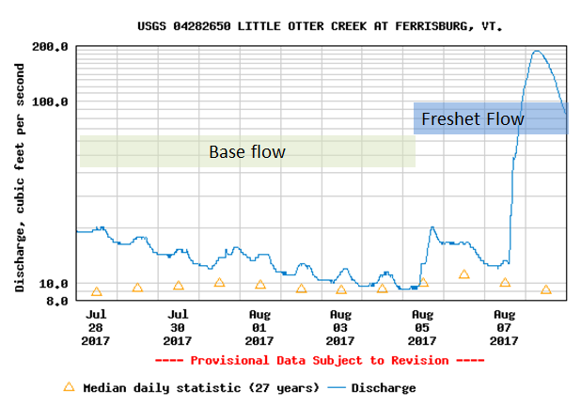

*Figure 5. Instantaneous discharge on the Little Otter Creek during August of 2017 exhibited small daily fluctuations in discharge during Base Flow conditions due to temperature changes that drove evapotranspiration rates.*

# 3.0 Qualitative Loading Estimates

Whether relying on USGS streamflow gaging data or field-based estimates, the assignment of Flow Level for each sample date allows for certain qualitative loading estimates to be made. In most cases, concentration data can serve as a meaningful proxy for loading. Data can be subset by flow level – separating low-flow/ base-flow events from moderate to high flow/ freshet conditions – to reveal patterns in pollutant transport under these different conditions.

## 3.1 Base-flow “Hot Spots”

For example, Figure 6 illustrates stations sampled on the New Haven River and tributaries during base-flow conditions in 2016. According to the Vermont Water Quality Standards (VWMD, 2016), the instream phosphorus criterion of 27 µg/L for warm-water medium gradient wadeable stream ecotypes in Class B waters is applicable only at low median monthly flow during the months of June through October. Based on gaging records from the New Haven River at Brooksville, flows were below the low median monthly flow on the July, August, and September sample dates, Therefore, Total Phosphorus (TP) results were subset to just those three low-flow/ base-flow events, and the mean of the results available for these three summer sampling dates exceeded the water-quality standard at all four stations on the Muddy Branch. These exceedences of the standard will be considered alongside other indicators, including biomonitoring data, to determine if these waters should be listed as impaired.

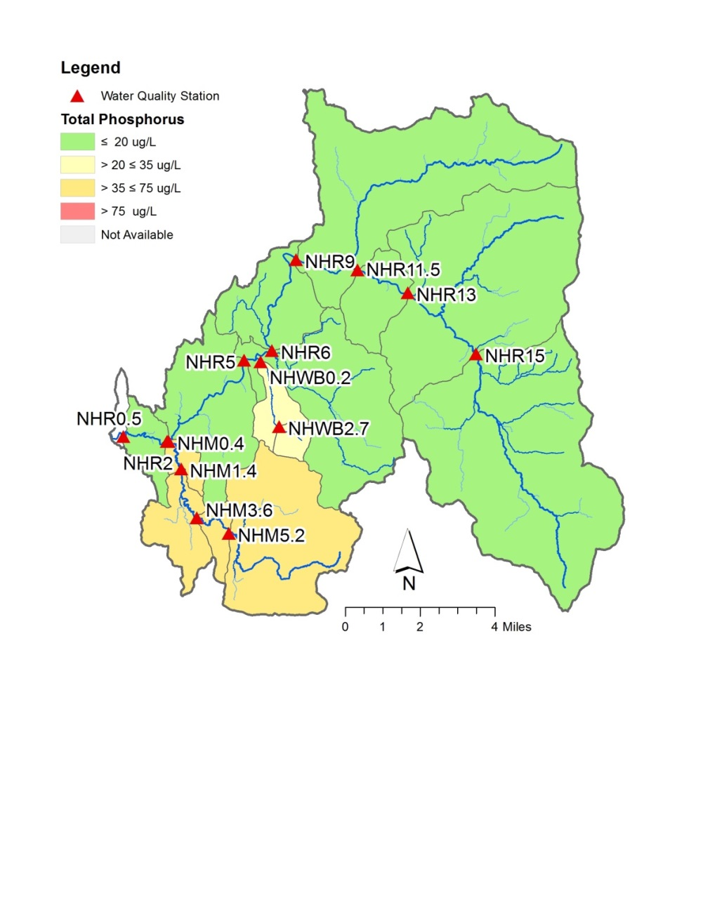Mean TP concentrations were illustrated in Figure 6 by color-coding the incremental subwatershed draining to each station. Under these base-flow, summer conditions, the Muddy Branch (NHM sites) and West Brook (NHWB sites) tributaries are disproportionate loaders of TP to the New Haven River. Agricultural and developed land uses are more concentrated in this southwestern part of the watershed, as compared to the headwaters. Each of these tributaries is also underlain by fine-grained silt and clay soils derived from glacial lake deposits, which have an affinity for phosphorus and which are easily entrained and transported by a range of flows. These are areas where restoration / mitigation actions should be focused, including nutrient management to reduce phosphorus inputs.

*Figure 6. Mean value of Total Phosphorus detected in July, August and September (2016) during base flow conditions at or below the Low-Median-Monthly Flow in the New Haven River watershed.*

Baseflow monitoring, in general, is also a good way to spatially locate critical source areas of pollutants that may preferentially impact groundwater, such as nitrates and dissolved phosphorus, or to identify point sources of pollutants, such as failing septic systems or illicit discharges from pipes.

## 3.2 High-flow Concentration Data as a Proxy for Loading

For those constituents with a strong correlation to discharge (e.g., sediment, particulate phosphorus), the majority of loading to receiving waters is occurring during infrequent, high-magnitude flow events – typically, in the spring and fall of the year, but occasionally during summer convective storms or hurricanes. Groups focused on loading to lakes should target storm events for sampling, as a means to identify high-loading sub-regions of their watersheds. For example, Lewis Creek Association carried out storm sampling in the Pond Brook tributary of Lewis Creek in 2012 to evaluate patterns in sediment and nutrient loading. Four monitoring stations were established along the Brook (Figure 7a), and seven high-flow events were captured, including a relatively intense rain event on May 12. Concentration data from these high-flow events revealed two subwatersheds that appeared to be disproportionate loaders of Total Suspended Solids (Figure 7b) and Total Phosphorus (Figure 7c). This information was communicated to landowners and partner agencies to support design and implementation of best management practices in the Pond Brook valley.

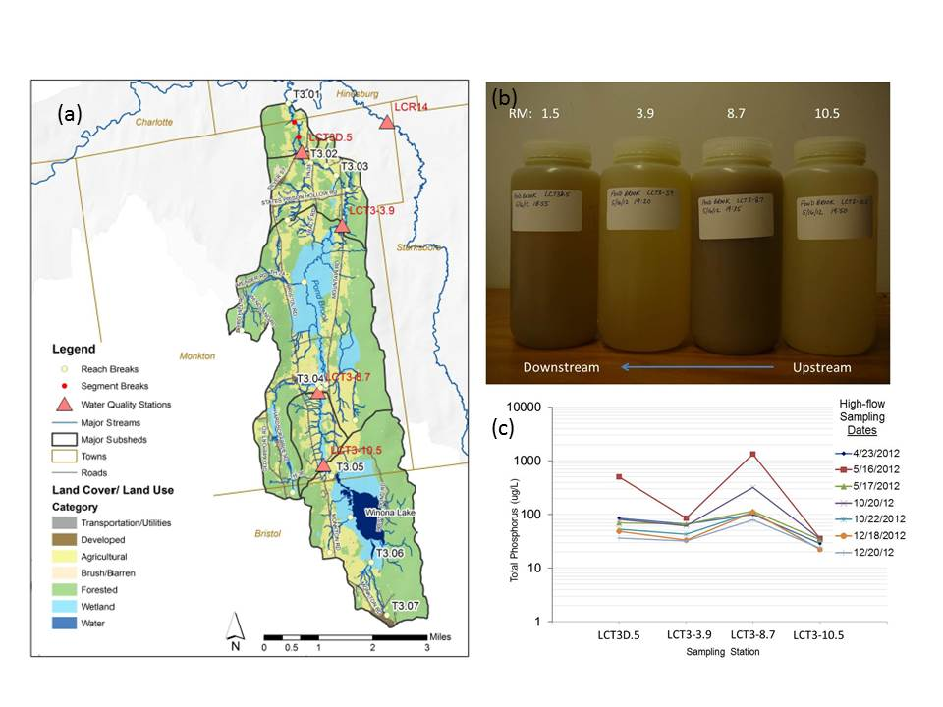

*Figure 7. Storm sampling in the Pond Brook tributary of Lewis Creek in 2012.*

While event-based sampling (i.e., “storm-chasing”) may not be practical for volunteer groups, it is still possible to capture some high-flow events during scheduled sampling efforts, especially if months of typically higher flows are represented in the schedule (e.g., April, May).

# 4.0 Quantitative Loading Estimates (Coarse-level)

Groups could generate coarse estimates of loading for a given sub-watershed in order to communicate its contribution to the overall watershed load. Consider an example calculation for the Muddy Branch tributary to New Haven River depicted in Figure 4.

A coarse estimate can be made of the contribution of this tributary to overall loading in the watershed, relying on mean concentration data for the monitored spring and summer months (April through September) and the daily mean discharge measured at the USGS gage near station NHR0.5 (Table 1).

The daily mean discharge at the gage was adjusted by the proportional area at each monitoring site. For example, Muddy Branch drains 17 sq. miles, which is 0.15 times the watershed area measured at the gage (115 sq. mi.). Mean daily discharge recorded at the gage was multiplied by 0.15 to obtain an estimate of daily mean discharge in Muddy Branch. The adjusted daily mean discharge for each day from April 1 through September 30 of 2017 was converted to liters, and the overall mean TP concentration (56.3 ug/L) was then multiplied by each day’s flux of water (and adjusted for unit conversions) to generate an estimate of daily mean flux of TP (in kilograms). Finally, the daily estimates of TP flux were summed for the period from April 1 through September 30 to arrive at a Spring/Summer 2016 TP load (Table 1). The same process was followed to generate a Spring/Summer 2016 TP load for stations NHR0.5 at the former Dog Team Tavern, which is the downstream-most station in the watershed and representative of loading from New Haven River to Otter Creek.

Thus, while the Muddy Branch sub-watershed represents only 15% of the watershed in area, it was responsible for approximately 71% of the overall load of phosphorus during baseflow conditions in the months of April through September of 2016. This finding would suggest that nutrient reduction strategies be focused in the Muddy Branch.

This method is approximate only, and does not account for the complex dynamics of nutrient and sediment cycling in rivers, and effects of variable discharge. However, the method does provide an estimate of relative pollutant load contributions from sub-regions of a watershed – that may compel action on the part of landowners or towns, and help to prioritize resources for mitigation efforts.

*Table 1. Coarse-level estimate of TP loading from Muddy Branch   
tributary of the New Haven River.*



# 5.0 References

USGS, 2016, National Water Information System, <http://waterdata.usgs.gov/vt/nwis/rt>

Vermont Watershed Management Division, 2016. *Vermont Water Quality Standards*.   
Effective 15 January 2017. Montpelier, VT. Available at: http://dec.vermont.gov/sites/dec/files/ documents/wsmd_water_quality_standards_2016.pdf

**Attachment 1**

**VTDEC *Guidance on Streamflow Observations   
at time of Water Quality Sampling of Rivers and Streams***

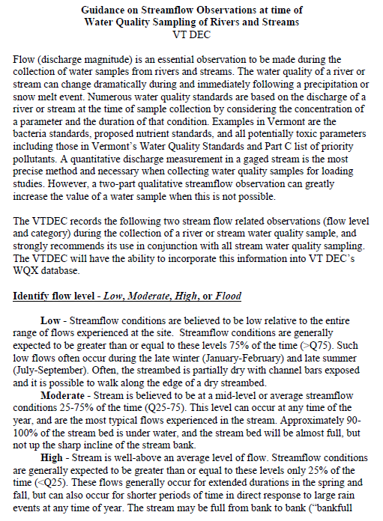

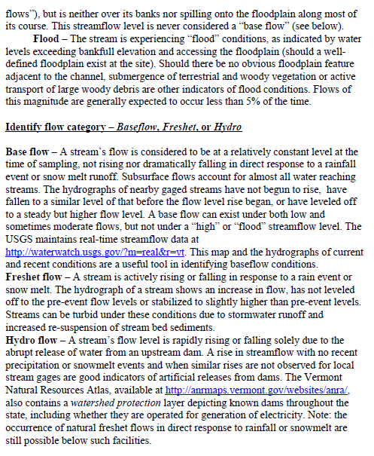

**Attachment 2**

**Example Field Data Sheet**

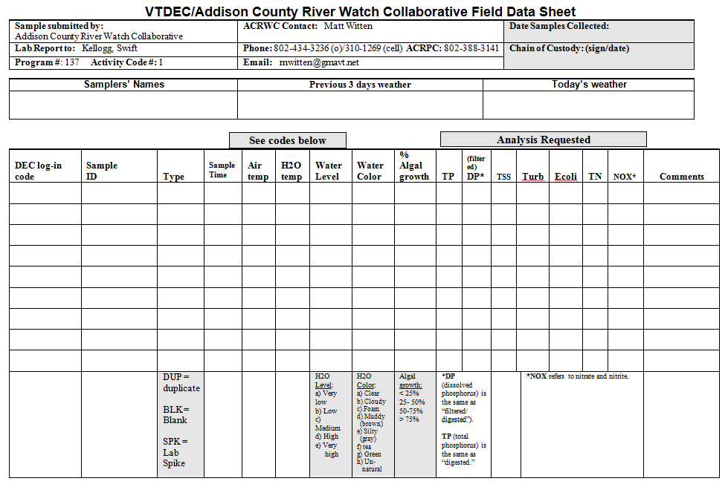

**Attachment 3**

**Example photographic log**

**for Flow Level and Flow Category**

The following pages display photographs from the same vantage point (facing downstream) on the Shepard Brook, tributary to the Mad River, collected during a variety of Flow Levels and Flow Categories. Provided discharge values are daily mean flows (DMF) in cubic feet per second, recorded at the USGS streamflow gaging station (#04288000) on the Mad River located approximately 5.3 miles downstream from this site. Dashed, white arrows indicate the approximate bankfull flow elevation, corresponding to a discharge with a 1.5-year recurrence interval.

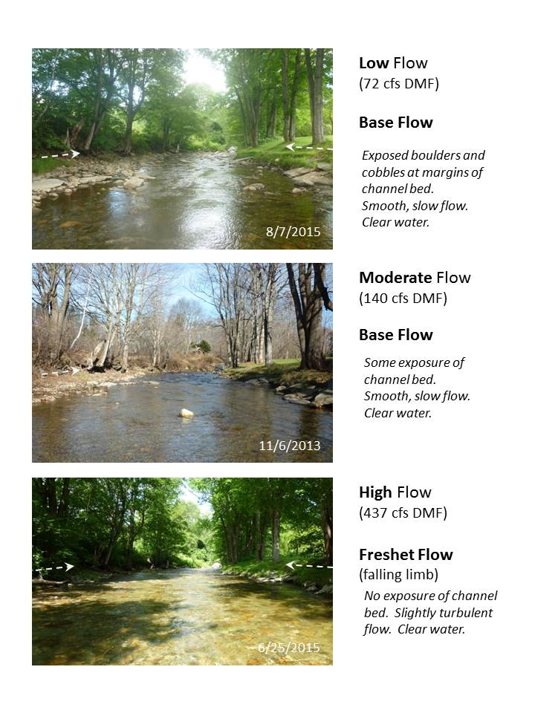

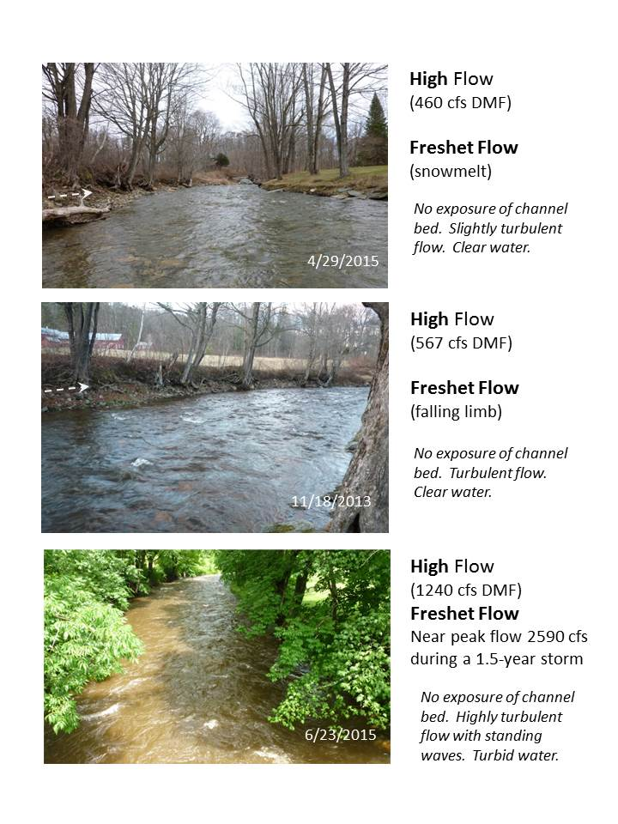

1. http://dec.vermont.gov/watershed/map/monitor/larosa
2. https://waterdata.usgs.gov/vt/nwis/rt