Registering samples in WIN LIMS
Creating a new order
On the top menu bar hold your arrow over “Sample Life Cycle”and choose option “Manage Orders” , and the choose “Add New”. You should see a screen the [auto] in the Order #.
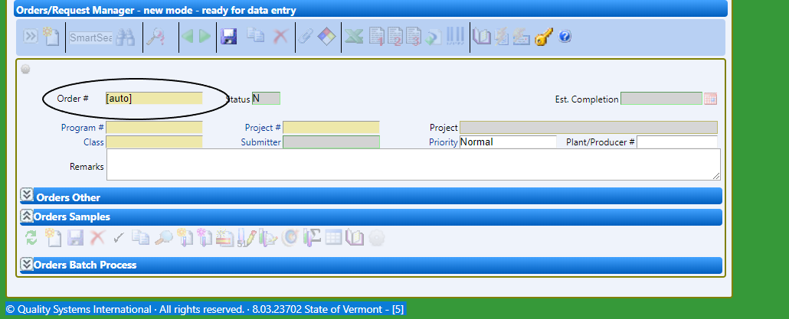

Click on “Program #” and select the program number. Then click on “Project #” and select the project number
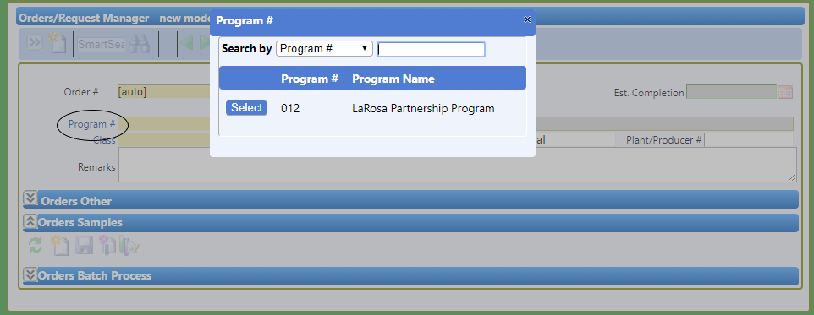
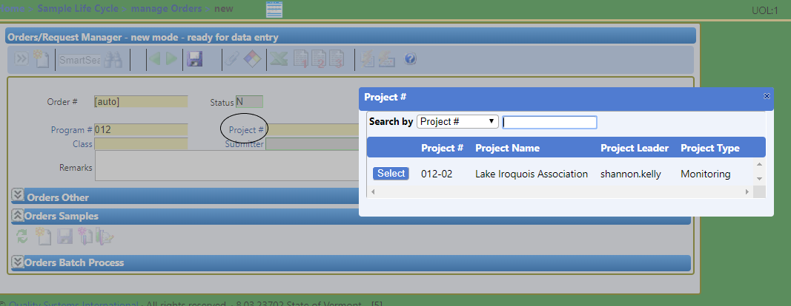

Then click on the save icon and you should now see an Order number.
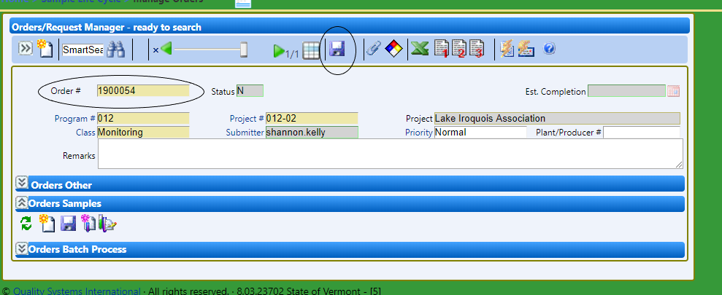

Creating Samples for an Order without Sub Groups
Go to the “Orders Samples section of the window and click on the new icon. A box will pop up asking for the number of samples. Enter a number and click on “OK”.
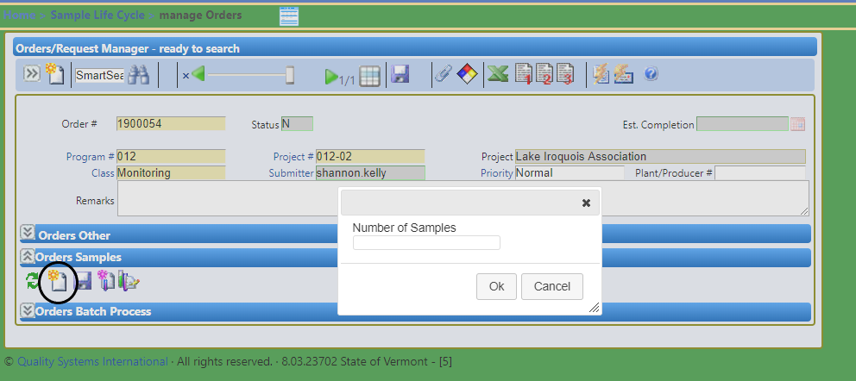

Check to see how many pages there are and adjust the number you see so there is only one showing.
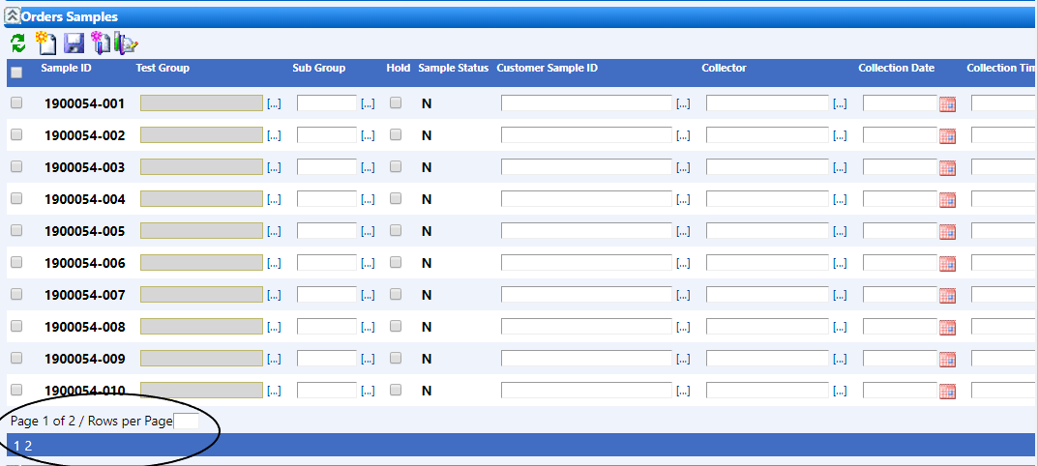
This is done by entering the number of rows per page in the box and then enter. There should now be a save icon. Click on that and then at the top of the Orders Samples click on the refresh samples list button on the far left.
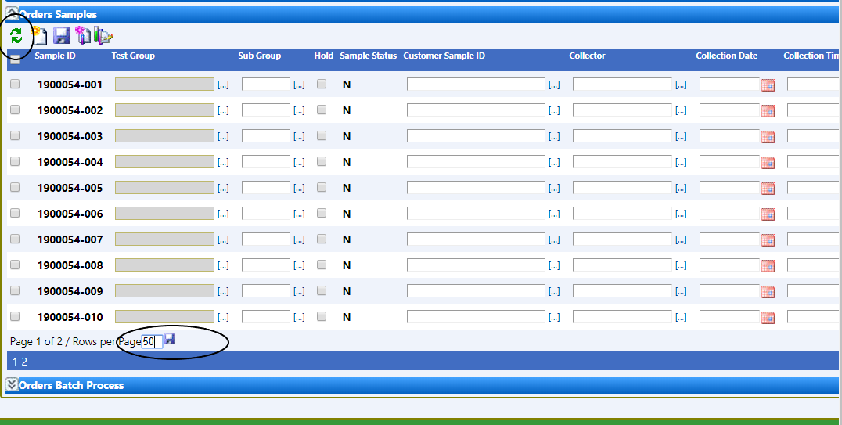

There should now be Page 1 of 1 at the bottom.
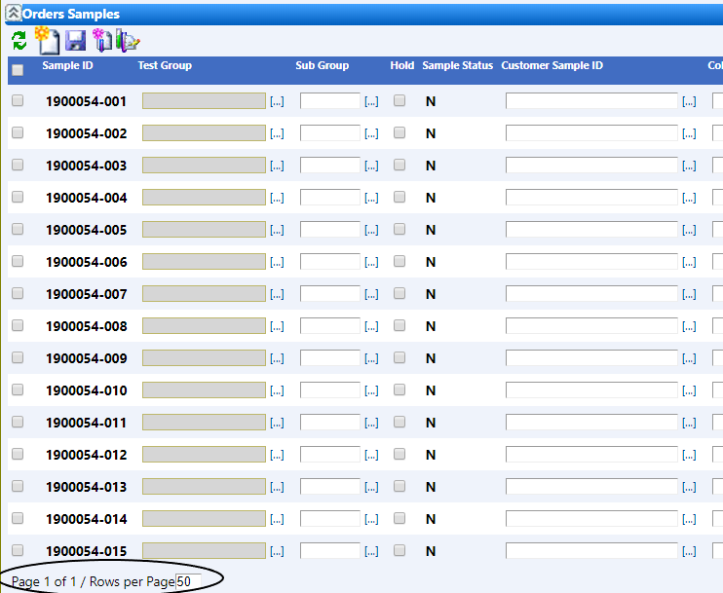

Now add the group test to all the samples by clicking on the 3 dots ([…]) next to the empty box under “Test Group”
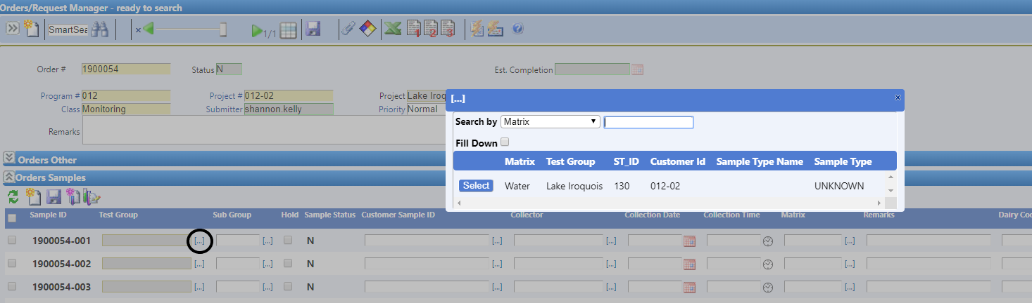
Be sure the “Fill Down” box is checked and click on select. All the boxes under “Test Group” should be filled in the same.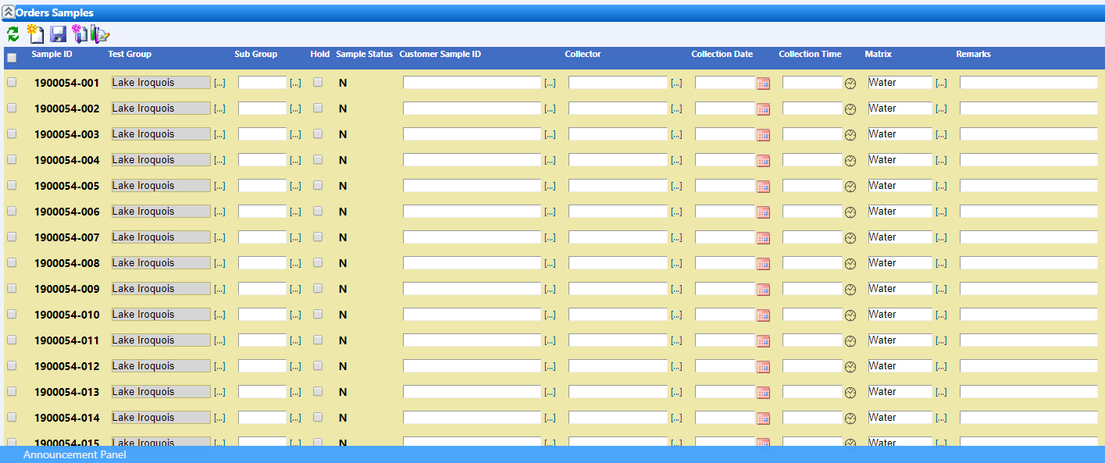
Fill out as much of the information as you can (Customer Sample ID is the same as it was in Sample Master). If you click on the 3 dots ([…]) and choose a collector, it will fill in all the samples with that name. For the date, once you enter the first date you can right click on the box and a pop up will ask if you want to fill down.

Once all the information you have is filled out save by clicking on the save icon under “Orders Samples” and at the top of the window.
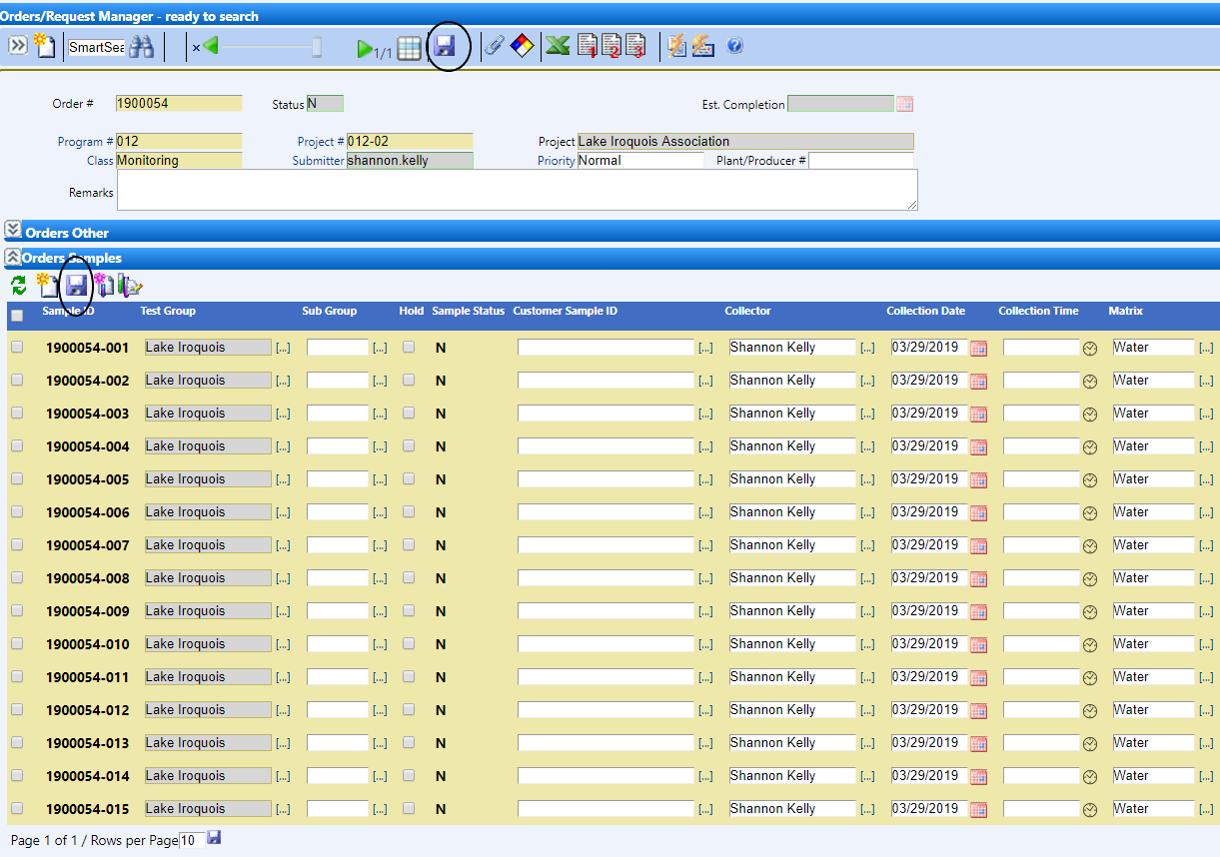

If you need labels and/or bottles from the lab, send a manual LIMS event (e mail to the lab) to tell us your order is resistered by clicking on the ‘Fire Manual LIMS’ icon.
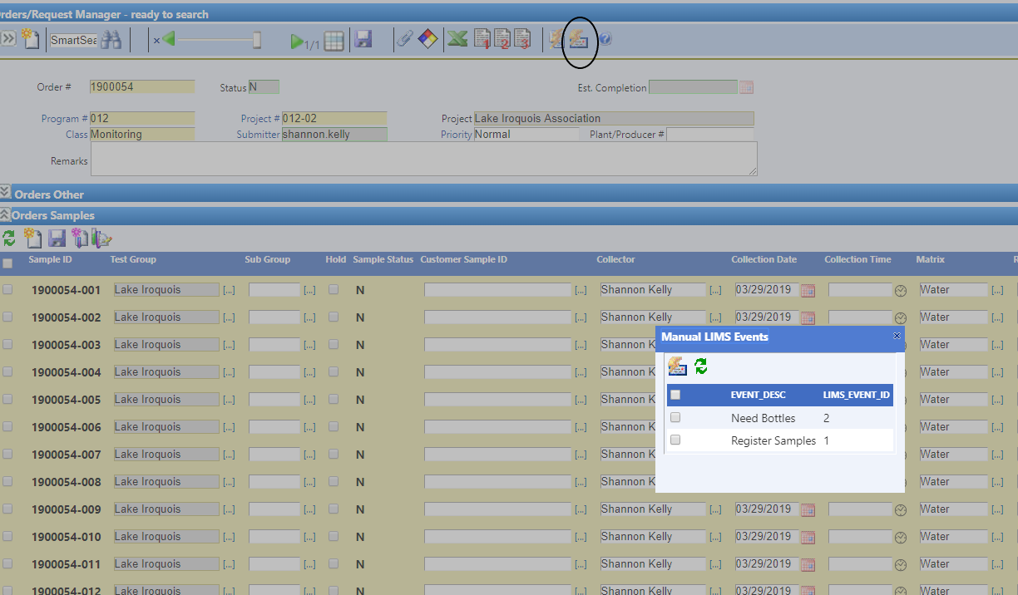
Click on the “Register Samples” box and the “Need Bottles” (if applies) and then click on the “Fire Manuel Event” icon in the box.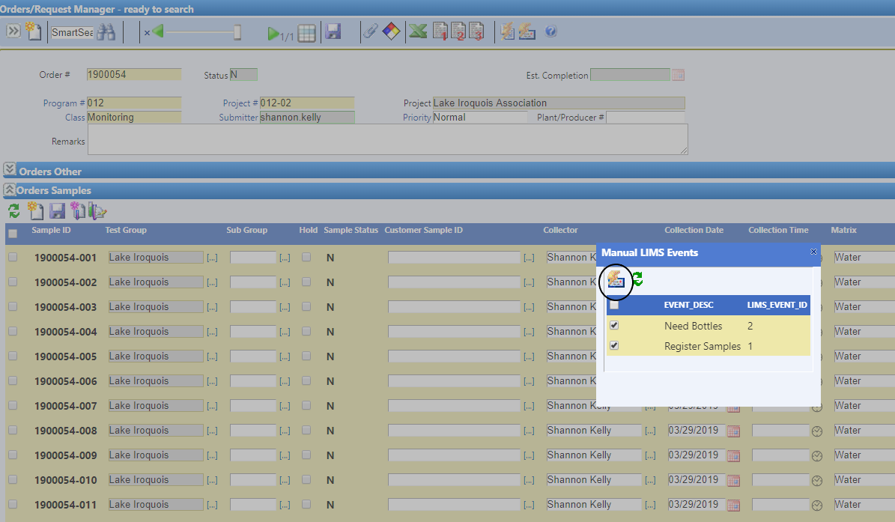
To print a sample field sheet, click on the report 2 icon at the top.
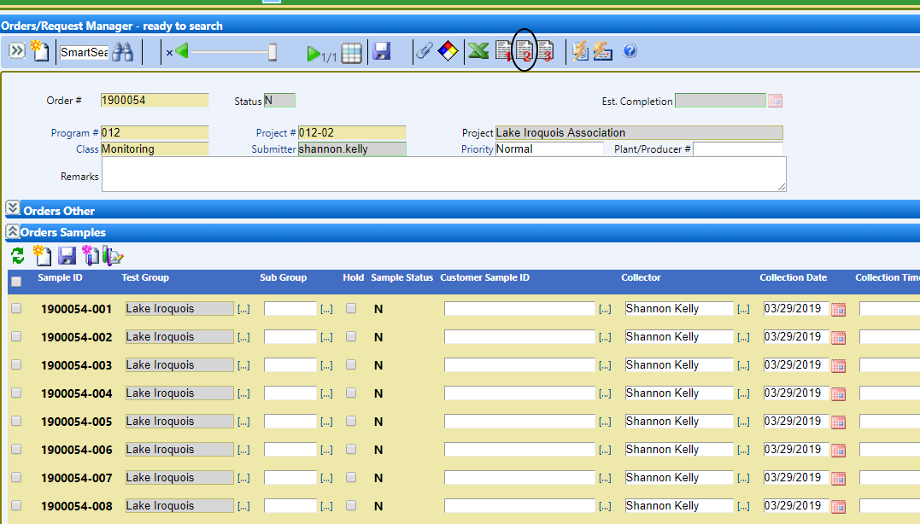
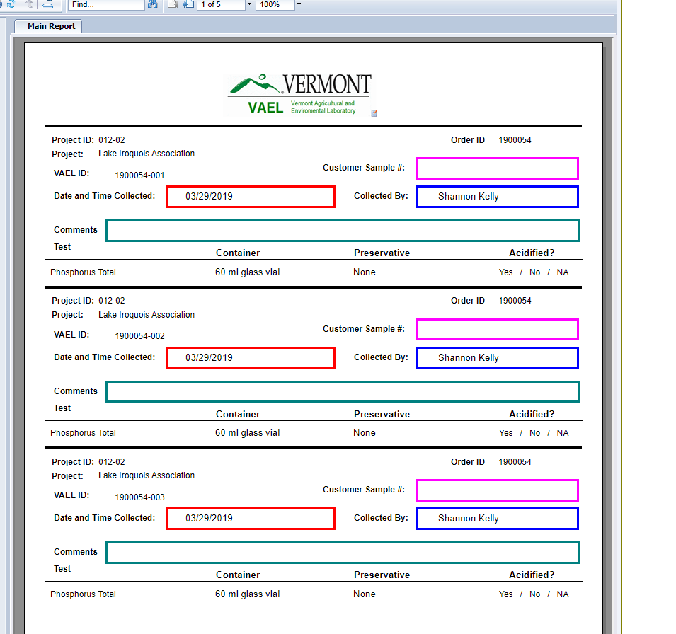
Creating Samples for an Order with Sub Groups
If you have a group of sites that you take different tests at under on order number, you will need to fill in the subgroups for the samples.
Follow the above instructions and after you add the group test, add the sub groups for each sample by clicking on the 3 dots ([…]) next to the box under Sub Groups for the sample that you need to add another test to.
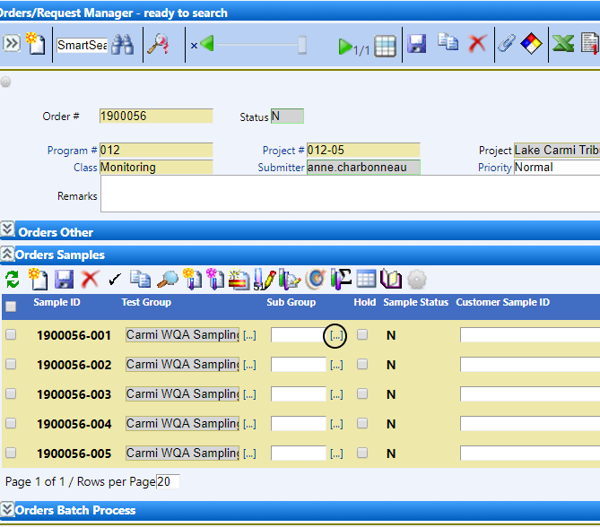

Select the test that you want to add to that sample
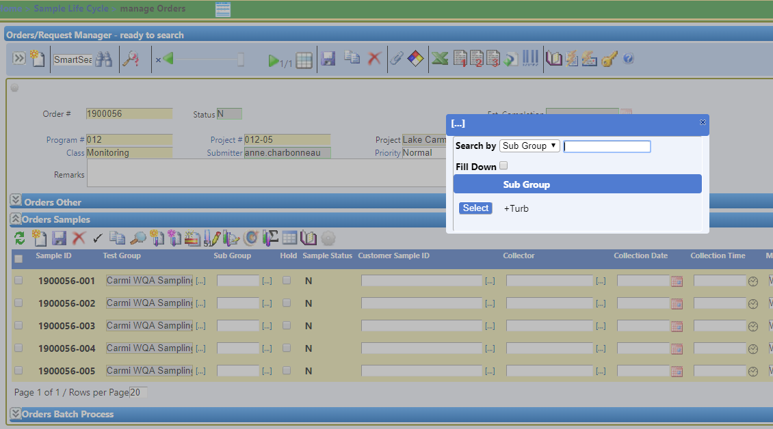
The test should now show up for that sample.
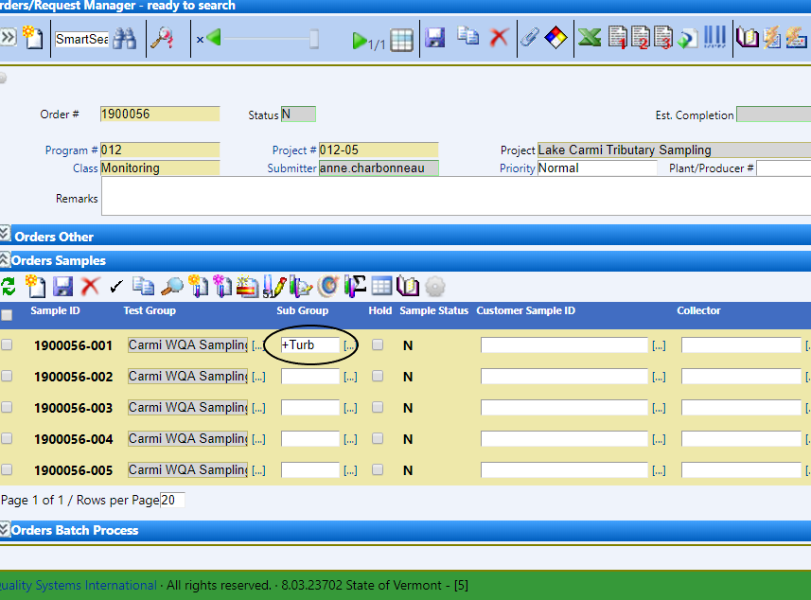
Follow the rest of the directions above

