LaRosa Field Sampling Guide
Sample Containers
Sample containers play an extremely important role in sample quality. Certain parameters require certain bottles. Some containers are able to be re-used, and some are disposed of after analysis. In the field, it is important to use the correct containers for the correct parameters, and to correctly label all containers to prohibit confusion when the samples are brought to the laboratory.
- Bacteria Sample Containers – 125mL or 290mL round IDEXX bottles with plastic seal, sterile – one use.
- Conductivity, Turbidity, and Alkalinity – 250mL square plastic bottle – reusable.
- Total Phosphorus/Dissolved Phosphorus (TP / TDP) – 50mL glass tube with white cap – one use.
- Chloride, Silica, Anions – 50mL plastic centrifuge tubes – PURPLE cap – one use.
- Total Nitrogen/Filtered Nitrogen (TN / TDN) – 50mL plastic centrifuge tubes – BLUE cap – one use.
- Total Suspended Solids (TSS) – 1 liter round plastic bottle – reusable.
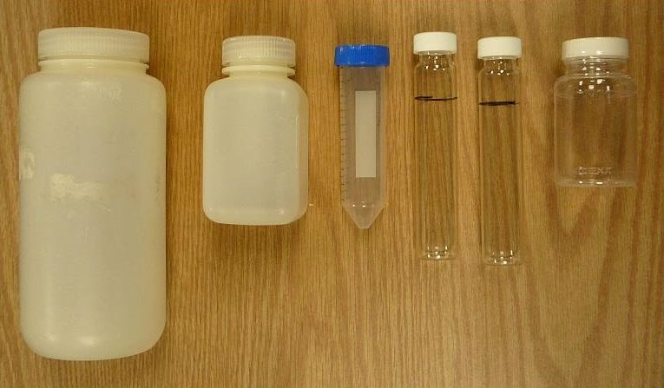
General Sampling Instructions:
- Collecting a representative sample requires that samplers are aware of the conditions of the water they are sampling.
- All sampling should begin with verifying (and/or writing down) on pre-log paperwork:
  - the correct sample site/bottle label
  - date of sampling
  - time of sampling
  - sampler name
All writing should be done in blue or black pen – NO PENCIL.
Sampling Procedure:
- Take samples near the centers of streams.
- Try not to disturb the bottom sediment of the stream when wading in, and always take the sample facing upstream.
- Avoid touching inside of bottles and caps.
- Plastic bottles and their caps generally should be rinsed three times before taking the sample.
  - Total and dissolved phosphorus samples are in glass bottles and should not be rinsed.
  - E. coli bottles do not get rinsed either.
- Open sample containers should be placed upside down over water, and water should be sampled in a “U” shape against the flow of water, away from the body.
- Take samples mid-way between the surface and bottom of the stream.
- Pour off samples to the required volume before capping, indicated by fill lines on the bottles.
  - If you pour off a phosphorus sample below the fill line, do not redo the whole sample! Either dip the bottle back into the water for a second or fill the cap with sample water to pour into the bottle.
- Make notes of anything unusual that happened during sampling, or anything that was changed during the process (labels, site locations, etc.).
After samples are collected and capped, they should be placed into a cooler with frozen ice packs/water frozen into bottles. Using free ice in a cooler should be avoided. Sample containers and tubes are not guaranteed to be leak-free, therefore, samples that are floating around in cooler of melted ice are at risk of unnecessary contamination.

River Dippers:
If a site is too deep or difficult to wade into to sample, you can use a river dipper to collect the sample water. To create your own, attach a 1 liter nalgene bottle to a PVC pipe or other pole using zip ties.
- Rinse out your river dipper three times with sample water.
- Collect the water using the same method described above.
- Use the river water in the nalgene to rinse out the individual, smaller sample bottles/caps (if rinsing is required) three times as well.
- Pour sample water from the nalgene bottle into your sample containers.

Quality Control Samples:
Field Duplicates and Field Blanks:
- Groups should include duplicate and blank site sampling into their bottle order requests, these duplicate/blank samples would have a laboratory label with a separate number than the original “parent” sample.
- Duplicates and blanks should each make up 10% of your samples.
- These are not the same as the extra duplicate containers labeled with a “duplicate/spike” sticker that are provided by the laboratory on some parameters (dissolved and total phosphorus, and E. coli).
Laboratory Duplicates:
- The lab will provide separate labels for partners to take extra duplicates. Take these samples using the same procedures as your field duplicates (indicate the site name on the label, write down time, etc.). The labels say “COLLECT SAMPLE FOR DUPLICATE/SPIKE.”
- The lab will use these duplicates for their own testing purposes. These duplicates can be taken at any site.

Deliver samples to the laboratory well before their hold times:
Parameter | Hold Time | Sample Preservation at Lab
E. coli / Bacteria | 8 hours/same day analysis | Refrigeration
Turbidity | 48 hours | Refrigeration
Total Suspended Solids | 7 days | Refrigeration
Alkalinity | 14 days | Refrigeration
Total/Dissolved Nitrogen | 28 days (must be acidified within 48 hours of sampling) | Acidification/Refrigeration
Total/Dissolved Phosphorus | 28 days | Room Temperature
Conductivity | 28 days | Refrigeration

