Water Quality of Barre-Montpelier area streams and rivers
Summer 2108

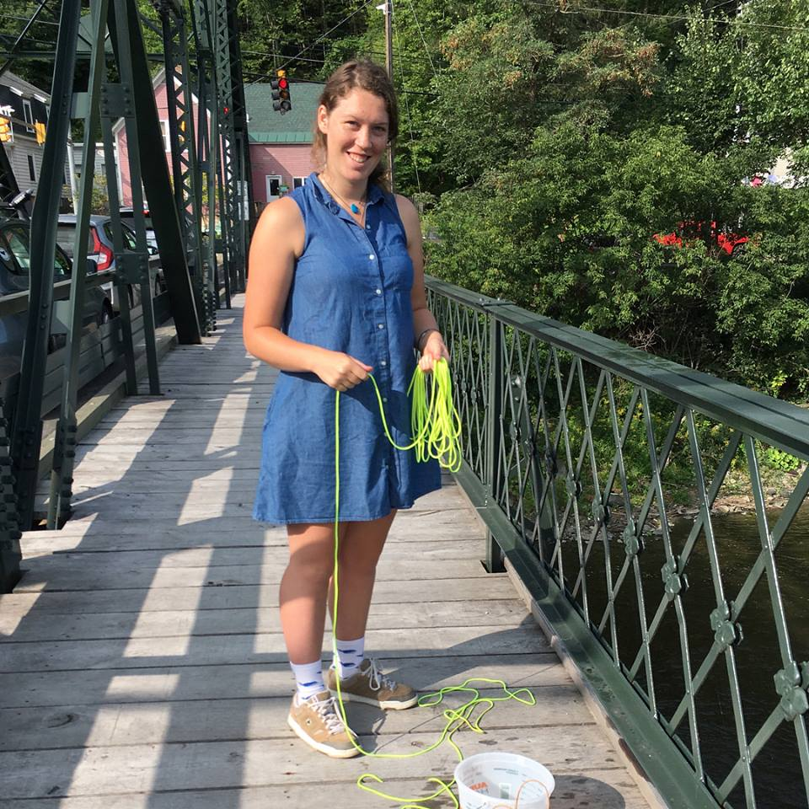

Friends of the Winooski River intern Mary Perchlik prepares to collect samples from the
Granite Street Bridge over the Winooski River in Montpelier

Acknowledgements
Funding for this project was provided by the Vermont Department of Environmental Conservation Watershed Management Division Clean Water Initiative and Monitoring, Assessment and Planning Programs. Water quality samples were collected by Friends of the Winooski River volunteers Dustin Rand; Jennifer and Ben Richardson-Skinder; Lyn, Ethan, Jay, & Nancy Munno; Suzanne and Simon Eikenberry; Juliana Plummer; Mary-Lynne Isham & Steven Adams; Kaitlin Hayes; Mary Perchlik; Jen & Indy Roberts; Karen Bates; and Jan Zemba. The cover photograph was taken by Michele Braun.

Introduction
The Friends of the Winooski River and its citizen scientist volunteers have been sampling water quality in the Barre-Montpelier area since the summer of 2008 as part of our Four Rivers Partnership Program. Sampling efforts have been mostly focused on E. coli levels in the area’s “Four Rivers”: Steven’s Branch, North Branch, Dog River, and Winooski River. In 2014 we added sampling for chloride, phosphorus, and turbidity at select sites. Phosphorus, chloride, and turbidity sampling helps us determine the quality of the aquatic habitat in a stream, as well as the nutrient load contributed by a to Lake Champlain. Engaging local volunteers in the monitoring process brings community members out to the rivers and helps them become more aware of the issues threatening the health of area streams, while sampling for E. coli allows us to educate the community about when to avoid local swimming holes, canoe routes, and fishing spots.
In recent years our primary purpose in sampling for E. coli has been to identify and address sources of the bacteria in the Winooski River, which is listed as impaired for high E. coli levels in the reach from Granite Street Bridge in Montpelier downstream to the confluence with the Dog River. E. coli levels at the Mill Pond canoe access in the North Branch River have also been slightly elevated relative to an upstream site at the North Branch Nature Center. Suspected sources of E. coli in both rivers include illicit discharge from the sanitary sewer system, failed septic systems, pet waste, and combined sewer overflows (CSOs). It should be noted that the first two sources would be expected to affect E. coli levels during dry weather, whereas the latter two would usually contribute E. coli to streams only during rainy conditions where stormwater runoff is generated. Our phosphorus, chloride, and turbidity sampling helps us identify potential problems associated with erosion, stormwater runoff, and road salt use. Problem sites help inform us of areas to focus our riparian restoration, stormwater runoff mitigation, and illicit discharge detection and elimination (IDDE) work.
In 2017 and 2018 the Friends of the Winooski River received Organizational Support funding from the VT Department of Environmental Conservation’s La Rosa Program to expand our E. coli sampling to include several more sites in Montpelier. These additional sites were added to our usual sampling to determine whether elimination of four sewage connections to the city’s stormdrain system discovered in a 2016 IDDE has resulted in a reduction of downstream E. coli levels in the North Branch and Winooski Rivers. For a detailed discussion of the results of sampling supported by this grant, see The Friends of the Winooski River’s "E. coli levels in the North Branch and Winooski Rivers of Montpelier, VT Summer 2018.” The Friends are also interested in documenting and locating other suspected sources of fecal matter entering these streams, particularly in the reach of the Winooski River between the Main Street and Taylor Street bridges and along the North Branch upstream of the Mill Pond canoe access. This document reports the results of our 2018 sampling.

Methods
In the summer of 2018, Friends of the Winooski River volunteers collected water samples from 24 sites in the Barre-Montpelier area - six on the Winooski mainstem, eight on the North Branch River, one on the Steven’s Branch, two on the Jail Branch, and seven on smaller tributaries to test for E. coli, phosphorus, turbidity, and chloride. Sampling occurred on a total of eight dates: June 26th, July 10th, July 24th, August 7th, August 21st, September 4th, September 11th, and September 25th. Two of these dates (7/26 and 9/11) coincided with rain events, while the remaining dates had little or no precipitation the morning of and the days prior to the sampling. E. coli was sampled at 17 sites on all dates except 7/26 and 9/11, chloride at six sites on all dates except 7/26, 9/11, and 9/25, phosphorus at 17 sites on all dates, and turbidity at nine sites on 9/11 only. The site IDs, descriptions, and locations for sites are given in Table 1 (dry-weather sampling sites) and Table 2 (rain event sites). Locations of all the sampling sites are also shown on a map (Figure 1).

Table 1. Montpelier area 2018 regular sampling site locations and descriptions. Sites that were sampled from a bridge are indicated by the ‡ symbol. All other sites were sampled in-stream.
Site ID | Waterbody | Description | Lat / Long
NBNC02 | North Branch | N Branch Nature Center swimming hole | 44.28349, -72.57136
NBSNOWD | North Branch | Just downstream of Montp snow dump | 44.27435, -72.57166
CUMMINGSBR‡ | North Branch | Cummings Street Bridge, upstream side | 44.27157, -72.57064
MILLPD | North Branch | Mill Pond Park Canoe Access | 44.26766, -72.56882
PEDBRID‡ | North Branch | Vine St Pedestrian Bridge, upstream side | 44.26527, -72.56904
SPRINGST‡ | North Branch | Spring Street Bridge, upstream side | 44.26318, -72.57199
STATEST‡ | North Branch | State Street Bridge, upstream side | 44.26044, -72.57645
NBMOUTH | North Branch | N Branch River just below RR bridge | 44.25935, -72.57789
GRANITE‡ | Winooski River | Granite Street Bridge | 44.25179, -72.57101
MAINSTBR‡ | Winooski River | Main Street Bridge | 44.25784, -72.57741
TAYLORST‡ | Winooski River | Taylor Street Bridge | 44.25957, -72.57987
BIKEBR‡ | Winooski River | Montpelier Rail Trail Bridge | 44.26013, -72.58123
MONTHS | Winooski River | Montpelier HS Access | 44.26186, -72.58641
I89MONTP | Winooski River | Just downstream of I-89 crossing | 44.25711, -72.60140
JBFIREST | Jail Branch | Stream access near Washington firehouse | 44.10745, -72.43428
SPAULD | Jail Branch | Just below Spaulding Falls swim hole | 44.18877, -72.48961
STEVEB‡ | Stevens Branch | Above Partridge Farm Rd bridge | 44.23311, -72.55185

Table 2. Montpelier area 2018 rain event sampling site locations and descriptions. Sites that were sampled from a bridge are indicated by the ‡ symbol. All other sites were sampled in-stream.
Site ID | Waterbody | Description | Lat / Long
Gunner10 | Gunner Brook | Mouth of Gunner Brook at confluence | 44.20388, -72.50954
Macs10 | Unnamed trib | Tributary to the Stevens, behind MacDo’s | 44.22784, -72.55109
VTRANS | Pond Brook | Pond Brook above confluence with Stevens Branch near VTRANS | 44.23265, -72.55318
STEVEB ‡ | Stevens Branch | Stevens Branch just above the Partridge Farm Road Bridge, Berlin | 44.23311, -72.55185
GALLHILL | Unnamed trib | Tributary to the Winooski at Gallison Hill Rd | 44.24209, -72.53673
OLDCCLUB | Unnamed trib | Tributary to the Winooski at the end of Old Country Club Rd @ confluence | 44.24894, -72.54916
Sabin10 | Blanchard Brook | Mouth of Blanchard Brook @ confluence with Winooski River, below Sabin’s Pasture | 44.25019, -72.56300
Bailey10 | Unnamed trib | Tributary to the Winooski at mouth, near Bailey St Bridge | 44.26203, -72.58692
MONTHS | Winooski River | Montpelier HS Access | 44.26186, -72.58641

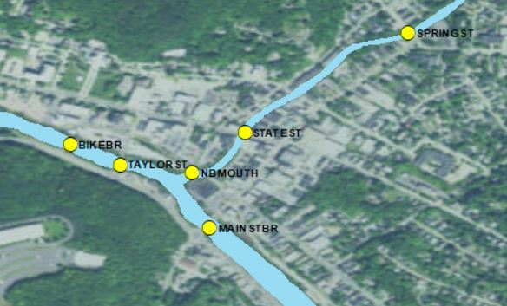
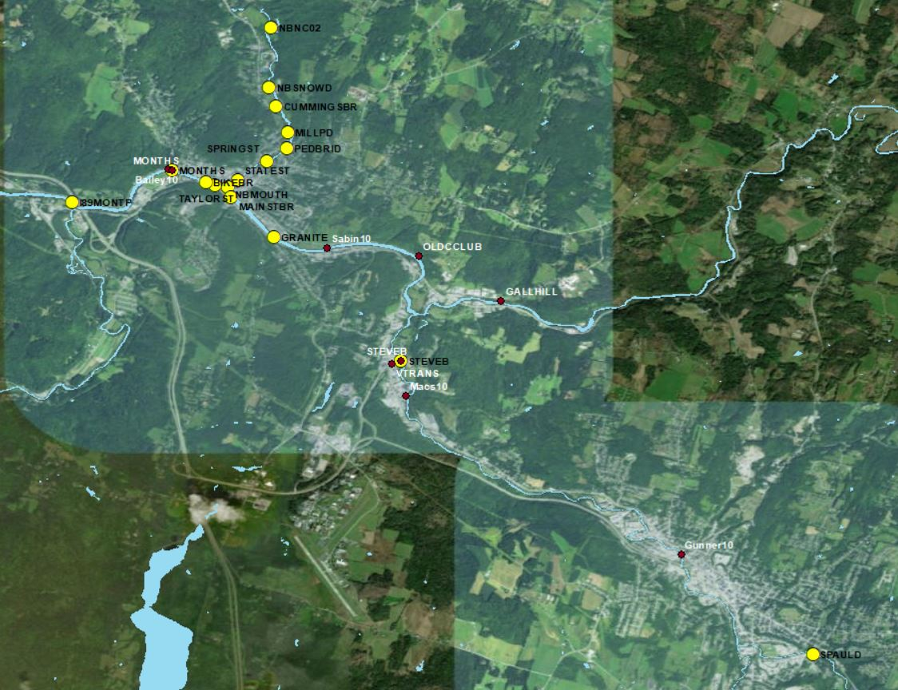
Figure 1. Montpelier area 2018 sampling locations. Regular biweekly sampling sites are shown in yellow with black labels, rain event sites in red with white labels. The insert shows the locations of the sampling sites near the mouth of the North Branch.

Samples were collected either as midstream grab samples using sterile bottles or, in cases where steep banks prevented safe access to the river, by a bucket-sampling method. Bucket sampling involved lowering a small plastic bucket (not sterile) into the deepest section of the stream channel four times – the first three to rinse the bucket with the river water, and the fourth to fill sterile sampling bottles with the water collected. All samples were put on ice directly after sampling, and transported to the Vermont Agricultural and Environmental Laboratory on the University of Vermont campus in Burlington, VT, where they were analyzed by VAEL staff. Quality assurance measures during sampling included taking 1 blank (negative control) and 1 duplicate sample per every ten samples collected. Field sheets required volunteers to not only record site IDs, but to give a written description of the site to avoid site ID mix-ups. Sample numbers were recorded on the field sheets when the bottles were filled so bottle mix-ups could be identified and corrected, and the results were screened for possible errors. The reproducibility of the sampling results was determined by calculating the relative percent difference (RPD) between the field duplicates (see Appendix B). The RPDs for the samples collected during the 2018 season were 1.6% for chloride, 15.4% for E. coli, 4.6% for total phosphorus, and 5% for turbidity. All RPD values fall well within the expected range of field duplicates for each parameter, but the variability between samples should still be taken into account when interpreting the results.

Results and Discussion
Rainfall and the resulting stormwater runoff carrying pollutants to streams in a major factor influencing a waterbody’s water quality. The Friends’ sampling plan for 2018 included both dry-weather and rain event sampling in order to distinguish between the effects of stormwater runoff and other factors contributing to water quality such as improper sewer discharge, septic-system failures, and contaminated ground water.
Since the specific intention of the E. coli sampling in this project was to focus on the effects of elimination of illicit sewage discharge connections into the stormdrain system on the E. coli levels in the North Branch and Winooski Rivers, and begin to locate the E. coli source(s) responsible for the uptick in in the concentration of the bacteria between Main Street and Taylor Street, E. coli levels were sampled only during dry-weather, low flow conditions. Chloride levels were also sampled during dry, low-flow conditions since they are often influenced by groundwater. Total phosphorus was sampled in both dry and rain conditions, and turbidity was sampled only on one rain event date.
Table 3 below shows the cumulative rainfall amounts for the 3 days prior to each sampling date. None of the dry-weather sampling dates had significant rain the day of sampling, and only a small amount of rain was recorded on the day before the 6/26, 8/7, and 9/4 sampling dates. Rain event sampling took place on 7/26 and 9/11 during moderate rainfall events.

Table 3. Rainfall (in inches) on the sampling dates and 1-3 days before sampling. Rainfall amounts for the day of sampling were obtained using the hourly weather observations listed on the Weather Underground Weather History webpage (https://www.wunderground.com/history/) for the Edward Knapp State Airport weather station (KMPV) near Montpelier. The total daily amounts used to calculate the rainfall amounts on the 3 days prior to sampling were downloaded from the National Climatic Data Center (https://www.ncdc.noaa.gov/cdo-web/). Rain event dates are shaded.
Date | rainfall the day of sampling before 8 am | rainfall on the day prior to sampling  (day 1) | cumulative rainfall 2 days before sampling (days 1+2) | cumulative rainfall 3 days before sampling  (days 1+2+3)
6/26/18 | 0 | 0.05 | 0.11 | 0.2
7/10/18 | 0 | 0 | 0 | 0
7/26/18 | 0.4 | 0.76 | 0.76 | 1.5
8/7/18 | 0 | 0.08 | 0.08 | 0.8
8/21/18 | 0 | 0 | 0 | 0.07
9/4/18 | 0 | 0.07 | 0.07 | 0.07
9/11/18 | 0.78 | 0.11 | 0.11 | 0.11
9/25/18 | 0 | 0 | 0 | 0

According to the Vermont Department of Environmental Conservation’s “Guidance on Streamflow Observations at time of Water Quality Sampling of Rivers and Streams”, low flow conditions are defined as the lowest quartile of all flows experienced at a site (Q25) while flow between the Q25 and Q75 quartiles are considered medium, and flow above the 75th percentile is considered high. The discharges measured at the USGS stream gauges on the Winooski River downtown of Montpelier and the MONTHS sampling site (USGS gauge 0428600) is shown in Table 4 and in Figure 2. All of the flow levels on the 2018 dry-weather sampling dates were less than 197 cu ft/s, the Q25 quartile value for 2018, can therefore be considered low, at least for the Winooski River sites. Other sites in the watershed were likely to have similar flow levels.

Table 4. Winooski River daily discharge at the USGS stream gauge downstream of Montpelier (USGS 04286000) on the eight 2018 sampling dates, with corresponding quartiles and flow levels. Daily flow data retrieved from the National Water Information System Web Interface: https://waterdata.usgs.gov/nwis/dv/?site_no=04286000&agency_cd=USGS&amp;referred_module=sw
USGS discharge statistics for this gauge in cuft/s: Min=17.0, 25th %=197.0, Mean = 617.8, 75th % = 693.0, Max = 12,200 as retrieved from: https://waterwatch.usgs.gov/index.php?sno=Winooski+&ds=dv01d_por&btnGo=GO&m=sitempnn)
on February 2, 2019.
Date | Daily discharge (cuft/s) | Quartile | Corresponding flow level based on quartile
6/26/18 | 155 | <Q25 | low
7/10/18 | 112 | <Q25 | low
7/26/18 | 307 | Q25-75 | medium
8/7/18 | 146 | <Q25 | low
8/21/18 | 172 | <Q25 | low
9/4/18 | 124 | <Q25 | low
9/11/18 | 187 | Q25-75 | medium
9/25/18 | 161 | <Q25 | low
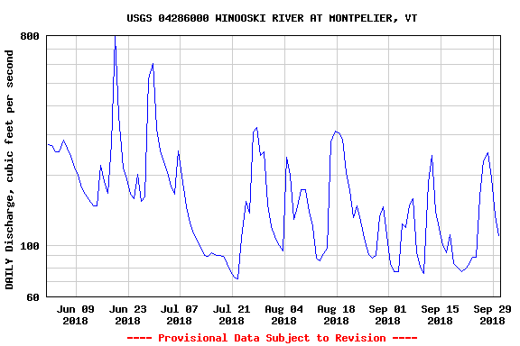

Figure 2. Discharge at the Winooski River gauge at Montpelier, VT during the summer of 2018. The discharge on the regular sampling dates and the rain event dates is indicated by the red and yellow dots, respectively.

The discharge measured at the USGS stream gauges on the North Branch River downstream of the Wrightsville dam and upstream of the sampling site NCNB02 (US04285500) on the 2018 sampling dates relative to the Q25 and Q75 quartiles are shown in Table 5. Figure 3 shows a hydrograph of the discharge on the North Branch for the summer 2018 season. For all dry-weather sampling dates but the last one (9/25/18), flows were less than the Q25 quartile, and can be considered low flow. The discharge on the North Branch on 9/25/18 falls between the Q25 and Q75 quartiles and is therefore medium flow. The North Branch River and its tributaries were not sampled during rain events in 2018.

Table 5. North Branch River daily discharge at the USGS stream gauge downstream from Wrightsville dam (USGS 0428550) on the six 2017 sampling dates, with corresponding quartiles and flow levels. Daily flow data retrieved from the National Water Information System Web Interface: https://waterdata.usgs.gov/nwis/dv/?site_no=04285500&agency_cd=USGS&amp;referred_module=sw
USGS discharge statistics for this gauge in cuft/s: Min=0.2, 25th %=31.0, Mean = 140.8, 75th % = 154.0, Max = 1620 as retrieved from: https://waterwatch.usgs.gov/index.php?sno=North+Branch+Winooski&ds=dv01d_por&btnGo=GO&m=sitempnn on February 2, 2019.
Date | Daily discharge (cuft/s) | Quartile | Flow level
6/26/18 | 17.5 | <Q25 | low
7/10/18 | 10.8 | <Q25 | low
8/7/18 | 8.58 | <Q25 | low
8/21/18 | 24.5 | <Q25 | low
9/4/18 | 8.95 | <Q25 | low
9/25/18 | 133 | Q25-75 | medium

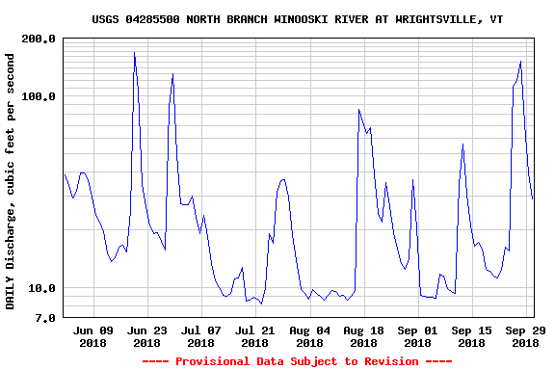

Figure 3. Discharge at the North Branch River gauge at Wrightsville Dam, VT during the summer of 2018. The discharge on the sampling dates is indicated by the red dots.

E. coli sampling results
Escherichia coli (E. coli) is a species of bacteria found in the lower digestive tract of mammals and is commonly used as an indicator of fecal contamination in rivers, streams, lakes, and oceans. While most strains of E. coli do not themselves cause disease, their presence may be associated with other bacteria and viruses that are pathogenic. E. coli amounts are often given in units of most probable number (mpn) - a reflection of the laboratory test used to measure the number of E. coli cells in a sample. Both the Vermont and US EPA standards for E. coli are based on the geometric mean of samples taken over a period of time and/or single-sample measurements. The Vermont and EPA standards for the geometric mean E. coli level for Class B waters is 126 mpn /100mL. This corresponds to a level in which there is a probability that 32-36 individuals/1000 would get sick from water contact. To meet the single sample measurement standard, less than 10% of the single sample measurements should have E. coli levels above the single sample maximum (SSM) value of 235 mpn/100mL.
Since almost all E. coli samples collected during the 2018 season were taken during low flows, the levels measured were probably not significantly influenced by surface runoff and hydroelectric power plant releases (hydro flows). The E. coli present are more likely due to failing septic systems, illicit sewer connections to the stormdrain system, in-stream wild or domesticated animals, or free-living bacteria. Furthermore, since the summer of 2018 was particularly dry, the diluting effects of groundwater would be expected to be minimal.
A summary of E. coli results for each site relative to the geometric mean and single sample maximum standards are shown as a box plot in Figure 4. Geometric mean E. coli numbers along the North Branch River met the Vermont water quality standard of less than 126 mpn/100mL at the North Branch Nature Center (NBNC02) and the Montpelier snow dump (NBSNOWD) sites but rose slightly above the EPA standard further downstream at the Cummings Street bridge location (CUMMINGSBR) and remained elevated at Mill Pond Park (MILLPD) and the Vine Street Pedestrian Bridge (PEDBRID). The geometric mean E. coli was slightly lower further downstream at Spring Street (SPRINGST), but was still above the minimum standard. The higher E. coli levels at CUMMINGSBR, MILLPD and PEDBRID may be due to an illicit discharge of E. coli downstream from the NBSNOWD site, and/or to free-living E. coli in the sediment accumulated behind the Lane Shops dam between MILLPD and PEDBRID. For the most part, however, E. coli levels in the uppermost sites of the North Branch in Montpelier were relatively low.

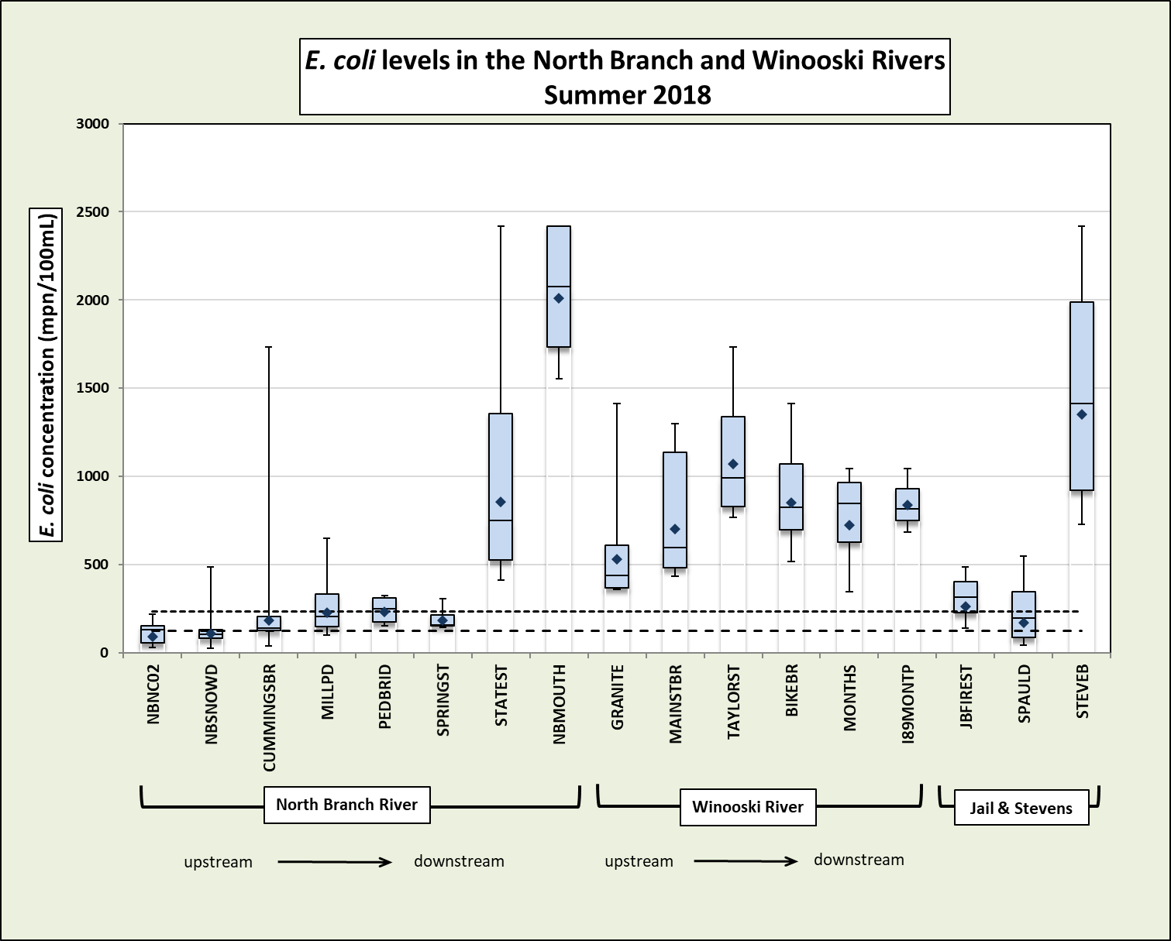
Figure 4. Box and whisker plot of 2018 E. coli concentrations in the Barre-Montpelier area water quality sampling locations on the North Branch and Winooski Rivers. The geometric mean values for each site are shown by the blue diamonds ( ), the single sample maximum standard by the short-dotted line ( ), and the geometric mean by the longer-dotted line ( ). First and third quartiles are shown by the light blue boxes, separated by the median value. Minimum and maximum values are shown by the whiskers.

The two most-downstream sampling sites on the North Branch, at State Street (STATEST) and the mouth (NBMOUTH) had significantly higher geometric mean values that far exceeded the standard for E. coli. The mouth in particular had an extremely high geometric mean of over 2000 mpn/100mL. Since the laboratory tests used to measure E. coli samples have a maximum result of 2419 mpn/100mL, and three out of the samples collected at the NBMOUTH had this value, the geometric mean for this site is likely even higher. These two E. coli “hot spots” are very unlikely to be due to surface runoff or combined sewer overflow events since samples were collected in dry conditions when less than 0.11 inches of rain had fallen in the previous 48 hours. Instead, it appears there are one or more sources of fecal matter to the North Branch between Spring Street and the river’s confluence with the Winooski. Possible sources of this fecal matter are previously over-looked or very recent sewer discharge(s) not identified in the 2016 IDDE study of Montpelier’s stormdrains or sewage entering the North Branch via a direct discharge not associated with the stormdrain system. A regular homeless population living near the mouth of the North Branch may also be a source. The Friends of the Winooski River plan to sample this reach of the North Branch in 2019 at several sites in order to identify and eliminate these sources. Elimination of the source of fecal matter in this reach is especially important since the City of Montpelier has plans to create a small park with a river access point right at the confluence of the North Branch and Winooski Rivers.
The geometric mean, median, maximum, and minimum values on the Winooski River were more variable than on North Branch and were well above both standards at all sites, particularly downstream of the MAINST bridge. The uptick in the E. coli between the Main Street and Taylor Street bridges, observed in 2017 and again in 2018, is likely due at least in part to the influx of fecal matter from the North Branch River, which flows into the Winooski between the two bridges. A smaller increase in E. coli levels was observed between the Granite and Main Street Bridges and may be due to another sewage source to the Winooski River. Another source of E. coli must exist upstream of the Granite Street Bridge as well, since levels at that site, upstream of all Montpelier CSOs, has consistently exceeded geometric mean standards in 2018 and previous years.
E. coli levels at two sampling sites on the Jail Branch, a tributary to the Steven’s Branch, were slightly above the geometric mean standard and similar to the levels seen at the upstream sites on the North Branch River. The E. coli count at the upstream JBFIREST, where a local resident had reported his dog had become sick after swimming in the stream, was somewhat elevated. The E. coli level downstream on the Jail Branch at Spaulding Falls (171 mpn/100mL) was lower and only slightly above the standard. The geometric mean value at Stevens Branch (STEVEB), in contrast, was very high at over ten times the standard. Several illicit sewer connections to Barre City and Barre Town stormdrain system were identified in an outfall monitoring effort conducted by the Friends of the Winooski River and Stone Environmental in 2016. Many of these have yet to be corrected and may be responsible for the high E. coli in the Stevens Branch downstream.
Figure 5 shows the individual sample results for each site relative to the EPA’s 235 mpn/100mL single sample maximum (SSM) standard. Most of the individual samples taken on the North Branch River had E. coli concentrations below the SSM with the exception of the STATEST and NBMOUTH sites, where all samples exceeded this standard. All of the samples collected at NBMOUTH in 2018 had extremely high E. coli levels, and three had the maximum value the lab test can return. All samples collected from the Winooski River also exceeded the SSM, but were not as high at the levels at NBMOUTH. Clearly, follow-up is needed in the lower North Branch to find and correct the source of fecal matter influencing both levels at NBMOUTH as well as the Winooski River mainstem.
Single sample E. coli counts on the Jail Branch were variable, with one sample (out of two) at JBFIREST and two samples at SPAULD exceeding the SSM. All the individual samples at the Stevens Branch site, however, far exceeded the single sample maximum of 235 mpn/100mL.

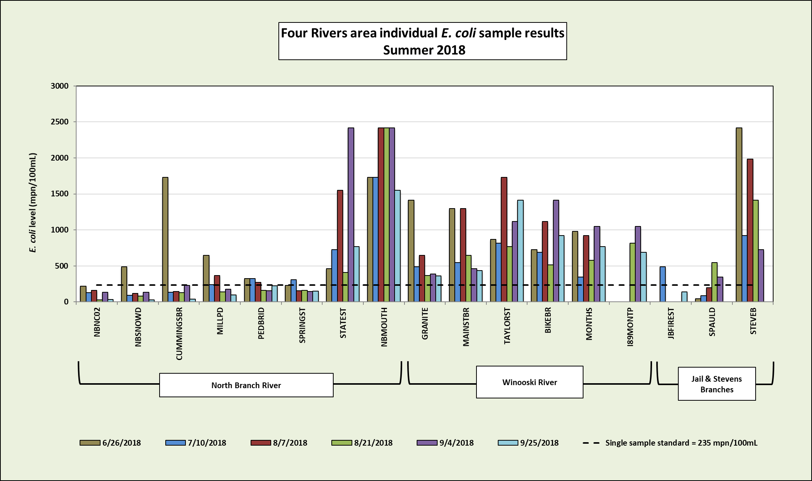
Figure 5. Individual E. coli sample results for 6 regular sampling dates at 17 sampling locations on the North Branch, Winooski, Jail Branch, and Stevens Branch Rivers in the Barre-Montpelier area. The EPA standard for individual samples (235 mpn/100mL) is shown by the dotted line.

Chloride results

According to the Vermont Surface Water Management Strategy, chloride levels above 230 mg/L, the Vermont “chronic” standard for chloride, can lead to poor health and reduced reproduction in aquatic species and may increase stratification in ponds and lakes, thereby inhibiting natural mixing and limiting oxygen availability. Chloride levels in streams tend to be higher during dry times of the year when ground water contributes a larger proportion of the water in streams than in wetter times of the year, when rainfall has a diluting effect. Chloride sources include road deicing salts, wastewater, and leachate from landfills. Predictably, chloride levels also tend to spike in the spring when road salts are washed into streams during spring rains and snowmelt.
The Friends of the Winooski River sampled for chloride at four sites in 2018: Macs10, on a tributary that was found to have very high chloride levels in previous sampling years; the Stevens Branch site in Berlin downstream from the Macs10 tributary; and two sites just downstream from Montpelier snow-dumping– NBSNOWD on the North Branch and I89MONTP on the Winooski.
The results of the 2018 chloride sampling are shown in Figure 6. The Macs10 site had one extremely high chloride reading on 8/21, the only date on which chloride was sampled at this site. This site is of interest since it has had mean chloride levels well above the chronic standard in previous years. Prior stormwater outfall monitoring and stream sampling further up this stream’s watershed strongly suggests that road salt use on the parking lots of the Central Vermont Medical Center has contaminated the groundwater feeding this stream. The Friends of the Winooski River have been in communication with the facilities manager at the medical center to help the facility get information on updated de-icing techniques and will continue to monitor this site.
Chloride levels on the Stevens Branch below the confluence of the tributary were consistently somewhat elevated, but the mean for the season was below the chronic standard. The North Branch site below one of the Montpelier snow dump locations (NBSNOWD) had low chloride levels similar to an upstream site at NBNC02, and both Winooski River sites upstream and downstream from the snow dump site under I89 were similarly somewhat elevated. It therefore appears Montpelier’s snow dump sites do not affect chloride levels of the nearby rivers appreciably.

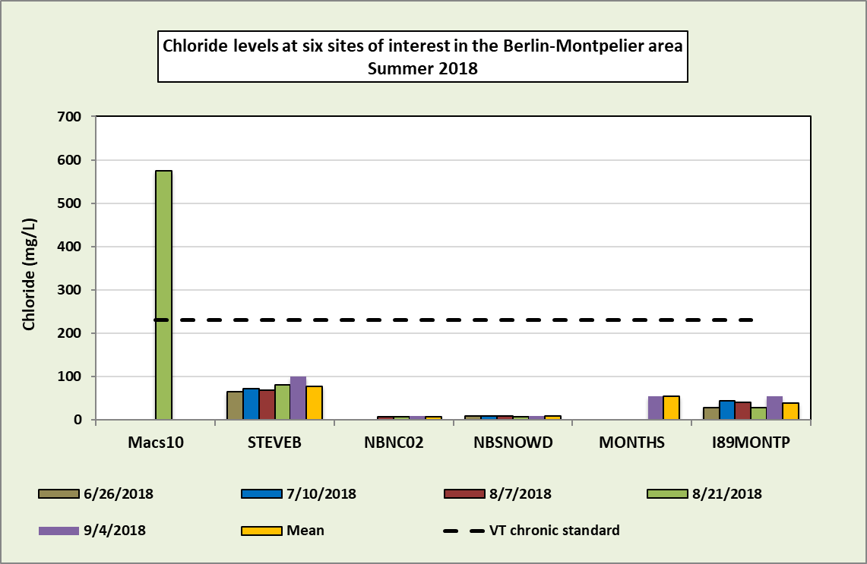
Figure 6. Chloride levels at six sites in the Berlin-Montpelier area in the summer of 2018. Vermont’s chronic chloride standard of 230 mg/L is shown by the dotted line.

Phosphorus results, dry low flow conditions

Phosphorus is a main pollutant of concern in Lake Champlain and can also cause problems in rivers and streams. As a nutrient limiting the growth of algae, any increases in its concentration can result in algal blooms that discourage recreation and are sometimes toxic. Furthermore, when the algal cells die, their decomposition depletes the water of oxygen needed by fish and other aquatic organisms, causing a reduction in the quality of aquatic habitat. Phosphorus sources include fertilizers, manure, pet waste, wastewater, and organic matter. Sediment from erosion of soils, streambeds, or streambanks also contributes to phosphorus levels since phosphorus tends to adhere to soil particles.

The Vermont standard for phosphorus in streams is based on concentrations during low flow conditions and depends on the class, gradient, size, and temperature of the stream. The streams in the Barre-Montpelier area, including the Winooski River, are considered class B cold medium-gradient streams, for which the phosphorus standard is an average of 15 ug/L. Based on the USGS gauge data for 2018, flow levels were low on the Winooski and North Branch Rivers for all the 2018 dry-weather sampling dates. The results for all these dates were therefore used to determine the mean phosphorus value for the season. The results of the low-flow phosphorus sampling are shown in Figure 7.

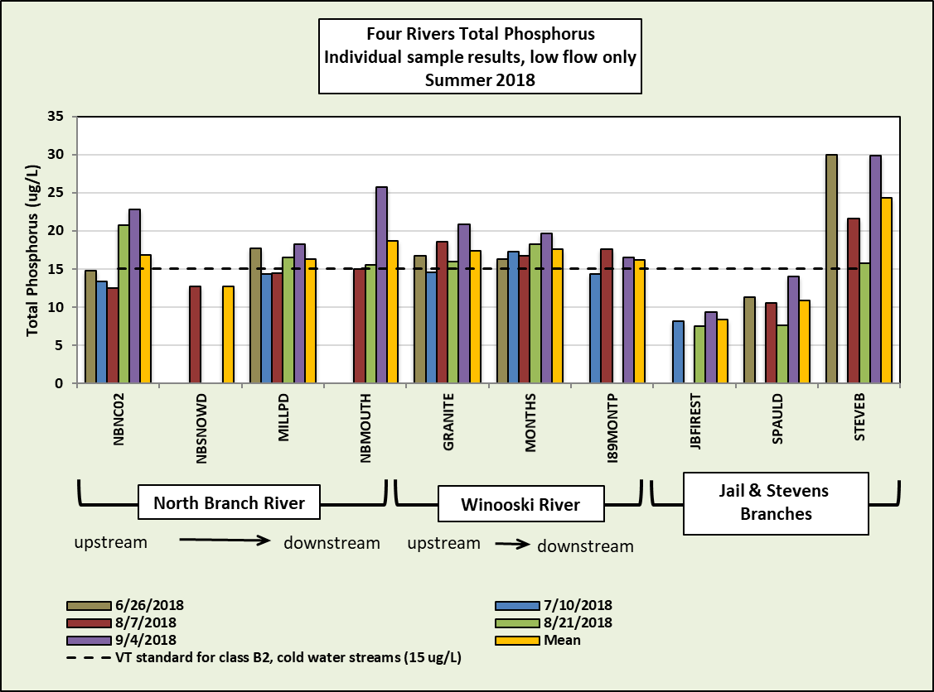
Figure 7. Low-flow phosphorus levels at 10 sites in the Montpelier-Barre area. The standard for phosphorus in cold medium-gradient streams (15 ug/L) is shown by the dotted line.

The mean phosphorus level exceeded the standard at most sites, but only by about a small amount. Levels were fairly consistent between sites; the Jail Branch sites had the lowest values, and the Stevens Branch site had the highest. Since the target goal for phosphorus levels in the Main Lake of Lake Champlain is 10 ug/L, the rivers in the Barre-Montpelier area are contributing to the phosphorus in the lake rather than diluting it.

Phosphorus and turbidity results, rain events
Since phosphorus and turbidity often spike due to stormwater runoff or high flow levels, the Friends of the Winooski River also sampled several area tributaries during rain events. This allows us to determine whether specific sub-watersheds contribute more phosphorus than others, and to focus our mitigation efforts to areas with higher phosphorus loads. Including turbidity sampling during rainfall events is one way to determine how much erosion is being caused by stormwater runoff.
Phosphorus was sampled on both rain dates while turbidity was sampled only on 9/11. On both dates the flow levels in the Winooski were in the Q25-Q75 range and can therefore be considered medium flow. For the 7/26 date, 0.76 inches of rain had fallen the day before sampling, and 0.4 inches fell in the morning before 8 am. On 9/11, 0.11 inches fell the day before sampling, while 0.78 inches fell before 8 am (see Figure 3). Samples were collected from 6:50 -10:05 am on 7/26/18 and from 5:55- 9:38 am on 9/11/18, so the total rain amount that occurred before samples were collected varied by site.
Figure 8 shows the total phosphorus levels in individual samples on these two rain event dates at each of the nine sites sampled in 2018. Phosphorus levels were generally lower during the 7/26 date than on 9/11, despite the greater total rainfall for that rain event. This is perhaps because the sampling on 7/26 occurred longer after the ‘first flush” of runoff carrying the bulk of pollutants washed from land surfaces. The sampling on 9/11, on the other hand occurred sooner after rainfall began.
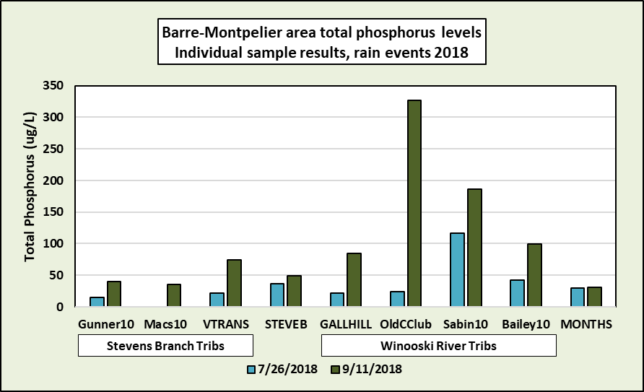Figure 8. Total phosphorus amounts for Barre-Montpelier tributaries to the Stevens Branch and Winooski Rivers during 2018 rain events. Phosphorus amounts for the Stevens Branch and Winooski Rivers below the tributaries are represented by the STEVEB and MONTHS samples, respectively.

Most sites had moderately elevated phosphorus levels on 7/26, with measurements at most sites under 50 ug/L. The Sabin10 site on Blanchard Brook had the highest levels on that date (116 ug/L). This site is situated close to the mouth of the brook, below Sabin’s Pasture and Montpelier’s suburban “Towne Hill” neighborhood.
On 9/11/18 the phosphorus five sites exceeded 50 ug/L, and the Sabin10 and OldCClub sites had phosphorus levels of 187 and 327 ug/L, respectively. OldCClub is a site on an unnamed tributary that runs from the Towne Hill neighborhood through the Montpelier Elks Country Club golf course. High phosphorus levels at these two sites may stem from fertilizers spread on lawns, erosion, sewage leaks, and/or animal waste and warrant additional sampling.
Turbidity levels measured during the 9/11 rain event are shown in Figure 9. As with phosphorus on this date, turbidity was elevated at all sites and the OldCClub sample had the highest turbidity reading. Since both phosphorus and turbidity levels were extremely high at this site, it may be that significant erosion is happening somewhere upstream. The Gallison Hill (GallHill) and Sabin10 sites also had high turbidity readings. The Friends of the Winooski River plan to continue rain-event sampling all three sites.

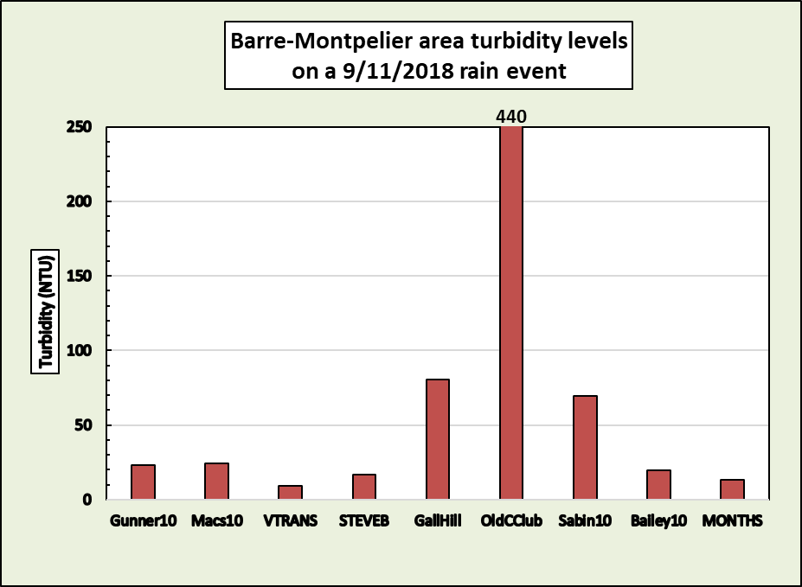
Figure 9. Turbidity of Barre-Montpelier tributaries to the Stevens Branch and Winooski Rivers during the 9/11/2018 rain event. Turbidity amounts for the Stevens Branch and Winooski Rivers below the tributaries are represented by the STEVEB and MONTHS samples, respectively.

Conclusion
The Friends of the Winooski River’s 2018 sampling efforts in the Barre-Montpelier area revealed several problem sites. In particular, the North Branch River has very high E. coli concentrations at two sites in Montpelier close to the confluence with the Winooski. One or more significant sources of fecal matter seems to be entering the river somewhere downstream of the Spring Street Bridge. Possible sources include improper sewer discharge, a homeless population that frequents the confluence of the two rivers, and/or a population of mallards that lives between Spring and Langdon Streets. The Friends plans to follow up trying to determine the location(s) of the source(s) by adding more sampling sites in the reach from State Street to the NBMOUTH site. It is our understanding that there will also be DEC-led efforts to locate any sewer discharges in that area.
Our 2018 sampling also suggests that two tributaries to the Winooski River are contributing relatively high levels of phosphorus during rain events. Both tributaries flow off the Montpelier Towne Hill neighborhood, and one flows through a golf course. Possible sources of the high phosphorus on these two streams include fertilizer use on the prevalent lawns in the area and/or erosion of soils. The Friends will continue to sample these two tributaries and plan to walk these streams to look for areas of erosion. We would also like to continue to monitor chloride levels at the Macs10 site since it has had extremely high levels of this pollutant in the past.
Appendix A - Individual sample results
Sample Number | Location | Date | Chloride (mg/L) | Final E. coli (mpn/100ml) | TN (mg/l) | TP (ug/L) | Turbidity (NTU) | Flow Level on field sheet
181532-01 | Bailey10 | 7/26/2018 |  |  |  | 42.7 |  | M
181880-10 | Bailey10 | 9/11/2018 |  |  |  | 99.1 | 19.5 | M
181880-12 | Bailey 10-BLANK | 9/11/2018 |  |  |  | 5.71 | < 0.2 | M
181880-11 | Bailey 10-DUP | 9/11/2018 |  |  |  | 101 | 18.5 | M
181149-16 | BIKEBR | 6/26/2018 |  | 726.99 |  |  |  | M
181268-15 | BIKEBR | 7/10/2018 |  | 686.67 |  |  |  | M
181533-13 | BIKEBR | 8/7/2018 |  | 1119.87 |  |  |  | M
181644-15 | BIKEBR | 8/21/2018 |  | 517.21 |  |  |  | L
181804-15 | BIKEBR | 9/4/2018 |  | 1413.61 |  |  |  | M
182033-14 | BIKEBR | 9/25/2018 |  | 920.84 |  |  |  | L
181149-05 | CUMMINGSBR | 6/26/2018 | 8.56 | 1732.89 |  |  |  | M
181268-05 | CUMMINGSBR | 7/10/2018 |  | 133.44 |  |  |  | M
181533-03 | CUMMINGSBR | 8/7/2018 |  | 144.97 |  |  |  | L
181644-03 | CUMMINGSBR | 8/21/2018 |  | 127.4 |  |  |  | L
181804-03 | CUMMINGSBR | 9/4/2018 |  | 228.18 |  |  |  | L/M
182033-03 | CUMMINGSBR | 9/25/2018 |  | 39.86 |  |  |  | M
181532-07 | GALLHILL | 7/26/2018 |  |  |  | 21.9 |  | M
181880-06 | GALLHILL | 9/11/2018 |  |  |  | 85 | 80.7 | (no entry)
181149-12 | GRANITE | 6/26/2018 |  | 1413.61 |  | 16.7 |  | L/M
181268-11 | GRANITE | 7/10/2018 |  | 488.44 |  | 14.6 |  | L/M
181533-10 | GRANITE | 8/7/2018 |  | 648.82 |  | 18.6 |  | L
181644-12 | GRANITE | 8/21/2018 |  | 365.4 |  | 16 |  | M
181804-12 | GRANITE | 9/4/2018 |  | 387.32 |  | 20.8 |  | M
182033-09 | GRANITE | 9/25/2018 |  | 360.87 |  |  |  | L
181532-11 | Gunner10 | 7/26/2018 |  |  |  | 15.2 |  | L
181880-01 | Gunner10 | 9/11/2018 |  |  |  | 39.8 | 23.4 | M
181149-18 | I89MONTP | 6/26/2018 | 29.2 |  |  |  |  | M
181268-17 | I89MONTP | 7/10/2018 | 44.75 |  |  | 14.4 |  | M
181533-15 | I89MONTP | 8/7/2018 | 41.1 |  |  | 17.6 |  | M
181533-21 | I89MONTP-BLANK | 8/7/2018 | < 2 |  |  | <5 |  | M
181533-20 | I89MONTP-DUP | 8/7/2018 | 41.2 |  |  | 17.2 |  | M
181644-17 | I89MONTP | 8/21/2018 | 27.8 | 816.41 |  |  |  | M
181804-17 | I89MONTP | 9/4/2018 | 55 | 1046.24 |  | 16.5 |  | M
182033-16 | I89MONTP | 9/25/2018 |  | 686.67 |  |  |  | L
181267-01 | JBFIREST | 7/10/2018 |  | 488.44 | 0.32 | 8.16 |  | L/M
181654-01 | JBFIREST | 8/21/2018 |  |  | 0.27 | 7.47 |  | M
181804-20 | JBFIREST | 9/4/2018 |  | 648.82 | 0.31 | 9.4 | 0.58 | M
182033-17 | JBFIREST | 9/25/2018 |  | 142.09 |  |  |  | L
181644-19 | Macs10 | 8/21/2018 | 575 |  |  |  |  | L
181880-03 | Macs10 | 9/11/2018 |  |  |  | 35.8 | 24.1 | M
181149-13 | MAINSTBR | 6/26/2018 |  | 1299.65 |  |  |  | M
181268-12 | MAINSTBR | 7/10/2018 |  | 547.5 |  |  |  | L
181533-11 | MAINSTBR | 8/7/2018 |  | 1299.65 |  |  |  | L
181644-13 | MAINSTBR | 8/21/2018 |  | 648.82 |  |  |  | L
181804-13 | MAINSTBR | 9/4/2018 |  | 461.11 |  |  |  | M
182033-10 | MAINSTBR | 9/25/2018 |  | 435.17 |  |  |  | L
182033-12 | MAINSTBR BLANK | 9/25/2018 |  | < 1 |  |  |  | L
182033-11 | MAINSTBR DUP | 9/25/2018 |  | 344.8 |  |  |  | L
181149-06 | MILLPD | 6/26/2018 |  | 648.82 |  | 17.7 |  | M
181268-06 | MILLPD | 7/10/2018 |  | 238.22 |  | 14.4 |  | M
181533-04 | MILLPD | 8/7/2018 |  | 365.4 |  | 14.5 |  | M
181644-04 | MILLPD | 8/21/2018 |  | 137.61 |  | 16.5 |  | M
181644-06 | MILLPD-BLANK | 8/21/2018 |  | < 1 |  | < 5 |  | M
181644-05 | MILLPD-DUP | 8/21/2018 |  | 125.91 |  |  |  | M
181804-04 | MILLPD | 9/4/2018 |  | 178.21 |  | 18.2 |  | M/H
181804-05 | MILLPD-DUP | 9/4/2018 |  |  |  | 17.9 |  | M/H
182033-04 | MILLPD | 9/25/2018 |  | 98.95 |  |  |  | M
181149-17 | MONTHS | 6/26/2018 |  | 980.39 |  | 16.3 |  | M
181268-16 | MONTHS | 7/10/2018 |  | 344.8 |  | 17.3 |  | M
181532-02 | MONTHS | 7/26/2018 |  |  |  | 29.8 |  | M
181532-04 | MONTHS - BLANK | 7/26/2018 |  |  |  | < 5 |  | M
181532-03 | MONTHS - DUP | 7/26/2018 |  |  |  | 29.6 |  | M
181533-14 | MONTHS | 8/7/2018 |  | 920.84 |  | 16.7 |  | M
181644-16 | MONTHS | 8/21/2018 |  | 579.43 |  | 18.2 |  | M
181804-16 | MONTHS | 9/4/2018 | 55 | 1046.24 |  | 19.7 |  | M
181880-09 | MONTHS | 9/11/2018 |  |  |  | 31.4 | 13.5 | M
182033-15 | MONTHS | 9/25/2018 |  | 770.1 |  |  |  | L
181149-10 | NBMOUTH | 6/26/2018 |  | 1732.89 |  |  |  | M
181268-10 | NBMOUTH | 7/10/2018 |  | 1732.89 |  |  |  | M
181533-08 | NBMOUTH | 8/7/2018 |  | 2419.57 |  | 15 |  | M
181644-10 | NBMOUTH | 8/21/2018 |  | 2419.57 |  | 15.5 |  | M
181804-08 | NBMOUTH | 9/4/2018 |  | 2419.6 |  | 25.7 |  | M
181804-10 | NBMOUTH-BLANK | 9/4/2018 |  | < 1 |  | < 5 |  | M
181804-09 | NBMOUTH-DUP | 9/4/2018 |  | 2419.6 |  | 21.8 |  | M
182033-08 | NBMOUTH | 9/25/2018 |  | 1553.12 |  |  |  | M
181149-01 | NBNC02 | 6/26/2018 |  | 218.72 |  | 14.8 |  | L
181149-03 | NBNC02-Blank | 6/26/2018 |  | < 1 |  | 5.41 |  | L
181149-02 | NBNC02-DUP | 6/26/2018 |  | 209.82 |  | 15.5 |  | L
181268-01 | NBNC02 | 7/10/2018 |  | 129.06 |  | 13.4 |  | L
181533-01 | NBNC02 | 8/7/2018 | 8.14 | 161.62 |  | 12.5 |  | L
181644-01 | NBNC02 | 8/21/2018 | 7.66 | 29.17 |  | 20.7 |  | L
181804-01 | NBNC02 | 9/4/2018 | 8.51 | 135.4 |  | 22.8 |  | L
182033-01 | NBNC02 | 9/25/2018 |  | 34.51 |  |  |  | L
181149-04 | NBSNOWD | 6/26/2018 | 8.46 | 488.44 |  |  |  | L
181268-02 | NBSNOWD | 7/10/2018 | 8.55 | 90.63 |  |  |  | M
181268-04 | NBSNOWD-Blank | 7/10/2018 | < 2 | < 1 |  |  |  | M
181268-03 | NBSNOWD-DUP | 7/10/2018 | 8.75 | 117.76 |  |  |  | M
181533-02 | NBSNOWD | 8/7/2018 | 9.98 | 116.19 |  | 12.7 |  | M
181644-02 | NBSNOWD | 8/21/2018 | 8.21 | 83.92 |  |  |  | L
181804-02 | NBSNOWD | 9/4/2018 | 9.94 | 135.4 |  |  |  | L
182033-02 | NBSNOWD | 9/25/2018 |  | 28.2 |  |  |  | L
181532-06 | OLDCCLUB | 7/26/2018 |  |  |  | 24.6 |  | L
181880-07 | OLDCCLUB | 9/11/2018 |  |  |  | 327 | 440 | (no entry)
181149-07 | PEDBRID | 6/26/2018 |  | 325.54 |  |  |  | L
181268-07 | PEDBRID | 7/10/2018 |  | 325.54 |  |  |  | L
181533-06 | PEDBRID | 8/7/2018 |  | 272.3 |  |  |  | (no entry)
181644-07 | PEDBRID | 8/21/2018 |  | 160.71 |  |  |  | M
181804-21 | PEDBRID | 9/4/2018 |  | 155.25 |  |  |  | L
182033-05 | PEDBRID | 9/25/2018 |  | 224.68 |  |  |  | L
181532-05 | Sabin10 | 7/26/2018 |  |  |  | 116 |  | L
181880-08 | Sabin10 | 9/11/2018 |  |  |  | 186.8 | 69.3 | M
181149-11 | SPAULD | 6/26/2018 |  | 45.85 |  | 11.3 |  | L
181268-19 | SPAULD | 7/10/2018 |  | 86.24 |  |  |  | L/M
181533-16 | SPAULD | 8/7/2018 |  | 195.59 |  | 10.6 |  | L
181644-18 | SPAULD | 8/21/2018 |  | 547.5 |  | 7.67 |  | L
181804-18 | SPAULD | 9/4/2018 |  | 344.8 |  | 14 |  | M
181149-08 | SPRINGST | 6/26/2018 |  | 230.98 |  |  |  | L
181268-08 | SPRINGST | 7/10/2018 |  | 307.59 |  |  |  | L
181533-05 | SPRINGST | 8/7/2018 |  | 157.56 |  |  |  | M
181533-23 | SPRINGST-BLANK | 8/7/2018 |  | < 1 |  |  |  | M
181533-22 | SPRINGST-DUP | 8/7/2018 |  | 228.18 |  |  |  | M
181644-08 | SPRINGST | 8/21/2018 |  | 160.71 |  |  |  | M
181804-06 | SPRINGST | 9/4/2018 |  | 143.87 |  |  |  | L
182033-06 | SPRINGST | 9/25/2018 |  | 150.01 |  |  |  | L
181149-09 | STATEST | 6/26/2018 |  | 461.11 |  |  |  | M
181268-09 | STATEST | 7/10/2018 |  | 726.99 |  |  |  | M
181533-07 | STATEST | 8/7/2018 |  | 1553.12 |  |  |  | L
181644-09 | STATEST | 8/21/2018 |  | 410.58 |  |  |  | M
181804-07 | STATEST | 9/4/2018 |  | 2419.6 |  |  |  | L
182033-07 | STATEST | 9/25/2018 |  | 770.1 |  |  |  | M
181149-19 | STEVEB | 6/26/2018 | 66 | 2419.6 |  | 30 |  | L
181268-18 | STEVEB | 7/10/2018 | 72.5 | 920.84 |  |  |  | L/M
181532-08 | STEVEB | 7/26/2018 |  |  |  | 37.1 |  | L/M
181533-17 | STEVEB | 8/7/2018 | 68 | 1986.29 |  | 21.6 |  | L
181644-20 | STEVEB | 8/21/2018 | 81.7 | 1413.61 |  | 15.8 |  | L
181644-22 | STEVEB-BLANK | 8/21/2018 | < 2 | < 1 |  |  |  | L
181644-21 | STEVEB-DUP | 8/21/2018 | 83.6 | 1553.12 |  |  |  | L
181804-19 | STEVEB | 9/4/2018 | 100 | 726.99 |  | 29.8 |  | L/M
181880-05 | STEVEB | 9/11/2018 |  |  |  | 49 | 16.9 | H
181149-14 | TAYLORST | 6/26/2018 |  | 866.44 |  |  |  | M
181268-13 | TAYLORST | 7/10/2018 |  | 816.41 |  |  |  | M
181533-12 | TAYLORST | 8/7/2018 |  | 1732.89 |  |  |  | M
181644-14 | TAYLORST | 8/21/2018 |  | 770.1 |  |  |  | M
181804-14 | TAYLORST | 9/4/2018 |  | 1119.87 |  |  |  | M
182033-13 | TAYLORST | 9/25/2018 |  | 1413.61 |  |  |  | L
181268-14 | TAYLORST-NORTH | 7/10/2018 |  | 613.14 |  |  |  | M
181533-18 | TAYLORST-NORTH | 8/7/2018 |  | 2419.6 |  |  |  | M
181644-23 | TAYLORST-NORTH | 8/21/2018 |  | 770.1 |  |  |  | M
181804-22 | TAYLORST-NORTH | 9/4/2018 |  | 1299.65 |  |  |  | M
181149-15 | TAYLORST-SOUTH | 6/26/2018 |  | 866.44 |  |  |  | M
181804-11 | U32 | 9/4/2018 |  | 613.14 |  | 21.1 |  | L
181532-10 | VTRANS | 7/26/2018 |  |  |  | 21.7 |  | M
181880-02 | VTRANS | 9/11/2018 |  |  |  | 74.8 | 9.28 | M/H

Appendix B – Quality Control
Sample Number | Location | Date | Chloride (mg/L) | Final E. coli (mpn/100ml) | TP (ugP/L) | Turbidity (NTU) | RPD Chloride | RPD E. coli | RPD TP | RPD Turbidity
181880-10 | Bailey10 | 9/11/2018 |  |  | 99.1 | 19.5 |  |  | 2 | 5
181880-12 | Bailey 10-BLANK | 9/11/2018 |  |  | 5.71 | < 0.2
181880-11 | Bailey 10-DUP | 9/11/2018 |  |  | 101 | 18.5
181533-15 | I89MONTP | 8/7/2018 | 41.1 |  | 17.6 |  | 0.2 |  | 2.3
181533-21 | I89MONTP-BLANK | 8/7/2018 | < 2 |  | < n 5
181533-20 | I89MONTP-DUP | 8/7/2018 | 41.2 |  | 17.2
182033-10 | MAINSTBR | 9/25/2018 |  | 435.17 |  |  |  | 23
182033-12 | MAINSTBR BLANK | 9/25/2018 |  | < 1
182033-11 | MAINSTBR DUP | 9/25/2018 |  | 344.8
181644-04 | MILLPD | 8/21/2018 |  | 137.61 | 16.5 |  |  | 9
181644-06 | MILLPD-BLANK | 8/21/2018 |  | < 1 | < 5
181644-05 | MILLPD-DUP | 8/21/2018 |  | 125.91
181804-04 | MILLPD | 9/4/2018 |  | 178.21 | 18.2 |  |  |  | 2
181804-05 | MILLPD-DUP | 9/4/2018 |  |  | 17.9
181532-02 | MONTHS | 7/26/2018 |  |  | 29.8 |  |  |  | 1
181532-04 | MONTHS - BLANK | 7/26/2018 |  |  | < 5
181532-03 | MONTHS - DUP | 7/26/2018 |  |  | 29.6
181644-16 | MONTHS | 8/21/2018 |  | 579.43 | 18.2
181804-08 | NBMOUTH | 9/4/2018 |  | 2419.6 | 25.7 |  |  | 0 | 16.4
181804-10 | NBMOUTH-BLANK | 9/4/2018 |  | < 1 | < 5
181804-09 | NBMOUTH-DUP | 9/4/2018 |  | 2419.6 | 21.8
181149-01 | NBNC02 | 6/26/2018 |  | 218.72 | 14.8 |  |  | 4.2 | 4.6
181149-03 | NBNC02-Blank | 6/26/2018 |  | < 1 | 5.41
181149-02 | NBNC02-DUP | 6/26/2018 |  | 209.82 | 15.5
181268-02 | NBSNOWD | 7/10/2018 | 8.55 | 90.63 |  |  | 2.3 | 26
181268-04 | NBSNOWD-Blank | 7/10/2018 | < 2 | < 1
181268-03 | NBSNOWD-DUP | 7/10/2018 | 8.75 | 117.76
181533-05 | SPRINGST | 8/7/2018 |  | 157.56 |  |  |  | 36.6
181533-23 | SPRINGST-BLANK | 8/7/2018 |  | < 1
181533-22 | SPRINGST-DUP | 8/7/2018 |  | 228.18
181644-20 | STEVEB | 8/21/2018 | 81.7 | 1413.61 | 15.8 |  | 2.3 | 9.4
181644-22 | STEVEB-BLANK | 8/21/2018 | < 2 | < 1
181644-21 | STEVEB-DUP | 8/21/2018 | 83.6 | 1553.12
Average Relative Percent Difference |  |  |  |  |  |  | 1.6 | 15.443 | 4.617 | 5

