Summary Report: 2018 Water Quality Sampling Results
South Chittenden River Watch

29 March 2019
Updated 28 May 2019

Prepared by:
This report has been prepared by Krista Hoffsis of Lewis Creek Association using a template, partial text, and map provided by Kristen Underwood of South Mountain Research & Consulting, and in collaboration with the Addison County River Watch Collaborative.

Prepared for:
South Chittenden River Watch
Lewis Creek Association

and

Jim Kellogg
VTDEC Watershed Management Division
Monitoring, Assessment and Planning Program

TABLE OF CONTENTS

1.0 Introduction 1
2.0 Background 1
3.0 Precipitation and Streamflow Data 3
4.0 Methods 3
5.0 Spatial Trend Monitoring and Sentinel Station Results 5
6.0 Project Implementation 9
7.0 References 10

Appendix A – Flow Data
Appendix B – Water Quality Data Tables by Watershed
Appendix C – Monitoring Station Locations and Rationale
Appendix D – Physical Characteristics of SCRWC Watersheds

1.0 Introduction
This report provides a summary of the 2018 monitoring results for the South Chittenden River Watch (SCRW) stations. Sampling in 2018 generally targeted high-flow conditions, although select stations were also monitored during low-flow conditions to bracket wastewater treatment facilities (WWTF) in Hinesburg and Shelburne.

Sampling was carried out by a network of volunteers, operating under an EPA-approved Quality Assurance Project Plan. Analytical services were provided by the Vermont Agricultural & Environmental Laboratory in Burlington, VT, through an analytical services partnership grant. A quality assurance review of data was performed by SCRW Sampling Coordinator, Krista Hoffsis. This summary report has been prepared by Krista Hoffsis, with technical editing by Kristen Underwood of South Mountain Research & Consulting.

2.0 Background
The SCRW has been monitoring water quality (including sediment, phosphorus, nitrates, and E.coli ) in four watersheds in southern Chittenden County (Figure 1) for several years, with the earliest monitoring efforts beginning in 2004 on the LaPlatte River.
- LaPlatte River (53 mi²)
- McCabe’s Brook (tributary of LaPlatte River, 6.2 mi²)
- Thorp Brook (4.6 mi²)
- Kimball Brook (2.9 mi²)

In Figure 1, highlighted segments of the LaPlatte River main stem and Mud Hollow Brook are listed as impaired for contact recreation uses due to impacts from agricultural runoff and streambank erosion (VTDEC, 2016a). Additionally, the LaPlatte River main stem downstream of Hinesburg, Patrick Brook from Lower Pond to its confluence with the LaPlatte, and the lower 1.1 miles of Kimball Brook are each listed as stressed waters with impacts to aquatic health, aesthetics and secondary contact recreation uses resulting from development, channelization and agricultural land uses (VTDEC, 2016b).
Since baseline data now exist for these four watersheds during low to moderate flow conditions, the goal during the 2018 season was to sample water quality during high flow events, as a means of estimating the relative contributions of sediment and nutrients to Lake Champlain in the context of the Lake Champlain Total Maximum Daily Load (TMDL) for phosphorus. High-flow sampling has occurred since 2014. Additional stations were established in 2016 on the Thorp and Kimball Brooks to bracket potential hot spots of sediment and nutrients, and to better understand baseline conditions. Four sentinel study sites were monitored in McCabe’s Brook, and three sentinel stations were monitored in LaPlatte River (Table 1, Figure 1). In past years, SCRW tested samples for chloride, nitrate, E. coli, and turbidity in addition to total phosphorus, dissolved phosphorus, total nitrogen, and total suspended sediments. Due to lab constraints, SCRW was only able to test for the latter parameters in 2018. A separate SCRW/VT DEC initiative was also carried out this season in the LaPlatte River and McCabe’s Brook under low flow conditions to characterize potential impacts from the Hinesburg WWTF and Shelburne WWTF, respectively (Figure 2). These results are analyzed separately by VTDEC.

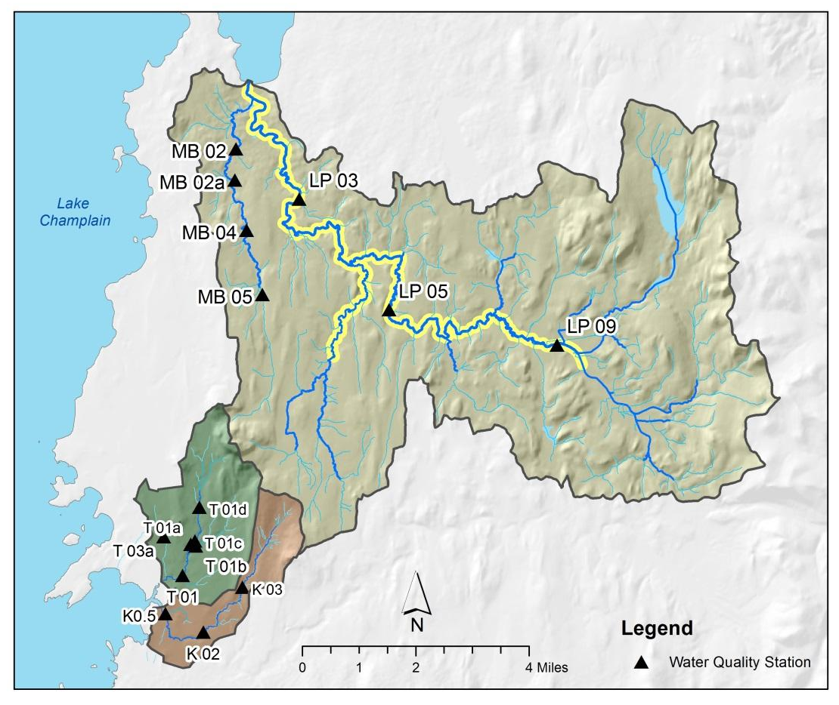
Figure 1. Location of 2018 high-flow monitoring stations.

Table 1. 2018 Schedule of Sites / Parameters
Stream and Location | Scheduled Analyses
 | E. coli | Cl | TSS | Turb. | TP | DP | TN | NOx
Spatial Trend Monitoring and Sentinel Stations (target: High Flows)
LaPlatte River – LP09, LP05, LP03 |  |  | X |  | X | X | X
McCabe’s Brook – MB05, MB04 MB02a, MB02 |  |  | X |  | X | X | X
Thorp Brook – T01, T01a, T01b, T01c, T01d, T03a |  |  | X |  | X | X | X
Kimball Brook – K03, K02, K0.5 |  |  | X |  | X | X | X
Bracket Monitoring of Waste-Water Treatment Facilities (target: Low Median Monthly Flow)
LaPlatte River – LP07a, LP09 |  |  |  |  | X | X | X
McCabe’s Brook – MB01a, MB02sup |  |  |  |  | X | X | X

Figure 2. Location of bracket monitoring stations that targeted Low Flows. Located upstream and downstream of WWTF discharge in (A) Hinesburg and (B) Shelburne.

3.0 Precipitation and Streamflow Data
Overall, calendar year 2018 was a near-normal precipitation year, as recorded by the National Weather Service. While precipitation was near normal for the year on average, spring melt and rain events began earlier than usual (March and April were about 50% precipitation above average) and weren’t able to be sampled. The months of May through October then received lower-than-normal precipitation, and November received 50-100% precipitation above average. (NOAA, 2018).
Streamflow data were compiled from the LaPlatte River USGS streamflow gauging station (#04282750) at Shelburne Falls, VT, which has been operational since 1991. Figure A-1 in Appendix A presents a graph of the instantaneous discharge record (provisional data) from calendar year 2018 for the LaPlatte River station. Flows were somewhat elevated in the Spring months, but then trended below normal from June through October.
A flow duration curve is also presented in Appendix A for the LaPlatte River gage based on daily mean flows recorded over 27 years from water years 1991 through 2018 (Figure A-2). According to the VTDEC Guidance on Streamflow Observations at time of Water Quality Sampling of Rivers and Streams, high flow levels are defined as those flow conditions which are equaled or exceeded only 25% of the time. Low flow levels are those equaled or exceeded more than 75% of the time, while those flows occurring between 25 and 75% of the time are classified as moderate. Based on this flow duration curve, daily mean flows recorded on the 2018 sampling dates were classified as low or high (Table 2, Figure 2).

4.0 Methods
Water quality samples were collected by SCRW volunteers in accordance with quality assurance procedures outlined in the EPA-approved Quality Assurance Project Plan prepared by VTDEC. A Quality Assurance Summary report for the 2018 sampling data has been provided under separate cover. Samples were delivered to the Vermont Agricultural & Environmental Laboratory housed in the Hills Building in the University of Vermont campus in Burlington, Vermont.
SCRW volunteers collected grab samples in these four watersheds at 19 sites during one spring event, four summer events, and two fall/winter events (Table 2). Drier than normal conditions in the late summer, timing of storms (occurring on weekends, or overnight), and starting the sampling season after the wettest months (March and April) made it difficult to fulfill the original sampling goal to capture high flow events. In the end, three freshets of reasonable size were sampled on April 30, November 5, and December 3; all three events were classified as high flows and captured water quality conditions as on the falling limb or peak of the discharge hydrograph (Figure 2). One low-flow, base-flow events was captured on June 14, and will be helpful to compare water quality results to State standards.
For select stations on the LaPlatte River and McCabe’s Brook, samples were collected on three low-flow summer sampling dates (June 20, July 3, and August 7) as part of the separate SCRW/VTDEC study to monitor potential influence of the Hinesburg WWTF and Shelburne WWTF, respectively.
Table 2. Daily Mean Flows recorded at USGS gage on Sample Dates in 2018, LaPlatte River.
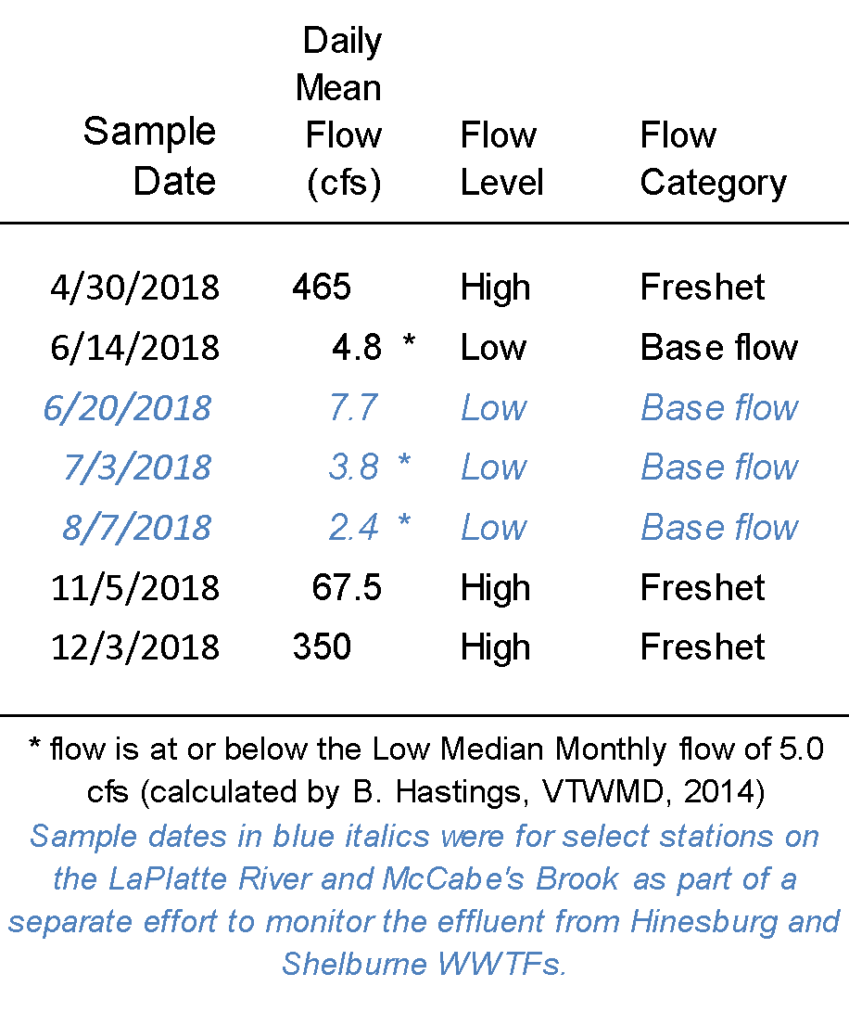

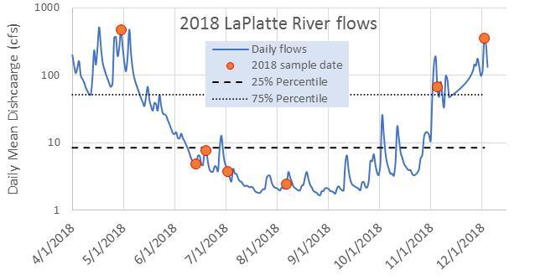
Figure 3. Daily mean discharge (provisional data) recorded for LaPlatte River at Shelburne Falls (USGS Stn #04282750) during 2018. Sample dates are indicated by orange circle symbols.

5.0 Spatial Trend Monitoring and Sentinel Station Results

A quality-assurance report for the 2018 season for the four SCRW watersheds has been submitted under separate cover to VAEL. In general, water quality results for 2018 were consistent with historic results and trends summarized in previous summary reports for each of the four watersheds. Expanded information has been gathered for newly-established stations in the Thorp watershed to add to the evaluation of spatial trends in constituent concentrations.
5.1 Total Phosphorus
5.1.1 High-flow Events
Figure 3 depicts the distribution of Total Phosphorus (TP) concentrations recorded during the three 2018 high-flow sampling events. The incremental subwatersheds draining to each water quality station are color-coded based on the mean TP recorded during three sampling events occurring during high flows in April, November, and December. Highest TP concentrations were detected in the western extents of each watershed, coincident with increasing density of glaciolacustrine soils and agricultural and developed land uses (Appendix D, Figures D-1, D-2, D-3). Lower LaPlatte was not monitored by SCRW in 2018, but will be part of the 2019 sampling plan.
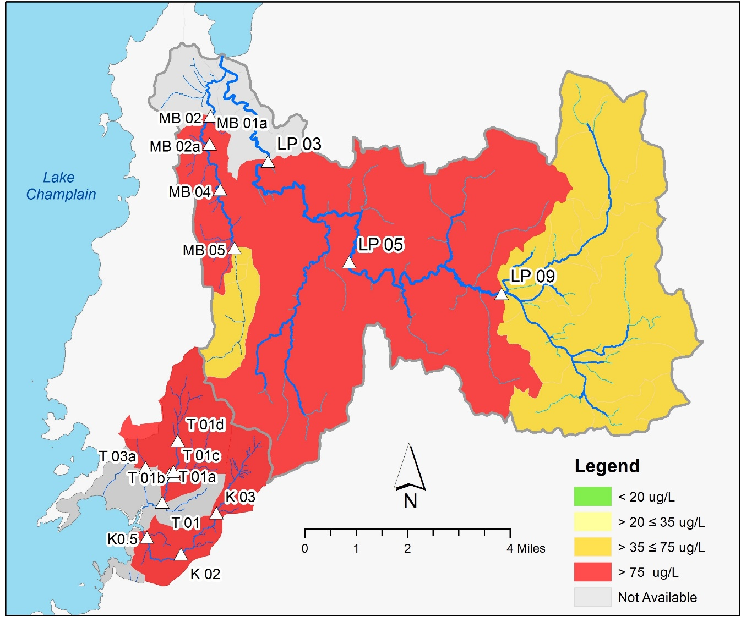

Figure 4. Distribution of Mean Total Phosphorus in Watersheds Monitored by the SCRW. Subwatersheds draining to each water quality station are color coded based on mean TP recorded during three sampling events occurring during high flows in April, November, and December, 2018.

Water quality in the SCRW watersheds varies in space, depending on the geologic setting and soil types present in the catchment areas draining to each station, as well as variation in land use and land cover characteristics. A separate study recently completed by the Addison County River Watch Collaborative found a strong, and statistically-significant, positive correlation between mean water quality concentrations (for Total Phosphorus, E. coli and Turbidity) and both the percentage of fine-grained glacial lake soils and the percentage of agricultural land use in the catchments draining to water quality stations (ACRWC & SMRC, 2016). Except for the headwater portions of LaPlatte River east of the Hinesburg village, SCRW watersheds tend to have a high percentage of low-infiltration, fine-grained silt and clay soils derived from glacial lake sediments (Appendix D, Figures D-1, D-2). These areas are also characterized by higher densities of agricultural and developed land uses (Figure D-3).
The Thorp Brook watershed has been the focus of bracket monitoring since 2017 to better define spatial patterns in water quality, as a series of best management practices either have been implemented or are being considered for implementation in the watershed. These preliminary TP results (Figure 4) build on 2017 results and suggest a source of TP between station T01d (at Common Way crossing) and station T01c (just above E. Thompson’s Point Rd), during high flows in April and November. A similar increase in TP was evident at low-flow, base-flow conditions on June 14. The upstream to downstream pattern from T01d to T01 seems to suggest a source of TP upstream of T01d. Results are presented for main stem stations alongside results from station T01b located on a tributary that joins Thorp Brook between stations T01c and T01a (Figure 5). Relatively lower detected concentrations of TP at station T01b suggest that TP concentrations in the Thorp Brook main stem are diluted by surface water contributions from this eastern tributary.
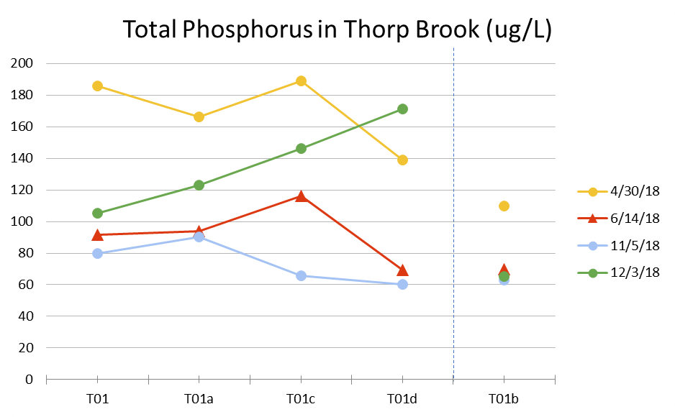
Figure 5. Total Phosphorus on Thorp Brook main stem during freshet flow conditions (circles) and dry-weather base flow conditions (triangles). Results are presented for main stem stations alongside results from station T01b located on a tributary that joins Thorp Brook between stations T01c and T01a.
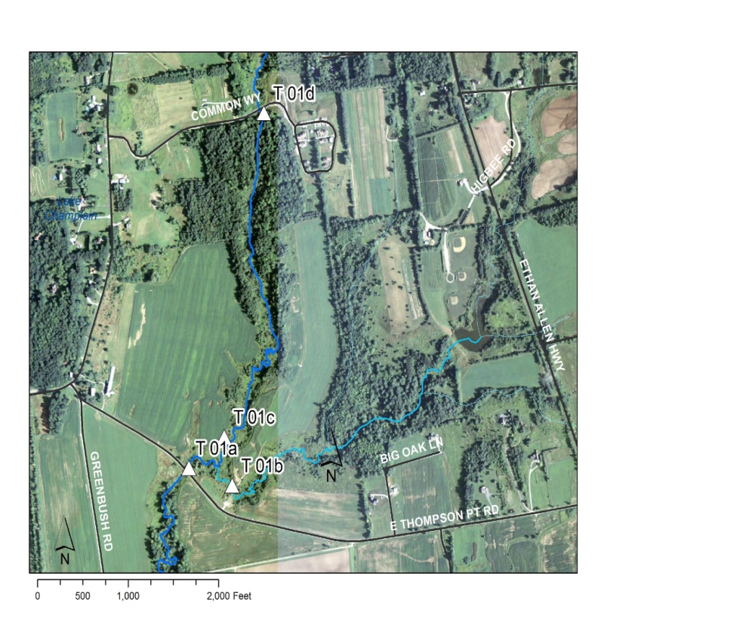
Figure 6. Location of bracket monitoring stations on Thorp Brook.

5.1.2 Low-flow Event
The instream phosphorus criterion of 27 µg/L for warm-water medium gradient (WWMG) wadeable stream ecotypes in Class B waters is applicable at low median monthly (LMM) flow conditions during June through October (VWMD, 2016). Only the June 14 sampling event was classified as a low flow, where daily mean flow measured at Shelburne Falls on the LaPlatte River (4.82 cfs) was nearly at the LMM (5 cfs) (Table 2). TP concentrations on this date exceeded 27 µg/L at all fifteen sampling stations in SCRW watersheds except LP03. It should be noted that the TP concentration at K0.5 was by far the highest during this base-flow event, which was measured at 490.5 µg/L - more than twice as much as the next highest value.
5.2 Dissolved Phosphorus
Dissolved phosphorus (DP) was analyzed during each event at all 15 spatial-trend-monitoring stations, and ranged from 5 to 87% of the TP concentration. The range and mean of these percentages did not vary significantly when results were stratified by flow condition (i.e., low flows vs high flows), but did vary based on time of year. In the two Spring/Summer events (one high flow and one base flow), median DP concentration was 36.5%, and in the two Fall/Winter events (both high flow), the median DP concentration was 64%. This could be due to how land is used in the Spring/Summer versus the Fall/Winter (agricultural activity, construction, etc.). This could also be due to differences in temperature, vegetation conditions, and antecedent moisture conditions, as well as many other factors that affect the fate and transformation of phosphorus in the environment. Generally speaking, highest DP as a percentage of TP was reported for McCabe’s Brook and Kimball Brook, which is consistent with 2017 results. Lowest DP as a percentage of TP was reported for Thorp Brook stations. The percentage of TP in the dissolved form tended to be inversely related to Total Suspended Solids, particularly at high flows. In other words, more turbid water tended to have lower percentages of DP and higher particulate phosphorus levels.
5.3 Nitrogen
Total Nitrogen (TN) was analyzed during each event at 14 stations (LP07a was sampled instead of LP05 on November 15 by mistake), and ranged from 0.41 to 6.03 mg/L. This is a significant increase from last year’s TN range, which was 0.2 to 2.1 mg/L. TN concentrations on these low-flow (June 14) and high-flow (April, November, December) sample dates still were well below the water quality standard for Class B waters of 5.0 mg/L as nitrate-N (which applies at flows exceeding LMM; VTWMD, 2016), with the exception of K0.5 on November 15th (6.03mg/L) (Figure 7). Elevated TN values are likely attributed to agricultural activity.
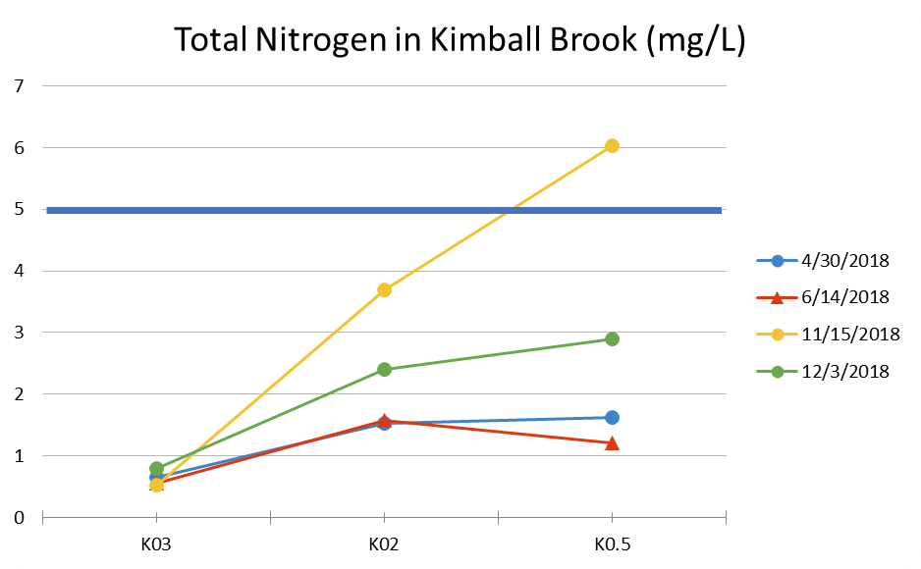
Figure 7. Total Nitrogen on Kimball Brook main stem during freshet flow conditions (circles) and dry-weather base flow conditions (triangles). All but one sample (at K0.5) was below the water quality standard of 5.0 mg/L (solid blue line).

5.4 Sediment

Sediment was monitored in each of the SCRW watersheds by analyzing for Total Suspended Solids (TSS). Historically, Turbidity had been monitored alongside TSS in SCRW watersheds and determined a positive correlation between Turbidity and TSS. While, Vermont Water Quality Standards are established for Turbidity, TSS is monitored to examine patterns in the relative phosphorus burden of sediments with fluctuating discharge, and to enable coarse estimates of sediment and particulate Phosphorus loading to receiving waters. In 2018, Turbidity analyses were completely eliminated from the sampling plan due to the high cost of analysis.
5.4.1 Total Suspended Solids
TSS was analyzed during each event at all 15 stations (however 9 samples from various LaPlatte River stations could not be analyzed because there wasn’t enough sample volume), and ranged from 2 to 129 mg/L. TSS values seemed to be highest during the first sampling event in April (high flow) and decrease as we got later into the sampling season, irrespective of flow condition. Highest TSS concentrations were detected in Thorp Brook stations during the April event, which is consistent with 2017 results. Like 2017, in Thorp Brook, a source of suspended solids is indicated between bracket stations T01d and T01c particularly during the April event when vegetative cover would have been less. As well, numerous edge of field gullies are documented in the Thorp Brook corridor upstream of T01c.
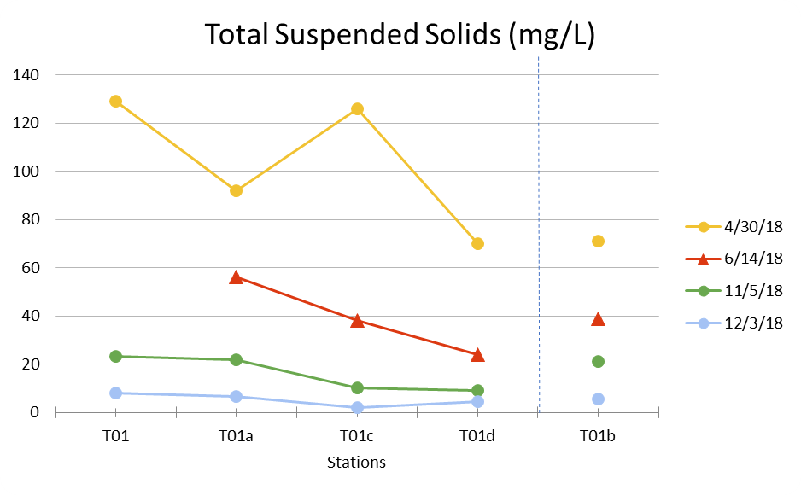
Figure 8. Total Suspended Solids on Thorp Brook main stem during freshet flow conditions (circles) and dry-weather base flow conditions (triangles). Results are presented for main stem stations alongside results from station T01b located on a tributary that joins Thorp Brook between stations T01c and T01a.

5.5 Low Flow Events and WWTF Study

Three low flow, or base flow, events were captured to contribute to an ongoing VTDEC study of waste water treatment facility (WWTF) outfalls in Hinesburg and Shelburne. Biological data captured by VTDEC indicates a decrease in benthic macro-invertebrate health downstream of the WWTF in Hinesburg and Shelburne. By bracketing the WWTFs - sampling above stream and below stream - we can determine the chemical changes in the water to help explain the decrease in biological health. Temperatures were consistent above and below the WWTF outfalls. In Shelburne, there was a slight but consistent increase in total nitrogen and dissolved phosphorus between the upstream and downstream stations on McCabe’s Brook during all 3 sampling events. However, the noted difference between upstream and downstream values is less than the detection limit of the respective analytical method for TN (7/3 and 8/17) and DP (6/20, 8/7). In Hinesburg, there was a substantial increase in total nitrogen (yet still below the detection limit), total phosphorus, and dissolved phosphorus between the upstream and downstream stations on the LaPlatte River during all 3 sampling events. In some cases this difference between upstream and downstream values is less than the detection limit of the method (TP on 6/20, DP on 6/20 and 7/3). It should be noted that the McCabe’s Brook low flow sampling location for MB02sup in 2017 and 2018 was not consistent with where the biology data was collected due to sampler error (approximately 120 meters downstream, but still upstream of the WWTF outfall). This “new” station has now been re-named MB8 under DEC advisement.

6.0 Project Implementation and Recommendations for 2019
In 2019, SCRW will continue high-flow monitoring to track longer-term water quality trends in these direct-drainage systems to prioritize outreach and remedial actions at the subwatershed scale, but will target low flow events in addition. In the Thorp Brook, SCRW will continue with T03 monitoring and bracket monitoring upstream of station T01a to further refine spatial trends and bracket three watershed improvement practices recently implemented with partners (Table 3). These projects have been identified as part of the “Ahead of the Storm” project and will address water quality stressors including pathogens, sediments and nutrients, as well as concentrated stormwater runoff. The upstream to downstream pattern from T01d to T01 seems to suggest a source of TP upstream of T01d; results for 12/3 may indicate the need to add another upstream station. SCRW will also continue to monitor WWTF bracket monitoring stations in Shelburne and Hinesburg during low-flow conditions, only.
Station K0.5 should be paid special attention to next sampling season, as it is a new station as of midway through the 2017 sampling season, and has consistently high total phosphorus and nitrogen values.
Since some values of TN were above 1 – especially in Kimball Brook – we recommend sampling for NOx in 2019 to determine whether the major form of TN is nitrate.
Patrick Brook stations will be added in 2019 to understand the baseline conditions for Patrick Brook, which discharges to the LaPlatte River upstream of the WWTF.
Water quality results for South Chittenden River Watch watersheds are used by Lewis Creek Association for community education and outreach, and water quality improvement project planning. They will be shared with partners including watershed towns, Lake Iroquois Association, CCRPC, VLT, TNC, Champlain Valley Farmers Alliance, VT DEC, Vermont Agency of Agriculture, the Natural Resources Conservation Service and District offices, UVM Extension, USDA Farm Service Agency, US Fish & Wildlife Service, and Vermont Fish & Wildlife Department. Results are used to understand baseline water quality conditions, determine effectiveness of BMPs, and identify hot spot phosphorus loading and critical source area locations in need of remediation recommendations and investments. Towns, regional government and citizens rely on SCRW monitoring data results to understand stream water quality conditions under current regulations, inform education outreach efforts, town plan and regulation updates, regional plan updates, monitor effectiveness of stormwater practices and sewer treatment systems and to inform optimal conservation practice designs for water quality improvement projects.

Table 3. Description of select improvement projects to be implemented in Thorp Brook watershed.
Site | Description | Partners
A | Mack Farm Field gullies – stabilization  Status: Monitoring to see if change in land use from corn to hay will naturally stabilize gullies | Landowner, USDA Farm Service Agency, NRCS
B | East Thompson’s Point Road – road ditch improvements including stone-lined swale, grass swale, buffer improvements, check dams, and bioretention  Status: Funded and installed August 2016, Annual Monitoring | Town of Charlotte, Better Back Roads, Milone & MacBroom
C | Big Oak Lane – gully stabilization and enhanced stormwater retention  Status: Funding and installed July 2018, Annual Monitoring | Big Oak Lane association, VT Watershed Grant, Milone & MacBroom

7.0 References

Addison County River Watch Collaborative and South Mountain Research & Consulting, 2016, Workshops and Analysis to Enhance Flood Resiliency of Headwater Forests, Final Grant Summary Report, Grant Award #: WG224-16.

Olson, S.A., 2014, Estimation of flood discharges at selected annual exceedance probabilities for unregulated, rural streams in Vermont, with a section on Vermont regional skew regression, by Veilleux, A.G.: U.S. Geological Survey Scientific Investigations Report 2014–5078, 27 p. plus appendixes, http://dx.doi.org/10.3133/sir20145078.

NOAA Online Weather Data: Daily Almanac accessed in March 2019 at: https://water.weather.gov/precip/index.php

USGS, 2018, on-line surface water data, <http://waterdata.usgs.gov/vt/nwis>.

VTDEC, 2011, Vermont Statewide Total Maximum Daily Load (TMDL) for Bacteria Impaired Waters, prepared by FB Environmental Associates, Inc., Portland, ME. Including Appendix 9.

VTDEC Water Quality Division, 2009 (August 18), Proposed Nutrient Criteria for Vermont’s Lakes and Wadeable Streams. http://www.anr.state.vt.us/dec/waterq/lakes/docs/lp_2009nutrientcriteria.pdf

VT DEC Water Quality Division, 2016a, State of Vermont 2016 303(d) List of Waters: Part D – Impaired Surface Waters in Need of TMDL.
VT DEC Water Quality Division, 2016b, State of Vermont Stressed Waters List.
Vermont Watershed Management Division, 2016. Vermont Water Quality Standards.
Effective 15 January 2017. Montpelier, VT. http://www.watershedmanagement.vt.gov/rulemaking/docs/wrprules/wsmd_wqs2014.pdf

Appendix A

Flow Data

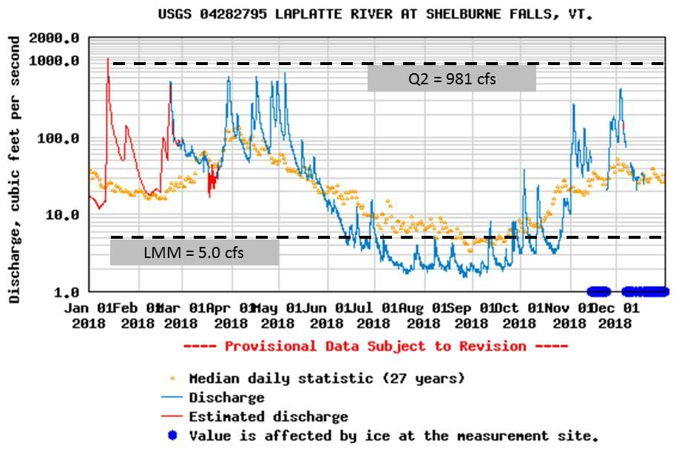

Figure A-1. Instantaneous Discharge Recorded at Shelburne Falls on the LaPlatte River in 2018.

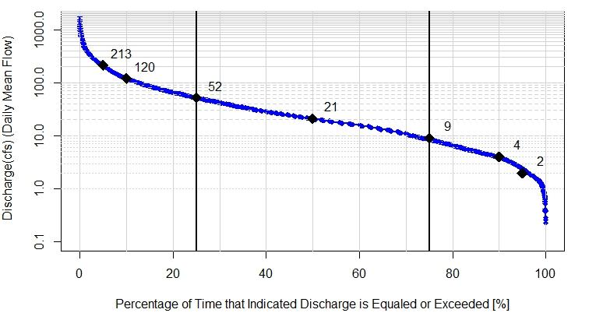
Figure A-2. Flow Duration Curve for LaPlatte River at Shelburne Falls, water years 1992-2018.

Appendix B

Water Quality Data Tables by Watershed

Abbreviations:

TN = Total Nitrogen
TP = Total Phosphorus
DP = Dissolved Phosphorus
TSS = Total Suspended Sediments

MPN/100 mL = organisms per 100 milliliters
mg/L = milligrams per liter
µg/ L = micrograms per liter
NTU = Nephelometric Turbidity Units

-- = No Data
NS = Not Sampled
NA = Not Analyzed (e.g., insufficient sample volume; vial broken in transit)
NM = Not Measured

JB = estimated value; constituent was present in an associated field blank

JD = estimated value; Relative Percent Difference (RPD) of primary and field duplicate sample values exceeded the QAPP RPD goal for that constituent

Note: QA/QC issues further detailed in separate QA Summary Report

LaPlatte River

Spatial Trend and Sentinel Station Monitoring
Site | Date | Flow Level | Flow Category | TN (mg-N/L) | TP (µg/L) | DP (µg/L) | TSS (mg/L)
LP03 | 4/30/18 | High | Freshet | 0.65 | 127 | 39.6
LP05 | 4/30/18 | High | Freshet | 0.49 | 72.3 | 27.8
LP09 | 4/30/18 | High | Freshet | 0.41 | 47 | 17
LP03 | 6/14/18 | Low | Base | 0.43 | 25.4 | 12.8
LP05 | 6/14/18 | Low | Base | 0.81 | 44.1 | 26.8
LP09 | 6/14/18 | Low | Base | 0.54 | 57.1 | 20.4
LP03 | 11/5/18 | High | Freshet | 1.02 | 90.1 | 55.2 | 9.8
LP07a | 11/5/18 | High | Freshet | 0.89 | 47.7 | 28.5 | < 2
LP09 | 11/5/18 | High | Freshet | 0.7 | 39.1 | 27.1 | 4.2
LP03 | 12/3/18 | High | Freshet | 1.09 | 164.4 | 60.8 | 5.33
LP05 | 12/3/18 | High | Freshet | 0.86 | 103.8 | 55 | 2.67
LP09 | 12/3/18 | High | Freshet | 0.67 | 76.6 | 37.2 | 3

WWTF Bracket Monitoring
Station | Date | Flow Level | Flow Category | TN (mg-N/L) | TP (µg/L) | DP (µg/L) | TSS
LP07a | 6/20/18 | Low | Base | 1.34 | 51.1 | 23.9
LP09 | 6/20/18 | Low | Base | 0.48 | 46.9 | 21.7
LP07a | 7/3/2018 | Low | Base | 2.81 | 61.5 | 34.9
LP09 | 7/3/18 | Low | Base | 0.77 | 53.7 | 31.4
LP07a | 8/7/18 | Low | Base | 3.26 | 102 | 35.8 | 18
LP09 | 8/7/18 | Low | Base | 0.52 | 72.8 | 25.9 | 17.75
_____
VT Water Quality Standards, 2016 (effective January 15, 2017):
- Turbidity (warm water Class B) = 25 NTUs as an annual average under dry weather base-flow conditions.
- E. coli (Class B): Not to exceed a geometric mean of 126 organisms /100ml obtained over a representative period of 60 days, and no more than 10% of samples above 235 organisms/100 ml.
In waters receiving combined sewer overflows, the representative period shall be 30 days.
- Phosphorus (Class B, Warm-water Medium Gradient): Not to exceed 27 µg/L at low median monthly flow during June through October in a section of the stream representative of well-mixed flow.
- Nitrogen as nitrate (NO3) is not to exceed 5.0 mg/L at flows exceeding the low median monthly discharge. Total nitrogen includes organic and inorganic forms of nitrogen. A test of NO3-NO2 inorganic forms of nitrogen is required to evaluate water quality relative to the VWQS.

McCabe’s Brook (LaPlatte River Tributary)

Spatial Trend and Sentinel Station Monitoring
Site | Date | Flow Level | Flow Category | TN (mg-N/L) | TP (µg/L) | DP (µg/L) | TSS (mg/L)
MB02 | 4/30/18 | High | Freshet | 0.82 | 225 | 82.2 | 106
MB02a | 4/30/18 | High | Freshet | 0.79 | 202 | 93.9 | 79.41
MB04 | 4/30/18 | High | Freshet | 0.83 | 162.8 | 106 | 16.25
MB05 | 4/30/18 | High | Freshet | 0.43 | 54.7 | 36.6 | 10
MB02 | 6/14/18 | Low | Base | 0.53 | 67.5 | 25.4 | 24
MB02a | 6/14/18 | Low | Base | 0.31 | 34.7 | 23.1 | < 2
MB04 | 6/14/18 | Low | Base | 0.51 | 63.6 | 35.5 | < 2
MB05 | 6/14/18 | Low | Base | 0.83 | 90.4 | 31.7 | < 2
MB02 | 11/5/18 | High | Freshet | 0.85 | 84.7 | 63.3 | 9
MB02a | 11/5/18 | High | Freshet | 0.81 | 77.3 | 62.9 | 4.6
MB04 | 11/5/18 | High | Freshet | 0.87 | 88.2 | 70.4 | 4.4
MB05 | 11/5/18 | High | Freshet | 0.74 | 71.5 | 55.3 | < 2
MB02 | 12/3/18 | High | Freshet | 1.17 | 158.6 | 97.8 | 10.67
MB02a | 12/3/18 | High | Freshet | 1.13 | 148.8 | 106 | 11.8
MB04 | 12/3/18 | High | Freshet | 1.11 | 149.8 | 115 | 4.64
MB05 | 12/3/18 | High | Freshet | 0.67 | 86.4 | 53.7 | 4.33

WWTF Bracket Monitoring
Station | Date | Flow Level | Flow Category | TN (mg-N/L) | TP (µg/L) | DP (µg/L) | TSS
MB01a | 6/20/18 | Low | Base | 0.74 | 64.1 | 32
MB02sup | 6/20/18 | Low | Base | 0.52 | 64.3 | 28
MB01a | 7/3/18 | Low | Base | 0.88 | 78.1 | 49.6
MB02sup | 7/3/18 | Low | Base | 0.8 | 69.2 | 40.1
MB01a | 8/7/18 | Low | Base | 0.46 | 80.2 | 42.9 | 15.8
MB02sup | 8/7/18 | Low | Base | 0.43 | 84.2 | 40.2 | 18.67

______________________________________________________________________________
VT Water Quality Standards, 2016 (effective January 15, 2017):
- Turbidity (warm water Class B) = 25 NTUs as an annual average under dry weather base-flow conditions.
- E. coli (Class B): Not to exceed a geometric mean of 126 organisms /100ml obtained over a representative period of 60 days, and no more than 10% of samples above 235 organisms/100 ml.
In waters receiving combined sewer overflows, the representative period shall be 30 days.
- Phosphorus (Class B, Warm-water Medium Gradient): Not to exceed 27 µg/L at low median monthly flow during June through October in a section of the stream representative of well-mixed flow.
- Nitrogen as nitrate (NO3) is not to exceed 5.0 mg/L at flows exceeding the low median monthly discharge. Total nitrogen includes organic and inorganic forms of nitrogen. A test of NO3-NO2 inorganic forms of nitrogen is required to evaluate water quality relative to the VWQS.

Thorp Brook (direct drainage to Lake Champlain)

Spatial Trend and Sentinel Station Monitoring
Site | Date | Flow Level | Flow Category | TN (mg-N/L) | TP (µg/L) | DP (µg/L) | TSS (mg/L)
T03a | 4/30/18 | High | Freshet | 1.06 | 76.9 | 39.1 | 13.2
T01d | 4/30/18 | High | Freshet | 0.91 | 139 | 34.1 | 70
T01c | 4/30/18 | High | Freshet | 0.91 | 189 | 32.7 | 126
T01b | 4/30/18 | High | Freshet | 0.63 | 110 | 25.5 | 71
T01a | 4/30/18 | High | Freshet | 0.8 | 166 | 34 | 92
T01 | 4/30/18 | High | Freshet | 0.95 | 185.8 | 35.2 | 129
T03a | 6/14/18 | Low | Base | 0.32 | 230 | 12.1 | < 2
T01d | 6/14/18 | Low | Base | 1.43 | 69.4 | 25.5 | 24
T01c | 6/14/18 | Low | Base | 1.04 | 116 | 18.3 | 38
T01b | 6/14/18 | Low | Base | 0.44 | 69.9 | 15.1 | 38.67
T01a | 6/14/18 | Low | Base | 0.56 | 93.9 | 15.9 | 56
T01 | 6/14/18 | Low | Base | 0.57 | 91.6 | 28.2 | 31
T03a | 11/5/18 | High | Freshet | 2.77 | 131 | 50.6 | 10
T01d | 11/5/18 | High | Freshet | 0.94 | 60 | 32.5 | 9.2
T01c | 11/5/18 | High | Freshet | 0.85 | 65.8 | 35.5 | 10.2
T01b | 11/5/18 | High | Freshet | 0.63 | 62.9 | 24.3 | 21
T01a | 11/5/18 | High | Freshet | 0.95 | 90.4 | 44.8 | 21.8
T01 | 11/5/18 | High | Freshet | 0.88 | 79.9 | 36.7 | 23.4
T03a | 12/3/18 | High | Freshet | 1.67 | 49.6 | 34.7 | < 2
T01d | 12/3/18 | High | Freshet | 1.25 | 171 | 118 | 4.6
T01c | 12/3/18 | High | Freshet | 1.16 | 146 | 97.9 | < 2
T01b | 12/3/18 | High | Freshet | 0.63 | 65 | 32.2 | 5.6
T01a | 12/3/18 | High | Freshet | 0.95 | 122.8 | 107 | 6.8
T01 | 12/3/18 | High | Freshet | 0.94 | 105.4 | 63.9 | 8.2

_____________________________________________________________________________
VT Water Quality Standards, 2016 (effective January 15, 2017):
- Turbidity (warm water Class B) = 25 NTUs as an annual average under dry weather base-flow conditions.
- E. coli (Class B): Not to exceed a geometric mean of 126 organisms /100ml obtained over a representative period of 60 days, and no more than 10% of samples above 235 organisms/100 ml.
In waters receiving combined sewer overflows, the representative period shall be 30 days.
- Phosphorus (Class B, Warm-water Medium Gradient): Not to exceed 27 µg/L at low median monthly flow during June through October in a section of the stream representative of well-mixed flow.
- Nitrogen as nitrate (NO3) is not to exceed 5.0 mg/L at flows exceeding the low median monthly discharge. Total nitrogen includes organic and inorganic forms of nitrogen. A test of NO3-NO2 inorganic forms of nitrogen is required to evaluate water quality relative to the VWQS.

Kimball Brook (direct drainage to Lake Champlain)

Spatial Trend and Sentinel Station Monitoring
Site | Date | Flow Level | Flow Category | TN (mg-N/L) | TP (µg/L) | DP (µg/L) | TSS (mg/L)
K03 | 4/30/18 | High | Freshet | 0.66 | 116 | 60 | 39
K02 | 4/30/18 | High | Freshet | 1.53 | 177 | 54 | 80
K0.5 | 4/30/18 | High | Freshet | 1.63 | 271 | 169 | 24
K03 | 6/14/18 | Low | Base | 0.55 | 56 | 45.4 | < 2
K02 | 6/14/18 | Low | Base | 1.57 | 50 | 32.1 | 16.67
K0.5 | 6/14/18 | Low | Base | 1.21 | 490.5 | 380.5 | < 2
K03 | 11/5/18 | High | Freshet | 0.53 | 52.6 | 41.7 | 4.2
K02 | 11/5/18 | High | Freshet | 3.69 | 66.7 | 47.7 | 10.8
K0.5 | 11/5/18 | High | Freshet | 6.03 | 306 | 248 | 8.6
K03 | 12/3/18 | High | Freshet | 0.8 | 114.3 | 73.4 | 5.4
K02 | 12/3/18 | High | Freshet | 2.41 | 158.1 | 88.6 | < 2

_____________________________________________________________________________

VT Water Quality Standards, 2016 (effective January 15, 2017):
- Turbidity (warm water Class B) = 25 NTUs as an annual average under dry weather base-flow conditions.
- E. coli (Class B): Not to exceed a geometric mean of 126 organisms /100ml obtained over a representative period of 60 days, and no more than 10% of samples above 235 organisms/100 ml.
In waters receiving combined sewer overflows, the representative period shall be 30 days.
- Phosphorus (Class B, Warm-water Medium Gradient): Not to exceed 27 µg/L at low median monthly flow during June through October in a section of the stream representative of well-mixed flow.
- Nitrogen as nitrate (NO3) is not to exceed 5.0 mg/L at flows exceeding the low median monthly discharge. Total nitrogen includes organic and inorganic forms of nitrogen. A test of NO3-NO2 inorganic forms of nitrogen is required to evaluate water quality relative to the VWQS.

Appendix C

Monitoring Station Locations and Rationale

LaPlatte River

Site ID | Flow Target | Site Location and Remarks | Site Lat | Site Long
LP 03  (LR04) | H | LaPlatte River at Falls Road. East (right bank), 30 meters  south of Falls Rd bridge. Shelburne. Upstream drainage 44.8 sm. | 44.37022 | -73.21577
LP 05 | H | LaPlatte River at Carpenter Road Bridge. Left bank, 5 meters upstream from bridge. Charlotte. Upstream drainage 31.2 sm. | 44.34176 | -73.1838
LP07a | L | LaPlatte River below Hinesburg WWTF Outfall near DEC Biostation | 44.33308 | -73.12757
LP 09 | H/L | LaPlatte River. 15 meters upstream of Hinesburg WTF Outfall. Hinesburg. Upstream drainage 17.7 sm. | 44.33395 | -73.126

McCabe’s Brook (LaPlatte River watershed)

Station  No. | Flow  Target | Coordinates | Town | Description | Remarks
MB 02 | H | 44.38305  -73.23853 | Shelburne | McCabe’s Brook, Harbor Rd. bridge. Left bank, 30 meters below bridge. | Surface drain channel enters from right bank about half way between the bridge and the sampling point.  Upstream drainage 4.57 mi².
MB 02a | H | 44.37502  -73.23881 | Shelburne | McCabe’s Brook off path starting from the end of School Street in Shelburne. Right bank. | Upstream from the School Street neighborhood. Stream flows from Bostwick Road to sampling location along fields and through woods. Small tributary enters upstream from west.
MB 03  (LR 03) | H | 44.36892  -73.23586 | Shelburne | McCabe’s Brook, Bostwick Rd. Bridge. Left bank at downstream discharge from culvert. | Stream plunges upstream below Route 7. Forest, wetlands, in-stream pebble, sand, and silt deposition.
MB 04 | H | 44.36230  -73.23461 | Shelburne | McCabe’s Brook, Route 7 bridge. Right bank at upstream end of bridge. | Upstream bank erosion. Vermont Teddy Bear storm drainage pond overflow immediately upstream on east drainage.
MB 04a | H | 44.36086  -73.23405 | Shelburne | McCabe’s Brook, Vermont Teddy Bear access road | Upstream Route 7 fill disposal on farm fields on east drainage. Upstream from disposal site, pasture and corn fields with manure spreading on west drainage. Upstream drainage 3.31 mi².
MB 05  (LR 05) | H | 44.34582  -73.22868 | Charlotte | McCabe’s Brook, Lime Kiln Rd. bridge. Downstream discharge from culvert. | Horses upstream, west (left) bank. Nordic Farm upstream west drainage.

Thorp and Kimball Brooks
Station  No. | Target Flow | Coordinates | Town | Description | Remarks
T 01 | H | 44.273073  -73.256597 | Charlotte | Thorp Brook west of Greenbush Road. Right bank. Walk downstream about 50 feet. Sample mainstem below confluence of tributary | Upstream from Lake Champlain backwater. Drains residential, farms and agricultural land from the north. Upstream drainage 2.93 mi².
T 01a | H | 44.28177  -73.25335 | Charlotte | Thorp Brook north side of East Thompson’s Point Road and downstream of trib. | Drains road, residential,farm and agricultural land from the north. Upstream drainage ____ mi².
T 03 | H | 44.2835  -73.26279 | Charlotte | West Tributary to Thorp Brook south side of Thompson’s Point Road. | Drains residential and agricultural land. History of very high nitrogen levels at T 03.5 located east side of Lake Road at Converse Bay Road latitude.
K 0.5 | H | 44.2639  -73.26209 | Charlotte | Kimball Brook just downstream of trib on Town Line LLC property | Drains agriculture and pollutants from Town Line Rd to Greenbush Road. Access through Peter Swift property.
K 02 | H | 44.25934  -73.24867 | Charlotte | Kimball Brook 25 feet east of Greenbush Road. | Upstream from Lake Champlain backwater. Drain farmland and housing lots from the east, and including wooded land west of Route 7 and Mount Philo. Upstream drainage 1.87 mi².
K 03 | H | 44.2706  -73.2352 | Charlotte | Kimball Brook west of Route 7, about 20 feet upstream of the culvert under road into the Claflin Farm development. | Drains agricultural runoff and Route 7 and local roads runoff.

Appendix D

Physical Characteristics of SCRW Watersheds

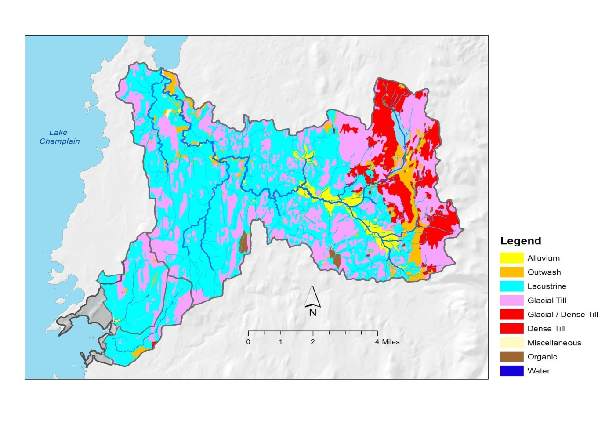
Figure D-1. Distribution of Soils, by Parent Material, in the SCRW watersheds.
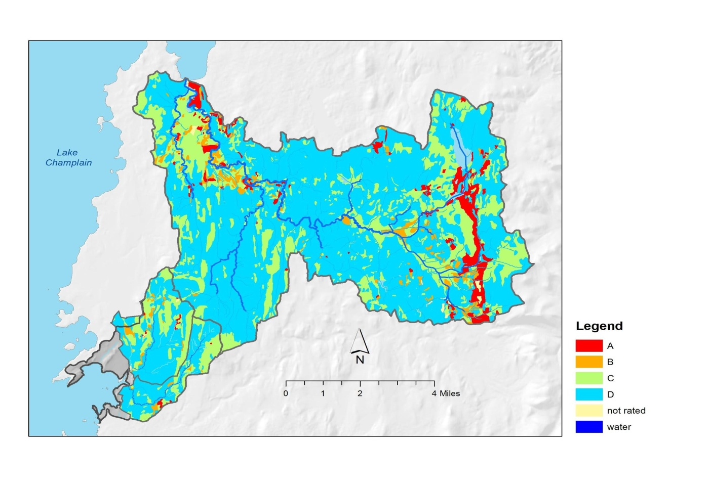
Figure D-2. Distribution of Soils, by Hydrologic Soil Group, in the SCRW watersheds.
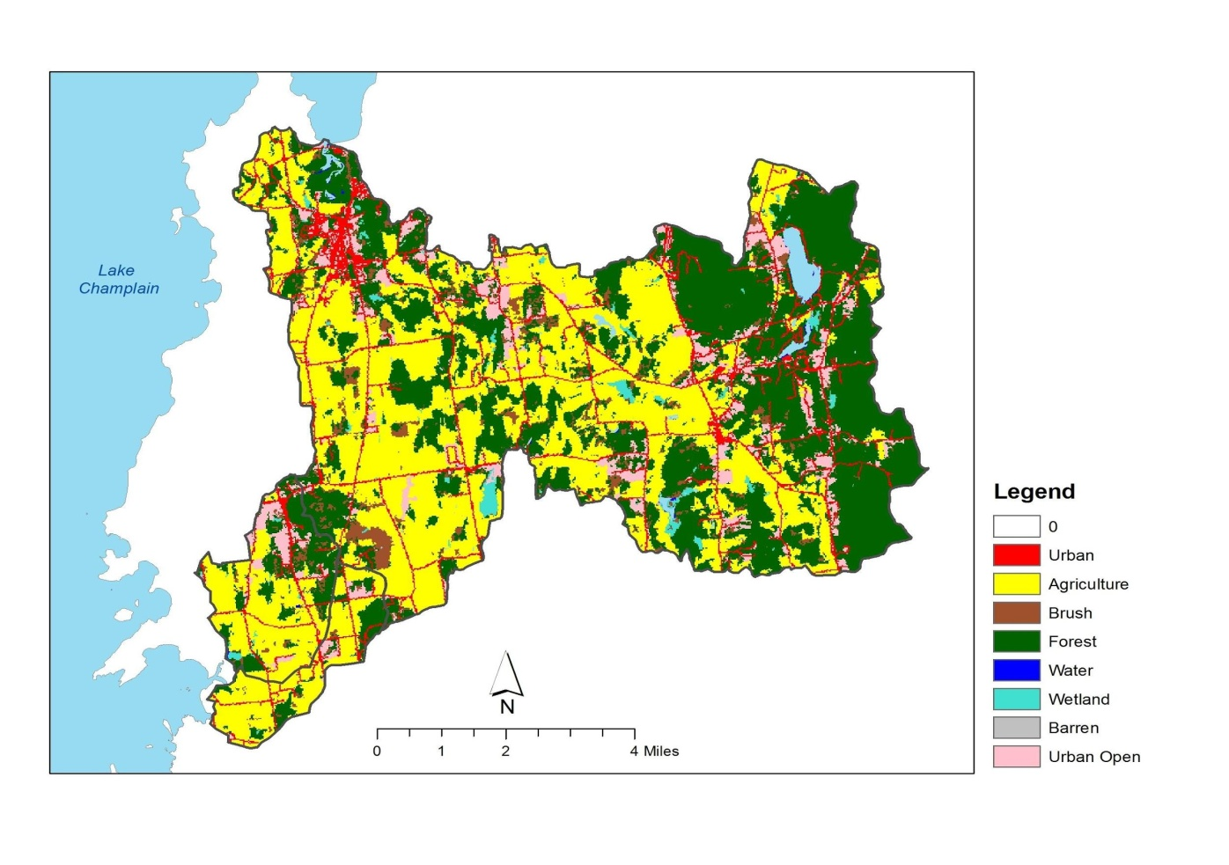
Figure D-3. Distribution of Land Cover / Land Use in the SCRW watersheds (source date: 2001).

