Poultney Mettowee NRCD
South Lake Watershed

Final Report: Water Quality Monitoring
2016 Data

February 10, 2018

Prepared by:
Hilary Solomon
Poultney-Mettowee Natural Resources Conservation District
Poultney, VT. 05764

Prepared under contract to:
VT Agency of Natural Resources
Watershed Management Division
Montpelier, VT

Table of Contents
Executive Summary 4
Introduction 5
Background 5
2.1 Description of Watershed 6
(from SMRC, 2007, Castleton River and SMRC, 2007, Mettowee River Watershed) 6
2.2 Water Quality Monitoring Sites 7
Water Quality Monitoring Map with Sampling Sites 10
Water Quality in “Areas of Concern” Watersheds 11
2.3 Discharge Measurement 12
Methods 14
3.1 Meteorological Conditions 15
3.2 Sample Collection and Analysis 16
3.3 Quality Assurance / Quality Control 17
Results and Discussion 17
4.1 Meteorological and Hydrological Conditions 17
4.2 Water Quality Results 19
4.2.2 E.coli 20
Phosphorus 22
5.0 Conclusions 26
References 27

Attachment 1. Soil Parent Materials, Little Otter Creek Watershed
Attachment 2. Land Cover / Land Use, Little Otter Creek Watershed
Attachment 3. Water Quality Data

Executive Summary
The Poultney Mettowee Natural Resources Conservaiton District has monitored streams and rivers in the South Lake watershed since 2003. The goal of monitoring is to prioritize areas for project implementation and to monitor the effectiveness of past projects. Currently, the District collects E. coli and Total Phosphorus samples, because this data provides the most valuable to guidance for our conservation work. The District has multiple objectives for ongoing water quality monitoring:
- Identify the current conditions in the watershed and track changes to water conditions as they occur,
- Identify sources and causes of water pollution in the watershed, to inform work priorities and project implementation,
- Assist partner agencies with the evaluation of local conservation project efficacy,
- Inform the public about current conditions, changes as they occur, and project effectiveness.

Spatial trend analysis has been undertaken for many years in the South Lake (Poultney-Mettowee) watershed. In 2016, water quality data was collected during six discrete events in the spring and summer of 2016 - a drier-than-normal year - at sites chosen for location and/or history as a sentinel site. A congruent round of sampling included the Poultney River mouth, the Mettowee River mouth, and the barge canal and occurred on five summer sample dates (sites were accessed by canoe) (please refer to a separate report). Additionally, new sites were added within the Lake Bomoseen watershed at the end of the sampling season in September.
TP exhibited an increasing trend in concentration on the upstream-most station on Flower Brook on the main stem (FB03). This area is dominated by fine-grained glacial lake soils and rural residential land uses.
E. coli counts at several of the stations exceeded the state’s geometric-mean-based water quality standard, including a newly-established station located within a low density cow pasture. While additional monitoring is warranted, these 2016 results suggest that ...
These 2016 results suggest the need for additional focus along the upper main stem of Flower Brook to discern source areas for elevated phosphorus. In the context of a previous river corridor plan (SMRC, 2007), current High Meadows supported work, and the South Lake Basin Plan (VTDEC, 2017), various river conservation projects and watershed improvement practices have been identified for the Flower Brook watershed to address water quality impairments. The Lake Bomoseen and Flower Brook watersheds will continue to be a focus areas in 2017, with the same sentinel and rotational sites monitored for E.coli and total phosphorus. In addition a future focus study, additional bracketing of source areas in the upper headwaters would be warranted to define sources of elevated phosphorus and E.coli, pending landowner access.

Introduction
The Poultney Mettowee Natural Resources Conservation District has collected samples, managed data, and interpreted the results of water quality analysis for 13 years between 2003, the inception of the LaRosa Partnership program, and 2017. The overarching goal of monitoring is to prioritize areas for project implementation and to monitor the effectiveness of past projects. The District has several objectives for ongoing water quality monitoring:
- Identify the current conditions in the watershed and track changes to water conditions as they occur,
- Identify sources and causes of water pollution in the watershed, to inform work priorities and project implementation,
- Assist partner agencies with the evaluation of local conservation project efficacy,
- Inform the public about current conditions, changes as they occur, and project effectiveness.

The District first collected samples on the Poultney River in 2003, and then expanded to sites on the Mettowee River, Flower Brook, and Beaver Brook in 2005, corresponding with the first geomorphic assessment completed on the Mettowee Mainstem (reaches M04-M08) and several reaches on Beaver and Flower Brooks.

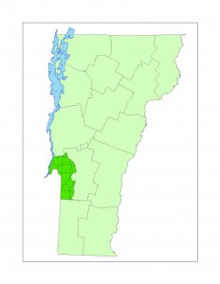
In 2012, the TMDL for Flower Brook was released, and concurrently, the District received an ERP grant to prioritize projects in the Mettowee Watershed. The project’s advisory committee elected to focus resources on the Flower Brook subwatershed and the District increased the sampling effort in that area. The new sites allowed us to isolate several sections of the brook and determine the areas in the Village with the highest bacteria concentrations; this data was used in the 2015 Pawlet IDDE contracted by VDEC. The new sites also allow us to monitor the effectiveness of four livestock exclusion projects that have been implemented in the intervening years along Flower Brook and two tributaries to Beaver Brook.

In addition to new sites in the Flower Brook watershed, four sites were added on Wells Brook. The District established the monitoring locations on the Well Brook (Wells 01 – 04 and Tadmer01) in 2014. In 2015, to characterize the phosphorus loads and to help prioritize beneficial project types and locations, the District reinstated sampling on several old sites and added nearly 20 new sites in the Poultney watershed, focusing on the Lake Bomoseen and Castleton Headwaters watershed, where the District is in the process of stormwater master planning. In 2016, these sites were refined, and seven sites were added to capture the remaining tributaries to Lake Bomoseen.

Background

2.1 Description of Watershed

(from SMRC, 2007, Castleton River and SMRC, 2007, Mettowee River Watershed)

Stream Types

All stream reaches in the Mettowee River geomorphic assessment were classified as Rosgen (1996) and Montgomery Buffington (1996) stream types A, B, or C.
- Stream type “A”- steep, cascading, headwater reaches
- Stream type “B”- include moderately steep, step-pool streams
- Stream type “C”- the most common stream type in the Mettowee Basin, “C” streams include less-steep, pool-riffle streams with floodplain access. The “C” stream type predominated, especially in the valleys.

The stream types in the Poultney River watershed are similar with maily stream types A, B, and C, and with areas in Fair Haven and West Haven including stream type E.
- “E”- low slope, highly sinuous rivers with deep banks and sandy bottoms.

Basin Characteristics: Geology and Soils

The nature of the sediments and soils present in the South Lake Watershed reflect the glacial and post-glacial lake history of the region. Upland slopes are dominated by shallow- to moderate glacial till deposits overlying bedrock. Meltwater channels and tributaries deposited sands, gravels and cobbles along the margins of the ice at the valley walls. These ice contact deposits are typically non-cohesive and have moderate to high erodibilities when exposed in stream banks and beds (Stewart & MacClintock, 1966; MacClintock, no date, from SMRC, 2007, Castleton River SGA).

The Poultney River drains 262 square miles and the Mettowee river drains approximately 135 square miles in Vermont. The largest tributary in the Poultney River Watershed, the Castleton River, drains approximately 99.3 square miles of land area located in Rutland County, Vermont (Figure 1). The Castleton River joins the Poultney River at the Vermont / New York border. The Poultney River flows to the Champlain Canal to the north of Whitehall, New York; waters then drain to the north via the canal to the southern extent of Lake Champlain.

As the Lake Vermont waters inundated the Castleton River valley following deglaciation, fine silts and clays were deposited upstream of the Gully Brook confluence, and sands and fine gravels downstream of Castleton village. Coarser sands and fine gravels underlying the village of Fair Haven, comprise the delta deposit which extended out into Lake Vermont at the former confluence of Castleton River (Stewart & MacClintock, 1966; MacClintock, no date). The Castleton River network today is eroding and re-depositing the mix of glacial and post-glacial sediments of the watershed. Upland tributaries are winnowing the finer-grained sediments from the mix (SMRC, 2007).

Land Cover and Reach Hydrology

The Poultney River watershed is 262 square miles with approximately 3% of the watershed in crops, 9% as fields, 78% as forest, 3.3% residential, and 4.5% as open water. The Hubbardton subwatershed makes up 44.38 square miles of the Poultney River watershed and has a slightly different land use composition with 3.5-5.4% crops, 8.5-20% fields, roughly 65% forests, 12% open water, and 4% residential.

The Mettowee River Watershed is comprised of approximately 211 square miles of land in Rutland and Bennington Counties of Vermont and Washington County, New York, of which 135 square miles or 64% of the watershed are in Vermont. Within the watershed (upstream of reach M04), approximately 75.4% of the land is forested, 16.1% of the land is in agriculture, 3.2% is developed, and the remainder is open water and wetlands[1] (p. 18).

The Indian River subwatershed, which originates in Vermont but drains to the Mettowee River in New York, comprises a total of 37 square miles in Vermont and New York. The Wells Brook subwatershed makes up 32.61 square miles of the northern Mettowee watershed. The Flower Brook (7 miles long) subwatershed comprises 19 square miles of the Mettowee watershed, with Beaver Brook making up 5.21 square miles of the Flower Brook subwatershed. The Sykes Hollow Brook watershed makes up 4.5 square miles at the southern boundary of the District near the Mettowee River headwaters[2]. The tributaries listed above are considered target watersheds for the District and are the focus of local conservation efforts.

Landuse in the watershed is mainly forested, with forest cover in each subwatershed ranging from 52.6 percent on one reach on Beaver Brook to 95.7 percent in the Sykes Hollow Brook headwaters. Historically, a much higher percent of the watershed was cleared for pasture and croplands. Landuse in the stream corridor is a mix of forested land, crops and fields and occasionally, urban areas. Urban areas make up as much as 48.2 percent of the landuse along one reach of Flower Brook. Woody vegetative buffers of greater than 100 feet in width dominate much of the watershed, though eight reaches show at least one bank with less than 25 feet of buffer dominating. Many of the reaches had long stretches of minimal vegetation along fields, roads or developed areas. Groundwater and wetland inputs vary greatly by reach.

2.2 Water Quality Monitoring Sites

Poultney River Watershed - Sampling Sites

Site Name | River | Lat/Long | Description | Significance?
Bretton01 | North Breton Brook | 43.62790  -73.15925 | Ford to agricultural field on Monument Hill Road, north of the Route 4 Bypass | Evaluate the sediment and nutrient flow from the North Breton watershed to Castleton
Coggman01 | Coggman Creek | 43.6547  -73.36218 | Coggman Creek at Burr Road crossing | Accessible Coggman Creek site to evaluate the downstream brook
CA01 | Castleton | 43.60944  -73.11484 | At the downstream end of the wetland along the Birdseye Ski Area access road. | Monitor the wetlands nutrient levels; farms in vicinity and upstream
CA05 | Castleton | 43.5998  -73.2329 | Blissville Road crossing | Downstream of Castleton
Hubb01 | Hubbardton | 43.64693  -73.31209 | Hubbardton River at Main Road and River Road | Downstream Hubbardton measurement; previously measured
Hubb02 | Hubbardton | 43.696743  -73.275901 | Hubbardton River downstream of the Mill Pond | Mid-Hubbardton measurement
Hubb3 | Hubbardton | 43.736230  -73.243413 | Hubbardton River at Route 144 | Upstream Hubbardton measurement
Lavery01 | Tributary | 43.50662  -73.17124 | Tributary at Morse Hollow Road | Tributary to Poultney River with heavy sediment load

Five sites along the Castleton River were originally sampled in 2006. It begins in a rich marsh and flows through agricultural and residential lands, constrained by roads and train tracks. It flows through both Castleton and Fair Haven and is the receiving waters of Lake Bomoseen. The Castleton River was originally targeted because the District and our partners were implementing a floodplain restoration along one of the major tributaries to the Castleton River, Gully Brook. There was also active channel movement with two avulsions in 2007, one through a horse pasture owned by a large stable and one through an annually cropped field. These five sites were sampled in 2006, 2007, and 2008.

The Castleton River was again sampled in 2015 - 2017, as the District focused on subwatershed-specific monitoring and data analysis. To better understand the nutrient and bacteria flow in the Castleton River, but with deference to limited sample capacity, the District picked the uppermost site CA01, downstream of a wetland and draining several discrete agricultural areas, and the site downstream of Castleton Village, CA05.

The District measured one location on the Hubbardton River in 2006. In 2015, the District added two additional sites on the Hubbardton River, Hubb02, downstream of the Mill Pond, and Hubb03, near the headwaters along Route 144 in the Hortonia region.
Bretton Brook is a tributary to the Castleton River, and drains East Hubbarton and Castleton.

Coggman Creek drains the town of West Haven, into the lower Poultney River.
Lavery Brook is a tributary to the Poultney River, which runs parallel to Morse Hollow Road in Poultney.
Flower Brook Watershed - Sampling Sites

Site Name | River | Lat/Long | Description | Significance?
Flower01 | Flower Brook | 43.35345  -73.17885 | Behind the town offices, Pawlet | Sentinal site, critical for continual monitoring of bacteria in the village
Flower01.5 | Flower Brook | 43.34778  -73.17492 | At the fire station, upstream of the mill pond. | Monitors bacteria levels upstream of the mill pond
Flower02 | Flower Brook | 43.354565  -73.153286 | At the 133 crossing near Gould’s farm (last 133 crossing) | Monitors bacteria levels from agricultural areas in the watershed
Flower03 | Flower Brook | 43.36848  -73.10159 | Flower Brook at the Lily Hill Road crossing | Measures upland bacteria levels and is downstream of rural development
Beaver01 | Beaver Brook | 43.363518  -73.148297 | Beaver Brook at Brimstone Road crossing | Upstream site; downstream of a wetland
Beaver02 | Beaver Brook | 43.37284  -73.13704 | Beaver Brook at the 133 crossing North of Flower02 | Downstream of wetlands and beaver ponds/pasture
Beaver03 | Beaver Brook | 43.38841  -73.13258 | Beaver Brook at the Kelley Hill Road crossing | Downstream of agricultural lands and quarries
Beaver04 | Beaver Brook | 43.35952  -73.15463 | Beaver Brook at Andrus Lane culvert (upstr) | Rural residential area and trib from a farm we work with extensively

The Flower Brook watershed has been a target watershed of PMNRCD for several years. In 2012, VDEC commissioned a TMDL aimed at curbing excessive bacteria levels found in the lower half mile of the stream. Beaver Brook is a significant tributary to the Flower Brook. The watershed has been targeted with a variety of project through the Agronomy and Conservation Assistance Program, Trees for Streams, exclusion fencing, and other conservation programs.
Lake Bomoseen Tributaries - Sampling Sites
Site Name | River | Lat/Long | Description | Significance?
LBSB01 | Sucker Brook | 43.66165  -73.18977 | Sucker Brook at the Route 30 crossing/Crystal Beach access | Assessment; no previous info, but sediment source
LBSB02 | Sucker Brook Trib | 43.661764  -73.170993 | Sucker Brook at Barker Hill Road | Assessment; no previous info, but sediment source
LBSB03 | Sucker Brook | 43.679876  -73.175183 | Sucker Brook at Gill Hill Road | Assessment; no previous info, but sediment source
LBSB04 | Sucker Brook | 43.693213  -73.164747 | Sucker Brook at Howland Road Crossing | Assessment; no previous info, but sediment source
LBSB05 | Sucker Brook | 43.653812  -73.177549 | Sucker Brook at North Road, past Barker Hill | Assessment; no previous info, but sediment source
DHTrib | Trib | 43.69641  -73.18413 | Trib to Lake Bomoseen at Dikeman Hill Rd and Route 30 | Assessment; no previous info
Giddings01 | Giddings Bk | 43.70722  -73.18454 | Trib to Lake Bomoseen at Monument Hill and Rte 30 | Assessment; no previous info, animal pasture
Giddings02 | Unnamed Trib near Giddings | 43.70786  -73.18822 | Trib to Lake Bomoseen at private road (branch of the above creek) | Assessment; no previous info, downstream of wetland

Lake Bomoseen sites were added in 2015; the resulting data has been incorporated into Stormwater Master Planning work. The sites added in 2015 and sampled in 2016 and 2017 include five sites on the lake’s largest trubutary, Sucker Brook, a site on Giddings Brook, a site draining from Love’s Marsh, and an unnammed tributary near Dikeman Hill Road.

Seven additional sites on miner inflows to Lake Bomoseen were added at the end of the 2016 sampling season and were sampled twice in September, 2016. these sites were monitored again in 2017 and sampled throughout the summer.

Maps 1 and 2, below, give a spatial overview of the water quality in the South Lake basin.

Map 1: Water Quality Monitoring Map with Sampling Sites
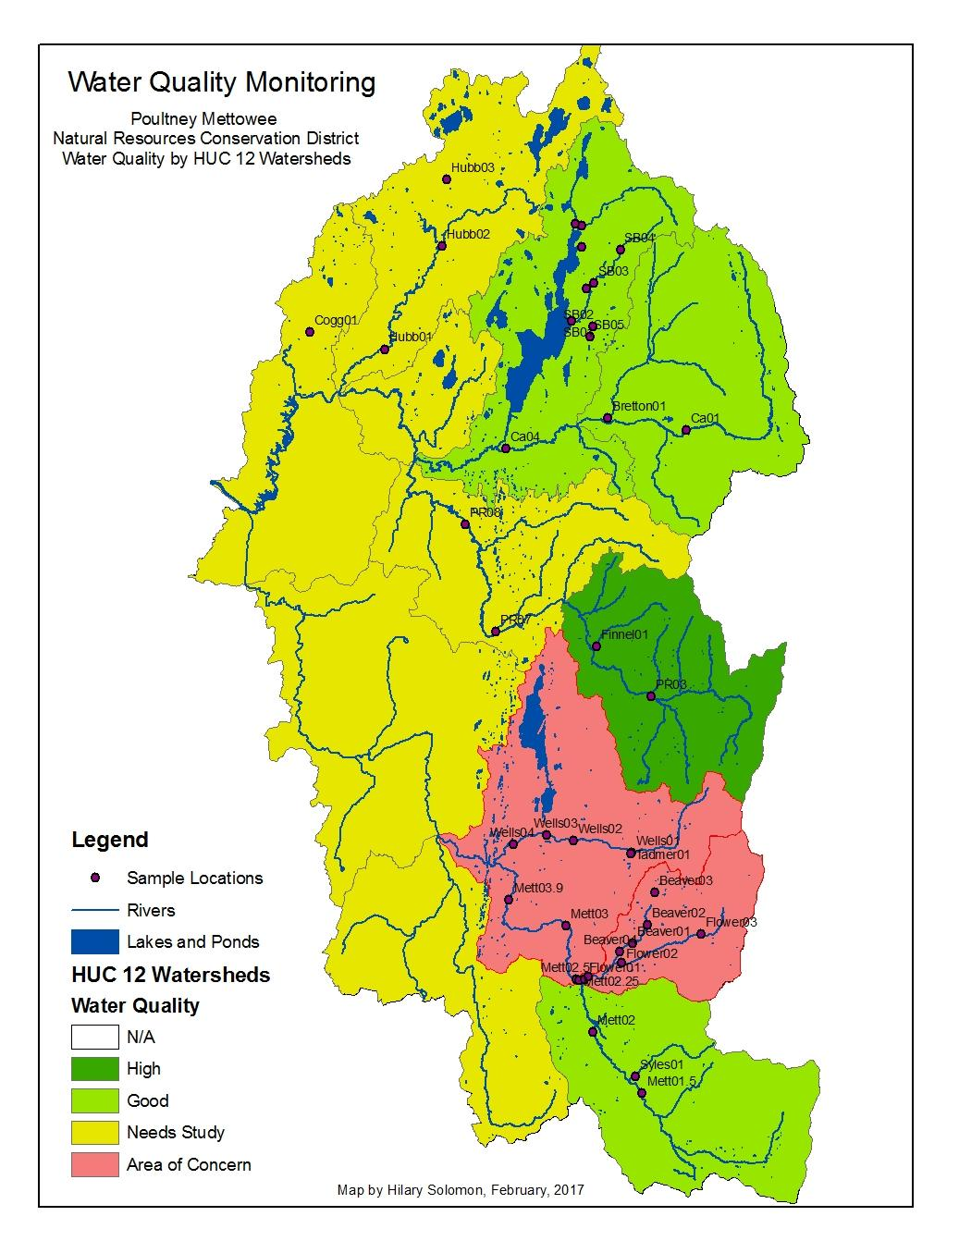

Map 2: Water Quality in “Areas of Concern” Watersheds
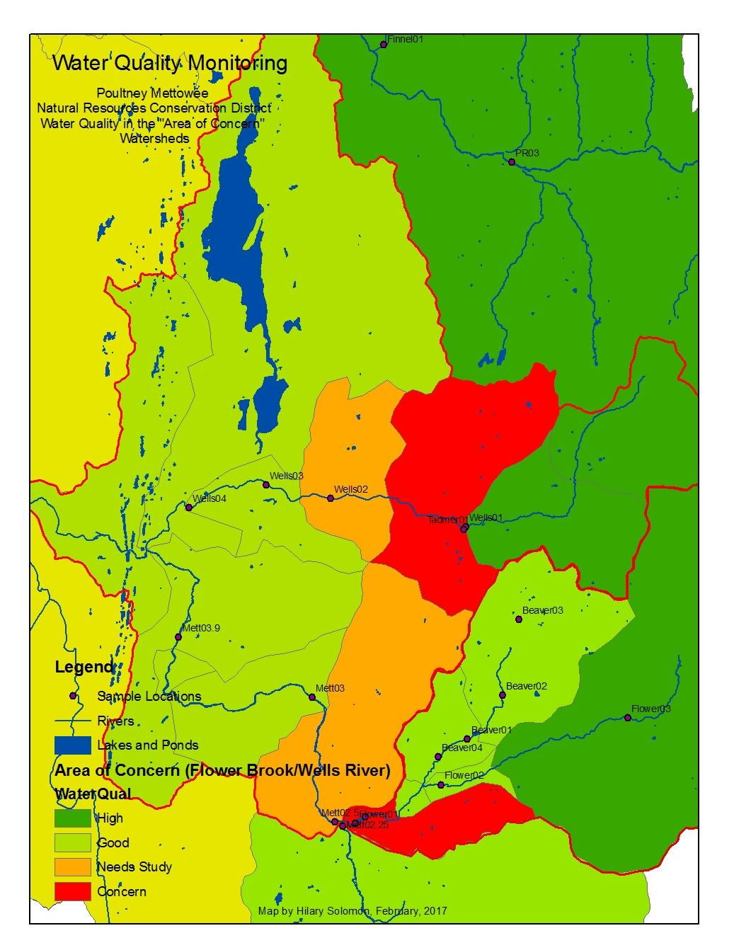

2.3 Discharge Measurement

The United States Geological Survey (USGS) maintains streamflow gaging stations on the Poultney and Mettowee Rivers. The Poultney River station, (04280000), is located below Fair Haven, Vermont, and measures flow from an approximate drainage area of 262 square miles in the towns of: Poultney, Fair Haven, West Haven, Middletown Springs, Tinmouth, Ira, Castleton, Pittsford, West Rutland, Hubbardton, Benson, Orwell, Sudbury, and Wells (PMNRCD Geomorphic Assessment, 2008). The Mettowee River station, (04280450), is located in Middle Granville, New York, and measures a drainage area of 167 square miles in the towns of Dorset, Rupert, East Rupert, Wells, and Pawlet (where the Flower Brook joins the river).

PMNRCD assigned a discharge for each sample date based on reference to the daily mean flow recorded at this gage, applying a correction factor for the proportional drainage area at each sampling station. This method approximates discharge at the sample station, but may over- or under-estimate the actual flow value, due to natural variability in precipitation and river flow patterns across the watershed.
For Figures 1 & 2 below:
Flows have been categorized following VTDEC Guidance on Streamflow Observations at time of Water Quality Sampling of Rivers and Streams. High flows are defined as those flow conditions which are equaled or exceeded only 25% of the time, and low flow levels are those equaled or exceeded more than 75% of the time, while those flows occurring between 25 and 75% of the time are classified as medium.

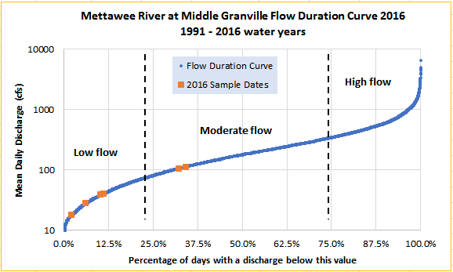
Figure 1: Flow Duration Curve for the Mettowee River at the USGS stream gauge in Middle Granville, Vermont (04280450). Orange data points correspond to the 2016 sampling dates. Blue data points correspond to USGS historical data of approved daily mean flow records for water years 1991 to 2016.
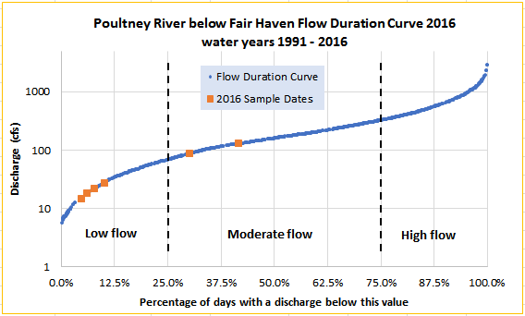
Figure 2: Flow Duration Curve for the Poultney River at the USGS stream gauge below Fair Haven, Vermont (04280000). Orange data points correspond to the 2016 sampling dates. Blue data points correspond to USGS historical data of approved daily mean flow records for water years 1991 to 2016.

Methods

Please refer to the PMNRCD 2016 QAPP for sample collection and analysis methods. Information about watershed-specific methods are included below.

PMNRCD collects water samples at historic, or sentinel, sites along the mainstem of the Poultney, Castleton, and Mettowee Rivers to monitor trends in bacteria and phosphorus concentrations transported from the landscape and flowing to Lake Champlain. The District determined through past studies and based on clear public input at an April 16, 2015, meeting followed by an April 20, 2015, meeting with farmers and other landowners that the District should collect samples at the mouth of the Poultney River, Mettowee River, the Barge Canal, and directly in South Lake.

The District has also determined that sampling from smaller tributaries is beneficial for ‘tracing’ nutrients and bacteria back to their source. Increasingly, samples are collected from smaller watersheds and projects are identified that appear to relate directly to a specific source of the pollutants.

Each year the District attempts to map our flow and rainfall data to help with sample result interpretation. In 2006, there were three USGS flow gages in our area, two on the Mettowee River and one on the Poultney River. Currently, there is one USGS gage on the Mettowee River in Middle Granville that is supported through the Lake Champlain Basin Program and one gage on the Poultney River below Fair Haven. These gages are important for determining the mechanism of pollutant transport; overland runoff versus groundwater infiltration and movement. Flow data also speaks to dilution processes and is necessary for any loading estimates to Lake Champlain.

The State has created Water Quality Standards for pollutants in Vermont streams measured during low-flow conditions. Without loading studies related to flow, these Standards do not seem entirely meaningful. The District has historically differentiated to some degree between samples collected at low and high flow but was less confident differentiating between results collected at low versus moderate flow. The new flow-duration curves will help to categorize data as low versus moderate flow. Again, without flow volume and loading information, the sample results represent a snapshot, not a clear analysis of the amount of phosphorus entering the Lake.

Storm samples are difficult to plan for, so are only collected when District staff are available during a storm event, usually 1-2 events per season. The District targets downstream mainstem sites and smaller tributaries with suspected pollution sources when sampling during storm events. The hope is that the mainstems sites represent some information on loading rates to Lake Champlain (but see above for limitations), while the targeted sites on smaller tributaries help confirm unusually high levels of pollution from specific properties or land use activities. So far, this type of sampling has confirmed suspicions about specific farms, driveways, and an airstrip. As we continue to sample within the watershed, more site-specific anomalies are identified through small tributary and storm sampling.

The State is interested in nutrient loading data from the two major South Lake tributaries, the Poultney River and the Mettowee River, and we hope to continue pursuing accurate information about flow and loading relationships.

The District collected South Lake samples through a project with the South Lake Champlain Trust, one of the VCF funds, the District plans to analyze data from the South Lake and Tributary outlet samples to see if we can find useful clues pointing to loading. The State-led monitoring program includes samples from the Barge Canal, but it is unclear whether the State collects samples in Mettowee River at the mouth upstream of the Barge Canal.

Though all lands need conservation measures and thoughtful management, the District needs to delve more deeply into the causal relationships related to the pollutant concentrations we record and needs to actively pursue the project opportunities identified that are contributing excessive amounts.

Hopefully, the District can use empirical data to show the true conservation value of the projects implemented, while respecting the complexity of data interpretation and the limitations of our understanding of natural processes.

Our data, combined with research and studies about the efficacy of conservation practices in various soil types and at a range of background/enriched soil nutrient concentrations, should help determine the potential range for associated nutrient and other reductions related to the use of various conservation measures on the landscape. The work being completed by Stone Environmental on edge of field monitoring of various practices is very illuminating. More work along these lines should be funded and the results from these studies should be made readily available to the conservation partner working with landowners in the field.

As opposed to edge of field studies, bracket monitoring may provide some information about practice efficacy, but analysts need to be careful to maintain that a farm or other land use likely contributes nutrients and sediment to local waterbodies even when up- and downstream concentration differences aren’t shown through water monitoring.

One question considered by the District are the monitoring responses that we expect to see at different times of year. The District plans to work on flow curve / concentration ratings for phosphorus over the next several years and hopes to capture the most important pollution contributions in the spring flush and early fall storms. District staff are concerned that the summer, low-flow phosphorus levels for our watersheds should be lower than 27 ug/l, possibly 10 ug/l, and that the low-flow summer stream levels may only carry limited amounts of anthropomorphically-generated phosphorus. District staff is unsure how to accurately document implementation-related practice decreases during high-flow events.

The District is aware that the rate of project implementation can lag behind climate and land use changes, making water quality improvements related to practices even more difficult to document. The District is currently working to understand the current landscape, then to track changes, both positive and negative, as they occur. PMNRCD hopes to quantify how these changes relate to water quality conditions, and to plan for conservation measures that will reduce both current levels of pollution and address additional levels of pollution related to future development and other future land use changes.

3.1 Meteorological Conditions
To characterize meteorological conditions during sampling, PMNRCD researched historical weather reported by Weather Underground for June to September of 2016. Weather stations utilized include: Crystal Beach, Castleton (KVTBOMOS1), Rush Hollow, West Pawlet (KVTWESTP1), Stage Road, Benson (KVTORWELL2), and Spruce Knob, Middletown Springs (KVTMIDDL6).
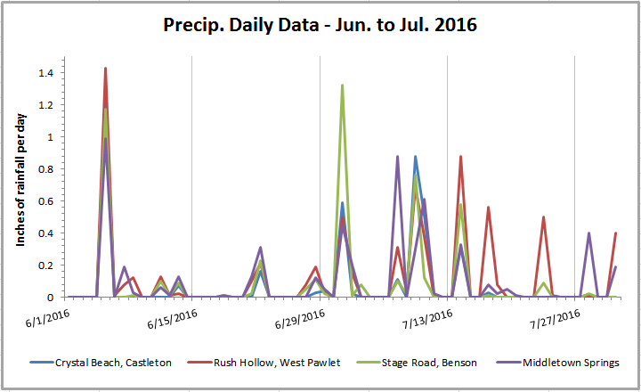
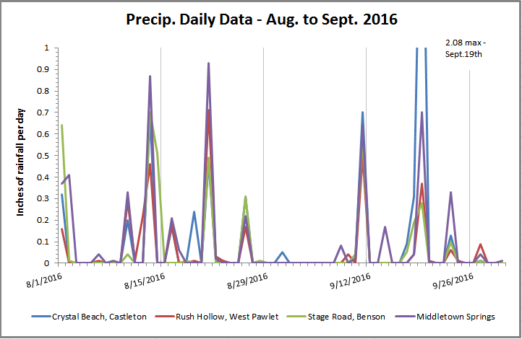
Figure 3-4: Precipitation data for the summer of 2016 from a variety of local gages (weather underground) including gages in Castleton, West Pawlet, Benson, and Middletown Springs.

3.2 Sample Collection and Analysis

Biweekly water samples were collected June, July, August, and September of 2016 from various sites. Samples were analyzed for E.coli, (colonies per 100ml of water or MPN ‘most probably number’) and total phosphorus (micrograms per liter – ug/L). There were six complete sample days; additional sampling for total phosphorous took place on Lake Bomoseen tributaries.

Samples were a combination of grab samples from wadeable streams at a depth approximately half-way between the water surface and the bottom of the stream and collected samples in buckets from bridges, if the depth was greater than three feet. Samples were collected by canoe from the mouths of the Poultney and Mettowee Rivers as well as from the Barge99 canal site, South Lake (SL01 & SL02), and Back Bay (BB01), as part of a study funded by the South Lake Champlain Trust. Bottles were stored on ice packs in a cooler until delivery to the Vermont Agricultural & Environmental Laboratory in Burlington, VT.

All samples were analyzed in accordance with the Vermont Agricultural and Environmental Laboratory SOPs and Analytical Methods as found in their QAPP.

3.3 Quality Assurance / Quality Control

In accordance with the PMNRCD 2016 QAPP, field duplicates and field blanks were collected at a 10% frequency during each sampling event. The location of the field duplicates varied across sampling events. To prepare field blanks, bottles for each scheduled analyte were filled with lab-supplied deionized water and accompanied the regular sample bottles during transport in the field and to the lab. Results of regular and field duplicate pairs from selected stations were evaluated and the average of the Relative Percent Difference (RPD). Results for Total Phosphorus data were compared to a data quality goals, specified in the QAPP.
Data validation results from this sample season showed that samples should be free of cross contamination from other samples and that the data was within the data validation criteria listed in the QAPP (except for one RPD listed below).

Results and Discussion

4.1 Meteorological and Hydrological Conditions
Overall, calendar year 2016 was a below-normal precipitation year, as recorded at weather stations in South Burlington (Airport) and Rutland; all sampling months (April – September) saw lower than normal precipitation (with “normal” defined as the average condition for years 1981 through 2010; NOAA, 2017). Snowfall in the winter of 2015–2016 was far below normal at the Burlington airport and Rutland stations (NOAA, 2017). The region was in a moderate drought condition for much of the year (US Drought Monitor, 2017). Based on records for the USGS streamflow gage on the Mettowee River, mean annual flow was below normal for water year 2016 (USGS, 2016).
June 13 and July 11 sampling events took place during moderate flow conditions. Given below-normal rainfall, the other June, July, August and September events occurred during low to very-low flows (in September) representing baseflow conditions (i.e., relatively stable flow stage, not significantly rising or falling in response to a rainfall or snowmelt event). Discharge on all six sample dates was much lower than flows occurring during February thaw and final ice-out and snowmelt in early March.
Daily Mean Flows recorded at USGS gage on Sample Dates in 2016, Poultney River.
Date | Daily Mean Flow (cfs) | Flow Category | % of days w/discharge  below this value
6/13/2016 | 89.8 | Moderate | 30%
6/27/2016 | 28.2 | Low | 9.9%
7/11/2016 | 133.0 | Moderate | 41.5%
7/25/2016 | 22.8 | Low | 7.7%
8/8/2016 | 18.6 | Low | 5.9%
9/14/2016 | 15.2 | Low | 4.5%

Daily Mean Flows recorded at USGS gage on Sample Dates in 2016, Mettowee River.
Date | Daily Mean Flow (cfs) | Flow Category | % of days w/discharge  below this value
6/13/2016 | 106 | Moderate | 32%
6/27/2016 | 39.9 | Low | 10%
7/11/2016 | 114 | Moderate | 34%
7/25/2016 | 41.6 | Low | 11%
8/8/2016 | 28.7 | Low | 6%
9/14/2016 | 18.3 | Low | 2%

Figure 5: Flow data from the USGS Poultney River gage.
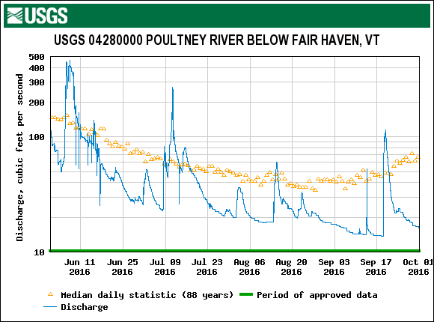
.

4.2 Water Quality Results
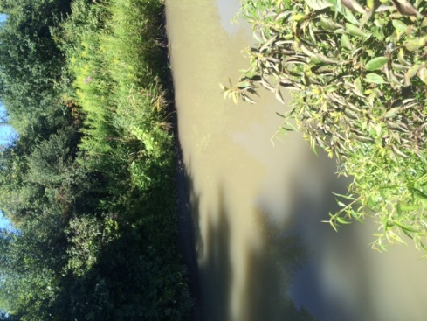
South Lake sample results for 2016 are tabulated in Appendix C. ‘Regular’ samples were collected on six sample dates in June through September. Stormwater TP samples were collected on June 13 and July 11, regular sample dates, and were ‘moderate’ flow on the sample duration curve, though some locations, such as Bretton Brook were at bankfull conditions. South Lake samples were collected on five sample dates, the day after regular sampling and the samples were delivered to the lab during the next regular sample event. The first round of Lake Bomoseen samples from the new sites for 2016 were sampled on September 13 and all Lake Bomoseen sites were sampled on September 24, 2016.
Data validation results often met the requirements in the PMNRCD QAPP, though the samples from SB01 on July 25, 2016 had a RPD of 171%. The results were both below the water quality standard, (what to do with the related results? flag or not?). The highest TP results were collected on 7/11 at site Hubb01 and the lowest TP data was collected on 6/13 at site Giddings01.
Coggman Creek during low flow conditions on August 8, 2016

4.2.2 E.coli
Vermont Water Quality Standards (VWMD, 2016) state that no more than 10% of samples should have E.coli levels above 235 colonies per 100 mL of water (MPN-most probably number).
For Figures 6, 7, & 8: The uppermost part of the shaded box represents Q3, (75% Quartile), the lowermost edge of the shaded box represents Q1, (25% Quartile), and the middle division represents the Median of the data set. The upper and lower “tails” represent the Minimum and Maximum values of the data set.
Figure 6- Poultney River Tributaries, Lavery Brook, North Bretton Brook, Castleton River, Coggman Creek, and the Hubbardton River.
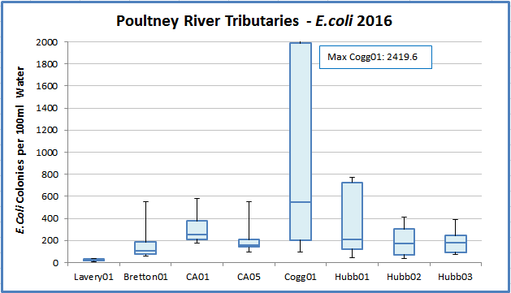

E.coli counts at Poultney River sampling sites ranged from 5.21 to 2419.6 organisms/100 ml of water (most probable number, MPN). E. coli counts at all sites, except Lavery01, had maximum E. coli values above this standard from 387.32 at Hubb03 to 2419.6 at Cogg01. The bacteria range at Coggman01 showed the highest variability, with a range from 135 to 2420 MPN. The District plans to add sites on Coggman Creek to trace the source of bacteria and nutrients to this site.
Figure 7- Lake Bomoseen Tributaries including an unnamed tributary (DH Trib), Giddings Brook, Loves Marsh drainage (Gidding02), and 5 sites in the Sucker Brook watershed (LBSB01-05).
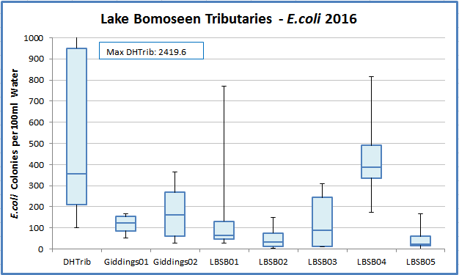
E.coli counts at Lake Bomoseen sampling sites ranged from 1 to 2419.6 organisms/100 mL. Sites with consistently high E. coli include DH Trib and LBSB04. PMNRCD is working with two farms upstream of monitoring site LB04. The District plans additional reconnaissance related to site DH Trib in the summer of 2018.
Figure 8- Flower Brook Watershed- including sites on Flower Brook and Beaver Brook.
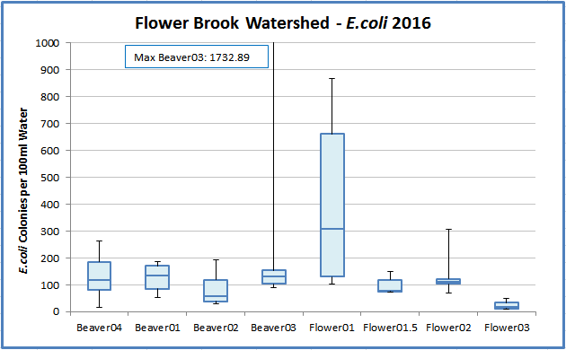
Beaver03 is downstream of a wetland, which likely has beaver activity and slower moving waters. Flower01 is in the village of Pawlet, where many of the houses have dry wells for septic treatment and where evidence shows that partially treated wastewater enters Flower Brook, likely through preferential pathways in the soil and through shallow groundwater flow. Flower Brook in the Village has a bacteria TMDL.

Phosphorus
Total phosphorus (TP) was detected at low to moderate concentrations during the six spring and summer sampling dates, ranging from 5.1 to 120 µg/L. The instream phosphorus criterion of 27 µg/L for warm-water medium gradient (WWMG) wadeable stream ecotypes in Class B waters is applicable at low median monthly (LMM) flow conditions during June through October. Flows in the South Lake watershed were near the LMM flow during each of the sample dates in June, July, August, and September. Two of the sample dates had low-moderate flow, near the low threshold (June 13 and July 11).
The box-and-whisker plots in the Figures shows the full distribution of TP results available for 2016. The blue line marks the mean of that subset of samples collected during baseflow conditions at or below the LMM. The mean of the TP results available for Coggman01, Hubbardton01, and Hubbardton02 exceeded the instream nutrient standard of 27 µg/L during each of the sample dates (Figures 9 and 10).
Results suggest that phosphorus concentrations are higher in the Clayplain streams, Coggman and the Hubbardton River, than in the gravel bottom streams (Poultney River, Mettowee, Wells, etc). The tributaries to Lake Bomoseen show phosphorus concentrations that generally remain above the water quality standards, though the samples from 2016 were all collected in low to moderate flow conditions. LB03 remained below the WQS, around 20 ppb phosphorus concentration. The phosphorus concentrations at Beaver01 and Beaver03 are higher than other results in the Flower Brook watershed and can possibly be attributed to these sites being directly downstream of wetlands with rich biological nutrient cycling. The five Sucker Brook watershed sites remain below the standard in 2016, though LBSB04 has the highest TP concentration of the five sites. This site is located in a pasture and has additional pasture lands upstream.

Figure 9- Total phosphorus concentrations at Lavery Brook, North Bretton Brook, Castleton River, Coggman Creek, and the Hubbardton River.
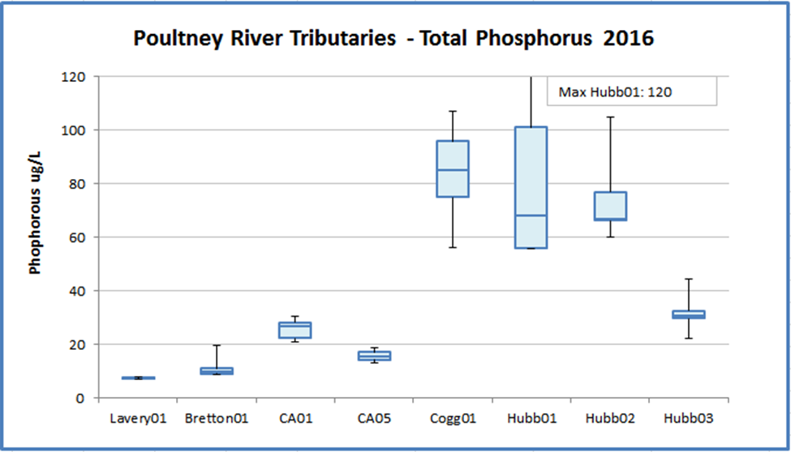

Figure 10- Total phosphorus at the Lake Bomoseen tributaries.
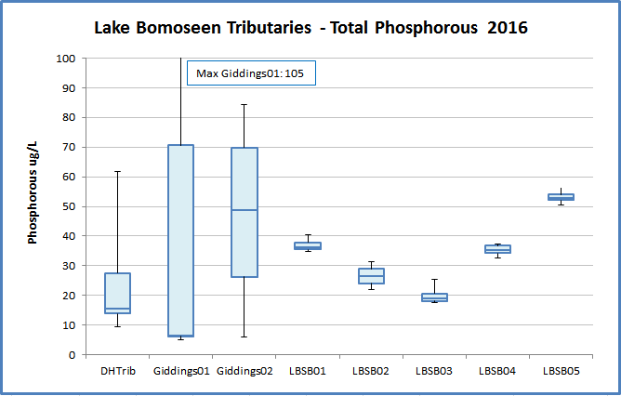

Figure 11: Total phosphorus concentrations measured in the Flower Brook Watershed
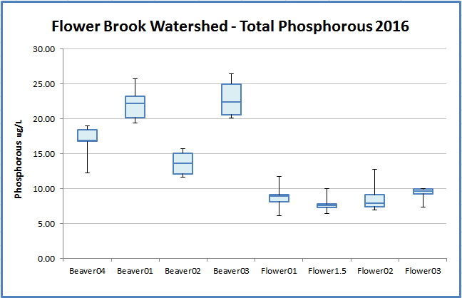

Figure 12: Total phosphorus concentrations, more detail on the Lake Bomoseen tributaries
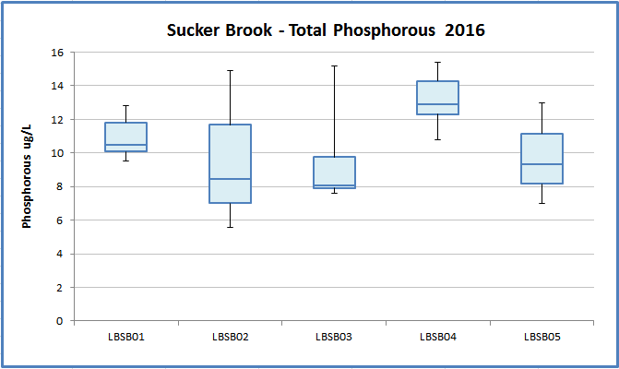

Additional Lake Bomoseen Tributaries TP
In September 2016, the District sampled seven additional sites that captured the remaining inputs to Lake Bomoseen, making the total number of tributaries monitored ten. The sites were sampled twice (depending on water depth) and showed results nearing the 27 ug/l TP WQS, but there weren’t enough results per site to graph the data in box plots or use the data for conclusive analysis. The flow for both sample dates was low and the sample collected at the golf course (LB01) may be showing some pond characteristics due to the slow refreshing of the pond under low flow conditions.
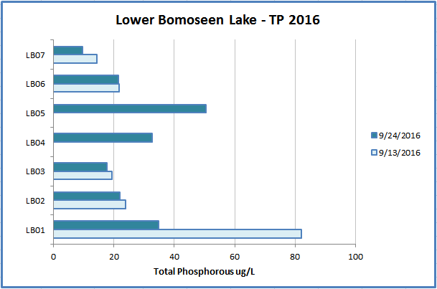

5.0 Conclusions

Spatial trend analysis has been undertaken for many years in the South Lake (Poultney-Mettowee) watershed. In 2016, water quality data was collected during six discrete events in the spring and summer of 2016 - a drier-than-normal year at a number of sites each chosen for its location and/or its history as a sentinel site. A congruent round of sampling included the Poultney River mouth, the Mettowee River mouth, and the barge canal and occurred on five summer sample dates (sites were accessed by canoe). Additionally, new sites were added within the Lake Bomoseen watershed at the end of the sampling season in September. The 2016 monitoring effort expanded the spatial resolution of water quality data in this catchment to include more information about headwater areas and small tributaries entering the lake.
TP exhibited an increasing trend in concentration on the upstream-most station on Flower Brook on the main stem (FB03). This area is dominated by fine-grained glacial lake soils and rural residential land uses.

NOTE: This could be relevant here— A separate study recently completed by ACRWC found a strong, and statistically-significant, positive correlation between mean water quality concentrations (for Total Phosphorus and Turbidity) and both the percentage of these fine-grained glacial lake soils and the percentage of agricultural land use in the catchments draining to water quality stations in the Little Otter Creek and New Haven River watersheds (ACRWC & SMRC, 2016).
E. coli counts at several of the stations exceeded the state’s geometric-mean-based water quality standard, including a newly-established station located within a low density cow pasture. While additional monitoring is warranted, these 2016 results suggest that ...
These 2016 results suggest the need for additional focus along the upper main stem of Flower Brook to discern source areas for elevated phosphorus. In the context of a previous river corridor plan (SMRC, 2007), current High Meadows supported work, and the South Lake Basin Plan (VTDEC, 2017), various river conservation projects and watershed improvement practices have been identified for the Flower Brook watershed to address water quality impairments. Recommended projects and practices included nutrient management to reduce P and sediment/gravel inputs, riparian buffer plantings where gaps exist, cover cropping, no-till cropping, edge-of-field gully stabilization, stormwater treatment measures to disconnect road ditch networks from the stream, stormwater treatment measures to disconnect private driveways from the stream, culvert upgrades, riparian wetland restoration and river corridor protection (PMNRCD). These recommendations have been shared with partner agencies including the VT Department of Environmental Conservation and with the towns of Danby and Pawlet, to support outreach to landowners and farmers and to inform the design of best management practices by these partner agencies.
The Lake Bomoseen and Flower Brook watersheds will continue to be a focus areas in 2017, with the same sentinel and rotational sites monitored for E.coli and total phosphorus. In addition a future focus study, additional bracketing of source areas in the upper headwaters would be warranted to define sources of elevated phosphorus and E.coli, pending landowner access.

References

South Mountain Research & Consulting, 2007, Castleton River Watershed: Phase 2 Stream Geomorphic Assessment, Rutland County, Vermont, prepared under contract to Poultney Mettowee NRCD.

South Mountain Research & Consulting, 2007, Mettowee River Watershed: Phase 2 Stream Geomorphic Assessment, Rutland County, Vermont, prepared under contract to Poultney Mettowee NRCD.

Stewart, David P. and Paul MacClintock, 1969, The Surficial Geology and Pleistocene History of Vermont. Vermont Geological Survey Bulletin No. 31.
USDA Natural Resource Conservation Service, 2011, State Data Table Top 20, published by the United States Department of Agriculture, NRCS; available at: ftp://ftp-fc.sc.egov.usda.gov/VT/Soils/top20/
USDA Natural Resource Conservation Service, 2013, Soil Survey Geographic (SSURGO) database, available at: http://www.vcgi.org/dataware/default.cfm?layer=
GeologicSoils_SO. Accessed: [3/9/2013].
US Drought Monitor, accessed 6 February 2018, http://droughtmonitor.unl.edu/Home/StateDroughtMonitor.aspx?VT
USGS, 2017, on-line surface water data, <http://waterdata.usgs.gov/vt/nwis>.
USGS, 2016, Water Year Summary for Site USGS 04280450, available at https://waterdata.usgs.gov/ny/nwis/wys_rpt/?site_no=04280450&agency_cd=USGS
VTDEC, 2014, South Lake Basin Water Quality Management Plan, including appendices. Available at: http://dec.vermont.gov/sites/dec/files/wsm/mapp/docs/mp_southlakeplan.pdf http://dec.vermont.gov/sites/dec/files/wsm/mapp/docs/mp_southlakeappendix.pdf
VTDEC, 2011, Vermont Statewide Total Maximum Daily Load (TMDL) for Bacteria Impaired Waters, prepared by FB Environmental Associates, Inc., Portland, ME, including Appendices 3 and 4. Available at: http://dec.vermont.gov/sites/dec/files/wsm/mapp/docs/mp_bacteriatmdl.pdf
http://dec.vermont.gov/sites/dec/files/documents/WSMD_mapp_3littleottercreek1.pdf
http://dec.vermont.gov/sites/dec/files/documents/WSMD_mapp_4littleottercreek2.pdf
VT DEC Water Quality Division, 2016a, State of Vermont 2016 303(d) List of Waters: Part D – Impaired Surface Waters With Completed and Approved TMDL. Available at: http://dec.vermont.gov/sites/ dec/files/documents/WSMD_mapp_Part_D_2016_final_complete.pdf
VT DEC Water Quality Division, 2016b, State of Vermont 2016 Stressed Waters List. Available at: http://dec.vermont.gov/sites/dec/files/documents/wsmd_mp_stressed_waters_list_2016.pdf
VT DEC Water Quality Division, 2016c, State of Vermont 2016 303(d) List of Waters: Part A – Impaired Surface Waters in Need of TMDL. Available at: http://dec.vermont.gov/sites/dec/files/documents/ WSMD_mapp_303d_Part_A_2016_final_complete.pdf
Vermont Watershed Management Division, 2016. Vermont Water Quality Standards.
Effective 15 January 2017. Montpelier, VT. Available at: http://dec.vermont.gov/sites/dec/files/ documents/wsmd_water_quality_standards_2016.pdf

Attachment 1 /2?

Soil Parent Materials
Land Cover / Land Use
South Lake watershed

District has no GIS right now, but coming soon!

UPDATE!! AS of 3/9/18, DISTRICT HAS NEW GIS!! YEA!

Attachment 3
Water Quality Results
Total Phosphorous Results 2016

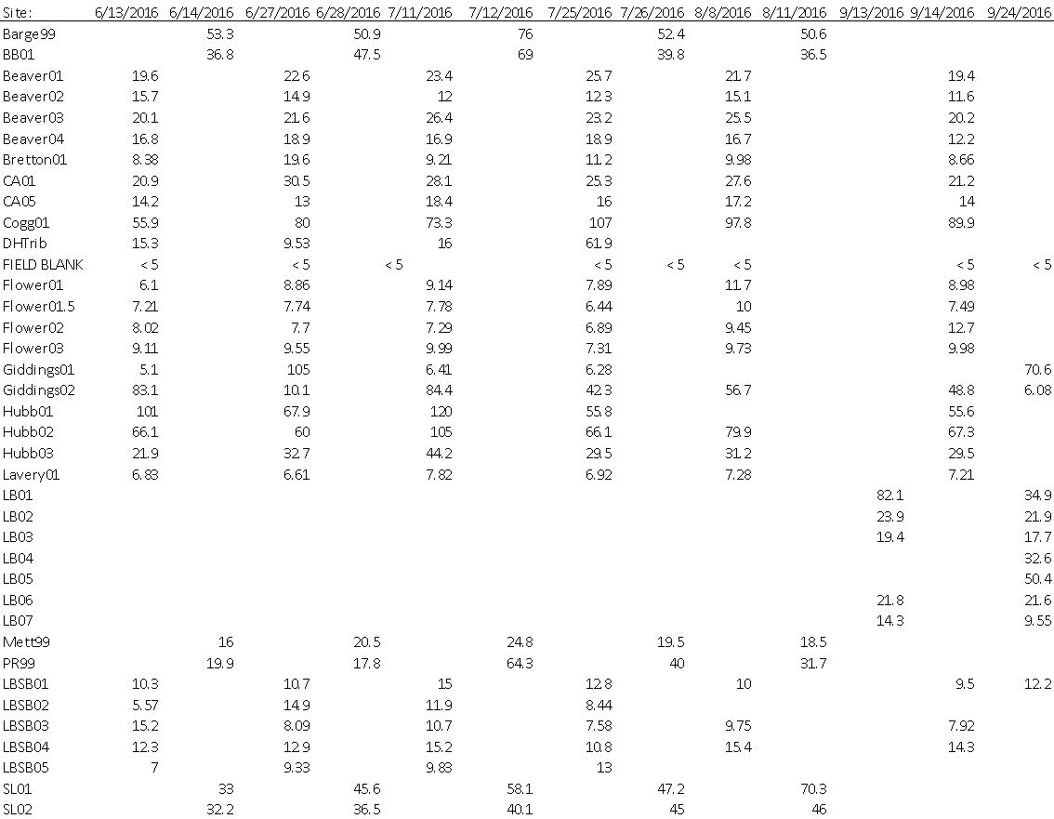

VT Water Quality Standards (effective October 2014):
- Phosphorus (Class B, Warm-water Medium Gradient): Not to exceed 27 ug/L at low median monthly flow during June through October in a section of the stream representative of well-mixed flow.

E.coli Results 2016

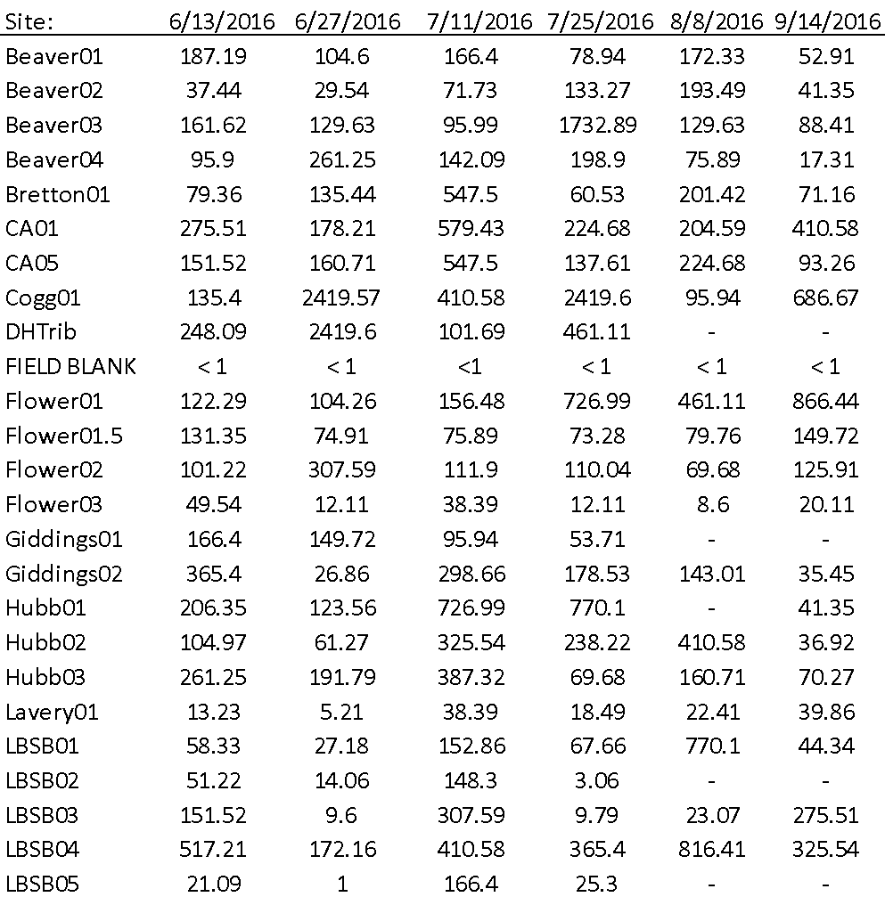

VT Water Quality Standards (effective October 2014):
- E. coli (Class B): Not to exceed a geometric mean of 126 organisms /100ml obtained over a representative period of 60 days, and no more than 10% of samples above 235 organisms/100 ml.
In waters receiving combined sewer overflows, the representative period shall be 30 days.

[1] SMRC, 2007, Phase 2 Geomorphic Assessment, Mettowee River Watershed, Rutland and Bennington Counties
[2] ANR, SGS, DMS, project reports, data accessed at https://anrweb.vt.gov/SGA/projects/phase1/reports.aspx.
From: Phase 2 Stream Geomorphic Assessment Mettowee River Watershed, Pawlet, Rutland County, VT. Draft. Page 24. Sept. 2005.
Source: http://dec.vermont.gov/sites/dec/files/documents/WSMD_mp_Poultney-Mettawee_AssessmentReport_2013.pdf – not sure how to site this!

E. coli and TP RPD
Date | Location | E.coli | Duplicate | RPD | TP | Duplicate | RPD
6/13/2016 | Cogg01 | 135.4 | 143.87 | 6 | 55.9 | 56 | 0.18
6/13/2016 | Flower03 | 49.54 | 25.9 | 63 | 9.11 | 8.43 | 7.75
6/14/2016 | Barge99 | - | - |  | 53 | 42 | 23.16
6/27/2016 | Flower03 | 12.11 | 5.16 | 80 | 9.55 | 10.3 | 7.56
6/28/2016 | Barge99 | - | - |  | 50.9 | 68.4 | 29.34
7/11/2016 | Hubb02 | 325.54 | 285.1 | 13 | 105 | 105 | 0
7/12/2016 | Barge99 | - | - |  | 76 | 71.1 | 6.66
7/25/2016 | Flower01 | 726.99 | 613.14 | 17 | 7.89 | 12.1 | 42.12
7/25/2016 | SB01* | 67.66 | 5.21 | 171 | 12.8 | 7.67 | 50.12
7/26/2016 | Barge99 | - | - |  | 52.4 | 51.3 | 2.12
8/8/2016 | Flower01 | 461.11 | 344.8 | 29 | 11.7 | 10.5 | 10.81
8/8/2016 | SB01 | 770.1 | 1119.87 | 37 | 10 | 14 | 33.33
8/18/2016 | Bretton01 | 61.98 | 56.53 | 9 | 7.68 | 9.05 | 16.38
8/18/2016 | Lavery01 | 24.05 | 15.96 | 40 | 6.38 | 7.36 | 14.26
8/18/2016 | LBGiddings02 | 66.31 | 98.81 | 39 | 56.8 | 54.5 | 4.13
9/13/2016 | LB01 | - | - |  | 82.1 | 143 | 54.11
9/14/2016 | Beaver01 | - | - |  | 19.4 | 18.1 | 6.93
9/14/2016 | CA05 | 93.26 | 98.81 | 6
9/24/2016 | LB06 | - | - |  | 21.6 | 23.4 | 8
 |  |  | Average | 43 |  | Average | 17.61
*double checked data entry
Field Blanks
Site | Date | E. Coli | TP
 | 6/13/2016 | <1 | <5
 | 6/27/2016 | <1 | <5
 | 7/25/2016 | <1 | <5
PR99 | 7/26/2016 |  | <5
CA05 | 8/8/2016 | <1 | <5
 | 8/18/2016 | <1 | <5
CA01 | 9/14/2016 | <1 | <5
LB07 | 9/24/2016 |  | <5

