Stormwater Treatment Practice (STP) Calculator Instructions

The STP Calculator (https://anrweb.vt.gov/DEC/CleanWaterDashboard/STPCalculator.aspx) is a tool developed by the Department of Environmental Conservation (DEC) to estimate total phosphorus load reductions achieved by stormwater treatment practices (STPs). The user enters STP data into the tool and the tool calculates the estimated annual average total phosphorus load reduction. Calculations are based on the same methods DEC will use to track progress reducing phosphorus pollution loading into Lake Champlain and Lake Memphremagog. The tool can currently only be applied to estimate total phosphorus reductions in the Lake Champlain and Lake Memphremagog watersheds, as pollutant loading rates are currently unavailable outside these basins in Vermont. The calculator tool focuses on STPs treating runoff from developed lands, only, and should not be used for agricultural, forested, or other types of land use. The calculator may not be suited for complex STP systems or retrofit projects. The STP calculator should only be used for planning purposes to understand pollutant reduction potential for STPs. Data entered in the STP calculator will not be stored in a database. DEC retains the right to verify the data input and will provide final phosphorus load reduction crediting based on data reported to and stored in DEC’s Watershed Projects Database.
Please direct any questions to Helen.Carr@vermont.gov or 802-490-6115.

Loading Information

Drainage area
Select the drainage area where the STP is located. Drainage areas are subsections of basins with like-modeled and calibrated pollutant loading rates. Drainage area boundaries can be viewed on the Natural Resource Atlas. The drainage areas in the dropdown menu are based on modeling completed to support the Lake Champlain and Lake Memphremagog phosphorus total maximum daily loads (TMDLs).
- Navigate to your site by either zooming and panning or use the “Quick Tools” button at the top left of the map to zoom to the town your STP is in or find a specific address.
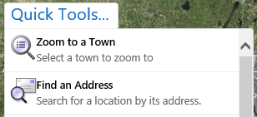
- Once you have found the location, click the layers tab at the bottom of the menu on the left. Scroll down on this menu until you see the “Lake Segment Basins” layer and check the box next to it, as shown below.
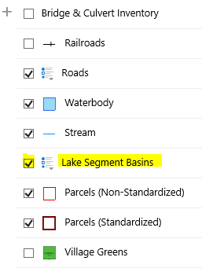
- The map should populate with a color and wording that indicates the Lake Segment, and the drainage area. Determine what the drainage is for this site. In the image below it is, “Winooski River.”
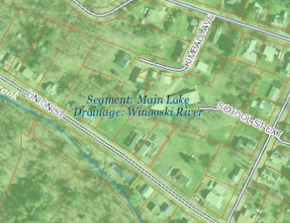

Impervious Area (acres)
Enter the acres of impervious surface draining to the practice. Acres should include all types of impervious area (i.e., rooftop, road, gravel, parking lot, driveway, etc.). This is used to calculate the total phosphorus load from impervious surface within the area draining to the practice.

Pervious Area (acres)
Enter the acres of pervious surface draining to the practice. Acres should include all types of pervious area (i.e., vegetation, trees, grass, or landscaped areas, etc.). This is used to calculate the total phosphorus load from pervious surface within the area draining to the practice.

STP Information

STP Type and Storage Volume
Determine the most appropriate and accurate STP type based on definitions provided. Enter the STP type in the calculator. Calculate the STP storage volume based on the “method for calculating design storage volume” column, below.
STP Type | Description | STP Calculator Type | Method for Calculating Design Storage Volume (DSV)
Infiltration Trench | Provides storage of runoff using the void spaces within the soil/sand/gravel mixture within the trench for infiltration into the surrounding soils. | Infiltration Trench | DSV = void space volumes of stone and sand layers  DSV = (A_{trench} x D_{stone} x n_{stone} )+ (A_{trench} x D_{sand} x n_{sand})
Subsurface Infiltration | Provides storage of runoff using the combination of storage structures and void spaces within the washed stone within the system for infiltration into the surrounding soils. | Infiltration Trench | DSV = storage volume of storage units and void space of backfill materials. Example for subsurface galleys backfilled with washed stone: DSV = (L x W x D)_{galley} + (A_{backfill} x D_{stone} x n_{stone})
Surface Infiltration | Provides storage of runoff through surface ponding (e.g., basin or swale) for subsequent infiltration into the underlying soils. | Surface Infiltration | DSV = volume of storage structure before bypass. Example for linear trapezoidal vegetated swale.  DSV = (L x ((W_{bottom}+W_{top@Dmax})/2) x D)
Rain Garden/ Bioretention (no underdrains) | Provides storage of runoff through surface ponding and possibly void spaces within the soil/sand/washed stone mixture that is used to filter runoff prior to infiltration into underlying soils. | Surface Infiltration | DSV = Ponding water storage volume and void space volumes of soil filter media. Example for raingarden:  DSV = (A_{pond} x D_{pond}) + (A_{soil} x D_{soil} x n_{soil mix})
Rain Garden/ Bioretention (w/underdrain) | Provides storage of runoff by filtering through an engineered soil media. The storage capacity includes void spaces in the filter media and temporary ponding at the surface. After runoff passes through the filter media it discharges through an under-drain pipe. | Bioretention | DSV = Ponding water storage volume and void space volume of soil filter media.  DSV = (A_{bed} x D_{ponding})+ (A_{bed} x D_{soil} x n_{soil})
Gravel Wetland | Provides surface storage of runoff in a wetland cell that is routed to an underlying saturated gravel internal storage reservoir (ISR). Outflow is controlled by an orifice that has its invert elevation equal to the top of the ISR layer and provides retention of at least 24 hours. | Gravel Wetland | DSV = pretreatment volume + ponding volume + void space volume of gravel ISR.  DSV = (A _{pretreatment} x D _{Pretreatment}) + (A _{wetland} x D _{ponding}) + (A_{ISR} x D _{gravel} x n _{gravel})
Porous Pavement with infiltration | Provides filtering of runoff through a filter course and temporary storage of runoff within the void spaces of a subsurface gravel reservoir prior to infiltration into subsoils. | Infiltration Trench | DSV = void space volumes of gravel layer  DSV = (A_{pavement} x D_{stone} x n_{stone})
Porous pavement w/ impermeable underlining or underdrain | Provides filtering of runoff through a filter course and temporary storage of runoff within the void spaces prior to discharge by way of an underdrain. | Porous Pavement | Depth of Filter Course = D _{FC}
Sand Filter w/underdrain | Provides filtering of runoff through a sand filter course and temporary storage of runoff through surface ponding and within void spaces of the sand and washed stone layers prior to discharge by way of an underdrain. | Sand Filter | DSV = pretreatment volume + ponding volume + void space volume of sand and washed stone layers. DSV = (A _{pretreatment} x D_{preTreatment}) + (A _{bed} x D_{ponding}) + (A_{bed} x D_{sand} x n_{sand}) + (A_{bed} x D_{stone} x n_{stone})
Wet Pond | Provides treatment of runoff through routing through permanent pool. | Wet Pond | DSV= Permanent pool volume prior to high flow bypass DSV=A_{pond} x Dpond (does not include pretreatment volume)
Extended Dry Detention Basin | Provides temporary detention storage for the design storage volume to drain in 24 hours through multiple out let controls. | Dry Pond | DSV= Ponding volume prior to high flow bypass  DSV=A_{pond} x Dpond (does not include pretreatment volume)
Grass Conveyance Swale | Conveys runoff through an open channel vegetated with grass. Primary removal mechanism is infiltration. | Grass Swale | DSV = Volume of swale at full design flow  DSV=L_{swale}x A _{crossect. swale}
Footnotes:
DSV= Design Storage Volume = physical storage capacity to hold water
VSV=Void Space Volume
L= length, W= width, D= depth at design capacity before bypass, n=porosity fill material, A= average surface area for calculating volume
Infiltration rate = saturated soil hydraulic conductivity

Infiltration Rate
This field will automatically appear when an infiltration STP type is selected. Choose the infiltration rate that most closely matches the infiltration rate, without going over, of the surrounding soils of the site in question. If you do not know the exact infiltration rate of the surrounding soils this rate can be estimated based on the soil type. Soil type can be estimated using the Hydrologic Soil Group (HSG) layer on the Natural Resources Atlas. Determine the HSG type for the practice site and use the table below to estimate the site’s infiltration rate. Note: field verified infiltration rates are necessary to properly design STPs and to accurately estimate pollutant reductions achieved by constructed STPs.
Texture Class | HSG | Infiltration Rate
Sand | A | 8.27
Loamy Sand | A | 2.41
Sandy Loam | B | 1.02
Loam | B | 0.52
Silt Loam | C | 0.27
Sandy Clay Loam | C | 0.17
Clay Loam | D | 0.09
Silty Clay Loam | D | 0.06
Sandy Clay | D | 0.05
Silty Clay | D | 0.04
Clay | D | 0.02

Filter Course Depth
This field will automatically appear when the “Porous Pavement with underdrain” STP type is selected. The “Filter Course” component of a porous pavement system includes the depth of the filtering layer. It does not include the depth of pavement itself, nor does it include the gravel reservoir layer. The depth is usually between 12 and 36 inches.
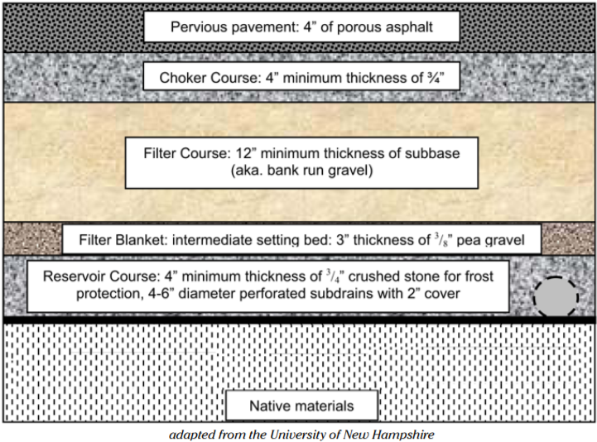

Estimated Phosphorus Reduction

Compute Button
The user must select the “Compute” button each time a value is changed to update phosphorus reduction calculations.

Phosphorus Load
This field indicates the modeled total phosphorus load (kilograms per year) coming off the land treated by the STP, based on land use data entered by the user.

STP Capacity
This field indicates the inches of rain runoff (i.e., treatment depth in inches) the STP is capable of treating, based on data entered by the user for storage volume and acres treated by the STP.

Efficiency
This field displays the annual average performance (i.e., efficiency) of the STP in treating total phosphorus, based on the above parameters entered by the user.

Phosphorus Reduction
This field indicates the annual average estimated total phosphorus reduction (kilograms per year) achieved by the STP, based on the above data entered by the user. Note: The user must select the “Compute” button each time a value is changed to update phosphorus reduction calculations.

To Report Button
This button will open a reporting page that will allow the user to export data in the current display to a PDF or other format. At the top of the new page, click the export drop down menu button and choose a format to export the data to. This could be used as a part of a grant application to show potential P reductions associated with a practice.

