DRAFT FOR COMMENT – JUNE 6, 2015

Findings and Reclassification Order

Reclassification to Class IV Groundwater at the General Electric 210 Columbian Avenue Facility
Rutland, Vermont

Vermont Agency of Natural Resources

I. General
This document contains the Secretary of the Vermont Agency of Natural Resources findings of fact, affirmative findings and order to reclassify groundwater from Class III to Class IV at the GE 210 Columbian Avenue site in Rutland, VT (see Figure 1 in Section III for a map of the area to be reclassified). The reclassified groundwater area includes the 210 Columbian Ave General Electric (GE) property (Facility) and properties cross and down gradient of the Facility. The Secretary’s affirmative findings are based on the factors described in §12-403 of the Vermont Groundwater Protection Rule and Strategy, effective February 1, 2005 (Rule). A copy of the Rule is available online at http://drinkingwater.vt.gov/dwrules/pdf/gwprs2005.pdf or by contacting Rodney Pingree, Department of Environmental Conservation, Drinking Water and Groundwater Protection Division at 1 National Life Drive (Main Building- Floor 2) Montpelier, VT 05620-3521. (802) 585-4912.
Copies of the petition to reclassify and other supporting documents are available at the Montpelier Office of the Department of Environmental Conservation (VT DEC), Drinking Water and Groundwater Protection Division. Much of the information that is the basis of this decision was obtained from the petition to reclassify groundwater, submitted and prepared by Environmental Resources Management (ERM) on behalf of GE, dated September 30, 2013 (Petition).

II. Findings of Fact
The information regarding site geology that is in quotes is from the Petition.
1. The area to be reclassified includes the Facility at 210 Columbian Avenue in Rutland, properties located directly adjacent to the GE property on the east, and various properties to the south terminating at the north bank of East Creek.
2. The Facility is located in an industrial zone and is abutted by residential properties to the north and west, railroad tracks to the immediate south, with residential and commercial properties located farther to the south. East Creek is located to the east, with a vacant lot and industrial/commercial properties located farther to the east.
3. A series of site investigations conducted by the VT DEC and GE indicate that at some point, possibly prior to GE moving into the manufacturing facility, trichloroethene (TCE) and tetrachloroethene (PCE) were released separately to the subsurface in two areas in the manufacturing facility.
4. Contaminated groundwater has migrated in a generally southerly direction from the Facility towards East Creek. The extent of the contaminant migration when considered with the geology at the site indicates an initial release of chlorinated solvents likely happened 40-50 years ago and possibly longer.
5. “The Vermont Geological Survey bedrock map of the Rutland Quadrangle (Ratcliffe, 1998) and the Vermont Center for Geographic Information website indicate that the Facility property is underlain by medium- to dark-grey dolostone of the Lower Cambrian Dunham Dolomite. Dolostone was observed beneath the Facility during bedrock drilling activities.”
6. “Interpretation of overburden geology is based on geologic data from soil borings advanced at the Facility and along West Street. The Facility property is located on an upland area that has been leveled using various types of fill. South of the Facility property boundary, the topography abruptly drops approximately 10 feet to railroad tracks and then an additional 20 feet to the elevation of West Street. As a result of this topographic change, observed shallow subsurface conditions beneath the Facility are moderately different than conditions observed beneath West Street. The deeper geologic sequence is similar in both areas. Surficial geology consists of the following geologic units, from shallowest to deepest:”
- “Facility shallow subsurface: Fine to medium sand with gravel and cobbles, poorly sorted with fragments of machined marble from historical activities (approximately 12 to 28 feet thick). At some locations, the man-made fill is underlain by a silt or silty sand approximately 1 to 14 feet thick.”

- “West Street shallow subsurface: Poorly sorted medium- to coarse-grained sand with some gravel in the vicinity of East Creek. This unit fines to a poorly sorted silty sand in the westernmost boring along West Street.”

- “Ablation Till: Medium brown, poorly sorted, loose sand and gravel with some silt. This layer ranged from approximately 20 to 48 feet thick”.

- “Lodgment Till: Light brown to light grey, poorly sorted, medium dense silt and sand with gravel and cobbles (including quartzite cobbles). This layer ranged from approximately 2.5 to 43 feet thick.”
7. Groundwater proposed for reclassification is contaminated with PCE, TCE and cis-1,2-dichloroethene (cDCE). The cDCE is likely primarily a degradation product of PCE and TCE although a small amount could have been present as an impurity in the PCE or TCE that was released on site.
8. All three compounds are present in the area proposed for reclassification in concentrations above groundwater enforcement standards with a 95% statistical certainty. Concentrations of PCE & TCE in the area proposed for reclassification have ranged from slightly above the enforcement standard of the Rule (5 µ/l) to over 1,000 µg/l. The two compounds are found in groundwater over a similar area, with the physical extent of the area TCE in groundwater above standards slightly larger than the area with PCE above standards. The cDCE above enforcement standards is found in a smaller area near the center of the TCE-PCE plume. This supports the concept that the primary source of this compound is degradation of the PCE and TCE. Concentrations of cDCE have ranged from slightly above the enforcement standard of the Rule to the low hundreds of µg/l.
9. TCE, PCE, and cDCE are considered recalcitrant and will not naturally degrade in a short time period.
10. Due to the heterogeneous nature of the till where the contamination is located, there are contaminated portions of the aquifer where the hydraulic conductivity (K) is very low. Considering the likely age of the release, there has likely been significant migration of contaminant mass into the low K portions of the aquifer via chemical diffusion. Further contaminant migration within the low K units will be slow and dominated by diffusion instead of advection.
11. A potentially significant portion of the contaminant mass is sorbed to organic carbon present in the aquifer. The sorption will retard migration of the dissolved phase plume, and as it is reversible, will also contribute to the dissolved plume as contaminants desorb based on equilibrium between concentration of contaminants in groundwater and the amount sorbed to the carbon.
12. Both the contamination in the low K portions of the aquifer and the contamination sorbed to the organic carbon will act a long term sources of contamination to groundwater flowing through the higher K portions of the aquifer. Therefore, the groundwater and soil contamination has likely been present at the site for at least 40-50 years and will likely remain in groundwater for significantly longer than five years.
13. The shallow dissolved phase volatile organic contamination associated with this plume has created a soil vapor plume that has created issues with contaminated soil vapor intrusion into several residences. The vapor intrusion issues have been remediated by GE.

14. The owners of record of the properties affected by the proposed reclassification area are listed in Appendix A.

iii. Class IV Boundary Delineation
The boundaries of the groundwater reclassification area as shown as Figure 1 were delineated following the methodology outlined in the Procedure for Class IV Groundwater Reclassification (VT DEC, 2000).
- The contaminants of concern (COC) concentration data were compared with applicable standards in the Rule and a map showing COC concentrations greater than those standards was developed to identify the lateral extent of COC impacts in groundwater (see Petition).

- A 200-foot buffer was then added along the cross-gradient (western) and up-gradient (northern) boundaries, as required. This buffer was not applied to the eastern cross-gradient boundary because it is bounded by a hydrogeologic boundary (i.e., East Creek). The down gradient boundary was placed at the midpoint of East Creek, which is a major surface water body. A larger buffer in the up gradient and cross gradient directions was determined to be unnecessary based on stagnation point calculations for a theoretical pumping well required by the delineation methodology. Stagnation point calculations were performed using the Javandal and Tsang method (Javandal, 1986) and are presented in the reclassification petition.

- If COCs were detected on a portion of a property at concentrations greater than standards in the Rule or if the 200-foot buffer incorporated a portion of a property, then the entire property was included within the proposed groundwater reclassification area.

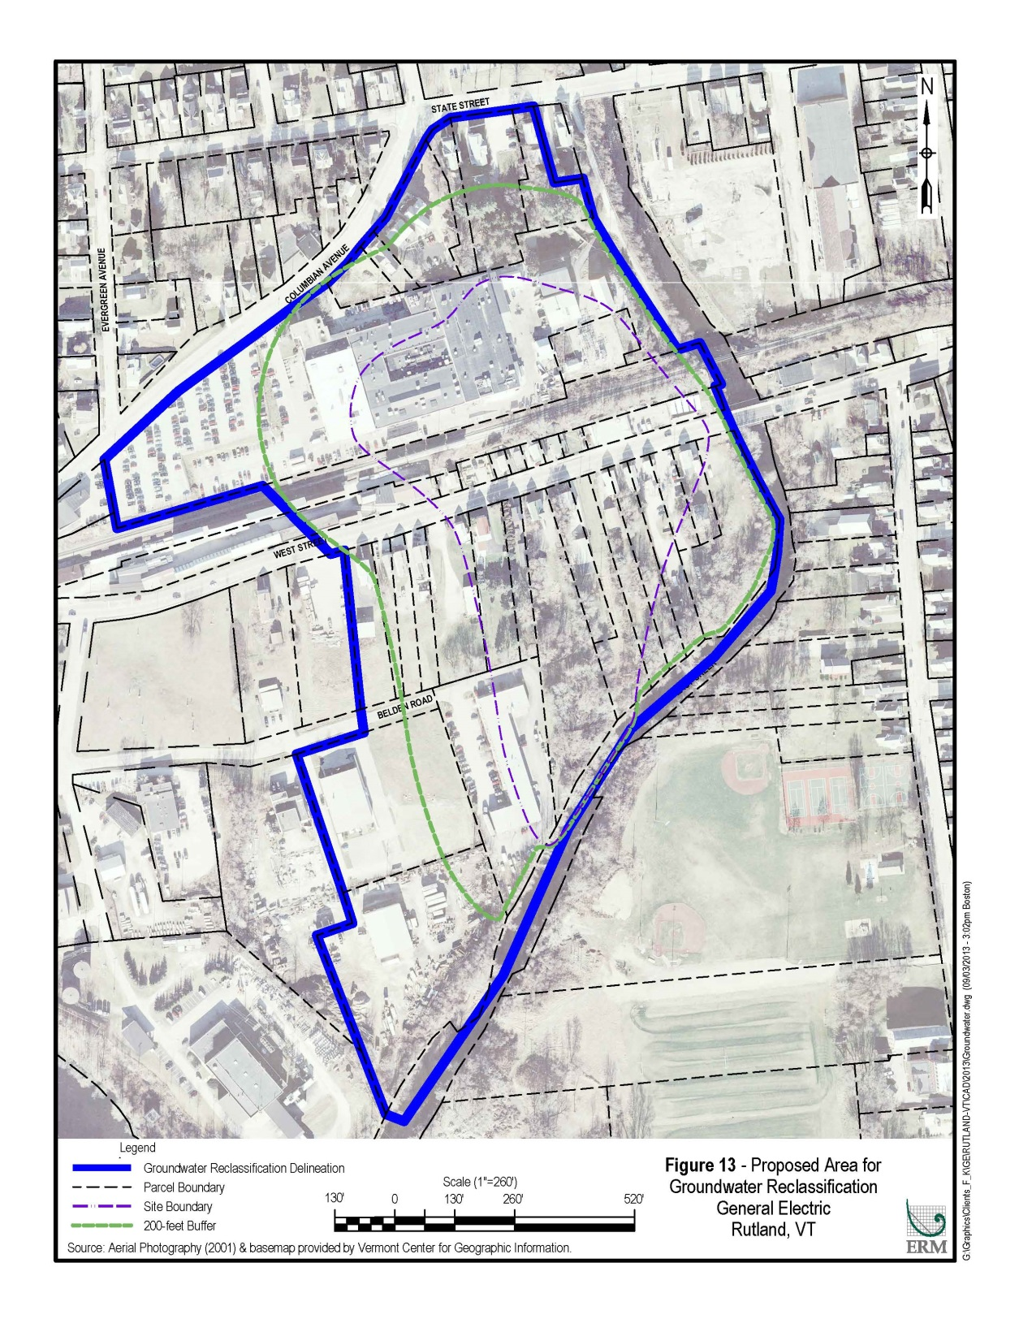
Figure 1: 210 Columbian Ave: Class IV Groundwater Area

iv. Affirmative Findings:
In accordance with §12-303 of the Rule, the Secretary makes the following findings:

(1) The use or potential future use of the groundwater as a public water supply source
Properties located within the proposed reclassification boundary are currently zoned for residential, industrial or gateway business use. There currently are no private residential potable water supply sources or public water system sources located in or in close proximity to the area proposed for groundwater reclassification and no groundwater in or in close proximity has been reclassified as Class I or Class II groundwater (i.e., suitable for public water supply) by the Secretary. The Facility and surrounding properties are currently serviced by Rutland City public community water system and the Rutland City wastewater treatment facility. Further, given the limited yield of the saturated geologic media beneath the Site and the existing contamination, it is not likely that either potable water supply sources or public water system sources would be installed within the proposed groundwater reclassification area in the future.
(2) The extent of activity which poses a risk to the groundwater
The Facility does not use or store the COCs identified in the groundwater to be reclassified. Therefore, there are no known or suspected ongoing sources of groundwater contamination at the Site. Historical releases of COCs to the subsurface during the mid to late twentieth century have resulted in impacts to groundwater at concentrations greater than the enforcements standards of the Rules.
(3) The current water quality of the groundwater
Groundwater at the Site has been monitored since 2009. Since that time, PCE, TCE and cDCE have consistently been detected in groundwater at concentrations greater than the enforcement standards of the Rules.
(4) The availability of groundwater in quantities needed for beneficial use
Under §§12-202(6) and (10) of the Rule, beneficial use refers to specific groundwater uses included in the groundwater Class. Class IV groundwater is not considered to be a potable water source but may be suitable for some agricultural, commercial, or industrial uses.
The Site is underlain by overburden deposits consisting of ablation and lodgment tills. To date, no pumping tests have been conducted at the Site to evaluate the sustainable yield of the aquifer; however, hydraulic conductivity testing has been conducted. As detailed in the site investigation report, hydraulic conductivity values range from 2.8 x 10-5 cm/s to 2.1 x 10-2 cm/s (8.0 x 10-2 ft/day to 59 ft/day), with a geometric mean hydraulic conductivity of 2.5 x 10-3 cm/s (7.1 ft/day). These hydraulic conductivity values are moderate to low, suggesting that the aquifer beneath the Site would exhibit a moderate to low yield, which is not ideal for development of a public water system source. The hydraulic conductivity testing also demonstrates that it is unlikely that the aquifer could produce enough water to be used as process water in manufacturing
There are no farms within the Class IV area and due to the existing development it is unlikely that a farm could be developed in this area. Furthermore, as described above, it is unlikely that the aquifer could produce enough water for any significant agricultural use.
(5) The consequences of potential groundwater contamination and the availability of alternate sources of water
Use of any onsite water source must be avoided until contaminant concentrations are reduced by natural attenuation. A Class IV designation will prevent development of any water supply source requiring a permit from the Secretary. All properties located within the groundwater reclassification boundary are serviced by the Rutland City public community water system. Currently, there are no groundwater uses located within or in close proximity to the proposed groundwater reclassification boundary.
(6) The classification of adjacent surface waters
The surface water body adjacent to the proposed reclassification area is East Creek located to the east and to the south of the proposed boundary. Under 10 V.S.A. §1253(b), all surface waters are Class B unless classified as Class A under §1253(a) and the Vermont Water Quality Standards. The reach of East Creek adjacent to the proposed reclassification area is not classified as Class A.
(7) The probability for use as a public water supply source
There is a very low probability that groundwater in and around the Site will be utilized as a public water supply source for the following reasons:
- The Facility and surrounding properties are currently serviced by the Rutland City public community water system; and
- The aquifer could not sustain a new source for a public water system.
(8) Other factors relevant to determining the maximum beneficial use of the groundwater
No other factors have been identified.

V. Reclassification Order
1. Based on the above findings, the area identified in Figure 1 shall be reclassified to Class IV Groundwater.
2. No new potable water supply or public water system sources shall be located within the reclassified area.
3. A notice of this reclassification order shall be recorded and indexed by GE in the City of Rutland land records for each of the properties listed in Attachment A. When recording the notice, the Secretary of the Agency of Natural Resources shall be identified as the Grantor and the property owner as the Grantee.

_______________________________ _________________
Deb Markowitz, Secretary Date
Agency of Natural Resources

Appendix A
Groundwater Reclassification Property List
Property Address | Parcel Number | Property Owner | Owner's Address
182 State Street | 14709 | Rogers, Charles M.  Rogers, Rosemary | 57 Ormsbee Avenue  Proctor, VT 05765-1229
182A State Street | 14710 | Rogers, Charles M | 57 Ormsbee Avenue  Proctor, VT 05765-1229
186 State Street | 17686 | P.O. Box 1064 | P.O. Box 1064  Manchester, VT 05254-1064
188 State Street | 10077 | Russel, Herbert | 188 State Street  Rutland, VT 05701-2739
194-198 Columbian Avenue | 11146 | Housing Trust of Rutland County, Inc. | 13 Center Street, 2nd Floor  Rutland, VT 05701-4016
20 Belden Road | 10373 | Belden Company, Inc | 20 Belden Road  Rutland, VT 05701-2631
200 Columbian Avenue | 14387 | Wood, Stanley A | 2 Pine Brook Lane  Apt A-2  North Springfield, VT 05150-9609
202 Columbian Avenue | 15039 | Ruggiers, John | P.O. Box 691  Rutland, VT 05702-0691
210-216 Columbian Avenue | 12097 | General Electric Company | P.O. Box 4900  Scottsdale, AZ 85261-4900
286 West Street | 20047 | City of Rutland | P.O. Box 969  Rutland, VT 05701-0969
288 West Street | 17864 | Temple, Thomas  Temple, Wayne D. | 288 West Street, Rutland, VT 05701-  3937
290 West Street | 10065 | Agway Petroluem Corp  c/o Suburban Propane LP | P.O. Box 206  240 Route 10 West  Whippany, NJ 07981-0206
292 West Street | 14178 | Patorti, Pasquale A.  Patorti, Paula S. | 646 Rice Willis Road, Castleton, VT  05735-9344
298 West Street | 10912 | Central Vermont Public Service  Green Mountain Power | 45 Union Street  Rutland, VT 05701
294 West Street | 16082 | Zullo, Victor  Zullo, Joseph | 294 West Street, Rutland, VT 05701-  2746
295 West Street | 10064 | Agway Petroluem Corp  c/o Suburban Propane LP | P.O. Box 206  240 Route 10 West  Whippany, NJ 07981-0206
296 West Street | 12638 | Elias, S. Alan | 56.5 Merchants Row, Rutland, VT  05701-5902
299 West Street | 11704 | Valente, Bernardo J.  Valente, Andrea S. | 1364 Pond Hill Road  Castleton, VT 05735-9303
300 West Street | 12901 | Kelly, John | 10 Rachel Drive, Rutland, VT 05701-  3770
301 West Street | 14283 | Peters, Tabitha  Loso, Ryan | 301 West Street  Rutland, VT 05701-2743
302 West Street | 11472 | West Street Self Storage, LLC C/O Derosia, James | RR1 - Box 543, Woodstock, VT  05091-9734
303 West Street | 14441 | Simonsen, Lindsay D.  Simonsen, Thelma | 844 Creighton Drive  Fort Myers, FL 33919-5015
304 West Street | 13306 | Lynch, Thomas M.  Lynch, Nancy J. | 304 West Street, Rutland, VT 05701-  2746
305 West Street | 15676 | Valente, Nancy A. | 305 West Street  Rutland, VT 05701-2743
308 West Street | 12024 | Fusco, Ronay J.  Fusco, Herminia M. | 308 West Street  Rutland, VT 05701-2746
309 West Street | 17464 | Rotella Group, Inc | 14 Southern Blvd.  Rutland, VT 05701-4532
311 West Street | 11703 | Rollins, Laurie A. | 311 West Street  Rutland, VT 05701-2743
312 West Street | 13359 | Carpenter, Carol A. | 312 West Street  Rutland, VT 05701-2743
316 West Street | 14765 | Rotella Group, Inc | . 14 Southern Blvd.  Rutland, VT 05701-4532
317 West Street | 14763 | Rotella Group, Inc. | 14 Southern Blvd.  Rutland, VT 05701-4532
318 West Street | 14763 | Rotella Group, Inc | 14 Southern Blvd.  Rutland, VT 05701-4532
320 West Street | 14763 | Rotella Group, Inc | 14 Southern Blvd.  Rutland, VT 05701-4532
321 West Street | 14754 | Rotella Group, Inc | 14 Southern Blvd.  Rutland, VT 05701-4532
322 West Street | 11016 | Cioffi, Alice | 322 West Street  Rutland, VT 05701-2746
332 West Street | 13360 | Medlin, Gregory S.  Medlin, Laura A. | 48 Crescent Street  Rutland, VT 05701-3126
50 Belden Road | 11977 | Casella Waste Management, Inc.  C/O Harding Carbone, Inc. | 3903 Bellaire Blvd  Houston, TX 77025-1119
80 Belden Road | 10372 | Belden Company, Inc. | 20 Belden Road  Rutland, VT 05701-2631
80-3 Belden | 13628 | Mclaughlin, Timothy  Welch, Peter | 765 Gleason Road  Rutland, VT 05701-2631

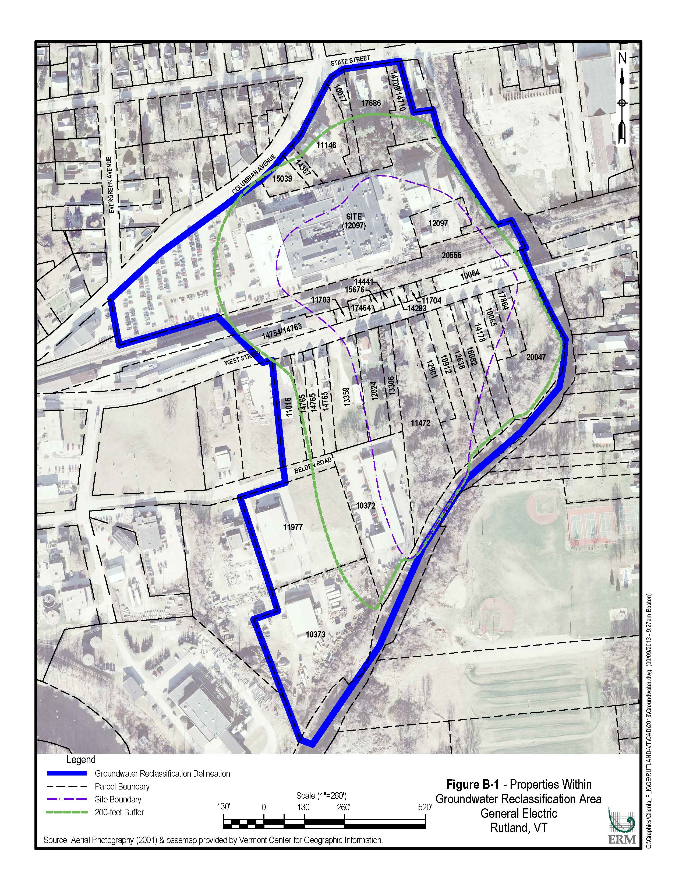
Figure 2: 210 Columbian Ave: Class IV Groundwater Area Parcel Map

