Upper Otter Creek Watershed Council (UOCWC)

Summer 2015

Water Quality Monitoring Program

Submitted by

Rutland Natural Resource Conservation District (RNRCD)
170 South Main Street
Rutland, VT 05701
nanci.mcguire@vt.vacdnet.net

Submitted to
VT Department of Environmental Conservation

Funding to create this report was provided by the City of Rutland through a cooperative agreement with the RNRCD. Report prepared by Kristen Switzer

2015 Upper Otter Creek Water Quality Monitoring Results

Sample Locations

All sampling sites monitored for this project were located in Rutland County on the main stem of the Otter Creek or on significant tributaries to the Otter Creek. The following table lists all of the sites monitored in 2015 and their location in the watershed.

Table 1: Sample names and locations for Upper Otter Creek Watershed Council Summer 2015 water quality monitoring project.

Site | Description
tenn1.0 | Lincoln Avenue (Rotary Park) – Rutland
tenn0.8 | Baxter St. at Confluence with East Creek – Rutland
east0.2 | Off of Meadow Street at recreation area – Rutland
east2.1 | Giorgetti Park – Rutland
moon0.3 | At Forest Street Bridge – Rutland
moon0.9 | At Porter Place – Above Porter Street Bridge to Howe Center - Rutland
moon1.5 | At White’s Playground – Rutland
moon 3.2 | At Charter Hill or RHS (Headwaters) – Rutland
mussey0.1 | At Park Street Bridge - Rutland
mussey0.8 | At Mussey Street Bridge near VT Sport & Fitness

The following maps show the locations of all of the sampling sites in this study:

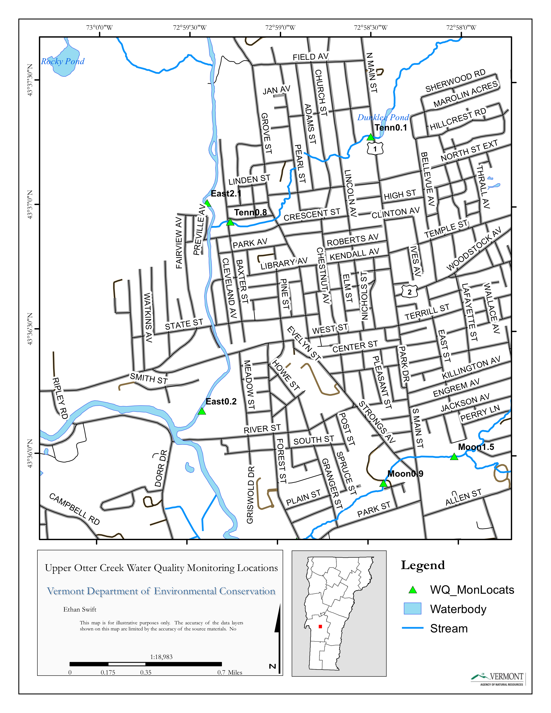

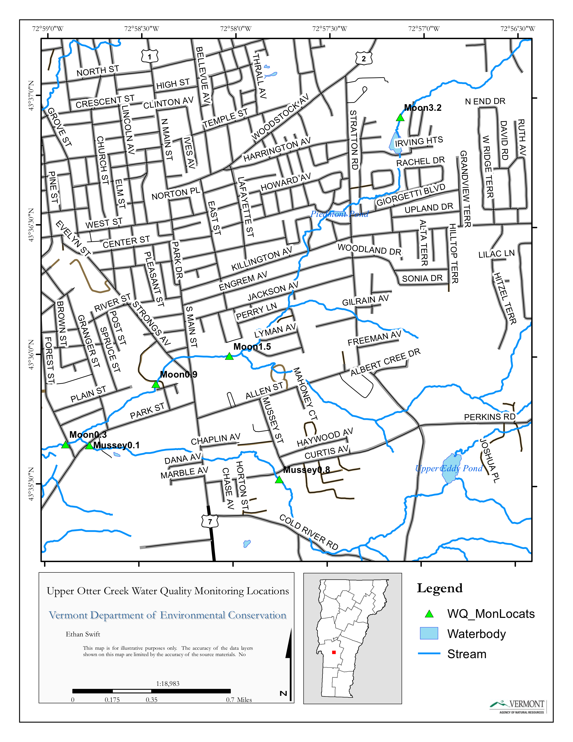

Map source: Ethan Swift (VT DEC)
Methodology

UOCWC followed all training, sample collection and sample transport protocols outlined in their June 2015 QAPP. The training schedule can be found in Appendix A.

Samples were collected at the above ten locations at six dates (every other Tuesday morning between June 23 and September 1, 2015 throughout the summer). 100% of the proposed samples were collected and analyzed. Samples were reviewed for quality assurance (QA) and quality control (QC) and all sample results were compiled and are listed in Appendix B.

Results

E. Coli (Escherichia coli)

E. coli counts measure one type of fecal coliform bacteria found in the digestive tracts of human and other warm-blooded animals. High E. coli levels indicate that fecal waste is being carried over land or through groundwater into streams. People exposed to fecal wastes of sick individuals can develop serious diseases or other health consequences. US EPA sets its recommended limits for E. coli levels in waters where swimming may occur at 235 colonies per 100mL of water, while the Vermont DEC sets their recommended limit for class B waters (current classification for most of the sites monitored) at 77 colonies per 100 ml of water.

Charts 1-3: E. Coli results for Tenney Brook, East Creek, Moon and Mussey Brooks
6/23 7/7 7/21 8/4 8/18 9/1

Many of the creeks measured exceeded State and Federal E. coli standards at some point during the summer. E. coli results for all of Moon Brook (Moon 0.9, Moon 0.3, Moon 3.2, and Moon 1.5) and part of East Creek (East 0.2) were chronically high during the 2015 sampling season. All of the levels fluctuated throughout the summer, but hit very high levels during the 6/23/2015 and 8/4/2015 sample days. East 0.2 also hit high levels during the 7/21/2015 sample period.

Mussey Brook started off with relatively high E. coli levels at the beginning of the summer, but dropped significantly by 7/7/2015. This could be due to the high levels of rainfall we experienced at the start of the summer that cause a lot of runoff into the streams. All of the samples had higher E. coli numbers at the beginning of the sample period.

Turbidity

The amount of turbidity found in water serves to determine its relative clarity. Suspended solids in the water create turbid (murky) conditions and reduce the transmission of light.

Water containing high levels of sediment loses its ability to support a diversity of aquatic organisms, becoming warmer as suspended particles absorb heat from the sunlight and cause depleted dissolved oxygen concentrations. Photosynthesis decreases because less light penetrates the water, resulting in even further drops in oxygen levels. The combination of warmer water, less light and oxygen depletion may make it impossible for some forms of aquatic life to survive.

Turbidity is a measure of sediment levels in the water. High turbidity is often associated with sediments carried in stormwater runoff, though anthropogenic sources such as water from car washing, cleaning of sidewalks or buildings and leaking septic systems can cause increases in turbidity when runoff is low.

Charts 4-6: Turbidity Results for Tenney Brook, East Creek, Moon and Mussey Brooks
6/23 7/7 7/21 8/4 8/18 9/1

6/23 7/7 7/21 8/4 8/18 9/1

All ten samples started of the sampling period with very high turbidity, and then by 7/7/2015 the numbers dropped almost to zero. The highest turbidity levels on that first day of sampling were in all of Moon Brook, Mussey 0.1, and East 0.2. This can be attributed to the heavy rain during our first sample that caused a lot of runoff into the stream and made the water flow very fast. By the end of the summer, water levels had gone down some and the stream had a lot slower flow. For most of the summer, the turbidity levels remained relatively low.

Total Phosphorus

Nitrogen and phosphorus are nutrients that, when above their natural levels in the environment can change the local ecologic balance. Phosphorus is often the nutrient that limits the amount of aquatic plant growth in freshwater systems. Excess phosphorus loading in surface waters in Vermont often contributes to the growth of algae and other plants. This accelerated plant growth may eventually damage stream ecosystems by changing the balance of organic matter, causing algal blooms and by draining the oxygen levels in the water when the plants decompose. Phosphorus is often introduced into the environment through human activities such as improper waste management, over-application of fertilizers, certain industrial wastes and land erosion. Phosphorus binds with soil and is often carried into streams during storms when suspended particulate (see total suspended solids or TSS) levels are high. Under certain conditions, phosphorus may disassociate from the soil and dissolve in the water column, where it may become biologically available for algae growth.

The recently revised and adopted Vermont Water Quality Standards (2014) contain the addition of a new phosphorus criteria framework for lakes and ponds and wadeable streams to comply with EPA's National Strategy for the Development of Regional Nutrient Criteria promulgated under Section 304(a) of the Clean Water Act. For all River Network information (Testing the Waters, Shannon Behar) states that phosphorous concentrations of 0.01 mg/L (10µg/L) or less may have measurable impact on nutrient poor upland streams, while larger rivers could be impacted when concentrations near 0.1 mg/L (100 µg/L). The phosphorus (nutrient) criterion for medium, high gradient streams (Class B) streams in Vermont is now 15 µg/L. The in-lake phosphorus concentration target per the Lake Champlain Phosphorus TMDL for the Otter Creek lake segment is 14 µg/L.

Charts: 7-9: Phosphorus Results for Tenney Brook, East Creek, Moon and Mussey

East 0.2 had a high level of phosphorous at the beginning of the sampling period, as did Mussey 0.1 and all of Moon Brook. The phosphorous levels for the rest of the locations, as well as East 0.2, Mussey 0.1, and Moon Brook for the rest of the sampling period, showed relatively low levels of phosphorous in the water, but still exceeded the water quality criterion for phosphorus in many instances.

Chloride:

Almost all water sources contain chloride, but their concentrations will vary depending on the content of the earth in a given area. Chloride in small amounts is insignificant and safe, but in large amounts they can create problems in the water. Higher concentrations can add palatability to the water, which is desirable at first, but when the concentration gets too high it affects the quality of drinking water. It can give it a salty taste and can add electrical conductivity to the water.

Chloride comes from sources like wastewater from industries, road de-icing, agricultural runoff, and water produced from gas and oil wells. The EPA Secondary Drinking Water regulations recommend a maximum concentration of 250 mg/1 for chloride ions. Numerous technical revisions have been made to toxic substances criteria contained within "Appendix C" of the current Water Quality Standards, including the addition of criteria for chloride (de-icing salt) for consistency with EPA's guidance under Section 304(a) of the CWA.

Charts: 10-12: Chloride results for Tenney Brook, East Creek, Moon and Mussey Brooks

The chloride levels for Tenney Brook remained consistently high throughout the summer. East 0.2 levels jumped up on 7/21/2015, but East 2.1 remained low. The chloride levels for Moon Brook increased gradually throughout our testing period, as did Mussey 0.1. Mussey 0.8 remained at a constant level around 40 mg/L throughout the summer.

Conclusions
In conclusion, East 0.2 and Moon Brook had the most significant levels of nutrients, turbidity, and E. coli results. Mussey also had relatively high levels of nutrients. The Moon and Mussey Brooks are urban streams and may receive fertilizer in runoff from gardens and lawns, as well as stormwater runoff in general. Other urban streams showed moderately elevated levels of chloride, especially the Tenney Brook sites.

East 0.2 is located just downstream from a couple of Combined Sewer Overflows (CSOs) in Rutland City, so there is a lot of potential for runoff and toxins getting into the water. That part of the river was always very cloudy and the other data shows that particular section of East Creek has high levels of E. coli and turbidity as well. A lot of the pollution in the streams is carried there by storm water. At the beginning of the summer, there were several episodes of heavy rainfall that contributed to these persistent conditions in sampled streams for the rest of the sampling period.

Overall, the data showed that nutrients, E. coli, and turbidity levels would all decrease from upstream to downstream. Moon 3.2 is furthest upstream in the Moon Brook, and almost always had the lowest levels. However the order of the other three locations in Moon Brook would change from nutrients to E.coli to turbidity.

The trend of increasing pollutants as the stream progresses suggests that there is a larger input of phosphorous, chloride, and E. coli downstream which then gets somewhat filtered out as the water travels. The lack of inputs further down the stream could also contribute to the decrease in turbidity. Levels of everything that we tested increased as the stream progressed in Tenney Brook.

Appendix A

Sample Coordinator | Nanci McGuire
QA Officer | Ethan Swift
Watershed Coordinator | Ethan Swift
UOCWC sample collection training |  | June 16, 2015 by Ethan Swift
 |  | Nanci McGuire
 |  | Kristen Switzer
 |  | Cindy Oas
 |  | George Hooker

Appendix B- QAQC data

Table 3: Field Duplicate Analysis

Sample Number | Location | Date | Test | Duplicate | Result | Mean Diff | Actual-Duplicate | RPD Dupe Avg
150719-11 | Moon 0.9 | 9/1/2015 | E. coli. | 298.66 | 261.25 | 279.96 | -37.41 | 13.3626
150706-11 | Moon 0.3 | 8/18/2015 | E. coli | 517.21 | 410.58 | 463.90 | -53.31 | 11.4917
150656-11 | East 2.1 | 8/4/2015 | E. coli. | 95.94 | 71.73 | 83.84 | -24.21 | 28.8764
150512-11 | East 0.2 | 7/21/2015 | E. coli | 2419.60 | 2419.60 | 2419.60 | 0 | 0
150439-11 | Tenn 0.8 | 7/7/2015 | E.coli | 142.09 | 123.56 | 132.83 | -18.53 | 13.9502
150438-11 | Tenn 1.0 | 6/23/2015 | E. coli. | 613.14 | 517.21 | 565.18 | -95.93 | 16.9734
 |  |  |  |  |  |  |  | 14.1090
Sample Number | Location | Date | Test | Duplicate | Result | Mean Diff | Actual-Duplicate | Dupe Avg
150719-11 | Moon 0.9 | 9/1/2015 | Chloride | 219.20 | 219.20 | 219.20 | 0 | 0
150706-11 | Moon 0.3 | 8/18/2015 | Chloride | 80.55 | 80.60 | 80.58 | 0.05 | 0.06205
150650-11 | East 2.1 | 8/4/2015 | Chloride | 13.19 | 13.18 | 13.185 | -0.01 | 0.07584
150512-11 | East 0.2 | 7/21/2015 | Chloride | 82.26 | 101.40 | 91.83 | 9.57 | 10.4214
150439-11 | Tenn 0.8 | 7/7/2015 | Chloride | 71.18 | 71.61 | 71.40 | 0.43 | 0.6022
150438-11 | Tenn 1.0 | 6/23/2015 | Chloride | 44.84 | 43.49 | 44.17 | -0.675 | 1.5282
 |  |  |  |  |  |  |  | 2.1149
Sample Number | Location | Date | Test | Duplicate | Result | Mean Diff | Actual-Duplicate | Dupe Avg
150719-11 | Moon 0.9 | 9/1/2015 | Phosphorus | 23.30 | 23.40 | 23.35 | 0.10 | 0.4283
150706-11 | Moon 0.3 | 8/18/2015 | Phosphorus | 29.70 | 27.50 | 28.60 | -2.20 | 7.6923
150656-11 | East 2.1 | 8/4/2015 | Phosphorus | 12.90 | 13.80 | 13.35 | 0.90 | 6.7416
150512-11 | East 0.2 | 7/21/2015 | Phosphorus | 60.90 | 52.40 | 56.65 | -8.50 | 15.0044
150439-11 | Tenn 0.8 | 7/7/2015 | Phosphorus | 27.00 | 27.10 | 27.05 | 0.10 | 0.3697
150438-11 | Tenn 1.0 | 6/23/2015 | Phosphorus | 40.50 | 44.70 | 42.60 | 4.20 | 9.8591
 |  |  |  |  |  |  |  | 6.6826
Sample Number | Location | Date | Test | Duplicate | Result | Mean Diff | Actual-Duplicate | Dupe Avg
150719-11 | Moon 0.9 | 9/1/2015 | Turbidity | 6.47 | 6.54 | 6.505 | 0.07 | 1.0761
150706-11 | Moon 0.3 | 8/18/2015 | Turbidity | 1.68 | 1.98 | 1.83 | 0.30 | 16.3934 | *
150656-11 | East 2.1 | 8/4/2015 | Turbidity | 2.75 | 3.53 | 3.14 | 0.78 | 24.8408 | *
150512-11 | East 0.2 | 7/21/2015 | Turbidity | 2.61 | 2.17 | 2.39 | -0.44 | 18.4100 | *
150439-11 | Tenn 0.8 | 7/7/2015 | Turbidity | 1.85 | 1.87 | 1.86 | 0.02 | 1.0753
150438-11 | Tenn 1.0 | 6/23/2015 | Turbidity | 11.10 | 10.50 | 10.80 | -0.60 | 5.5556
 |  |  |  |  |  |  |  | 11.2252

* These values exceeded the limits for turbidity but are still below standards.

