Upper Otter Creek Watershed Council (UOCWC)
Summer 2017

Water Quality Monitoring Program

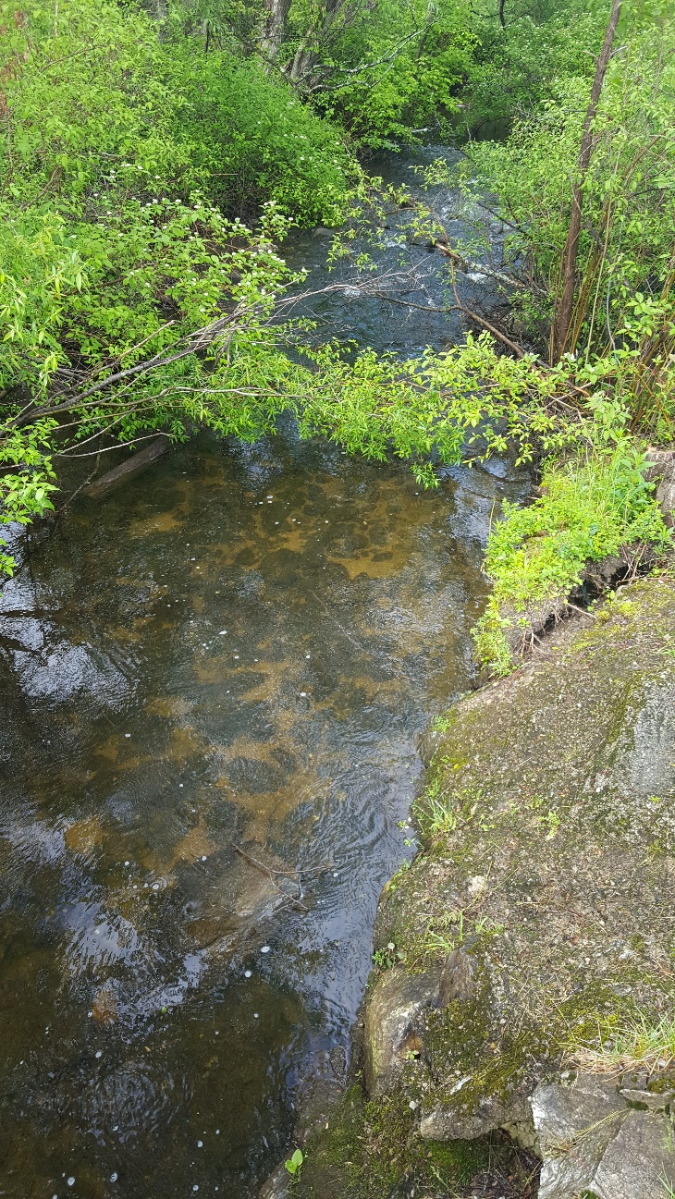
Moon Brook at White’s Park-May 2017

Report prepared by Susan Clark and Barbara Richter
with an introduction by Christina O’Brien

Introduction
Monitoring stream water quality is imperative to understanding natural conditions that support aquatic habitat, and food for many plants and animals. Even small streams can attenuate floodwater from heavy rainfall. Some streams provide drinking water, and many contribute to recreational and commercial uses farther downstream. There are many factors that contribute to the quality of a stream. The four factors analyzed in this study are the levels of Escherichia coli (E. coli), turbidity, total phosphorus, and chloride in multiple areas of four streams in Rutland County that either comprise or contribute to the Otter Creek.

E. coli, or fecal coliform, is a common bacteria found in the digestive systems of humans and animals. It usually enters a stream ecosystem by means of agricultural runoff, wastewater runoff, and other runoff of fecal matter from animals near the stream. The presence of E. coli in recreational water is not usually cause for alarm. However, at high levels, there are human health concerns regarding contact recreation, where such incidental contact can cause cramps, diarrhea, nausea, vomiting, and fever in humans. E. coli is measured by the number of organisms (coliforms) per 100 mL of water or most probable number of organisms (MPN) per 100 mL of water. For Class B Waters, the EPA sets the recommended limit for E. coli at a geometric mean of 126 organisms per 100mL of water over a period of 60 days and at 235 MPN/100mL for a single sample.

Turbidity is a measure of relative clarity of the stream. If a sample of water has a high level of turbidity it means that the water is cloudy or even opaque. Causes of high turbidity include high concentrations of clay, silt, algae, plankton, and/or other microscopic inorganic and organic matter. Heavy rainfall increases turbidity because it is generally accompanied with an increased amount of runoff into the stream which can cause higher flows and more erosive power, thereby eroding stream banks and river beds. Turbidity is often an indicator of runoff into a stream system. Turbidity is measured by shining a light through a sample; the scattered light is measured in nephelometric turbidity units (NTU). The State of Vermont has established a turbidity criterion of 10 NTU for cold-water and 25 NTU for warm-water surface waters (2016 Vermont Water Quality Standards).

Phosphorus is the essential nutrient for plant life and produced naturally from decaying plants and animals, and as mineralized compounds in soil, rocks, and sediment. When phosphorus gets to excessive levels, usually due to fertilizer runoff, manure, and runoff from other organic waste like sewage, it encourages eutrophication and algae growth. As the limiting nutrient in fresh waters, excessive nutrient enrichment can upset the balance of production vs. consumption in the ecosystem if nutrient loading exceeds the assimilative capacity of that system. This can affect aquatic life in a waterbody if the excessive nutrients and biological oxygen demand creates anaerobic conditions. In addition, ingestion of water with high levels of phosphorus can lead to digestive problems in humans. Phosphorus is measured in units of micrograms of phosphorus per liter. The criterion for phosphorus in streams in Vermont is 15 µg/L.

Low levels of chloride are present in almost all water sources due to the dissociation of salts (sodium chloride) in water from natural minerals. In some cases, the predominant source of chloride in surface waters is road use. With the addition of these man-made salts, chloride levels can rise to palpable levels in drinking water, giving it a salty taste. Too much chloride in water also affects the animals that live there. Smaller organisms like plankton are impacted to a greater degree than larger organisms like fish, but these plankton are also important food sources for the fish and help control the algae that contribute to eutrophication. The EPA recommends a maximum concentration of 250 mg/L of chloride ions in secondary drinking water.

Method
Samples were collected from the following eleven locations on seven dates throughout the summer on every other Tuesday morning from June 6th to August 29th.

Table 1: Sample names and locations
Site | Description
Tenn1.0 | Lincoln Avenue (Rotary Park) – Rutland
Tenn0.8 | Baxter Street at Confluence with East Creek – Rutland
East0.2 | Off of Meadow Street at recreation area – Rutland
East2.1 | Giorgetti Park – Rutland
Moon0.3 | At Forest Street Bridge – Rutland
Moon0.9 | At Porter Place – Above Porter Street Bridge to Howe Center – Rutland
Moon1.5 | At White’s Playground – Rutland
Moon3.2 | At Charter Hill or RHS (Headwaters) – Rutland
Mussey0.1 | At Park Street Bridge – Rutland
Mussey0.8 | At Mussey Street Bridge near VT Sport & Fitness

Figure 1: Locations of sampling sites
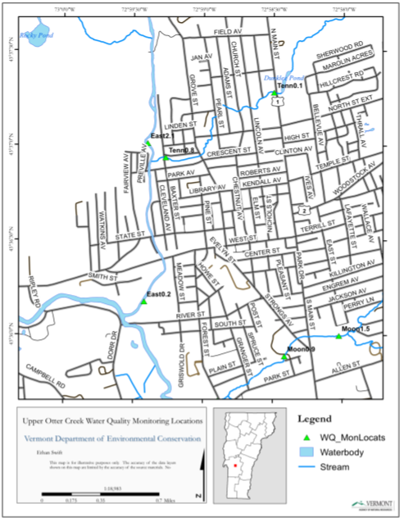

Figure 2: Location of sampling sites
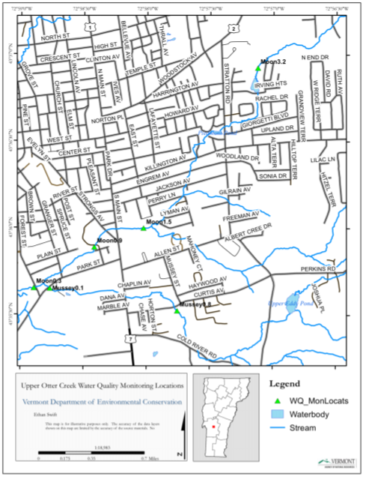
Map source: Ethan Swift, VT DEC
Results:
Figure 3: East Creek Coliform and E.coli

Figure 4: East Creek Turbidity

Figure 5: East Creek Phosphorous

Figure 6: East Creek Chloride

Figure 7: Moon Brook Coliform/E.coli

Figure 8: Moon Brook Turbidity

Figure 9: Moon Brook Phosphorous

Figure 10: Moon Brook Chloride

Figure 11: Mussey Brook Coliform/E.coli

Figure 12: Mussey Brook Turbidity

Figure 13: Mussey Brook Phosphorous

Figure 14: Mussey Brook Chloride

Figure 15: Tenney Brook Coliform/E.coli

Figure 16: Tenney Brook Turbidity

Figure 17: Tenney Brook Phosphorous

Figure 18: Tenney Brook Chloride

Figure 19: Precipitation Rate

Figure 20: Rutland high temperature

Figure 22: Rutland Low temperature

Figure 23: Temperatures on sampling dates

Results:
There are several data points that were lost due to laboratory error or a loss of volunteer samplers. The following data was irretrievable and therefor it cannot be included.
East Creek Omissions:
East creek coliform and e.coli for the 0.2 sample site on August 29th 2017; east creek turbidity for the 0.2 sample site for August 29th, 2017; east creek phosphorous for the 0.2 sample site on August 29th, 2017; The August 29th 2017 chloride data for all of the sampling sites on east creek.
Moon Brook Omissions:
Moon brook coliform and e.coli for the 0.3 and 0.9 sites on June 20th 2017; Moon brook turbidity for the June 20th 2017 is missing from 0.3 and 0.9 sample sites; moon brook site 1.5 is missing turbidity data from July 5th 2017; the June 20th 2017 sampling for moon book is missing phosphorous data for 0.3 and 0.9 sampling locations; the 1.5 sample site is missing phosphorous data for the July 5th sampling date; Moon brook is also without chloride data for the July 5th sampling for all sample locations.
Mussey Brook Omissions:
Coliform and E.coli data are missing from mussey brook for the 0.1 sample site for June 20th 2017 and July 5th 2017; all coliform and e.coli data for mussey brook sites for the August 15th sampling date were lost; Turbidity data is missing from the 0.1 site for June 20th, 2017; Site 0.1 is missing phosphorous for the June 20th 2017 sampling; the 0.1 mussey brook site is also missing the chloride sample for July 5th 2017.
Tenney Brook Omissions:
Coliform and E.coli data were not collected for either site on Tenney brook on August 15th 2017.

Analysis:
Please reference figures 19, 20 and 21, 22 and 23 for precipitation data as well as high and low temperature data for the Rutland region. Throughout the sampling dates there were noted periods of high precipitation. June 6th experienced a rain event that dropped just under an inch of rain in a 24 hour period, June 16th was also a rainy day with an accumulation of over half an inch. June 19th had a total rainfall of over an inch of rain and followed by an event on June 26th that was just shy of an inch within that 24 hour period. July was noticeably drier over all but began with a massive rainstorm that dropped almost 2.4 inches of rain in a day on July 1st 2017. The only other rain event of note occurred on July 13th, where just over a 0.5in of rain fell in a day. August continued to dry out with only two rain events at or above half an inch, one occurring on August third and the second on the 22nd.
Daily temperature stayed within the normal ranges for the season. June’s high temperature hit 90 degrees on June 12th 2017 with the low happening a few days before on June 6th with 50 ºF. In July it got up to 84 ºF on July 12th and the preceded to drop to the low of 51 ºF on July 25th. August experienced a more gradual climb to a high of 87 ºF on August 22nd and the month saw its lowest temp of 56 ºF on the 29th.
Figures 3-6 show the results from the East Creek sample sites. The upstream sampling locations of East creek 10 and East creek 13 had similar coliform/E.coli readings that stayed consistent throughout the summer, mostly staying between 3.06-59.4 mpn/100mL with one slight rise at the east 13 site to 111.23 mpn/100mL on June 20th. The downstream sample sites, east 0.2 and 2.1, saw a big spike in coliform/ e.coli on June 20th with the 0.2 site recording 1553.12 mpn/100mL and the 2.1 site recording 1119.8 mpn/100mL. The two sites decreased to below 250 mpn/100mL for the July 5th reading. The East Creek 0.2 sample location experienced another rise in coliform/E.coli on July 18th rising from the 228.18 reading on July 5th up to 1203.33 on July 18th.The downstream sample locations consistently registered higher levels of these contaminants throughout the summer.
The downstream sample locations of East Creek again followed similar trends when it came to turbidity; with the 0.2 and the 2.1 sample locations following in similar patterns to each other. Both sites saw their highest turbidity reading on June 20th with the 0.2 site at 8.24 NTU and the 2.1 site at 6.79 NTU, they rose again on July 18th with the 0.2 site recording 5.26 NTU and the 2.1 site with 3.51 NTU. The 13 sample site also saw its highest reading of turbidity on July 18th with a 4.58 NTU. The East Creek 10 site had its highest turbidity reading on August 1st with 3.78 NTU. By the end of the sampling cycle all of the sites had decreased turbidity below 1.7 NTU on August 29th 2017.
East creek recorded changing dissolved phosphorous levels throughout the sample period. The downstream sites continued to rise and fall together with the 0.2 site recording the higher phosphorous levels throughout the summer. The one exception is on June 20th when the 2.1 site recorded 48.9 µg P/L and the 0.2 site recorded 48.1 µg P/L. These were the highest phosphorous readings of the summer. The East creek 13 site started the summer with readings of 27.1 µg P/L and gradually declined to a low of 14.4 µg P/L on August 1st 2017 and ended the sampling cycle with two reading of 17.4 µg P/L on August 15th and August 29, 2017.
East Creek chloride levels gradually rose over the course of our sampling cycle. The East Creek 0.2 site began the summer at 21.2 mg/L on June 6th and ended on August 15th with 54mg/L. The East creek 2.1 site started at 14.7mg/L on June 6th and with the exception of a slight drop on July 5th it steadily increased to 32.8mg/L by August 15th. At the 10 sample location chloride levels stayed consistent for the first three sampling and then rose from 2.61mg/L on July 5th to 22.3 mg/L on July 18th; from there the site only experienced minimal reductions in overall chloride to end the sampling period at 17.5mg/L on August 15th 2017. We again see the trend that the higher contaminants were recorded at the downstream locations.
The Moon Brook coliform/E.coli data has some significant gaps and so is hard to interpret. Results show an increase in E.coli at the 1.5 sample site from 34.98 mpn/100mL on June 6th to a summer maximum of 2419.6 mpn/100mL on June 20th. E.coli at all three sample sites on moon brook declined between the July 18th and the August 29th samplings, with no clear distinction between upstream and downstream locations.
Turbidity at Moon brook went through several cycles of boom and bust. The 1.5 site had two peaks in turbidity, one on June 5th with 8.4 NTU and another on August 1st with 4.09 NTU. The two other sites experienced their peak turbidity in the July 18th sampling; the 0.3 site peaked at 6.68 NTU and the 0.9 site peaked at 2.71 NTU.
Phosphorous readings were equally tumultuous at the Moon brook sites. At the Moon brook 0.3 site phosphorous peaked at 36.7 µg P/L on July 18th before declining to 17.6 µg P/L on August, the 0.3 sample site continued to stay below 25 µg P/L for the rest of the summer. The Moon Brook 0.9 site saw a steady increase throughout the sampling period starting at 14 µg P/L on June 6th and ending at 17.6 µg P/L on August 29th. The 1.5 sampling location experienced peak phosphorous at the June 20th sampling with 58 µg P/L and then declined after that, fluctuating slightly to end the sampling period at 17.6 µg P/L on August 29th. The chloride readings for Moon Brook also have some significant gaps making a full analysis difficult, however, chlorine increased by over 40mg/L at every sample site from July 18th- August 29th. Moon brook recorded the highest levels of chloride in this sampling cycle, with the 0.9 sample site recording 120.5mg/L on August 29th 2017.
Mussey Brook is also missing some coliform/E.coli data, making it impossible to identify trend in the data for sample site 0.1. The Mussey brook 0.8 site experienced two spikes in coliform/E.coli over the summer. The first spike was recorded on June 20th when levels rose to a summer maximum of 2419.6 mpn/100mL. The second spike occurred on July 18th but was less dramatic, topping out at 980.39 mpn/100mL. The 0.1 sample site maxed out at 1299.65 mpn/100mL on July 18th 2017. Data shows that the 0.1 site dropped in the two subsequent samplings. The downstream location recorded higher coliform and ecoli throughout the summer.
Mussey Brook recorded the highest levels of turbidity than any other sample site in 2017, with the 0.1 site recording 15.9 NTU on July 5th 2017. The 0.8 sampling location had two spikes in turbidity, the first on June 20th with 14 NTU and the second, less dramatic on July 18th with 4.84 NTU. Again, the downstream location recorded higher turbidity levels than were recorded further upstream.
Mussey brook also recorded the highest levels of phosphorous when compared to the other waterways that were sampled during the summer. Both Mussey brook sampling locations followed similar tends in Phosphorous, both sites fluctuated up and down together throughout the summer. The higher readings were again recorded at the downstream location. On June 20th the 0.8 site recorded 61.7 µg P/L, with only one other spike happening on July 18th when levels reached 30.9 µg P/L. The 0.1 sampling location experienced its peak reading on July 18th with 44 µg P/L. Both sites then dropped and hovered under 16 µg P/L for the last three sample periods.
Mussey brook also saw a slight rise in chloride levels throughout the summer, with the downstream location, 0.1 site, recording more elevated levels than the 0.8 site. The 0.8 sampling site didn’t increase as drastically as its counterpart, it started the collection period on June 6th at 30.2 mg/L and ended at 41.3 mg/L on August 29th. The 0.1 sample location, however, went from 28 mg/L on July 18th and rise to 81 mg/L by August 19th.
Tenney Brook experienced tow distinctive spikes in coliform/e.coli during the sampling period, the first on June 20th and the second on July 18th 2017. The 0.8 site recorded its summer maximum on June 20th with 2419.6 mpn/100mL and the 1.0 site recorded 1732.89 mpn/100mL the same day. During the second spike on July 18th the 1.0 sample site peaked at 2419.6 mpn/100mL and the 0.8 site recorded 1986.29 mpn/mL.
Turbidity peaked twice at the 0.8 Tenney Brook sampling site, one on June 20th with 6.72 NTU and on July 18th with 6.04 NTU. The 1.0 site rose to 5.2 NTU on June 20th and stayed above 4 NTU until it reached 7.34 NTU on August 1st, declining to 2.9 NTU by August 29th.
The phosphorous recorded in Tenney brook rose between the first two sample periods abut then leveled off for the rest of the summer, declining only slightly in the August 29th readings. The 0.8 site rose to 52.2 µg P/L on June 20th and fluctuated between 40-50 µg P/L for the rest of the collection period. The Tenney Brook 1.0 site rise to 38.7 µg P/L on June 20th and stayed consistent for the next two samplings before peaking on August 1st at 47.6 µg P/L and declining to 27.1 µg P/L by August 29th.
Chloride in Tenney Brook saw a sharp decrease at both sample locations between the June 6th and June 20th readings. Both sample sites then gradually began to climb back up towards 70 mg/L by the end of the collection period.
Conclusion:
Particulate matter and dissolved chemicals can enter a waterway through of a variety of means and will be carried downstream flowing with the path of least resistance. It’s not surprising to see increased concentrations of pollutants at sampling locations as they get closer to the confluence with Otter Creek. That is not a hard and fast rule as observed in the data from this sample cycle, sometime sites that were further upstream experienced higher levels of contaminants. The natural conditions and structural impediments to a waterway can cause influence how chemicals and particulate matter travel downstream. The 1.1in of rain that feel on June 19th, combined with temperatures in the 80’s in the three days before seemed to have an impact on the June 20th readings. Almost every site saw an increase in coliform/E.coli, turbidity and phosphorous on June 20th most likely as a result of that rain event.
Moon Brook, Mussey Brook and Tenney Brook all experienced coliform/E.coli levels above 2,000 mpn/100mL throughout the summer. Mussey Brook experienced the highest levels of turbidity reaching 15.9 NTU at the 0.1 site on June 20th; Mussey also saw the highest phosphorous load reaching to 58 µg P/L for the 1.5 sample site on July 5th, 2017. Moon brook had the highest chloride samples of any of the waterways sampled this year. All Moon Brook sample sites recorded over 100 mg/L of chloride by the end of August 2017.
Sources
- https://www.epa.gov/sites/production/files/2014-12/documents/vtwqs.pdf
- https://thewaterproject.org/water-scarcity/health-implications-of-e-coli
- https://water.usgs.gov/edu/turbidity.html
- https://water.usgs.gov/edu/phosphorus.html
- http://www.water-research.net/index.php/phosphate-in-water
- http://www.ruf.rice.edu/~cbensa/Salinity/
- http://cels.uri.edu/docslink/ww/water-quality-factsheets/Chlorides.pdf
- https://archive.epa.gov/water/archive/web/html/index-17.html
- https://www.vacd.org/rcd/images/UOCWC_WQ_Monitoring_Report_2015_FINAL_1-2.pdf
- https://nwis.waterdata.usgs.gov/usa/nwis/uv/?cb_00060=on&cb_00065=on&format=gif_stats&site_no=04282000&period=&begin_date=2016-06-07&end_date=2016-08-30
- http://www.usclimatedata.com/climate/rutland/vermont/united-states/usvt0205/2016/8

