Analysis of Treatment Effectiveness at a   
Livestock Exclusion Site in the Lewis Creek watershed

31 October 2017

Prepared by:

Kristen L. Underwood, PG

South Mountain Research & Consulting

Bristol, VT

Prepared under contract to:

VT Agency of Natural Resources

Watershed Management Division

Montpelier, VT

Table of Contents

Acknowledgements 2

1.0 Introduction 1

2.0 Background 1

2.1 Description of Treatment 1

2.2 Water Quality Monitoring Data 3

2.3 Discharge Data 4

3.0 Statistical Methods 5

4.0 Results 6

5.0 Conclusion 7

6.0 References 8

Appendix A. Historic water quality sampling results from Rublee Farm bracket stations, Lewis Creek.

# Acknowledgements

This document is one of five templates or guidance documents generated by the VT Department of Environmental Conservation (VTDEC) to support watershed groups engaged in ambient water quality monitoring under the LaRosa Partnership Program. These templates provide examples of data reduction and visualization, as well as statistical analysis, that enable more effective communication of the data – to constituents of Partnership groups; to local, state and federal partners in project implementation; and to the VT Agency of Natural Resources for meeting a variety of needs (e.g., listing / delisting of waters, basin planning, prioritization of resources to groups for project implementation). This template has been prepared by South Mountain Research & Consulting of Bristol, VT, under contract to VTDEC.   
  
This template relies on water quality data from the Lewis Creek watershed, where sampling is carried out by a network of trained volunteers operating under the Addison County River Watch Collaborative (fiscal agent, Lewis Creek Association), with logistical and technical support provided by the VTDEC Monitoring, Assessment and Planning Program, the Addison County Regional Planning Commission and South Mountain Research & Consulting. Analytical services are provided by the Vermont Agricultural & Environmental Laboratory in Burlington, VT, (<http://agriculture.vermont.gov/vael>) through an analytical services partnership grant.

1.0 Introduction  
Lewis Creek Association has been monitoring water quality at several stations in the Lewis Creek watershed since 1992 - in later years, coordinated through its membership in the Addison County River Watch Collaborative (ACRWC). Nutrients, sediments, and bacteria are impacting the Creek as a result of channel erosion, land erosion, and non-erosion-related nutrient and pathogen loading (VTDEC, 2012; SMRC, 2010, 2013). Over the years, water quality data have been shared with local, state, and federal partner agencies to support outreach to landowners and farmers and to inform the design of best management practices for water quality improvement. This monitoring report examines historic water quality data at two stations that closely bracketed a livestock exclusion project implemented in 1998 at the Rublee farm in the upper Lewis Creek watershed. A statistical analysis was undertaken to determine the effectiveness of this treatment practice.

Funding for this statistical analysis has been provided to the ACRWC by a LaRosa Laboratory analytical services grant. This report has been prepared for ACRWC by South Mountain Research & Consulting of Bristol, Vermont.

# 2.0 Background

Based, in part, on historic water quality monitoring data, the State of Vermont has listed the following Lewis Creek segments as impaired for contact recreation use due to *E. coli* impacts resulting from agricultural runoff (VTDEC WQD, 2016; see Figure 1):

* Lewis Creek main stem, 12.3 miles from Quinlan Covered Bridge upstream to footbridge at LCR19.5, and
* Pond Brook from confluence with Lewis Creek upstream approximately 1.5 miles.

A *Vermont Statewide Total Maximum Daily Load (TMDL) for Bacteria-impaired Waters* was issued by the VTDEC in 2011 and addresses these Lewis Creek segments in Appendix 5 (VTDEC, 2011).

## 2.1 Description of Treatment

When early water quality data from Lewis Creek were shared with landowners, Les Rublee, a Starksboro farmer, decided to fence his dairy cows out of the Creek. The Rublee Farm is located in the Starksboro village, west of VT Route 116. With help from USDA Natural Resources Conservation Service and Farm Service Agency, Mr. Rublee installed fencing and constructed a livestock bridge for his cows to access pasture areas on the west side of the Creek (Figure 2). Alternate water sources were provided to the livestock, and volunteers from the Lewis Creek Association helped to plant riparian trees and shrubs. The project was completed in late autumn of 1998 (LCA, 1999, *The Kingfisher*).

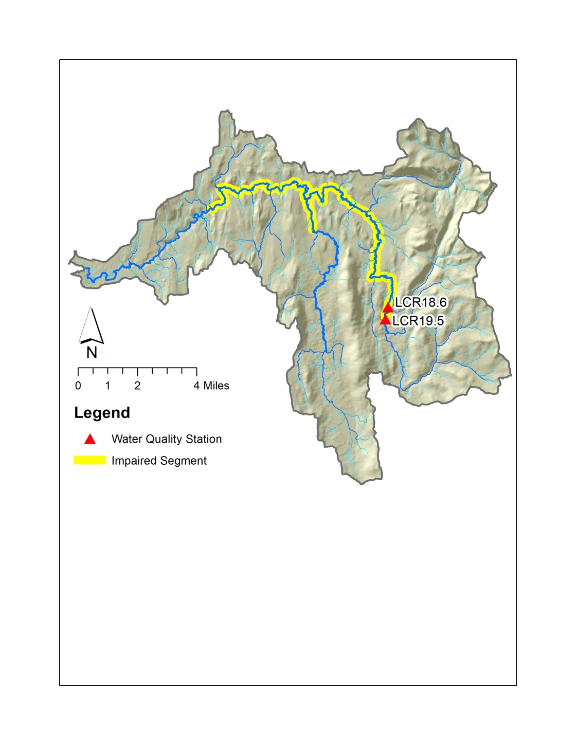

*Figure 1. Location of water quality stations bracketing Rublee farm   
in the 81-square-mile Lewis Creek Watershed*

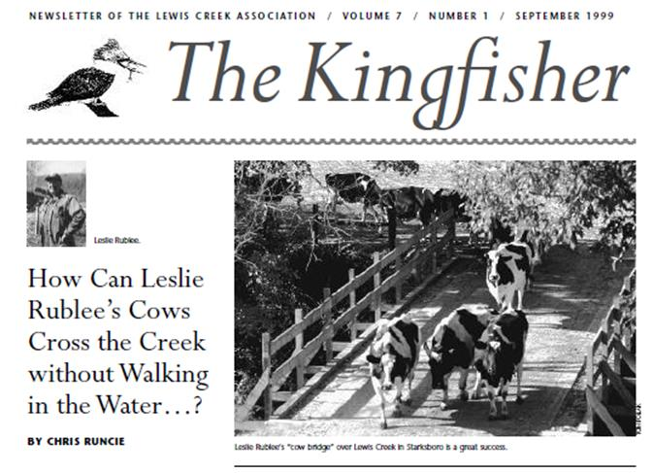

*Figure 2. Article excerpted from The Kingfisher, newsletter of Lewis Creek Association summarizing the installation of a livestock bridge and fencing at the Rublee Farm.*

## 2.2 Water Quality Monitoring Data

More than eight water quality stations have been regularly monitored over the years in Lewis Creek watershed. Two stations happened to closely bracket the Rublee Farm at the upstream end of the impaired segment (Figures 1 and 3):

* Upstream station, LCR19.5, was located at the Parsonage Road bridge; and
* Downstream station, LCR18.6, was located at the site of a former footbridge on the Lewis Creek Farm.

This river reach is classified as a Class B(2) cold-water fishery (VWMD, 2016, App. A, F).

The incremental drainage area between these two stations is relatively small (0.18 square mile) making up only 1.1 % of the total upstream drainage area at LCR18.6 (16.6 sq. mi.). No substantial tributaries enter the Lewis Creek between these two sampling stations (Figure 3a). Land use in this small catchment area (Figure 3b) has remained largely the same since at least 1992 and is characterized by forest cover (15.1%), rural-residential lands (8.3%), and cultivated and hay fields and pasture (75.7 %) of the Rublee Farm (Troy *et al.* 2007; source date: 2001).

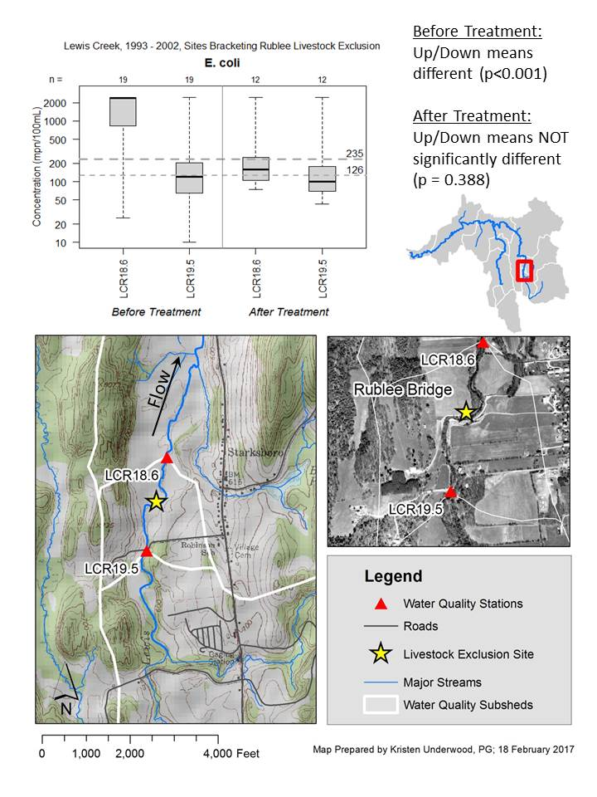

**(b)**

**(a)**

*Figure 3. Location of incremental drainage area between stations LCR19.5 and LCR18.6   
on (a) topographic base map and (b) orthophotograph base dated May 2006.*

Twenty-two years of historic water quality data are available for these two stations. In early years, only *E.coli* was tested; in later years, LCA added testing of Total Phosphorus, Dissolved Phosphorus, Turbidity and Total Suspended Sediments. Water quality sampling was carried out by a network of trained volunteers operating under a VTDEC- and EPA-approved Quality Assurance Project Plan. Samples were collected on pre-determined dates in the summer months as grab samples from wadeable stream reaches at a depth approximately half way between the water surface and bed of the stream. Bottles were stored on ice packs in a cooler until delivery to the laboratory. While current testing is performed at the Vermont Agricultural & Environmental Laboratory in Burlington, VT, in earlier years, analytical services were provided by Endyne, Inc. (2000-2002), and for select years *E. coli* was analyzed at the Middlebury Union High School (1998) and CVU High School (1993 – 1997).

## 2.3 Discharge Data

To determine discharge on a given sample date, LCA relies on records from a United States Geological Survey (USGS) streamflow gaging station (#04282780) on the Lewis Creek located just upstream from the US Route 7 crossing. This station measures flow from an approximate drainage area of 77.2 square miles, or 95% of the watershed (USGS, 2017). A discharge is assigned for each sample date based on reference to the daily mean flow recorded at this gage, applying a correction factor for the proportional drainage area at each station.

Figure 4 presents a flow duration curve computed on daily mean flows recorded for water years 1991 through 2015. Flows have been categorized following VTDEC *Guidance on Streamflow Observations at time of Water Quality Sampling of Rivers and Streams*. High flows are defined as those flow conditions which are equaled or exceeded only 25% of the time, and low flow levels are those equaled or exceeded more than 75% of the time, while those flows occurring between 25 and 75% of the time are classified as moderate.

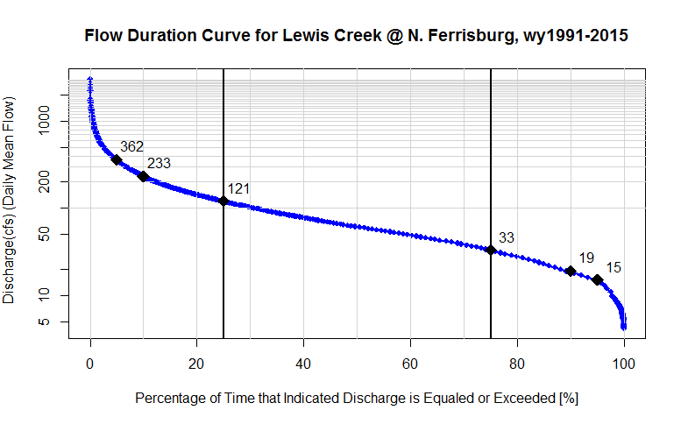  
*Figure 4. Flow Duration Curve for Lewis Creek at Ferrisburgh, VT (USGS Stn# 04282780).  
Indicated values (black diamonds) correspond to the discharge that is exceeded 5%, 10%, 25%, 75%, 90% and 95% of the time (reading from left to right). Based on approved daily mean flow record for water years: 1991 – 2015.*

Low Flows

Moderate Flows

High Flows

# 3.0 Statistical Methods

To evaluate treatment effectiveness of livestock exclusion practices at the Rublee Farm, a statistical t-test was applied to compare water quality upstream of the farm (at LCR19.5) to water quality downstream of the farm (at LCR18.6) for each of two time periods: pre-treatment and post-treatment. A t-test was chosen, since a livestock exclusion project was expected to manifest in a step trend (or abrubt shift) in water quality concentrations (Meals *et al*., 2013). During the immediate years spanning livestock exclusion, *E.coli* was the only water quality parameter being tested by LCA; therefore, the statistical test described below is limited to *E.coli* and does not consider other water quality parameters.

Under a parametric, one-sided, two-group t-test (unequal variances, Welch approximation), two groups are compared, and a null hypothesis is formulated: namely, that the mean of Group 1 is less than or equal to the mean of a Group 2 (Helsel & Hirsch, 2002). In our case, Group 1 was defined as the set of *E.coli* measurements collected at upstream station LCR18.6, and Group 2 was defined as the set of *E.coli* measurements collected at downstream station LCR19.5. A small p value less than the established level of significance (*α* = 0.05) rejects this null hypothesis, and it can be concluded that there is a statistically significant difference between group means. A p value greater than α fails to reject the null hypothesis, and the available data are insufficient to conclude whether there is a significant difference between group means.

Greater than two years of data for each of the pre- and post-treatment phases are required for discerning a step trend (Hirsch, 1988; Meals *et al*., 2011). Available data (Attachment 1) allowed for examination of four-year time spans before (1993- 1997) and after (2000-2003) installation of the bridge and fencing, which occurred in 1998 (Table 1). (No testing results for *E.coli* were available from 1999, and sampling at LCR18.6 was suspended in 2004). Water quality results were subset to exclude those measurements collected during high flows, since high flows might be expected to deliver additional non-livestock sources of *E.coli* from the direct watershed and upstream that could confound the analysis. Early *E. coli* results (from 1994 – 1997) were truncated at a value of >2,420 MPN/100mL, in order to be reported in a manner consistent with more recent data analyzed by Standard Methods 9223-B (2000 – 2003). The analytical methods used to measure *E.coli* concentrations differed somewhat between the two periods (before and after treatment). However, this statistical test compared the upstream vs downstream station results for one method (before treatment) separately from upstream vs downstream station results for the other method (after treatment). Ideally, evaluation of treatment effectiveness would utilize consistent analytical methods throughout pre-treatment and post-treatment monitoring. However, testing at these sites is historic in nature and was not expressly designed to measure effectiveness of livestock exclusion.

*E.coli* concentration data were log10 transformed to approximate a normal distribution for use in the parametric t-test method. The data for LCR19.5 (Group 2) before treatment was normally distributed (after log-transformation) based on a Shapiro-Wilks test of normality at α = 0.05. Other transformed data sets were approximately normally-distributed when viewed on a quantile-quantile plot.

*Table 1. Summary of E.coli Concentrations by Station*



# 4.0 Results

Figure 5 shows the distribution of *E.coli* count data for the downstream and upstream stations for the pre- and post-treatment time periods. Vermont Water Quality Standards (VWMD, 2016) state that *E.coli* is not to exceed a geometric mean of 126 org /100mL obtained over a representative period of 60 days, and no more than 10% of samples should be above 235 org/100 mL. The latter standard is a health-based number established for the protection of contact recreation users. These standards are depicted by the horizontal dashed gray lines on the plot in Figure 5.

A one-sided, two-group t-test determined that the mean *E.coli* concentrations downstream (LCR18.6) and upstream (LCR19.5) of the Rublee farm were significantly different in the years before treatment (1994-1997). The null hypothesis (that the downstream mean is less than or equal to the upstream mean) was rejected at a significance level, α, equal to 0.05 (*p* < 0.001). The one-sided t-statistic (t = +4.85) indicates that the mean *E.coli* concentration for the downstream station was significantly greater than the mean for the upstream station.

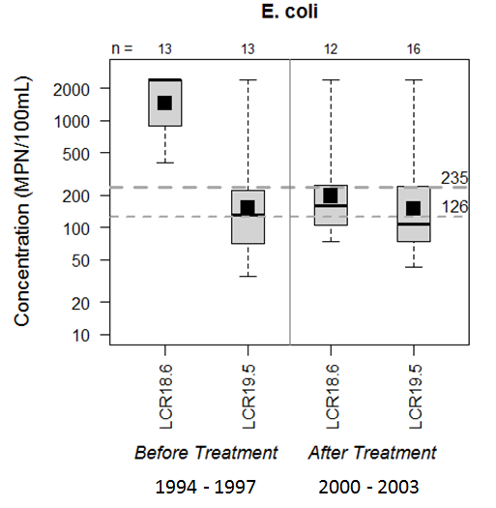

*Figure 5. Distribution of E. coli concentrations by station, before and after treatment.*

In contrast, for the years after treatment, the *E.coli* mean values at upstream and downstream stations were not significantly different (*p* = 0.190). Thus, during post-treatment years, the contribution of *E.coli* from the incremental drainage area between these two stations was not substantial as measured during discrete summer-time, low to medium discharge conditions. Water quality at the downstream station dropped by an order of magnitude, such that a majority of the detected values were below the health-based standard of 235 MPN/100 mL following livestock exclusion at the Rublee Farm.

# 5.0 Conclusion

A statistical analysis has been completed to evaluate the effectiveness of livestock exclusion efforts at the Rublee Farm in 1998, based on historic summer-time *E.coli* monitoring data for two Lewis Creek water quality monitoring stations that closely bracketed the farm. A two-group t-test was applied to compare water quality upstream of the farm (at LCR19.5) to water quality downstream of the farm (at LCR18.6) for each of two time periods: pre-treatment (1993-1997) and post-treatment (2000-2003). In the years before treatment, the mean *E.coli* concentration at the downstream station was significantly greater than the mean concentration at the upstream station, likely reflecting contributions of fecal matter from pastured livestock with unrestrained access to the Lewis Creek. Following livestock exclusion from the Creek, water quality at the downstream station dropped by an order of magnitude, such that a majority of the post-treatment detected values were below the health-based standard of 235 MPN/100 mL.

# 6.0 References

EPA, 2016. Monitoring and Evaluating Nonpoint Source Watershed Projects. https://www.epa.gov/nps/monitoring-and-evaluating-nonpoint-source-watershed-projects

Helsel, D.R., and R.M. Hirsch. 2002. Statistical Methods in Water Resources. Book 4, Chapter A3 in *Techniques of Water-Resources Investigations*. U.S. Geological Survey, Reston, VA. Accessed February 10, 2016. http://pubs.usgs.gov/twri/twri4a3/.

Hirsch, R. M., 1988, Statistical methods and sampling design for estimating step trends in surface water quality. *Water Resourc. Res*., 24: 493-503.

Meals, D. W., J. Spooner, S. A. Dressing, J. B. Harcum, 2013, Statistical analysis for monotonic trends, Tech Notes 6, Developed for U.S. Environmental Protection Agency by Tetra Tech, Inc., Fairfax, VA, 23 p. Available online at: https://www.epa.gov/sites/production/files/201605/documents/  
tech_notes_6_dec2013_trend.pdf

South Mountain Research & Consulting, 2013, Water Quality Management Plan: Pond Brook Tributary, Lewis Creek Watershed, prepared under contract to Lewis Creek Association.

South Mountain Research & Consulting, 2010, Lewis Creek Watershed: River Corridor Conservation & Management Plan, Addison & Chittenden Counties, Vermont, prepared under contract to Lewis Creek Association.

Troy, Austin, Deane Wang, & David Capen, 2007. Updating the Lake Champlain Basin Land Use Data to Improve Prediction of Phosphorus Loading, Lake Champlain Basin Program, Technical Report No. 54.

USGS, 2017, on-line surface water data, <http://waterdata.usgs.gov/vt/nwis>.

VTDEC, 2011, *Vermont Statewide Total Maximum Daily Load (TMDL) for Bacteria Impaired Waters*, prepared by FB Environmental Associates, Inc., Portland, ME. and Appendix 5. Available at: http://dec.vermont.gov/sites/dec/files/wsm/mapp/docs/mp_bacteriatmdl.pdf http://dec.vermont.gov/sites/dec/files/documents/WSMD_mapp_5lewiscreekpondbrook.pdf

VT DEC Water Quality Division, 2016, *State of Vermont 2016 303(d) List of Waters*: *Part D – Impaired Surface Waters in Need of TMDL*.

Vermont Watershed Management Division, 2016. *Vermont Water Quality Standards*.   
Effective 15 January 2017. Montpelier, VT. Available at: http://dec.vermont.gov/sites/dec/files/documents/wsmd_water_quality_standards_2016.pdf

Appendix A. Table A1. Historic water quality sampling results from Rublee Farm   
bracket stations, Lewis Creek.



Table A1 (continued).





Table A1 (continued).





Table A1 (continued)

.



Table A1 (continued)

.

