Analysis of Spatial Patterns in Water Quality

in the Little Otter Creek watershed

31 October 2017

Prepared by:

Kristen L. Underwood, PG

South Mountain Research & Consulting

Bristol, VT

Prepared under contract to:

VT Agency of Natural Resources

Watershed Management Division

Montpelier, VT

Table of Contents

Acknowledgements 3

Executive Summary 4

1.0 Introduction 1

2.0 Background 1

2.1 Description of Watershed 1

2.2 Water Quality Monitoring Sites 1

2.3 Discharge Measurement 2

3.0 Methods 4

3.1 Meterological Conditions 4

3.2 Sample Collection and Analysis 4

3.3 Quality Assurance / Quality Control 5

4.0 Results and Discussion 5

4.1 Meteorological and Hydrological Conditions 5

4.2 Water Quality Results 7

4.2.1 Turbidity 7

4.2.2 E.coli 9

4.2.3 Phosphorus 11

4.2.4 Nitrogen 13

5.0 Conclusions 14

6.0 References 15

Attachment 1. Soil Parent Materials, Little Otter Creek Watershed

Attachment 2. Land Cover / Land Use, Little Otter Creek Watershed

Attachment 3. Water Quality Data

# Acknowledgements

This document is one of five templates or guidance documents generated by the VT Department of Environmental Conservation (VTDEC) to support watershed groups engaged in ambient water quality monitoring under the LaRosa Partnership Program. These templates provide examples of data reduction and visualization, as well as statistical analysis, that enable more effective communication of the data – to constituents of Partnership groups; to local, state and federal partners in project implementation; and to the VT Agency of Natural Resources for meeting a variety of needs (e.g., listing / delisting of waters, basin planning, prioritization of resources to groups for project implementation). This template has been prepared by South Mountain Research & Consulting of Bristol, VT, under contract to VTDEC.   
  
This template relies on water quality data from the Little Otter Creek watershed, where sampling is carried out by a network of trained volunteers operating under the Addison County River Watch Collaborative (fiscal agent, Lewis Creek Association), with logistical and technical support provided by the VTDEC Monitoring, Assessment and Planning Program, the Addison County Regional Planning Commission and South Mountain Research & Consulting. Analytical services are provided by the Vermont Agricultural & Environmental Laboratory (<http://agriculture.vermont.gov/vael>) in Burlington, VT, through an analytical services partnership grant.

# Executive Summary

Spatial trend analysis has been undertaken for eight stations in the Little Otter Creek watershed, relying on water quality data collected during six discrete events in the spring and summer of 2016 - a drier-than-normal year. Objectives of this monitoring effort were to: (1) better define the extent and magnitude of sediment and nutrient concentrations in the watershed; (2) identify pollution source areas; and (3) share monitoring results with the public and with partner agencies engaged in the design of restoration and conservation practices that improve water quality. This 2016 monitoring effort has expanded the spatial resolution of water quality data in this catchment, to include more information about headwater areas.

Turbidity and Total Phosphorus each exhibited an increasing trend in concentration with distance downstream on the main stem, particularly between Plank Road in New Haven and the Route 7 bridge in Ferrisburgh - areas dominated by fine-grained glacial lake soils, developed with agricultural and rural residential land uses.

*E. coli* counts at four of the stations exceeded the state’s geometric-mean-based water quality standard, including a newly-established station approximately one mile upstream of an existing impaired segment in the headwaters. While additional monitoring is warranted, these 2016 results suggest that the length of the upper Little Otter Creek channel impaired for contact recreation uses may be greater than historic data suggest. Elevated Total Nitrogen in these same headwater segments indicates the presence of water quality stressors from developed or agricultural land uses.

These 2016 results suggest the need for additional focus along the upper main stem to discern source areas for elevated nitrogen and *E.coli*. Additionally, middle and lower portions of the watershed appear to be high loaders of phosphorus and turbidity, as further supported by a past loading study (SMRC, 2011). Monitoring results have been shared with partner agencies including the VT Agency of Agriculture, UVM Extension, USDA Farm Service Agency, Otter Creek NRCD, and the VT Department of Environmental Conservation to support outreach to landowners and farmers and to inform the design of best management practices by these partner agencies.

The Little Otter Creek will continue to be a focus watershed in 2017, with the same sentinel and rotational sites monitored for *E.coli*, total and dissolved phosphorus, total nitrogen, and turbidity. Given the elevated nitrogen concentrations at upper main stem sites, an additional lab analysis has been scheduled to detect nitrite and nitrate forms of nitrogen, in order to evaluate nitrogen levels with respect to the water quality standard. In a future focus study, additional bracketing of source areas in the upper headwaters would be warranted to define sources of elevated nitrogen and *E.coli*, pending landowner access.

# 1.0 Introduction

The Addison County River Watch Collaborative (ACRWC) has been monitoring water quality in the Little Otter Creek since 1997. Phosphorus, nitrogen, suspended sediments, and *E. coli* are impacting the Creek as a result of channel erosion, land erosion, and non-erosion-related nutrient and pathogen loading (VTDEC, 2012; SMRC, 2011). In the 2016 season, the Little Otter Creek was the subject of a more intensive monitoring focus, where additional stations were established to better define spatial variability in pathogen, sediment and nutrient concentrations. Specific objectives of this focus monitoring effort were to: (1) better define the extent and magnitude of sediment and nutrient concentrations in the watershed; (2) identify pollution source areas; and (3) share monitoring results with the public and with partner agencies engaged in the design of restoration and conservation practices that improve water quality. This spatial trend monitoring report examines 2016 water quality at eight stations sampled monthly from April through September.

# 2.0 Background

## 2.1 Description of Watershed

The Little Otter Creek watershed is a 72.5-square-mile basin located in Addison County, Vermont, which drains directly into Lake Champlain at Hawkins Bay south of Gardner Island. The watershed is located wholly within the Champlain Valley physiographic province (Stewart, 1973). The surficial sediments and soils present in the Little Otter Creek watershed reflect the glacial and post-glacial lake history of the region. The central and western portions of the watershed are dominated by silt loams derived from silty-clay deposits in post-glacial lake environments (Attachment 1). Generally, these soils have a low to very low infiltration rates, leading to ponding of water on flat surfaces and generating runoff of steeper surfaces. Sandier, lighter soils of greater permeability, tend to be associated with localized deposits of glaciofluvial and alluvial origin, and are concentrated along the eastern side of the watershed and in isolated pockets along the river network (Stewart, 1973; Stewart & MacClintock, 1969; USDA 2013, 2011).

Land use in the Little Otter Creek watershed is estimated as 51.7% agricultural, 33.7% forested, and 9.2% developed. Included within the developed category are transportation corridors (i.e., roads and railroads) and population centers of Bristol village and Ferrisburgh. Forest cover is somewhat more abundant in the northeastern extremes of the watershed. Higher densities of agricultural activities are present on the gently-sloping, silt and clay-rich soils found in the central and western portions of the watershed (Attachment 2).

## 2.2 Water Quality Monitoring Sites

Two sentinel stations have been established to track long-term variations in water quality resulting from naturally-fluctuating weather and vegetation, but also human-influenced factors such as shifting land use or changes in management practices (Figure 1; Table 1). Sentinel station LOC4.3 is located within a 7.8-mile river segment that is listed as impaired for contact recreation use (Figure 1) due to *E.coli* from agricultural runoff (303D list, Part D, VTDEC, 2016a) and is the subject of an EPA-approved Total Maximum Daily Load for Bacteria (VTDEC, 2011). Sentinel station MDC1.2 is located on Mud Creek tributary within a 4-mile segment that is considered stressed by *E.coli* from agricultural runoff that may be impacting contact recreation uses of these waters (VTDEC, 2016b). Stressed waters are those which meet VT Water Quality Standards (VTWMD, 2016), but attainment of highest water quality has been compromised by the presence of stressors (VTDEC, 2016b).

In 2016, three new water quality monitoring stations were established in the watershed to complement the existing sentinel stations and three rotational stations monitored during a previous focus effort in 2010 and 2011 (stations LOC7.8, LOC10, and LOC14.4). Station LOC20.3 was established at the Sawyer Road Bridge crossing of the upper Little Otter Creek. A one-mile segment of the river spanning this station is listed as impaired for aquatic life support uses due to nutrients and sediment resulting from agricultural runoff (303D List, Part A, VTDEC, 2016c). This segment is also addressed in the *Vermont Statewide Total Maximum Daily Load (TMDL) for Bacteria-impaired Waters* due to impairment for contact recreation uses resulting from elevated *E.coli* (VTDEC, 2011). A second station was established at LOC21.5, approximately one mile upstream of this Sawyer Road crossing and west of Burpee Road. A third new station (LOCNB0.2) was set up at the Plank Road crossing of Norton Brook a tributary to Little Otter Creek draining The Watershed Center and adjacent agricultural lands in northwest Bristol. All eight stations are located on river segments classified as Class B(2) cold-water fisheries (VWMD, 2016, App. A, F).

## 2.3 Discharge Measurement

The United States Geological Survey (USGS) maintains a streamflow gaging station on the Little Otter Creek just downstream from LOC4.3. Station #04282650 is located near the US Route 7 crossing and measures flow from an approximate drainage area of 57.1 square miles, or 79% of the watershed (USGS, 2017). This station has daily flow records dating back to 1990. ACRWC assigns a discharge for each sample date based on reference to the daily mean flow recorded at this gage, applying a correction factor for the proportional drainage area at each sampling station. This method approximates discharge at the sample station, but may over- or under- estimate the actual flow value, due to natural variability in precipitation and river flow patterns across the watershed.

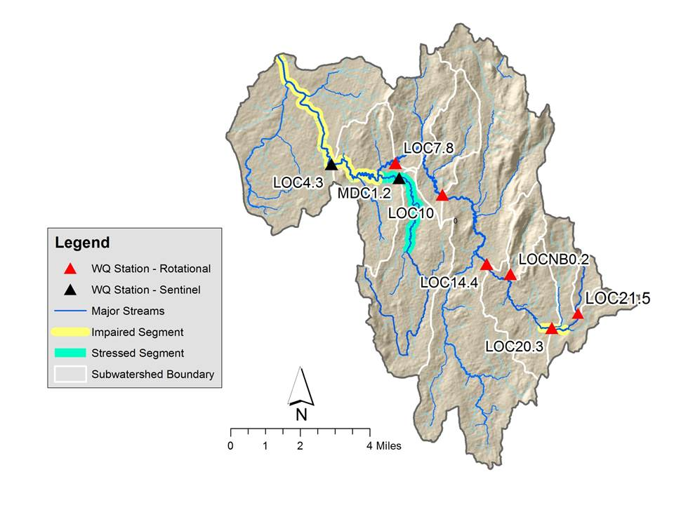

*Figure 1. Location of sentinel and rotational stations in Little Otter Creek watershed,   
along with river segments considered stressed or impaired as described in the text.*

*Table 1. List of water quality monitoring stations in the Little Otter Creek watershed.*



Figure 2 presents a flow duration curve computed on daily mean flows recorded for water years 1991 through 2014. The “water year” is a standard measure of time in hydrology which begins October 1st of the previous calendar year and extends through September 30th of the indicated year. Flows have been categorized following VTDEC *Guidance on Streamflow Observations at time of Water Quality Sampling of Rivers and Streams*. High flows are defined as those flow conditions which are equaled or exceeded only 25% of the time, and low flow levels are those equaled or exceeded more than 75% of the time, while those flows occurring between 25 and 75% of the time are classified as medium.

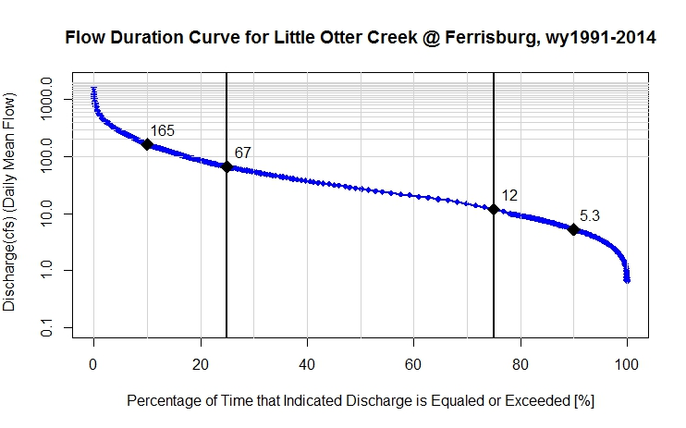  
*Figure 2. Flow Duration Curve for Little Otter Creek at Ferrisburgh, VT (USGS Stn #04282650). Indicated values (black diamonds) correspond to the discharge that is exceeded 10%, 25%, 75% and 90% of the time (reading from left to right). Based on approved daily mean flow record for water years: 1991 – 2014.*

High Flows

Moderate Flows

Low Flows

# 3.0 Methods

Water quality sampling in the Little Otter Creek is carried out by a network of trained volunteers operating under a VTDEC- and EPA-approved Quality Assurance Project Plan (QAPP).

## 3.1 Meteorological Conditions

To characterize meteorological conditions during sampling, ACRWC relies on a network of weather stations and data reported by the National Oceanic and Atmospheric Administration (NOAA). Additionally, weather conditions on the sample date, and three previous days, are recorded on field sampling data sheets to capture current and antecedent weather conditions for each sample date, local to the sampling stations.

## 3.2 Sample Collection and Analysis

Monthly samples were collected on pre-determined dates in the spring (April 6 and May 4) and summer (June 1, July 6, August 3, and September 7) of 2016. Samples were collected as grab samples from wadeable stream reaches at a depth approximately half way between the water surface and bed of the stream. Samples were analyzed for *E.coli*, phosphorus (total and dissolved), total nitrogen, total suspended solids, and turbidity; *E.coli* was scheduled for analysis only on the summer dates. Bottles were stored on ice packs in a cooler until delivery to the Vermont Agricultural & Environmental Laboratory in Burlington, VT. Filtering of dissolved phosphorus samples was conducted in the lab within 6 hours of sampling by trained ACRWC personnel, using a Gelman 0.45-*µ*m filter.

## 3.3 Quality Assurance / Quality Control

In accordance with the QAPP, field duplicates and field blanks were collected at a 10% frequency during each monthly event by ACRWC. The location of the field duplicate was rotated from month to month. To prepare field blanks, bottles for each scheduled analyte were filled with lab-supplied deionized water and accompanied the regular sample bottles during transport in the field and to the lab. Results of regular and field duplicate pairs from selected stations were evaluated and the average of the Relative Percent Difference (RPD) in results for each constituent was compared to a data quality goal, specified in the QAPP.

# 4.0 Results and Discussion

## 4.1 Meteorological and Hydrological Conditions

Overall, calendar year 2016 was a below-normal precipitation year, as recorded at weather stations in South Burlington (Airport) and Rutland; all sampling months (April – September) saw lower than normal precipitation (with “normal” defined as the average condition for years 1981 through 2010; NOAA, 2017). Snowfall in the winter of 2015–2016 was far below normal at the Burlington airport and Rutland stations (NOAA, 2017). The region was in a moderate drought condition for much of the year (US Drought Monitor, 2017). Based on records for the USGS streamflow gage on Little Otter Creek, mean annual flow was below normal for water year 2016 (USGS, 2016).

April and May sampling events took place during moderate and high flow conditions, respectively (Table 2). Given below-normal rainfall, the June, July, August and September events occurred during low to very-low flows representing baseflow conditions (i.e., relatively stable flow stage, not significantly rising or falling in response to a rainfall or snowmelt event). Daily mean discharge on the July, August and September dates (Table 2) was below the Low Median Monthly (LMM) flow for the Little Otter Creek (i.e., 6.6 cfs - B. Hastings, VTDEC, personal communication, 14 Jan 2014). Discharge on all six sample dates was much lower than flows occurring during February thaw and final ice-out and snowmelt in early March (Figure 3).

*Table 2. Daily Mean Flows recorded at USGS gage on   
Sample Dates in 2016, Little Otter Creek.*





*Figure 3. Daily mean discharge recorded for Little Otter Creek (USGS Stn #04282650)   
during 2016. Sample dates are indicated by black square symbols.*

## 4.2 Water Quality Results

Little Otter Creek sample results for 2016 are tabulated in Attachment 2. April and May samples were not able to be collected at station LOC21.5, due to a delay in securing landowner permission. For the June 1 event, no Total Phosphorus (TP) result was reported for the sample collected at station LOC7.8. Field data sheets and sample delivery check sheets indicate that this sample was collected and delivered to the lab. Lab notes indicate that this sample for TP was “not found” upon lab check in. Total Suspended Sediment (TSS) results for the July 6 event were flagged “JD”indicating that these values should be considered as estimates, due to a field duplicate RPD value above the accepted data-quality goal (Attachment 2).

### 4.2.1 Turbidity

Turbidity levels reported for the Little Otter Creek stations ranged from 0.5 to 156 NTUs over the six sample dates. The Vermont state standard of 10 NTUs (for Class B cold-water fisheries) is applicable during dry-weather, baseflow conditions (VWMD, 2016), which were relevant to the April, and June through September events (Table 2). The distribution of Turbidity concentrations for the six sampling events is displayed in the box-and-whisker plot below (Figure 4). The main stem sites in Figure 4 are ordered from downstream to upstream (left to right). Consistent with past years’ sampling results, the Turbidity values tend to increase with distance downstream along the main stem. The middle to lower regions of the watershed are dominated by fine-grained silts and clays derived from glacial lake sediments (Attachment 1; ACRWC & SMRC, 2016), and these fine grains are eroded from the channel margins during a broad range of flows, leading to frequently turbid conditions. Turbidity can become particularly elevated at times of high flow – with concentrations ranging up to 500 NTUs based on historic results from 2010 through 2015 (ACRWC & SMRC, 2016).

Figure 5 displays the spatial distribution of Turbidity across the watershed, as a mean concentration detected during the five dry-weather, baseflow events in 2016. The mean Turbidity concentration in mid- to-downstream stations exceeded the VT water quality standard of 10 NTUs.

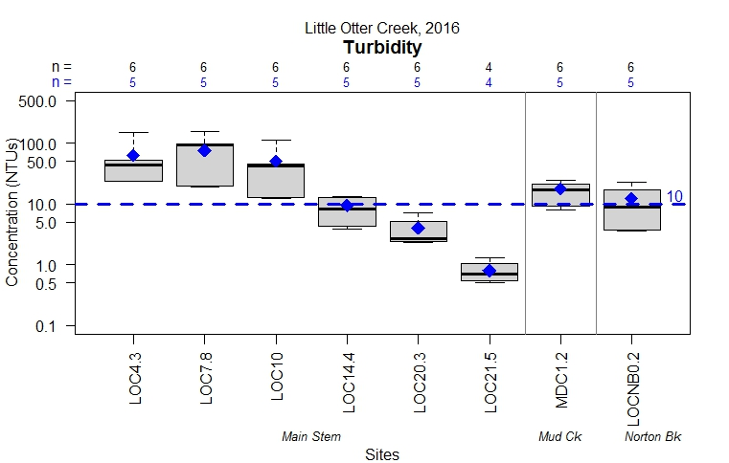

*Figure 4. Summary of Turbidity Results for Little Otter Creek, 2016. Whiskers extend to the maximum and minimum values detected over the six sampling events. Gray-shaded box represents the middle 50% of the results. The median value is marked by the dark horizontal line. The blue diamond marks the mean of that subset of samples collected during dry-weather, baseflow conditions, with the corresponding number of samples (n) indicated in blue along the top of the chart.*

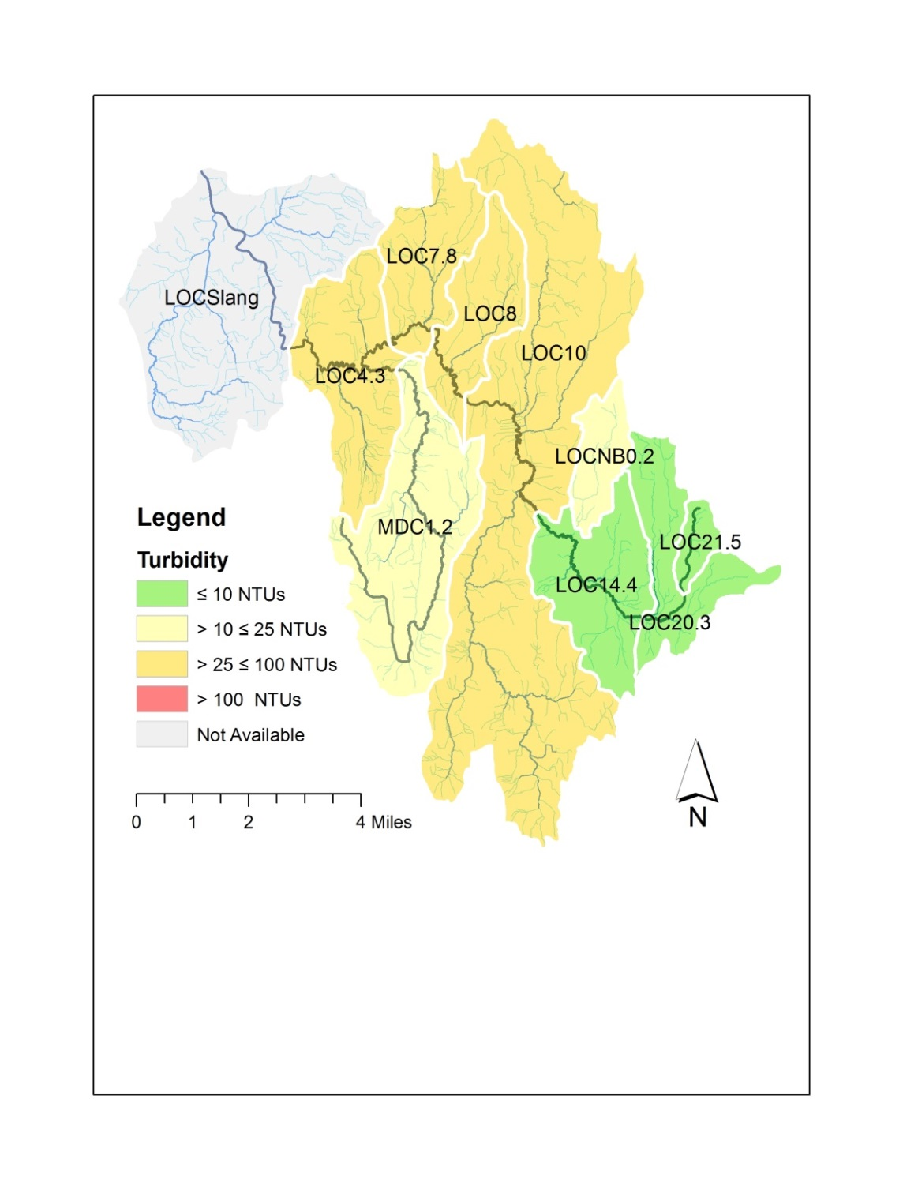

*Figure 5. Mean value of Turbidity detected during five 2016 sample events, exhibiting dry-weather, baseflow conditions, Little Otter Creek. Note: mean value for station LOC21.5 is based on only four events (June – September).*

ACRWC has been sampling Total Suspended Solids (TSS) in select watersheds during focus years to establish a relationship between TSS and Turbidity, and to enable coarse loading estimates of sediment and sediment-related constituents such as particulate phosphorus (estimated as the difference between Total and Dissolved Phosphorus). Figure 6 displays Turbidity concentration versus TSS concentration for the eight Little Otter Creek stations for all six 2016 events. The relationship is linear in nature, and could be used to estimate TSS concentrations based on Turbidity during years when TSS is not tested.

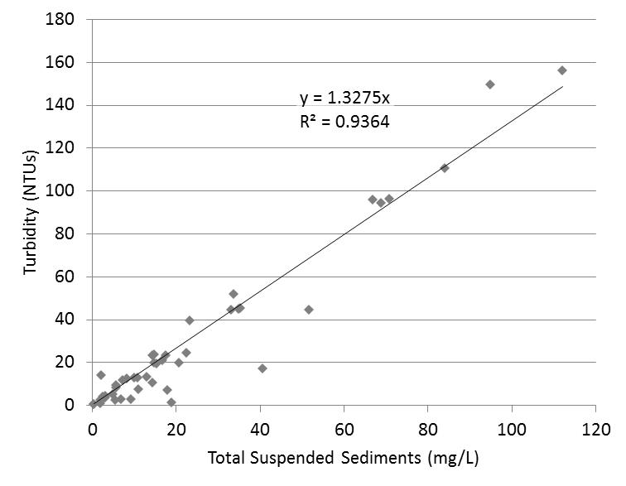

*Figure 6. Relationship between Turbidity and TSS for eight Little Otter   
Creek stations, 2016. Note: one outlier removed*

### 4.2.2 E.coli

*E.coli* counts at Little Otter Creek stations ranged from 14.5 to 1,414 organisms/100 mL. Vermont Water Quality Standards (VWMD, 2016) state that *E.coli* is not to exceed a geometric mean of 126 org /100mL obtained over a representative period of 60 days, and no more than 10% of samples should be above 235 org/100 mL. *E. coli* counts at four of the stations exceeded the state’s health-based standard of 235 org/100 mL on at least one of the four summer sampling dates: LOC7.8 (Middlebrook Rd), LOC20.3 (Sawyer Road), LOC21.5 (Kilbourn), and MDC1.2 (Mud Creek tributary at Middlebrook Rd) (Figure 7).

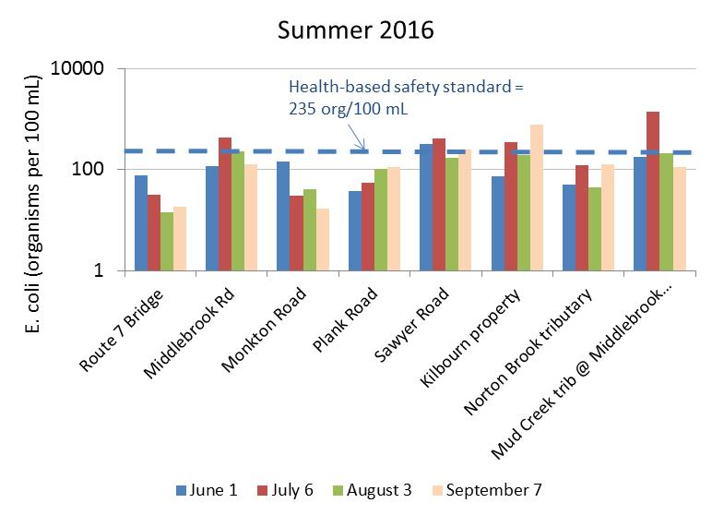

*Figure 7. E.coli measured at Little Otter Creek stations   
on four dry-weather, low-flow dates in 2016.*

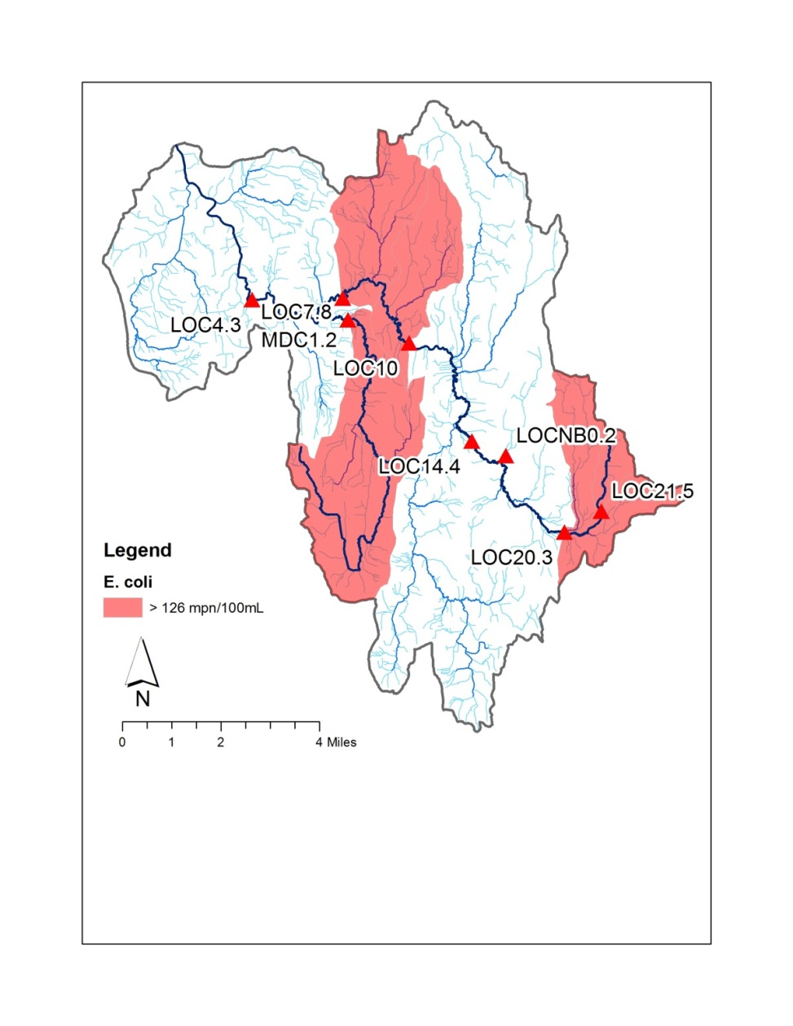The geometric mean value at these four sites also exceeded the state’s water quality standard of 126 org/ 100 mL (Figure 8). Detected *E.coli* counts at sentinel stations LOC7.8 and MDC1.2 were largely consistent with historic monitoring results which have indicated chronic exceedances of the standard.

*Figure 8. Geometric mean E.coli concentration for Little Otter Creek, on four summer sampling dates exhibiting dry-weather, low-flow conditions, 2016. Subwatersheds draining to stations with geometric mean values greater than 126 org/100 mL are depicted in red.*

### Phosphorus

Total phosphorus (TP) was detected at low to moderate concentrations during the six spring and summer sampling dates, ranging from 16 to 185 µg/L. The instream phosphorus criterion of 27 µg/L for warm-water medium gradient (WWMG) wadeable stream ecotypes in Class B waters is applicable at low median monthly (LMM) flow conditions during June through October. Flows in the Little Otter Creek were near the LMM flow during three sample dates in July, August, and September.

The box-and-whisker plot in Figure 9 shows the full distribution of TP results available for 2016. The blue diamond marks the mean of that subset of samples collected during baseflow conditions at or below the LMM (July, August and September events), with the corresponding number of samples (n) indicated in blue along the top of the chart. The mean of the TP results available for these three summer sampling dates exceeded the instream nutrient standard of 27 µg/L at all sampled stations (Figures 9 and 10).

Results suggest an increasing trend in phosphorus concentration with distance downstream of the Sawyer Road crossing (LOC20.3) on the main stem, consistent with historic results for these stations. Elevated TP concentrations from Mud Creek join the main stem between stations LOC7.8 and LOC4.3. This pattern is similar to the pattern exhibited for Turbidity (Section 4.2.1). There is a strong correlation between Turbidity and TP concentrations for samples collected during moderate to high flows (based on 2016 results and historic results), suggesting that phosphorus is being transported predominantly in particulate form during storm events. Sources of particulate phosphorus may include erosion of soil from unvegetated surfaces, edge-of-field gullies, ditches, streambanks and instream channel deposits.

During baseflow conditions, there is an apparent downward trend in mean TP between stations LOC7.8 and LOC4.3, which may possibly be attributed to attenuation within a large, channel-connected wetland complex, or dilution from groundwater, or both. A similar pattern in TP concentrations at these two stations was observed during monitoring in 2010 and 2011.

Dissolved phosphorus (DP) was also tested at each site. As a percentage of TP, DP ranged from 19 to 100% during the six sample dates in 2016. Highest ranges of DP as a percent of TP (exceeding 60%) were reported for headwater stations LOC21.5, LOC20.3, and LOC14.4 during the summer months when flow was near or below the LMM. This pattern is indicative of a groundwater source of DP, such as may be contributed from tile drains, or shallow soils over bedrock in areas of concentrated phosphorus application from manure or fertilizers . Land uses in the upstream drainage area to these headwater stations include development (ranging from 7 to 17%) and agriculture (ranging from 46 to 65%). Agricultural uses include crop fields in rotation, pasture, and a concentrated animal feeding operation for a Large Farm Operation. Developed uses include road and ditch networks and the northern portion of Bristol village.

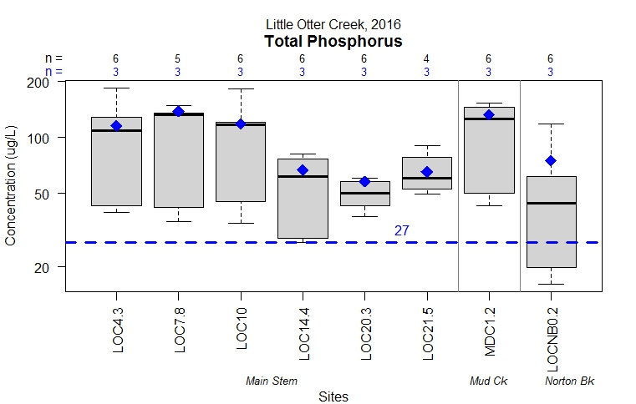

*Figure 9. Summary of Total Phosphorus Results for Little Otter Creek, 2016.   
Blue diamond marks the mean of that subset of samples collected during baseflow conditions at or below the LMM (July, August and September events), relative to the instream phosphorus criterion of   
27 µg/L for warm-water medium gradient (WWMG) wadeable stream ecotypes*

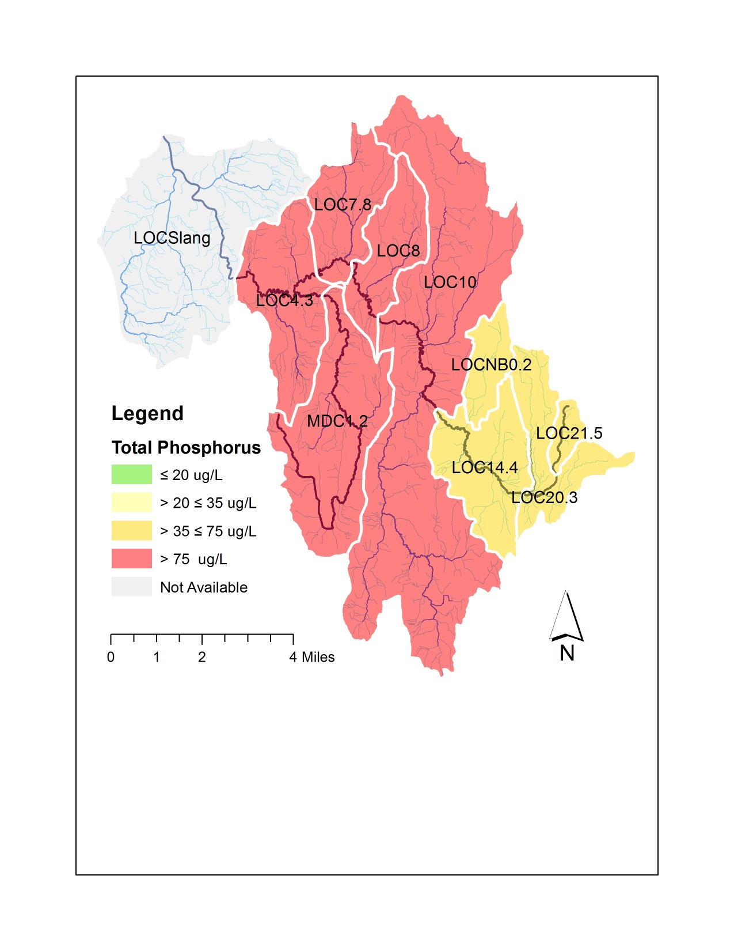

*Figure 10. Mean value of Total Phosphorus detected on July, August and September sample dates during low flow conditions at or below the Low-Median-Monthly flow, Little Otter Creek, 2016.*

### 4.2.4 Nitrogen

Nitrogen levels were detected at low to moderate concentrations at these stations during the spring and summer sampling dates, ranging from 0.2 to 6 mg/L. Highest nitrogen concentrations were detected in the two headwaters stations, LOC20.3 and LOC21.5, which have incremental drainage areas characterized by 42% and 65% agricultural land use, and 19% and 7% developed land use, respectively (ACRWC & SMRC, 2016). Figure 11 displays the spatial distribution of TN across the watershed, as a mean concentration of TN detected during the six events in 2016.

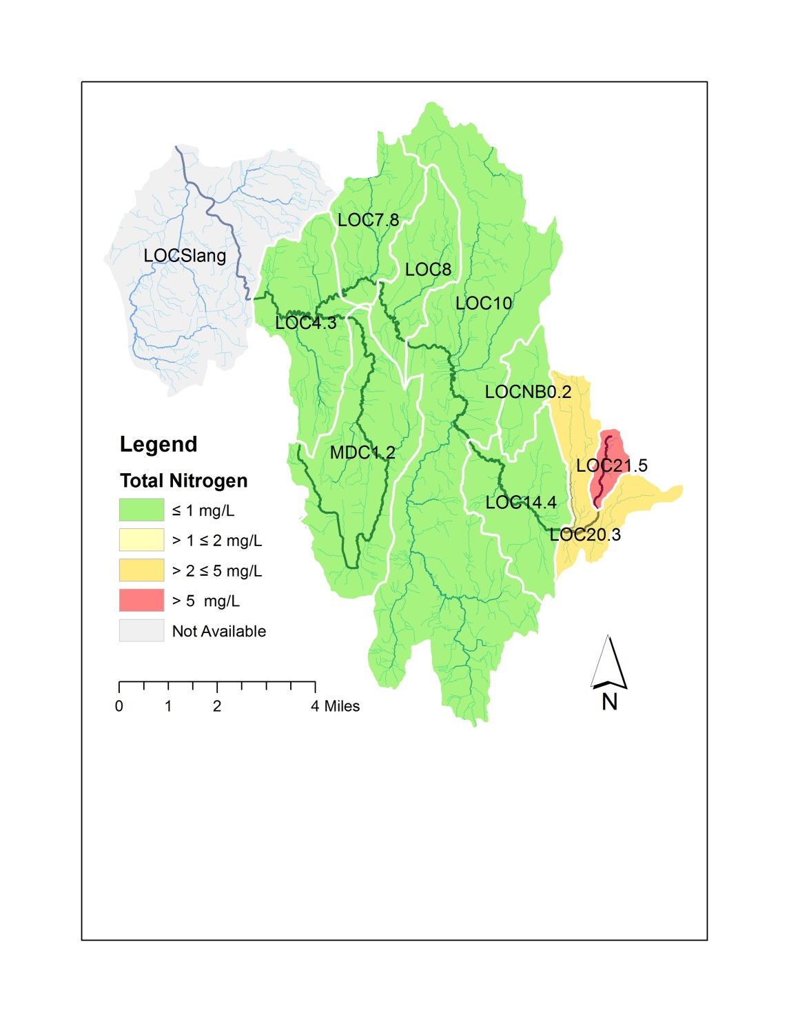

*Figure 11. Mean value of Total Nitrogen detected during six 2016 sample events, Little Otter Creek, 2016. Note: mean value for station LOC21.5 is based on only four events (June – September).*

According to Vermont Water Quality Standards (VWMD, 2016), nitrogen as nitrate (NO3-N) is not to exceed 5.0 mg/L at flows exceeding the LMM discharge in Class B(1) and B(2) waters. Since analyses were conducted for Total Nitrogen, and not NO3-N, and since flows during the July, August and September events were below the LMM discharge, it would be inappropriate to compare values displayed in Figure 11 to this NO3-N standard. Results do suggest a region of elevated nitrogen loading in the uppermost reaches of the watershed, a subwatershed containing a concentrated feeding operation for a dairy farm (LFO) and tile drain networks in fields which rotate between corn and hay.

# 5.0 Conclusions

Spatial trend analysis has been undertaken for eight stations in the Little Otter Creek watershed, relying on water quality data collected during six discrete events in the spring and summer of 2016 - a drier-than-normal year. The 2016 monitoring effort has expanded the spatial resolution of water quality data in this catchment to include more information about headwater areas.

Turbidity and TP each exhibited an increasing trend in concentration with distance downstream on the main stem, particularly between the Plank Road station (LOC14.4) and the Route 7 bridge (LOC4.3). These areas are dominated by fine-grained glacial lake soils, developed with agricultural and rural residential land uses. A separate study recently completed by ACRWC found a strong, and statistically-significant, positive correlation between mean water quality concentrations (for Total Phosphorus and Turbidity) and both the percentage of these fine-grained glacial lake soils and the percentage of agricultural land use in the catchments draining to water quality stations in the Little Otter Creek and New Haven River watersheds (ACRWC & SMRC, 2016).

*E. coli* counts at four of the stations exceeded the state’s geometric-mean-based water quality standard, including a newly-established station approximately one mile upstream of an existing impaired segment. While additional monitoring is warranted, these 2016 results suggest that the length of the upper Little Otter Creek channel impaired for contact recreation uses may be greater than historic data suggest. Elevated Total Nitrogen in these same headwater segments indicates the presence of water quality stressors from developed or agricultural land uses.

These 2016 results suggest the need for additional focus along the upper main stem to discern source areas for elevated nitrogen, dissolved phosphorus, and *E.coli*. Additionally, middle and lower portions of the watershed appear to be high loaders of phosphorus and turbidity, as further supported by a past loading study (SMRC, 2011). In the context of a previous river corridor plan (SMRC, 2011) and the Otter Creek Basin Plan (VTDEC, 2012), various river conservation projects and watershed improvement practices have been identified for the Little Otter Creek watershed to address water quality impairments. Recommended projects and practices included nutrient management to reduce P and N inputs, increased cropping setbacks in frequently inundated fields, riparian buffer plantings where gaps exist, cover cropping, no-till cropping, edge-of-field gully stabilization, tile drainage treatment, livestock exclusion, stormwater treatment measures to disconnect road ditch networks from the stream, riparian wetland restoration and river corridor protection (SMRC, 2011). These recommendations have been shared with partner agencies including the VT Agency of Agriculture, UVM Extension, USDA Farm Service Agency, Otter Creek NRCD, and the VT Department of Environmental Conservation to support outreach to landowners and farmers and to inform the design of best management practices by these partner agencies.

The Little Otter Creek will continue to be a focus watershed in 2017, with the same sentinel and rotational sites monitored for *E.coli*, total and dissolved phosphorus, total nitrogen, and turbidity. Given the elevated TN concentrations at upper main stem sites, an additional lab analysis has been scheduled to detect nitrite and nitrate forms of nitrogen, in order to evaluate nitrogen levels with respect to the water quality standard. In a future focus study, additional bracketing of source areas in the upper headwaters would be warranted to define sources of elevated nitrogen and *E.coli*, pending landowner access.

# 6.0 References

Addison County River Watch Collaborative and South Mountain Research & Consulting, 2017, Summary Report: 2016 Sampling Results for Addison County River Watch Collaborative.

Addison County River Watch Collaborative and South Mountain Research & Consulting, 2016, *Workshops and Analysis to Enhance Flood Resiliency of Headwater Forests*, Final Grant Summary Report, Grant Award #: WG224-16.

NOAA Online Weather Data: Daily Almanac accessed in February 2017 at: <http://www.weather.gov/climate/xmacis.php?wfo=btv>

South Mountain Research & Consulting, 2011, Little Otter Creek Watershed: Phase 2 Stream Geomorphic Assessment, Addison County, Vermont, prepared under contract to Lewis Creek Association.

Stewart, David P., 1973. *Geology for Environmental Planning in the Burlington-Middlebury Region, Vermont*. Vermont Geological Survey, Environmental Geology No. 3. Montpelier, Vermont: Water Resources Department.

Stewart, David P. and Paul MacClintock, 1969, *The Surficial Geology and Pleistocene History of Vermont*. Vermont Geological Survey Bulletin No. 31.

USDA Natural Resource Conservation Service, 2011, State Data Table Top 20, published by the United States Department of Agriculture, NRCS; available at: ftp://ftp-fc.sc.egov.usda.gov/VT/Soils/top20/

USDA Natural Resource Conservation Service, 2013, Soil Survey Geographic (SSURGO) database, available at: http://www.vcgi.org/dataware/default.cfm?layer=  
GeologicSoils_SO. Accessed: [3/9/2013].

US Drought Monitor, accessed 16 January 2017, <http://droughtmonitor.unl.edu/Home/StateDroughtMonitor.aspx?VT>

USGS, 2017, on-line surface water data, <<http://waterdata.usgs.gov/vt/nwis>>.

USGS, 2016, Water Year Summary for Site USGS 04282650, available at <https://waterdata.usgs.gov/vt/nwis/wys_rpt/?site_no=04282650&agency_cd=USGS>

VTDEC, 2012, *Otter Creek Basin Water Quality Management Plan*, including appendices. Available at: http://dec.vermont.gov/sites/dec/files/wsm/mapp/docs/mp_ottercreekplan.pdf http://dec.vermont.gov/sites/dec/files/wsm/mapp/docs/mp_ottercreekappendix.pdf

VTDEC, 2011, *Vermont Statewide Total Maximum Daily Load (TMDL) for Bacteria Impaired Waters*, prepared by FB Environmental Associates, Inc., Portland, ME, including Appendices 3 and 4. Available at: http://dec.vermont.gov/sites/dec/files/wsm/mapp/docs/mp_bacteriatmdl.pdf   
http://dec.vermont.gov/sites/dec/files/documents/WSMD_mapp_3littleottercreek1.pdf  
http://dec.vermont.gov/sites/dec/files/documents/WSMD_mapp_4littleottercreek2.pdf

VT DEC Water Quality Division, 2016a, *State of Vermont 2016 303(d) List of Waters*: *Part D – Impaired Surface Waters With Completed and Approved TMDL*. Available at: http://dec.vermont.gov/sites/ dec/files/documents/WSMD_mapp_Part_D_2016_final_complete.pdf

VT DEC Water Quality Division, 2016b, *State of Vermont 2016 Stressed Waters List*. Available at: http://dec.vermont.gov/sites/dec/files/documents/wsmd_mp_stressed_waters_list_2016.pdf

VT DEC Water Quality Division, 2016c, *State of Vermont 2016 303(d) List of Waters*: *Part A – Impaired Surface Waters in Need of TMDL.* Available at: http://dec.vermont.gov/sites/dec/files/documents/ WSMD_mapp_303d_Part_A_2016_final_complete.pdf

Vermont Watershed Management Division, 2016. *Vermont Water Quality Standards*.   
Effective 15 January 2017. Montpelier, VT. Available at: http://dec.vermont.gov/sites/dec/files/ documents/wsmd_water_quality_standards_2016.pdf

**Attachment 1**

**Soil Parent Materials**

**Little Otter Creek watershed**

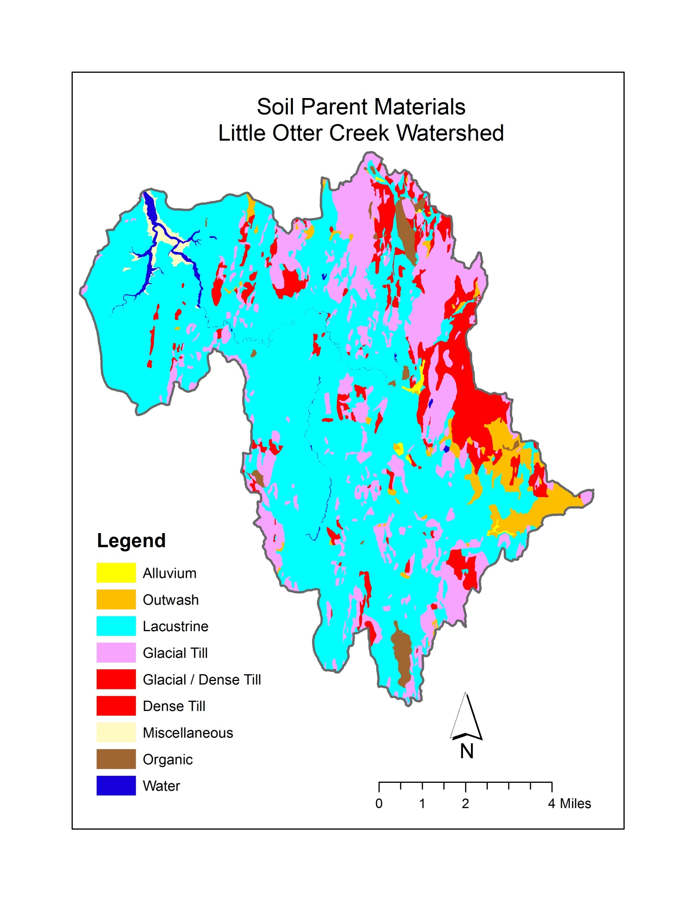

**Attachment 2**

**Land Cover / Land Use**

**Little Otter Creek watershed**

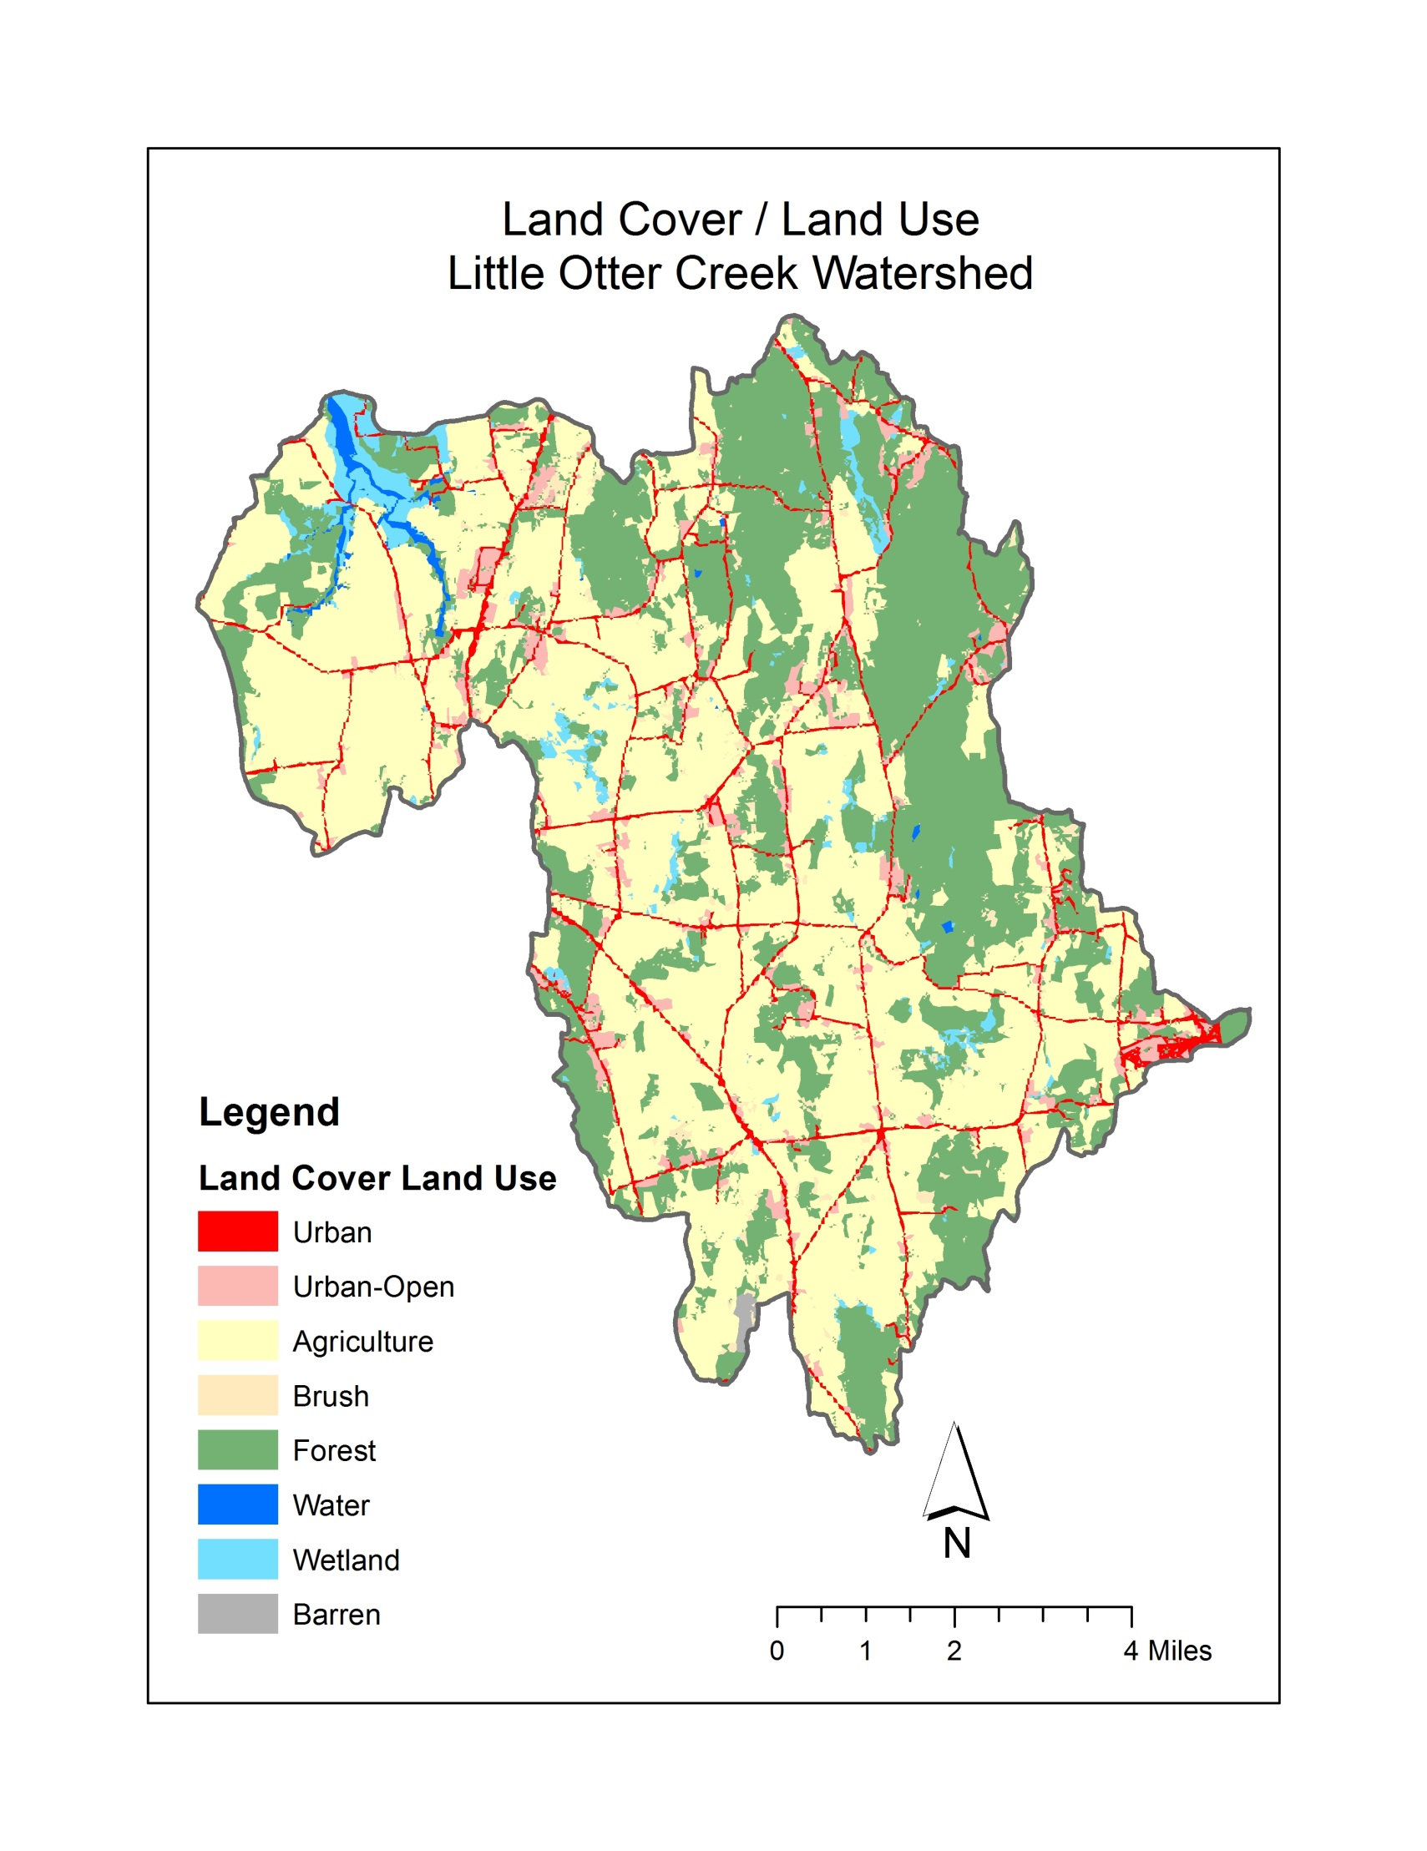

**Attachment 3**

**Water Quality Results**

**Abbreviations:**

TN = Total Nitrogen

TP = Total Phosphorus

DP = Dissolved Phosphorus

TSS = Total Suspended Sediments

MPN/100 mL = organisms per 100 milliliters

mg/L = milligrams per liter

ug/ L = micrograms per liter

NTU = Nephelometric Turbidity Units

-- = No Data

NS = Not Sampled

NA = Not Analyzed (e.g., insufficient sample volume; vial broken in transit)

NM = Not Measured

JB = estimated value; constituent was present in an associated field blank

JD = estimated value; Relative Percent Difference (RPD) of primary and field duplicate sample values exceeded the QAPP RPD goal for that constituent

Note: QA/QC issues further detailed in separate QA Summary Report

**Little Otter Creek**





VT Water Quality Standards (effective October 2014):

* **Turbidity** (cold water Class B) = **10 NTUs** as an annual average under dry weather base-flow conditions.
* **E. coli** (Class B): Not to exceed a geometric mean of 126 organisms /100ml obtained over a representative period of 60 days, and no more than 10% of samples above **235 organisms/100 ml**.   
  In waters receiving combined sewer overflows, the representative period shall be 30 days.
* **Phosphorus** (Class B, Warm-water Medium Gradient): Not to exceed **27 ug/L** at low median monthly flow during June through October in a section of the stream representative of well-mixed flow.

**Little Otter Creek (continued)**





VT Water Quality Standards (effective October 2014):

* **Turbidity** (cold water Class B) = **10 NTUs** as an annual average under dry weather base-flow conditions.
* **E. coli** (Class B): Not to exceed a geometric mean of 126 organisms /100ml obtained over a representative period of 60 days, and no more than 10% of samples above **235 organisms/100 ml**.   
  In waters receiving combined sewer overflows, the representative period shall be 30 days.
* **Phosphorus** (Class B, Warm-water Medium Gradient): Not to exceed **27 ug/L** at low median monthly flow during June through October in a section of the stream representative of well-mixed flow.