LaRosa Partnership Guidance Document for
Reporting E.coli Sampling Results for Recreational Sites

31 October 2017

Prepared by:
Kristen L. Underwood, PG
South Mountain Research & Consulting
Bristol, VT

Prepared under contract to:
VT Agency of Natural Resources
Watershed Management Division
Montpelier, VT

Table of Contents
Acknowledgements 1
1.0 Introduction 1
2.0 Background 1
3.0 Communicating Data 2
3.1 Tabular Display of results 2
3.2 Graphical Display of Results 2
3.3 Mapping of Results 5
3.4 Influence of Discharge on Concentration 6
4.0 References 7

Appendix A. Template for Posting E. coli results to Social Media, Website, or Press Release
Appendix B. Example E.coli Postings at Recreational Sites
Appendix C. Google Earth© Instructions

Acknowledgements
This document is one of five templates or guidance documents generated by the VT Department of Environmental Conservation (VTDEC) to support watershed groups engaged in ambient water quality monitoring under the LaRosa Partnership Program. These templates provide examples of data reduction and visualization, as well as statistical analysis, that enable more effective communication of the data – to constituents of Partnership groups; to local, state and federal partners in project implementation; and to the VT Agency of Natural Resources for meeting a variety of needs (e.g., listing / delisting of waters, basin planning, prioritization of resources to groups for project implementation). This template has been prepared by South Mountain Research & Consulting of Bristol, VT, under contract to VTDEC.
This template relies on water quality data from the New Haven River watershed, where sampling is carried out by a network of trained volunteers operating under the Addison County River Watch Collaborative (fiscal agent, Lewis Creek Association), with logistical and technical support provided by the VTDEC Monitoring, Assessment and Planning Program, the Addison County Regional Planning Commission and South Mountain Research & Consulting. Analytical services are provided by the Vermont Agricultural & Environmental Laboratory (http://agriculture.vermont.gov/vael) in Burlington, VT, through an analytical services partnership grant.

1.0 Introduction
The LaRosa Volunteer Water Quality Monitoring Analytical Services Partnership is comprised of more the nineteen separate groups around the state of Vermont engaged in ambient water quality monitoring. A common monitoring objective among the LaRosa Partnership groups has been to assess water quality at swimming holes and other recreational sites on rivers that they steward, to communicate health risk information to the public. This guidance document reviews a variety of data visualization and posting methods to evaluate and communicate E. coli levels at frequented recreation locations.

Background
Our rivers and lakes receive runoff and groundwater from a variety of land covers, and waters can become contaminated with fecal matter from humans, pets, wildlife and livestock. E. coli is one type of fecal coliform bacteria found in the intestines of humans and other warm-blooded animals. It is used as an indicator of potential fecal contamination of waters. While most strains of E. coli are themselves not pathogenic, detection of E. coli suggests that other disease-causing pathogens may be present, and may result in health risks to humans recreating in those waters.
E.coli is reported by the Vermont Agriculture & Environmental Laboratory (VAEL) in units of MPN per 100 milliliters (mL). MPN is an abbreviation for Most Probable Number and stems from the particular analytical testing method used (IDEXX Quanti-Tray®). Concentration is also sometimes expressed as colony-forming units (cfu) or organisms (org) per 100 mL.
Vermont Department of Health has established a health-based safety standard for E.coli of 235 org/100 mL (VDOH, 2012). This standard is based upon a statistical analysis by the US Environmental Protection Agency which estimated the risk as 8 in 1000 that swimmers will become ill from exposure to waters with 235 org/100mL (VWMD, 2012). E.coli concentrations below this standard are considered acceptable conditions for swimming. However, 100% safety is not guaranteed for waters with E.coli below this standard, as it is still possible that a swimmer will become ill. Conversely, not all swimmers will become ill from recreating in waters that have E.coli in excess of this level.
VAEL strives to make E.coli results available within 72 business hours of sample collection, subject to changing demands on laboratory services. Despite a timely lab turnaround and posting, E.coli results will be communicated to the public after the fact. However, groups may rely on historic testing results to advise the public about safe conditions for swimming and boating specific to their river. For example, previous sampling results have shown in many rivers that summer E.coli concentrations rise with increasing flows following heavy rains; general statements can be posted at popular swimming sites advising swimmers to avoid the river during these conditions when it is likely that E.coli levels will be high. For example, Friends of the Mad River included the following statement with their reporting of E.coli results for June 2017, as posted on their web site³:
When weather across the watershed varies from hill to hollow, swimming safety varies too! FMR’s E. coli sampling results are only a snapshot in time intended to give you a sense of the conditions that lead to high pathogen levels in the water so you can be informed. You are your best protector - use common sense and don't swim for several days after a rain. It is estimated that at the level of 235 colonies E. coli per 100 mL water, approximately 8 out of every 1,000 swimmers are likely to contract a water borne illness related to fecal contamination.

This guidance document focuses on reporting of E.coli monitoring results at recreation sites. Watershed groups may also be monitoring E.coli for other reasons (e.g., source identification). Interpretation and analysis of E.coli results to meet these other monitoring objectives are addressed in other report templates.

3.0 Communicating Data
A variety of data visualization and posting methods are possible to evaluate and communicate E. coli levels at frequented recreation locations.

3.1 Tabular Display of results
A simple table of results is quick to disseminate to the public when groups wish to achieve a timely reporting of provisional E.coli results. In many Vermont towns, watershed groups have access to community forums (e.g., Front Porch Forum, frontporchforum.com), social media, or email list-serves that help to publicize results. Still, many groups physically post data to kiosks at recreation sites and other community sites such as the town library or town hall, or share data via press release to a community newspaper. Appendix A provides a template that can be adapted by groups for reporting results from a single sampling event to various media outlets. An example of reporting styles can also be viewed at the website of Friends of the Mad River, a group that has been monitoring water quality since 1985.

3.2 Graphical Display of Results
“A picture is worth a thousand samples.” Often the meaning of sample results can be more concisely conveyed in an image or graphical display. A bar chart of sample results grouped by sample station can communicate how water quality is trending relative to the VT health-based standard of 235 MPN/100 mL (Figure 1).
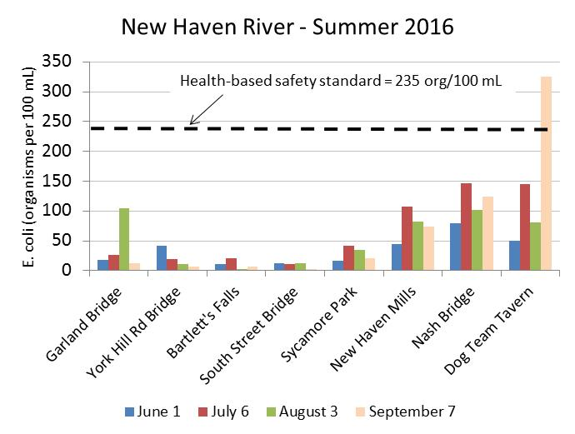
Figure 1. Example bar chart displaying reported E.coli results for four summer sampling events at eight swimming holes on the New Haven River.
Bar graphs can be depicted on signage or kiosks at public recreation sites to communicate health and safety conditions to swimmers, anglers and boaters (see Appendix B). Sources of grant funding to support development of signage are available through organizations such as the Lake Champlain Basin Program or the Vermont Department of Environmental Conservation Watershed Grant Program. A Microsoft Excel© template for preparing a bar chart similar to Figure 1 is provided as an attachment to this guidance document.
Another option for summarizing E.coli results is the box and whisker plot. The full range of reported concentrations for a given site can be displayed, as well as the central tendency, calculated as either the median (middle value in the range), arithmetic mean (average of all the values), or the geometric mean (Figure 2). While the arithmetic mean is computed as the sum of all the values divided by the total number of values, the geometric mean is calculated somewhat differently: as the product of the values divided by the square root of the total number of values. The geometric mean is often used in water quality studies since this measure of central tendency is less influenced by outlier data (Helsel & Hirsch, 2002).

Figure 2. A box-and-whisker plot summarizes the range and central tendency of a data series. Whiskers extend to the maximum and minimum values of the series, while the gray-shaded box represents the interquartile range (or middle 50%) of values. The central tendency can be characterized as the median value (middle value, marked by the dark horizontal line), the arithmetic mean (blue diamond), or geometric mean (black square).
For a series of stations located across a watershed, the box-and-whisker plot can be ordered to show data from upstream to downstream. For example, Figure 3 summarizes E. coli concentrations detected at all stations on summer sampling dates for sites located along the main stem of the New Haven River in 2016. From this style of plot, one can see the variability in E.coli counts for a given site over time (as shown by the vertical spread of the whiskers and box). In addition, the variation in E. coli counts from upstream to downstream can be visualized. On this river, E.coli concentrations decline from South Lincoln (NHR15) through West Lincoln (NHR13) and downstream to Bartlett’s Falls (NHR11.5) and Bristol Village at South Street (NHR9). This pattern may be due to dilution by cleaner waters from groundwater springs and tributaries draining the Green Mountain National Forest. Below Bristol village, geometric mean concentrations (and median and range of concentrations) begin to rise, as the river enters regions with less forest cover and greater density of agricultural and developed land uses (from NHR6 to NHR0.5).
Figure 3. Example box-and-whisker chart displaying reported E.coli results for eight swimming holes on the New Haven River. Horizontal dashed lines mark the value of the VDOH health-based standard (235 MPN/100mL) and the VT Water Quality Standard for Class B waters (126 MPN/100mL).
Still, E.coli concentrations are relatively low overall, and below the VT health-based standard of 235 org/100mL (except for occasional high readings at NHR0.5, former Dog Team Tavern). These results should be placed in the context of weather conditions experienced in 2016, which was a drier-than-normal year. In past years, E.coli concentrations at stations downstream of Bristol village can be elevated above 235 org/100mL.

3.3 Mapping of Results
For groups with access to Geographic Information System (GIS) services or other mapping software, a map of recreation sites can be a useful and concise way to communicate monitoring results. Figure 4 displays the eight New Haven River swimming holes on a map of the watershed, with E.coli results for the 7 September 2016 sampling event reduced to a colorized symbol: red for values exceeding the health-based standard.
Figure 4. Map of 7 September 2016 E.coli results
for eight swimming holes on the New Haven River.
Another alternative is to work within GIS software to generate a “kmz” file of these same swimming hole symbols that can be viewed on web-based platforms of Google Earth © (Figure 5) or the Vermont Natural Resource Atlas. An example kmz file for New Haven River swimming holes is presented as an attachment to this guidance document. Instructions for importing and viewing this file in Google Earth © are contained in Appendix C. Groups may wish to provide this option to enable mobile viewing of monitoring results. Links to these data could be provided at kiosks or sign posts at popular recreation sites.
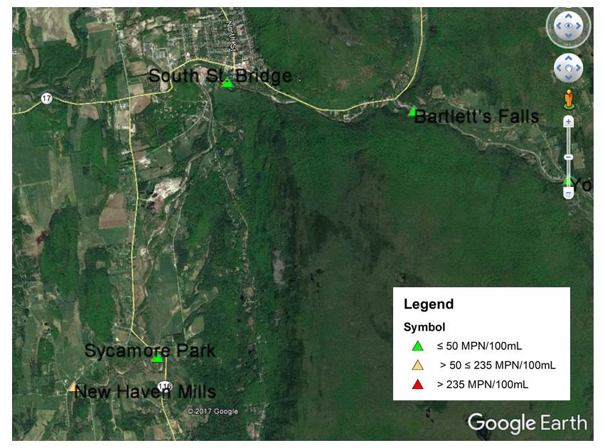
Figure 5. Computer screen-shot of Google Earth© application to view location of swimming holes in the vicinity of Bristol village, with color-coding to convey ranges of E.coli concentrations. Symbol colors reflect E.coli concentration from a single sample date, but could this style of mapping could also be used to display the geometric mean for a range of results collected over a season, for example.

3.4 Influence of Discharge on Concentration
For groups that have long-term data sets at sites collected during a variety of flow conditions, data could be summarized by flow condition, to better understand and communicate the variability in pollutant levels at each site in response to river discharge (Figure 6). Visualizing data in this manner may help to strengthen outreach regarding recommended management strategies for reduced human health risk. For example, high E. coli counts during moderate to high-flow, freshet conditions would indicate that swimming should be avoided during these times.
Observed patterns in the data may also suggest potential sources of a pollutant to inform watershed restoration efforts. For example, high E. coli counts during low flows may suggest a nearby point source(s) such as illicit discharges, failing septic systems or inadequate waste water treatment. On the other hand, high E.coli counts during moderate to high flows may instead point to the importance of nonpoint sources of bacteria, including surface runoff from agricultural lands, concentrated animal feeding operations, barnyards, or pet waste areas.
Moderate & High Flows

Figure 6. Example of box plot to stratify E.coli data by flow level. In this hypothetical scenario, high and moderate flows appear to generate greater E.coli concentrations, while low flows are generally associated with lower E.coli concentrations. This kind of pattern may indicate the importance of surface runoff sources of bacteria.

Additional guidance on estimating discharge is provided in a separate guidance document, LaRosa Partnership Guidance Document for Coarse-level Estimation of Pollutant Loads.

4.0 References
Helsel, D.R., and R.M. Hirsch. 2002. Statistical Methods in Water Resources. Book 4, Chapter A3 in Techniques of Water-Resources Investigations. U.S. Geological Survey, Reston, VA. Accessed February 10, 2016. http://pubs.usgs.gov/twri/twri4a3/.
VDOH, 2012, Healthy Recreational Waters, available at: http://www.healthvermont.gov/sites/default/files/documents/2016/11/Env_RW_healthy_recreational_waters_guidance-1.pdf

VTDEC, 2011, Vermont Statewide Total Maximum Daily Load (TMDL) for Bacteria Impaired Waters, prepared by FB Environmental Associates, Inc., Portland, ME, including Appendices 3 and 4. Available at: http://dec.vermont.gov/sites/dec/files/wsm/mapp/docs/mp_bacteriatmdl.pdf
http://dec.vermont.gov/sites/dec/files/documents/WSMD_mapp_3littleottercreek1.pdf
http://dec.vermont.gov/sites/dec/files/documents/WSMD_mapp_4littleottercreek2.pdf
Vermont Watershed Management Division, 2016. Vermont Water Quality Standards.
Effective 15 January 2017. Montpelier, VT. Available at: http://dec.vermont.gov/sites/dec/files/ documents/wsmd_water_quality_standards_2016.pdf
Vermont Watershed Management Division, 2012 (update to original dated 2003), Citizen’s Guide to Bacteria Monitoring in Vermont Waters, Available at: https://anrweb.vt.gov/PubDocs/DEC/WSMD/Lakes/Docs/lp_citbactmonguide.pdf
Appendix A. Template for Posting E. coli results to Social Media, Website, or Press Release
E.coli Results – <<river>>
The <<watershed group>> sampled <<number>> stations on the <<river>> on <<date>>.
Station <<site Id>> <<site description or name>> ### org/100 mL
Station <<site Id>> <<site description or name>> ## org/100 mL
Station <<site Id>> <<site description or name>> ## org/100 mL
Station <<site Id>> <<site description or name>> ## org/100 mL
Station <<site Id>> <<site description or name>> ### org/100 mL
E. coli is one type of fecal coliform bacteria found in the intestines of humans and other warm-blooded animals. It is used as an indicator of potential fecal contamination of waters. While most strains of E. coli are themselves not pathogenic, detection of E. coli suggests that other disease-causing pathogens may be present. The Vermont Department of Health sets a health-based safety standard for swimming of 235 organisms/100 mL.
E.coli concentrations at stations <<site ID(s)>> were below the safety standard for swimming.
AND / OR
E.coli concentrations at stations <<site ID(s)>> were above the safety standard, suggesting conditions unsuitable for swimming.
As appropriate, include a statement of weather conditions during and preceding the sample event with reference to nearest USGS gaging station and/or weather station(s). For example:
The <<river>> was at high flow levels on <<date>> following wetter-than-normal conditions in the month of <<month>>. Water levels in the <<river>> rose in response to steady rains that passed through the area on the previous day, and were just past peak by early morning on <<date>> when sampling occurred.
AND / OR
The <<river>> was flowing at very low levels on <<date>>, due to persistent hot weather and lack of substantial rain in the preceding weeks.
As appropriate, insert a brief statement regarding typical river conditions, based on historical data, and relevant cautionary statement concerning river access.
Based on past monitoring of these sites on the <<river>> , E. coli levels can become elevated when the river is running high following heavy rains. In general, swimmers should avoid the river during these times.
Our next sample date of the season will be on <<date>>. Contact <<sampling coordinator>>, <<(usernameATprovidor.com)>> with questions.

Appendix B. Example E.coli posting at Recreational Sites
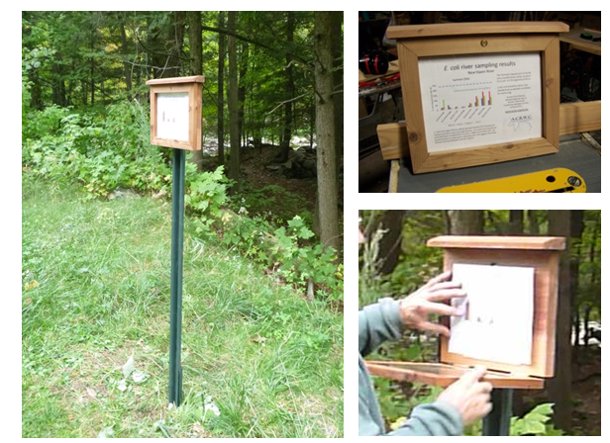
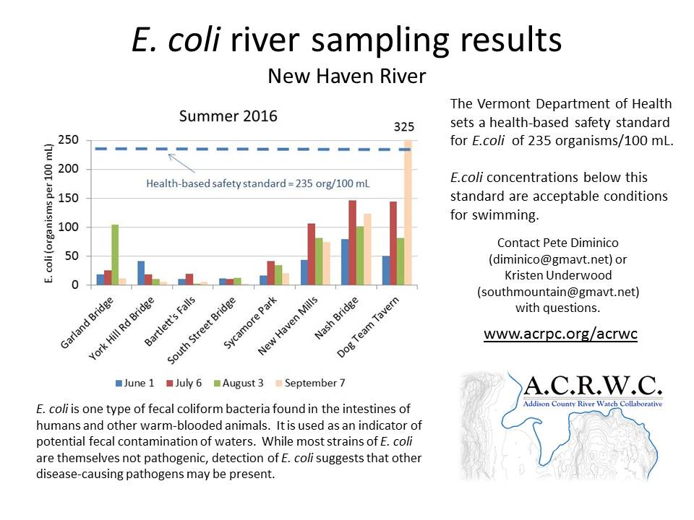

Signage recently deployed at recreation sites on the New Haven River, by the Addison County River Watch Collaborative, with support from a Lake Champlain Basin Program Education & Outreach grant.

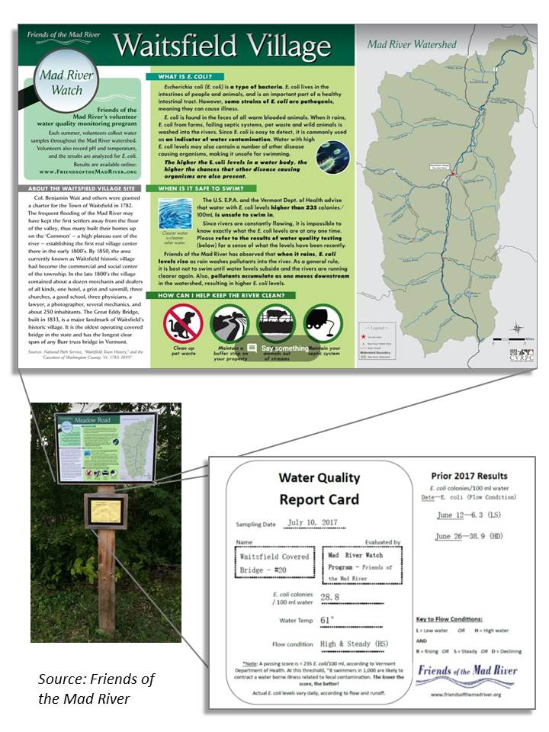
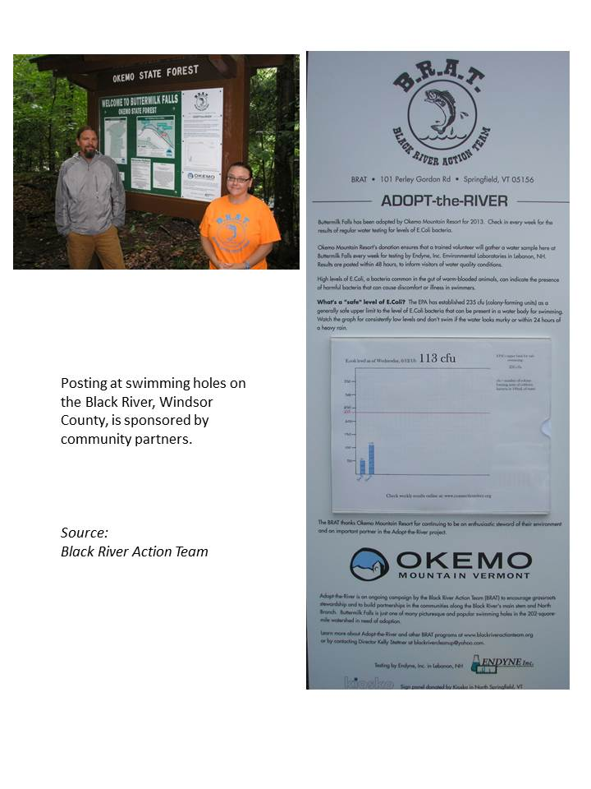

Appendix C. Google Earth© instructions
Download the kmz file and store it in a folder on your hard drive.
“NHR_Swimming_Holes.kmz”
Download Google Earth©
https://www.google.com/earth/download/ge/agree.html
Launch Google Earth©
Close the “Navigating in Google Earth” window.
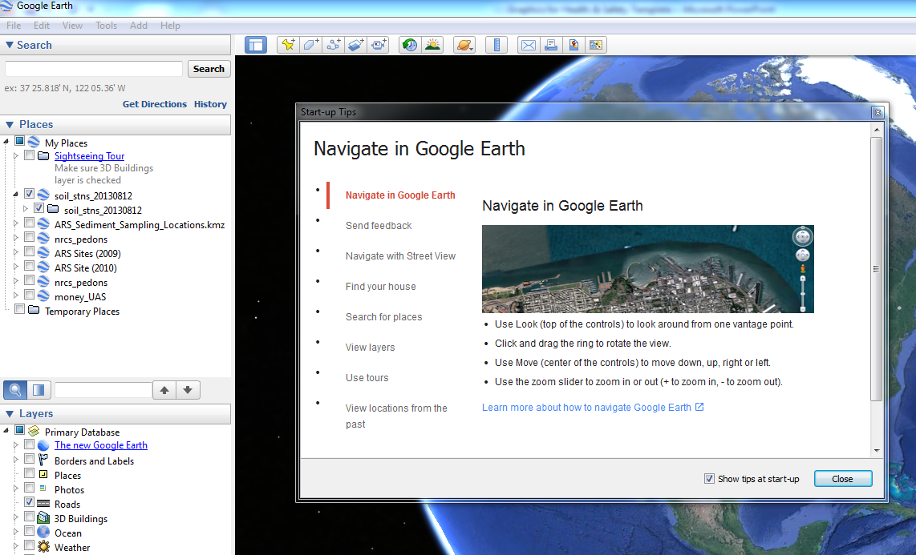

Select: File > Open

Navigate to the folder where you stored the kmz file. Select the kmz file and click “Open”
Google Earth© will automatically zoom into the area of interest (New Haven River watershed) and you should see the water quality monitoring stations sites appear as labelled triangles. Click and drag to pan around the area. Use the scroll bar of a mouse to zoom in or zoom out (or use the slider from + to – in the upper right of the screen).
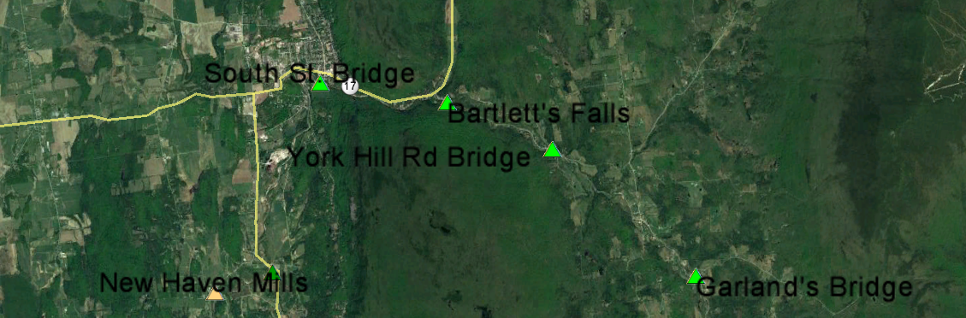

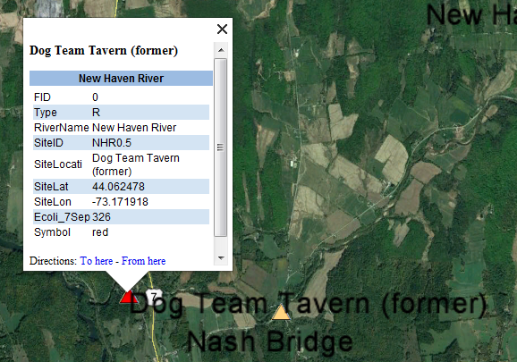
Click on any triangle symbol to display the information for each site, including: Site Identification No., Site Name, Latitude, Longitude, and E.coli concentration.

http://dec.vermont.gov/watershed/map/monitor/larosa
http://agriculture.vermont.gov/vael
http://www.friendsofthemadriver.org/
http://www.lcbp.org/about-us/grants-rfps/
http://dec.vermont.gov/watershed/cwi/grants/watershed-grants
https://www.google.com/earth/
http://anr.vermont.gov/maps/nr-atlas

