Poultney Mettowee NRCD
South Lake Watershed

Final Report: Water Quality Monitoring
2018 Data

Prepared by:

Poultney-Mettowee Natural Resources Conservation District
Poultney, VT. 05764

Prepared under contract to:
VT Agency of Natural Resources
Watershed Management Division
Montpelier, VT

Table of Contents
Executive Summary 3
1.0 Introduction 4
2.0 Background 5
2.1 Description of Watershed 5
(from SMRC, 2007, Castleton River and SMRC, 2007, Mettowee River Watershed) 5
2.2 Water Quality Monitoring Sites 6
2.3 Discharge Measurement 9
3.0 Methods 11
3.1 Meteorological Conditions 12
3.2 Sample Collection and Analysis 13
3.3 Quality Assurance / Quality Control 13
4.0 Results and Discussion 14
4.1 Meteorological and Hydrological Conditions 14
4.2 Water Quality Results 15
4.2.1 Total Phosphorus 15
5.0 Conclusions 20
6.0 References 21

Executive Summary
The Poultney Mettowee Natural Resources Conservation District has monitored streams and rivers in the South Lake watershed since 2003. The goal of monitoring is to capture long-term water quality trends, prioritize areas for project implementation, and to monitor the effectiveness of past projects. Currently, the District collects Total Phosphorus samples, because this data proves the most valuable as guidance for our conservation work. The District has multiple objectives for ongoing water quality monitoring:
- Identify the current conditions in the watershed and track changes to water conditions as they occur,
- Identify sources and causes of water pollution in the watershed, to inform work priorities and project implementation,
- Assist partner agencies with the evaluation of local conservation project efficacy,
- Inform the public about current conditions, changes as they occur, and project effectiveness.

The District has conducted spatial trend analysis for many years in the South Lake (Poultney-Mettowee) watershed. In 2018, water quality data was collected during the spring and summer seasons. New sites were added based on last year’s data results and project implementation. Sites new in 2018 include Tadmer02, Tadmer03, Saltis01, and Saltis02. Storm sites Green01, Eaton 01 and 01, and LVR01 and 02 were added to measure runoff at potential stormwater project sites, but could only be measured during rain events.
Total Phosphorus concentrations above water quality standards were measured at many of the sampling sites during periods of low flow. Of these, sites on Coggman Creek, the Hubbardton River and Tadmer brook were particularly high and further sampling and exploration is warranted. The trend of higher phosphorus found at the headwater sites compared to the downstream village sites again was apparent in this years sampling data. Sites on Tadmer tributary will be a focus of District outreach due to the exceedingly high levels of TP found at sample sites.

1.0 Introduction

The Poultney Mettowee Natural Resources Conservation District has collected samples, managed data, and interpreted the results of water quality analysis for 14 years between 2003, the inception of the LaRosa Partnership, and 2018. The overarching goal of monitoring is to capture long-term shifts in water quality, prioritize areas for project implementation, and to monitor the effectiveness of past projects. The District has several objectives for ongoing water quality monitoring:
- Identify the current conditions in the watershed and track changes to water conditions as they occur,
- Identify sources and causes of water pollution in the watershed, to inform work priorities and project implementation.
- Assist partner agencies with the evaluation of local conservation project efficacy,
- Inform the public about current conditions, changes as they occur, and project effectiveness.

Spatial trend analysis has been undertaken for many years in the South Lake B (Poultney-Mettowee) watershed. In 2018, water quality data included storm events and was collected during the spring and summer season.
Total Phosphorus exhibited an increasing trend in concentration on the upstream-most station on Flower Brook on the main stem (FB03). This area is dominated by fine-grained glacial lake soils and rural residential land uses. 2018 data follows the same pattern as the past two years, the average Total Phosphorus concentrations found in the Flower Brook headwaters exceeded those at the downstream Pawlet Village sites. Before 2016, this higher headwater trend had not been seen since monitoring on site FB03, Lilly Hill Road, began.
The District first collected samples on the Poultney River in 2003, and then expanded to sites on the Mettowee River, Flower Brook, and Beaver Brook in 2005, corresponding with the first geomorphic assessment completed on the Mettowee Mainstem (reaches M04-M08) and several reaches on Beaver and Flower Brooks. Sampling is incorporated into other work the District does including Stormwater Master Plans. The Lake Bomoseen data corresponds to the Castleton Bomoseen Masterplan and was concluded this season. Future sites sampled will have a focus on the Lake St Catherine Master Plan to be completed in 2019.

2.0 Background

2.1 Description of Watershed

(from SMRC, 2007, Castleton River and SMRC, 2007, Mettowee River Watershed)

Stream Types

All stream reaches in the Mettowee River geomorphic assessment were classified as Rosgen (1996) and Montgomery Buffington (1996) stream types A, B, or C.
- Stream type “A”- steep, cascading, headwater reaches
- Stream type “B”- include moderately steep, step-pool streams
- Stream type “C”- the most common stream type in the Mettowee Basin, “C” streams include less-steep, pool-riffle streams with floodplain access. The “C” stream type predominated, especially in the valleys.

The stream types in the Poultney River watershed are similar with predominantly stream types A, B, and C, and with areas in Fair Haven and West Haven including stream type E.
- “E”- low slope, highly sinuous rivers with deep banks and sandy bottoms.

Basin Characteristics: Geology and Soils

The nature of the sediments and soils present in the South Lake Watershed reflect the glacial and post-glacial lake history of the region. Upland slopes are dominated by shallow- to moderate glacial till deposits overlying bedrock. Channels formed by glacial meltwater deposited sands, gravels, and cobbles along the margins of the ice at the edges of the river valleys. These ice-contact deposits are typically non-cohesive and have moderate to high erodibilities when exposed in stream banks and beds (Stewart & MacClintock, 1966; MacClintock, no date, from SMRC, 2007, Castleton River SGA).

The Poultney River drains 262 square miles and the Mettowee river drains approximately 135 square miles in Vermont. The largest tributary in the Poultney River Watershed, the Castleton River, drains approximately 99.3 square miles of land area located in Rutland County, Vermont. The Castleton River joins the Poultney River at the Vermont / New York border. The Poultney River flows to the Champlain Canal to the north of Whitehall, New York; waters then drain to the north via the canal to the southern extent of Lake Champlain.

As the Lake Vermont waters inundated the Castleton River valley following deglaciation, fine silts and clays were deposited upstream of the Gully Brook confluence, and sands and fine gravels downstream of Castleton village. Coarser sands and fine gravels underlying the village of Fair Haven, comprise the delta deposit which extended out into Lake Vermont at the former confluence of Castleton River (Stewart & MacClintock, 1966; MacClintock, no date). The Castleton River network today is eroding and redepositing the mix of glacial and post-glacial sediments of the watershed. Upland tributaries are winnowing the finer-grained sediments (SMRC, 2007).

Land Cover and Reach Hydrology

Landuse throughout the watershed is mainly forested, with forest cover in each subwatershed ranging from 52.6% on one reach on Beaver Brook to 95.7% in the Sykes Hollow Brook headwaters. Historically, a much higher percentage of the watershed was cleared for pasture and croplands. Landuse in the stream corridor is a mix of forested land, crops and fields and occasionally, urban areas. Urban areas make up as much as 48.2 % of the landuse along one reach of Flower Brook. Woody vegetative buffers of greater than 100 feet in width dominate much of the watershed, though eight reaches show at least one bank with less than 25 feet of buffer dominating. Many of the reaches had long stretches of minimal vegetation along fields, roads or developed areas. Groundwater and wetland inputs vary greatly by reach.

The Poultney River watershed is 262 square miles with approximately 3% of the watershed in crops, 9% as fields, 78% as forest, 3.3% as residential, and 4.5% as open water. The Hubbardton subwatershed makes up 44.38 square miles of the Poultney River watershed and has a slightly different land use composition with 3.5-5.4% crops, 8.5-20% fields, roughly 65% forests, 12% open water, and 4% residential.

The Mettowee River Watershed is composed of approximately 211 square miles of land in Rutland and Bennington Counties of Vermont and Washington County, New York, of which 135 square miles or 64% of the watershed are in Vermont. Within the watershed (upstream of reach M04), approximately 75.4% of the land is forested, 16.1% of the land is in agriculture, 3.2% is developed, and the remainder is open water and wetlands (p. 18).

The Indian River subwatershed, which originates in Vermont but drains to the Mettowee River in New York, comprises a total of 37 square miles in Vermont and New York. The Wells Brook subwatershed makes up 32.61 square miles of the northern Mettowee watershed. The Flower Brook (7 miles long) subwatershed comprises 19 square miles of the Mettowee watershed, with Beaver Brook making up 5.21 square miles of the Flower Brook subwatershed. The Sykes Hollow Brook watershed makes up 4.5 square miles at the southern boundary of the District near the Mettowee River headwaters. The tributaries listed above are considered target watersheds for the District and are the focus of local conservation efforts.

2.2 Water Quality Monitoring Sites

Table 1: Poultney River Watershed - Sampling Sites

Site Name | River | Lat/Long | Description | Significance?
Bretton01 | North Breton Brook | 43.62790  -73.15925 | Ford to agricultural field on Monument Hill Road, north of the Route 4 Bypass | Evaluate the sediment and nutrient flow from the North Breton watershed to Castleton
Coggman01 | Coggman Creek | 43.6547  -73.36218 | Coggman Creek at Burr Road crossing | Accessible Coggman Creek site to evaluate the downstream brook
CA01 | Castleton | 43.60944  -73.11484 | At the downstream end of the wetland along the Birdseye Ski Area access road. | Monitor the wetlands nutrient levels; farms in vicinity and upstream
CA05 | Castleton | 43.5998  -73.2329 | Blissville Road crossing | Downstream of Castleton
Hubb01 | Hubbardton | 43.64693  -73.31209 | Hubbardton River at Main Road and River Road | Downstream Hubbardton measurement; previously measured
Hubb02 | Hubbardton | 43.696743  -73.275901 | Hubbardton River downstream of the Mill Pond | Mid-Hubbardton measurement
Hubb3 | Hubbardton | 43.736230  -73.243413 | Hubbardton River at Route 144 | Upstream Hubbardton measurement
Lewis01 | Lewis Brook | 43.56248  -73.22600 | Lewis Brook at York St Extension | Downstream of a large planting
Lewis02 | Lewis Brook | 43.55577  -73.23939 | Lewis Brook at Saltis Road | Upstream of a large planting
Eaton01 | Runoff | 43.64861  -73.14983 | Road runoff at the top of Eaton Hill Road | Pre project measurement
Eaton02 | Trib to N Bretton Bk | 43.64263  -73.14925 | Small trib to N Bretton Bk at the Eaton Hill Rd crossing | Pre project measurement

The Castleton River was originally targeted because the District and our partners were implementing a floodplain restoration along one of the major tributaries to the Castleton River, Gully Brook. There was also active channel movement with two avulsions in 2007, one through a horse pasture owned by a large stable and one through an annually cropped field. These five sites were sampled in 2006, 2007, and 2008. The river begins in a rich marsh and flows through agricultural and residential lands, constrained by roads and train tracks. It flows through both Castleton and Fair Haven and is the receiving waters of Lake Bomoseen.

The Castleton River was again sampled in 2015 - 2018, as the District focused on subwatershed-specific monitoring and data analysis. These sites serve as possible storm samples throughout the season.

The District measured one location on the Hubbardton River in 2006. In 2015, the District added two additional sites on the Hubbardton River, Hubb02, downstream of the Mill Pond, and Hubb03, near the headwaters along Route 144 in the Hortonia region. These sites were again sampled in 2016, 2017, and 2018.
Bretton Brook is a tributary to the Castleton River, and drains East Hubbardton and Castleton. It also receives water from Eaton Hill Road, a source of sediment with a mitigation project scheduled for completion summer 2019.

Coggman Creek drains the town of West Haven, into the lower Poultney River.

Table 2: Flower Brook Watershed - Sampling Sites

Site Name | River | Lat/Long | Description | Significance?
Flower01 | Flower Brook | 43.35345  -73.17885 | Behind the town offices, Pawlet | Sentinal site, critical for continual monitoring of bacteria in the village
Flower01.5 | Flower Brook | 43.34778  -73.17492 | At the fire station, upstream of the mill pond. | Monitors bacteria levels upstream of the mill pond
Flower02 | Flower Brook | 43.354565  -73.153286 | At the 133 crossing near Gould’s farm (last 133 crossing) | Monitors bacteria levels from agricultural areas in the watershed
Flower03 | Flower Brook | 43.36848  -73.10159 | Flower Brook at the Lily Hill Road crossing | Measures upland bacteria levels and is downstream of rural development
Beaver01 | Beaver Brook | 43.363518  -73.148297 | Beaver Brook at Brimstone Road crossing | Upstream site; downstream of a wetland
Beaver02 | Beaver Brook | 43.37284  -73.13704 | Beaver Brook at the 133 crossing North of Flower02 | Downstream of wetlands and beaver ponds/pasture
Beaver03 | Beaver Brook | 43.38841  -73.13258 | Beaver Brook at the Kelley Hill Road crossing | Downstream of agricultural lands and quarries
Beaver04 | Beaver Brook | 43.35952  -73.15463 | Beaver Brook at Andrus Lane culvert (upstr) | Rural residential area and trib from a farm we work with extensively
Flower04 | Flower Brook | 43.38179  -73.08797 | Upstream of Purchase Brook confluence | Flower Brook headwater stream
Flower05 | Flower Brook | 43.39571  -73.07262 | Upstream of Chandler residence | Flower Brook headwater stream
Purchase01 | Purchase Brook | 43.38173  -73.08823 | Downstream of the Little Village Road crossing | Flower Brook headwater stream
FBTrib01 | Trib | 43.39561  -73.07251 | Trib at FLower05 | Flower Brook headwater stream
Green01 | runoff | 43.39072  -73.09420 | Runoff from Green Hill Road | Flower Brook headwater sediment project
LVR01 | runoff | 43.39672  -73.07214 | Runoff from the end of LVR | Flower Brook headwater sediment project
LVR02 | runoff | 43.38531  -73.08415 | Runoff from the town turn around on LVR | Flower Brook headwater sediment project

The Flower Brook watershed has been a target watershed of PMNRCD for several years. In 2012, VDEC commissioned a TMDL aimed at curbing excessive bacteria levels found in the lower half mile of the stream. Beaver Brook is a significant tributary to the Flower Brook. The District has actively pursued water quality projects in the watershed through the Agronomy and Conservation Assistance Program (ACAP), Trees for Streams, exclusion fencing, and other conservation programs. The District has been working extensively with the Town management and individual landowners in this sub-watershed.
Table 3: Lake Bomoseen Tributaries - Sampling Sites
Site Name | River | Lat/Long | Description | Significance?
LBSB01 | Sucker Brook | 43.66165  -73.18977 | Sucker Brook at the Route 30 crossing/Crystal Beach access | Assessment; no previous info, but sediment source
LBSB02 | Sucker Brook Trib | 43.661764  -73.170993 | Sucker Brook at Barker Hill Road | Assessment; no previous info, but sediment source
LBSB03 | Sucker Brook | 43.679876  -73.175183 | Sucker Brook at Gill Hill Road | Assessment; no previous info, but sediment source
LBSB04 | Sucker Brook | 43.693213  -73.164747 | Sucker Brook at Howland Road Crossing | Assessment; no previous info, but sediment source
LBSB05 | Sucker Brook | 43.653812  -73.177549 | Sucker Brook at North Road, past Barker Hill | Assessment; no previous info, but sediment source
DHTrib | Trib | 43.69641  -73.18413 | Trib to Lake Bomoseen at Dikeman Hill Rd and Route 30 | Assessment; no previous info
Giddings01 | Giddings Bk | 43.70722  -73.18454 | Trib to Lake Bomoseen at Monument Hill and Rte 30 | Assessment; no previous info, animal pasture
Giddings02 | Unnamed Trib near Giddings | 43.70786  -73.18822 | Trib to Lake Bomoseen at private road (branch of the above creek) | Assessment; no previous info, downstream of wetland
LB01 | Tributary | 43.64406 -73.20018 | Trib at the golf course at from pine lake | Lake Bomoseen Stormwater Master Plan
LB02 | Tributary | 43.63324 -73.20780 | Trib Drake Road near Hart Tower Lane | Lake Bomoseen Stormwater Master Plan
LB03 | Tributary | 43.61459 -73.22525 | Trib at Indian point | Lake Bomoseen Stormwater Master Plan
LB04 | Tributary | 43.62224 -73.23370 | Trib at Point of Pines | Lake Bomoseen Stormwater Master Plan
LB05 | Tributary | 43.63881 -73.23473 | Trib drains a small pond at Coon Hill Road | Lake Bomoseen Stormwater Master PLan
LB06 | Danger Brook | 43.65747 -73.22964 | Trib at Glenn Lake and Lake Bomoseen State Park | Lake Bomoseen Stormwater Master Plan
LB07 | Tributary | 43.67817 -73.20670 | Upstream of Love’s Marsh | Lake Bomoseen Stormwater Master Plan

Lake Bomoseen sites were added in 2015; the resulting data has been incorporated into Stormwater Master Planning work. The sites added in 2015 and sampled in 2016- 2018 include five sites on the lake’s largest tributary, Sucker Brook, a site on Giddings Brook, a site draining from Love’s Marsh, and an unnamed tributary near Dikeman Hill Road. Seven additional sites on miner inflows to Lake Bomoseen were added at the end of the 2016 sampling season. These sites were again monitored in 2017 and 2018.

Table 4: Wells Brook Watershed - Sampling Sites
Site Name | River | Lat/Long | Description | Significance?
Wells01 | Wells River | 43.40734  -73.14734 | At Wells Brook Road crossing near Tadmer Rd | Upstream of Tadmer, headwaters site
Wells02 | Wells River | 43.41381  -73.18962 | At driveway to gravel quarry east of village on East Wells Road | Upstream of Wells Village
Wells03 | Wells River | 43.41632  -73.20476 | At South Street crossing in Wells | In Wells Village
Wells04 | Wells River | 43.41082  -73.22540 | At hydrants south of town on Route 30 | Downstream of Wells Village
Tadmer01 | Unnamed Trib | 43.40699  -73.14821 | Just above confluence with the Wells River; downstream of Tadmer Hill Rd. | Tributary, with fluctuating results, to the Wells River
Tadmer02 | Unnamed Trib | 43.40299  -73.15082 | Downstream of culverts | Tributary, with fluctuating results, to the Wells River
Tadmer03 | Unnamed trib | 4239907  -73.15007 | At culvert just before stream crossing on Tadmer Rd | Tributary, with fluctuating results, to the Wells River

Wells Brook, which originates in Tinmouth and flows through Wells Village, has been sampled since 2014. High phosphorus concentrations were found at Tadmer01 in 2017, leading to the addition of two more sites, Tadmer02 and Tadmer03, on the tributary in 2018.

2.3 Discharge Measurement
The United States Geological Survey (USGS) maintains streamflow gaging stations on the Poultney and Mettowee Rivers. The Poultney River station, (04280000), is located below Fair Haven, Vermont, and measures flow from an approximate drainage area of 262 square miles in the towns of: Poultney, Fair Haven, West Haven, Middletown Springs, Tinmouth, Ira, Castleton, Pittsford, West Rutland, Hubbardton, Benson, Orwell, Sudbury, and Wells (PMNRCD Geomorphic Assessment, 2008). The Mettowee River station, (04280450), is located in Middle Granville, New York, and measures a drainage area of 167 square miles in the towns of Dorset, Rupert, East Rupert, Wells, and Pawlet (where the Flower Brook joins the river).

PMNRCD assigned a discharge for each sample date based on reference to the daily mean flow recorded at these gages, applying a correction factor for the proportional drainage area at each sampling station. This method approximates discharge at the sample station, but may over- or under-estimate the actual flow value, due to natural variability in precipitation and river flow patterns across the watershed.
Flows have been categorized following VTDEC Guidance on Streamflow Observations at time of Water Quality Sampling of Rivers and Streams. High flows are defined as those flow conditions which are equaled or exceeded only 25% of the time, and low flow levels are those equaled or exceeded more than 75% of the time, while those flows occurring between 25 and 75% of the time are classified as medium.
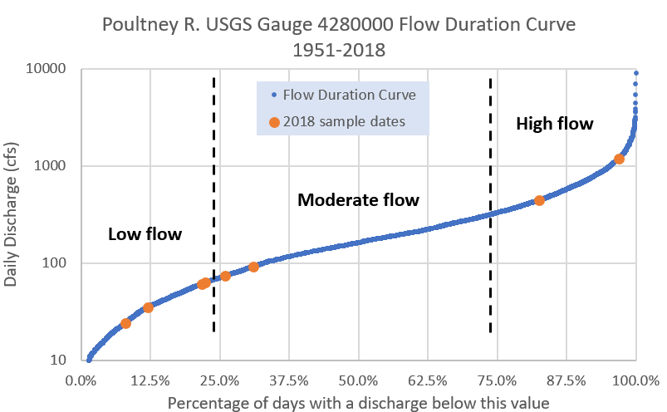
Figure 1: Flow Duration Curve for the Poultney River at the USGS stream gauge below Fair Haven, Vermont (04280000). Blue data points correspond to USGS historical data of approved daily mean flow records for water years 1991 to 2018. Orange data points correspond to the 2018 sampling dates.
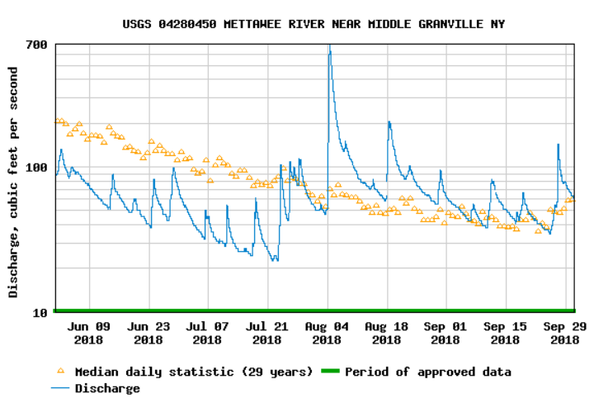
Figure 2: Flow Data from the USGS Mettawee River gage (04280450).

3.0 Methods
Please refer to the PMNRCD 2018 QAPP for sample collection and analysis methods. Information about watershed-specific methods are included below.

PMNRCD collects water samples at historic, or sentinel, sites along the mainstem of the Poultney, Castleton, and Mettowee Rivers to monitor trends in bacteria and phosphorus concentrations transported from the landscape and flowing to Lake Champlain. The District has determined that sampling from smaller tributaries is beneficial for ‘tracing’ nutrients and bacteria back to their source similar to a bracketing method. Increasingly, samples are collected from smaller watersheds and projects are identified that appear to relate directly to a specific source of the pollutants.

Each year the District attempts to map our flow and rainfall data to help with sample result interpretation. Currently, there is one USGS gage on the Mettowee River in Middle Granville that is supported through the Lake Champlain Basin Program and one gage on the Poultney River, below Fair Haven. These gages are important for determining the mechanism of pollutant transport; overland runoff versus groundwater infiltration and movement. Flow data also speaks to dilution processes and is necessary for any loading estimates to Lake Champlain.

The State has created Water Quality Standards for pollutants in Vermont streams measured during low-flow conditions. Without loading studies related to flow, these Standards do not seem entirely meaningful and would only represent a snapshot, not a clear analysis of the amount of phosphorus entering the Lake. Flow-duration curves help to categorize data as low versus moderate flow.

The District aims to delve more deeply into causal relationships related to measured pollutant concentrations and must actively pursue project opportunities highlighted by water monitoring activities. Sampling done on the Flower Brook Watershed and on Lewis Brook illustrate this effort. However, it should be noted that farms and other land use likely contributes nutrients and sediment to local water bodies even when up- and downstream concentration differences aren’t shown through water monitoring. All lands need conservation measures and thoughtful management practices put in place.

Hopefully, the District can use empirical data to show the true conservation value of the projects implemented, while respecting the complexity of data interpretation and the limitations of our understanding of natural processes.

The District is aware that the rate of project implementation can lag behind climate and land use changes, making water quality improvements related to practices even more difficult to document. The District is currently working to understand the current landscape, then to track changes, both positive and negative, as they occur. PMNRCD hopes to quantify how these changes relate to water quality conditions, and to plan conservation measures that will reduce both current levels of pollution and address additional levels of pollution related to future development and other future land use changes. In the continuation of water monitoring and project implementation the goal is to ensure future applications are best suited to this region.

Water quality data, combined with research and studies about the efficacy of conservation practices in various soil types and at a range of background/enriched soil nutrient concentrations, should help determine the potential range for associated nutrient and other reductions related to the use of various conservation measures on the landscape.

3.1 Meteorological Conditions
To characterize meteorological conditions during sampling, PMNRCD researched historical weather reported by Weather Underground for June to September 2018. Weather stations utilized include: Rutland Airprt (KVTRUT), Hooker Hill (KVTCASTL3), Little Lake (KVTWELLS3).

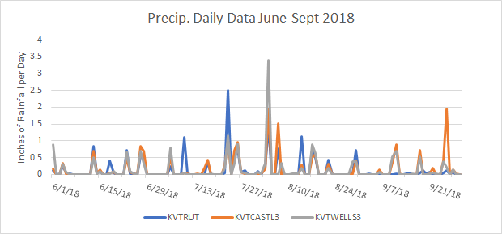
Figure 3: Precipitation data in inches of rainfall per day for the summer of 2018 from local gages (weather underground).

3.2 Sample Collection and Analysis

Biweekly water samples were collected June, July, and August from sites in 2018. Samples were analyzed for total phosphorus (TP) (micrograms per liter – ug/L). There were seven complete sample days; additional sampling for total phosphorus took place during storm events at select sites.

Samples were a combination of grab samples from wadeable streams at a depth approximately halfway between the water surface and the bottom of the stream and collected samples in buckets from bridges, if the depth was greater than three feet. Bottles were stored in a cooler until delivery to the Vermont Agricultural & Environmental Laboratory in Burlington, VT.

All samples were analyzed in accordance with the Vermont Agricultural and Environmental Laboratory SOPs and Analytical Methods as found in their QAPP.

3.3 Quality Assurance / Quality Control

In accordance with the PMNRCD 2018 QAPP, field duplicates and field blanks were collected at a 10% frequency during each sampling event. The location of the field duplicates varied across sampling events. To prepare field blanks, bottles for each scheduled analyte were filled with lab-supplied deionized water and accompanied the regular sample bottles during transport in the field and to the lab. Results of regular and field duplicate pairs from selected stations were evaluated and the average of the Relative Percent Difference (RPD) calculated. Results for Total Phosphorus data were compared to a data quality goals, specified in the QAPP.
Unfortunately, the deionized water from the lab appeared to be contaminated, with many field blanks reading 6.0 up/l and several field blanks at the end of the season reading 350 ug/l. Due to the consistency of the sample results for the field blanks, the presence of TP in the blanks appears to be related to DI water contamination, not sample contamination during transport. The field duplicates had average relative percent differences that met the 30% maximum difference specified in the QAPP.
4.0 Results and Discussion

4.1 Meteorological and Hydrological Conditions
During the months of sampling a portion of this region was considered abnormally dry to moderate drought. Moderate drought readings occurred within the Poultney Mettowee Watershed from the end of June through the beginning of August (Drought Monitor, 2018). Flows in the South Lake watershed were considered moderate flow during five of the sample dates, six of the sample dates had low-moderate flow (5/31, 6/1, 7/10, 7/24, 8/28, 9/4). Excluding spring flows only one sample date, August 8th, fell above the mid-point (50% of days w/ discharge below designated value) on the moderate flow rating.

Table 5: Daily Mean Flows Recorded at USGS gage on sample dates in 2018
Date | Daily Mean Flow (cfs) | Flow Category | % of days w/discharge  below this value
3/30/2018 | 1200 | H | 97%
5/31/2018 | 63.5 | L | 22%
6/1/2018 | 61.6 | L | 22%
6/14/2018 | 74.5 | M | 26%
6/29/2018 | 92.2 | M | 31%
7/10/2018 | 24.3 | L | 8%
7/24/2018 | 35.1 | L | 12%
8/4/2018 | 445 | H | 83%
8/7/2018 | 134 | M | 42%
8/21/2018 | 72.6 | M | 26%
8/28/2018 | 39.2 | L | 14%
9/4/2018 | 27.1 | L | 9%
9/28/2018 | 105 | M | 34%

4.2 Water Quality Results
All sample data gathered for the South Lake Watershed is tabulated in Appendix A.

4.2.1 Total Phosphorus
For Figures 6-14 : The uppermost part of the shaded box represents Q3, (75% Quartile), the lowermost edge of the shaded box represents Q1, (25% Quartile), and the middle division represents the Median of the data set. The upper and lower “tails” represent the Minimum and Maximum values of the data set.
The box-and-whisker plots in the Figures - shows the full distribution of TP results available for 2018. The green line marks the mean of all samples collected, four dates during medium flow conditions above the LMM, and one date just below this threshold. The TP results sampled for Flower03, Coggman03, Hubb01, Hubb02, Hubb03, Tadmer01, Tadmer02, Giddings01, and LB02 exceeded the instream nutrient standard of 27 µg/L during all of the sample dates.

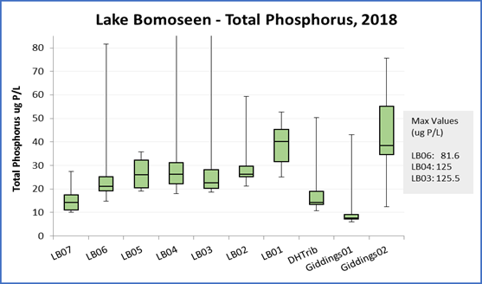
Figure 4: Total Phosphorus at the Lake Bomoseen tributary sites.

In relation to each other this years data follows a similar trend as the 2017 data. LB05 and LB01 had slightly higher measured TP concentrations in 2016 and 2017 than in 2018.

Table 2. Levels of TP measured at Lake Bomoseen sites during low flow, median and averages exclude levels measured during medium or high flow events.
Site | Median TP ug/L | Average TP ug/L
LB07 | 11 | 11.36
LB06 | 19.1 | 19.88
LB05 | 35.9 | 35.9
LB04 | 22.1 | 22.1
LB03 | 21.2 | 24.02
LB02 | 24.9 | 25.1
LB01 | 41.7 | 43.533333
DHtrib | 12.05 | 12.05
Giddings01 | 6.885 | 7.24
Giddings02 | 40.5 | 41.44

Giddings02 is located downstream of a wetland and LB01 is downstream of a pond at the Bomoseen Golf Course.

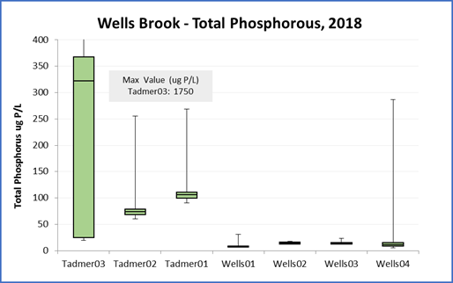
Figure 5 : Total Phosphorus at Wells Brook and the Tadmer tributary.

Table 3. Levels of TP measured at Wells Brook sites during low flow, median and averages exclude levels measured during medium or high flow events.
Site | Median TP ug/L | Average TP ug/L
Tadmer03 | 323* | 323*
Tadmer02 | 77.25 | 76.55
Tadmer01 | 101.5 | 101.975
Wells01 | 7.24 | 7.615
Wells02 | 13.75 | 13.475
Wells03 | 13.4 | 13.225
Wells04 | 10.7 | 11.85
*only one date during low flow was sampled, stream was dry otherwise

The current phosphorus concentrations for Tadmer01 were very similar to measurements from 2017. The site has the highest TP concentrations in the watershed. Tadmer02 and 03 were added upstream of Tadmer01 to follow the concentrations of phosphorus upstream and are new sites in 2018. Tadmer03 indicates a priority for this area due to the exceedingly high levels of TP recorded. This site runs at the edge of an agricultural field and may show direct contamination with runoff containing manure. Tadmer03 flow and TP levels fluctuated substantially throughout the sampling season.

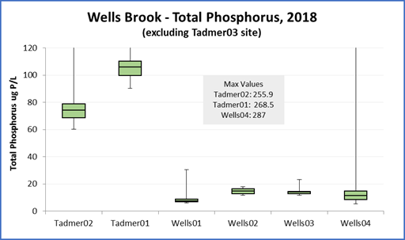
Figure 6: Total Phosphorus at Wells Brook and the Tadmer tributary.

The Wells Brook sites were below the set impairment standards of 27ug/L TP in samples monitored in 2018. Wells01 is just upstream from the confluence with Tadmer01. There is a slight increase seen at the Wells02 which may show the contribution of the Tadmer Tributary with the Wells River upstream of this site. The Wells river is much larger than the Tadmer tributary, and dilution is a likely factor reducing the increase in TP concentrations in Wells Brook downstream of the Tadmer Brook confluence.

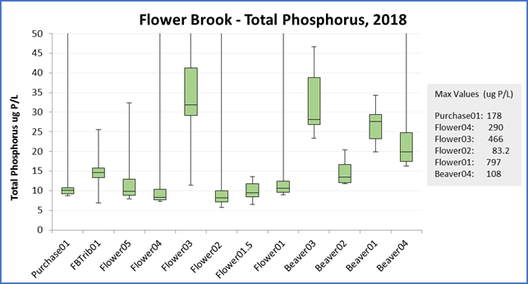
Figure 7: Total phosphorus at Flower Brook and Beaver Brook.

Flower Brook sites Flower03 and Beaver03 have the highest recorded phosphorus concentrations in the Flower Brook watershed. These sites are largely above the water quality standards for class B streams. Flower03 is located at the Lilly Hill Road bridge where an upwelling of clay can be seen in the river channel and Beaver03 is located downstream of a wetland.

Table 4. Levels of TP measured at Flower Brook sites during low flow, median and averages exclude TP levels measured during medium or high flow events.
Site | Median TP ug/L | Average TP ug/L
Purchase01 | 9.79 | 9.6375
FBTrib01 | 15.35 | 15.35
Flower05 | 9.67 | 9.52
Flower04 | 7.74 | 7.775
Flower03 | 33.8 | 35.875
Flower02 | 8.13 | 8.405
Flower01.5 | 8.795 | 8.9075
Flower01 | 9.945 | 10.055
Beaver03 | 25.85 | 28.45
Beaver02 | 15 | 15.55
Beaver01 | 25.4 | 25.625
Beaver04 | 18.4 | 18.575

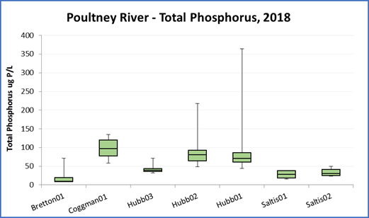
Figure 8 : Total phosphorus concentrations at North Bretton Brook, Coggman Creek, and the Hubbardton River.

The max at Hubb01 (364.00 ug/L) occurred during the spring sampling round during high flow. At Hubb02 the max was 218.00 ug/L and was recorded in August on a medium flow day. Hubb02 is located downsteam of the mill pond and the pond is likely biologically rich, leading to higher levels of phosphorus suspended in the water column.

Table 2. Levels of TP measured at Poultney River sites during low flow, median and averages exclude TP levels measured during medium or high flow events.
Site | Median TP ug/L | Average TP ug/L
Bretton01 | 9.09 | 11.904
Coggman01 | 76.2 | 73.78
Hubb03 | 37.5 | 36.64
Hubb02 | 78 | 71.98
Hubb01 | 60.1 | 59.06
Saltis01 | 27.5 | 24.54
Saltis02 | 31 | 32.38

5.0 Conclusions
Many of the streams sampled during 2018 are found to be above nutrient criteria for median TP during low flow. The streams in excess are already in focus of the District and additional attention will be given to them.

PMNRCD has continued efforts with landowners in the upstream sections of Flower and Beaver Brook to implement best management practices to reduce erosion. A portion of the focus has been property owner education on forest management of the land comprising the headwaters. We have held and will continue holding landowner meetings of the surrounding forest blocks in the Flower Brook watershed in order to advise management in a cohesive nature with an emphasis on water quality. This will be the third year we have seen higher levels of nutrients recorded in the headwaters compared to the village sites of the Flower Brook watershed, likely due to the persistent erosion present at the upland properties.. With climate change playing a role in the increased flow of nutrients it is especially important for there to be more education for those managing land in the headwater portion of streams, as this trend is likely to continue. Some of the fluctuations in Beaver Brook may be influenced by the surrounding wetland drainage. More research and study of these areas would be needed to determine the cycle of TP filtered and held within these systems.
Tadmer is of particular concern due to the high levels of TP found at the upstream sites. The Tadmer sites will need further monitoring as well as continued conversations with known source properties, which are likely to be contributing to the high nutrient loads. The spike in TP levels sampled occurred during a high flow day following a rain event in the area. This increase further points to contaminated runoff at the agricultural site. The low flow events were high compared to the 27ug/L standard allowed for streams of this type. The District plans to use this data when speaking to the landowners in order to convey the need for BMP’s to be implemented. In the past the District has used data during meetings with the agricultural community and has found it beneficial.

Due to the nature of the streams in the lower poultney River watershed we expect to see higher levels of TP at these sites. The District is aware of some possible agricultural sources along the Coggman and Hubbardton Rivers and is working to provide more support for farmers in that area of the watershed. PMNRCD is planning on conducting a Stormwater Masterplan for the Poultney River Watershed which will include the areas highlighted by this report. This plan, as well as past reports, combined with our water monitoring efforts will enable us to identify and prescribe possible remediation efforts for sites.

The Saltis Farm sample sites (Lewis01 and Lewis02) show a fairly high level of measured TP during low flow. During the majority of the sampling season the stream had exclusion fencing and the forested buffer was planted during the spring and fall, the effects of which would not yet be reflected in these samples. There is a slight increase at the downstream site, however, there are also other land use factors in the area such as slate quarries which may contribute to the nutrient levels seen.

One way PMNRCD attempts to provide education and resources to those within the watershed is by recommending and assisting in the installation of practices.. Recommended projects and practices included nutrient management to reduce phosphorus and sediment/gravel inputs, riparian buffer plantings where gaps exist, cover cropping, no-till cropping, edge-of-field gully stabilization, stormwater treatment measures to disconnect road ditch networks from the stream, stormwater treatment measures to disconnect private driveways from the stream, culvert upgrades, riparian wetland restoration and river corridor protection (PMNRCD).

6.0 References
South Mountain Research & Consulting, 2007, Castleton River Watershed: Phase 2 Stream Geomorphic Assessment, Rutland County, Vermont, prepared under contract to Poultney Mettowee NRCD.

South Mountain Research & Consulting, 2007, Mettowee River Watershed: Phase 2 Stream Geomorphic Assessment, Rutland County, Vermont, prepared under contract to Poultney Mettowee NRCD.

Stewart, David P. and Paul MacClintock, 1969, The Surficial Geology and Pleistocene History of Vermont. Vermont Geological Survey Bulletin No. 31.
USDA Natural Resource Conservation Service, 2011, State Data Table Top 20, published by the United States Department of Agriculture, NRCS; available at: ftp://ftp-fc.sc.egov.usda.gov/VT/Soils/top20/
USDA Natural Resource Conservation Service, 2013, Soil Survey Geographic (SSURGO) database, available at: http://www.vcgi.org/dataware/default.cfm?layer=
GeologicSoils_SO. Accessed: [3/9/2013].
US Drought Monitor, accessed 3 December 2018,
https://droughtmonitor.unl.edu/DroughtSummary.aspx

USGS, 2018, Water Year Summary for Site USGS 04280000, available at
https://waterdata.usgs.gov/nwis/wys_rpt/?site_no=04280000

VT DEC Water Quality Division, 2016a, State of Vermont 2016 303(d) List of Waters: Part D – Impaired Surface Waters With Completed and Approved TMDL. Available at: http://dec.vermont.gov/sites/ dec/files/documents/WSMD_mapp_Part_D_2016_final_complete.pdf
VT DEC Water Quality Division, 2016b, State of Vermont 2016 Stressed Waters List. Available at: http://dec.vermont.gov/sites/dec/files/documents/wsmd_mp_stressed_waters_list_2016.pdf
VT DEC Water Quality Division, 2016c, State of Vermont 2016 303(d) List of Waters: Part A – Impaired Surface Waters in Need of TMDL. Available at: http://dec.vermont.gov/sites/dec/files/documents/ WSMD_mapp_303d_Part_A_2016_final_complete.pdf
Vermont Watershed Management Division, 2016. Vermont Water Quality Standards.
Effective 15 January 2017. Montpelier, VT. Available at: http://dec.vermont.gov/sites/dec/files/ documents/wsmd_water_quality_standards_2016.pdf

7.0 Appendix

TP Raw Data
