Water Quality Monitoring in the Upper Winooski River Headwaters
2017

E. coli, chloride, alkalinity, phosphorus, nitrogen, and turbidity levels in the streams of
Cabot-Marshfield-Plainfield
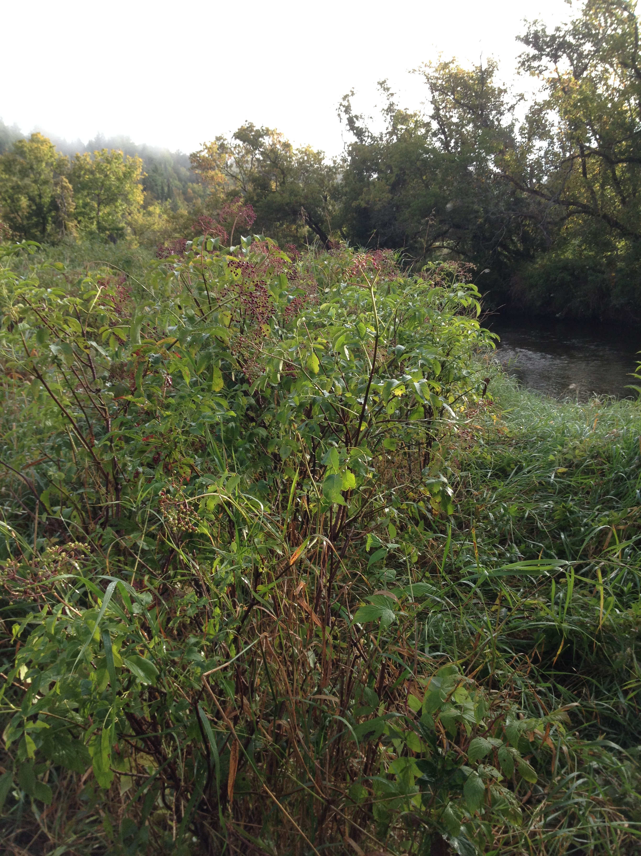
Elderberry plantings at Martin Bridge 2017

The Friends of the Winooski River in Cooperation with
The Conservation Commissions of Cabot, Marshfield, and Plainfield
with support from the
R.A. LaRosa Grants Program

Prepared by Steve Fiske and Shawn White for
The Vermont Department of Environmental Conservation
January 2018

Water Quality Monitoring by the Winooski Headwaters Partnership
The Winooski Headwaters Partnership is composed of the Conservation Commissions of Plainfield, Marshfield, and Cabot; the Friends of the Winooski River; and community members of Headwaters towns. The Headwaters Partnership has been conducting water quality monitoring of the Winooski River and several of its tributaries since 2007. Parameters of interest have included E. coli, total phosphorus, total nitrogen, turbidity, chloride, and alkalinity. Monitoring sites have been chosen based on recreational contact, suspected pollutant sources, locations of waste water treatment plants, and a population of a Vermont listed threatened species.
The following report describes the results of the Headwaters Partnership 2017 monitoring. Samples were collected by Headwaters volunteers six times, approximately biweekly on, June 27, July 11, July 25, August 8, August 22, and September 5. Descriptions and locations of the 11 sites sampled for bacteria (Escherichia coli), phosphorus, nitrogen and turbidity were tested at 17 sites on the same dates. Alkalinity and chloride were tested once at 14 locations on the July 27th sampling date. Descriptions of the sampling site locations, including lats and longs are shown in Appendix A. The summer of 2017 was wet overall, with high groundwater levels resulting in moderate flow levels on most sampling dates through the first week of September. Despite overall moderate flows there was no significant rainfall resulting in runoff immediately before or during all but two sampling dates: 7/25 and 8/8 (Table 1). Most rainfall occurred 2-4 days prior to the sampling dates, and the streams had already dropped back to a moderate base flow conditions by the day of sampling.

Date | rainfall the day of sampling before 8 am (day 0) | rainfall on the day prior to sampling (day 1) | cumulative rainfall 2 days before sampling (days 1&2) | cumulative rainfall 3 days before sampling  (days 1,2,&3) | cumulative rainfall 4 days before sampling  (days 1,2,3,&4)
6/27/17 | 0 | 0 | 0.07 | 0.86 | 2.11
7/11/17 | 0.03 | 0 | 0 | 0.41 | 0.51
7/25/17 | 0.04 | 0.75 | 0.75 | 0.75 | 0.76
8/8/17 | 0.08 | 0.35 | 0.35 | 0.65 | 0.65
8/22/17 | 0 | 0 | 0 | 0.01 | 0.8
9/5/17 | 0 | 0 | 1.01 | 1.01 | 1.01
Table 1. Rainfall on the sampling date and 1-4 days before sampling. Rainfall amounts for the day of sampling were obtained using the hourly weather observations listed on the Weather Underground Weather History webpage (https://www.wunderground.com/history/) for the Edward Knapp State Airport weather station (KMPV) near Montpelier. The total daily amounts used to calculate the 1- 4-day rainfall amounts were downloaded from the National Climatic Data Center (https://www.ncdc.noaa.gov/cdo-web/).
Samples were analyzed at the Vermont Department of Environmental Conservation La Rosa laboratory by laboratory staff. Individual sample results, including the results for duplicate and blank samples, are listed in Appendices B and C. Quality assurance measures (duplicate sample relative percent differences) and control blank met target values in all cases.
E. coli Background and Results
Fecal coliform bacteria are a group of bacteria primarily found in human and animal intestines and feces. Escherichia coli (E. coli) is one of the fecal coliform bacteria widely used as an indicator organism to detect the presence of fecal material in water and the possible presence of pathogenic (disease-producing) organisms. When E. coli is found in waters, its presence is not the problem of concern itself (most strains of E.coli are not pathogenic), but is rather an indicator of the presence of other pathogens found in fecal matter from humans or animals. E. coli monitoring is commonly conducted to inform people whether the water is safe for swimmers and other contact recreational activities. A relationship can often be established between high bacteria concentrations and its sources such as rainfall runoff from urban streets, waterfowl or other wildlife congregations, pastured animals, pet waste, and untreated waste (septic or sewage) wastewater. Vermont’s E.coli criteria matches the EPA recommendations: “Not to exceed a geometric mean of 126 organisms /100ml obtained over a representative period of 60 days, and no more than 10% of samples above 235 organisms/100 ml”. This equals to a risk factor of about 36 illnesses/1,000 ingestions. The EPA also provides an E. coli “Beach Action Value” (BAV) of 235 MPN/mL for single water samples. States can adopt this value and use it to close a recreational water site to the public when E. coli levels are above this standard.
Table 1 below shows the geometric mean of E.coli results from all six sampling dates for each location. The table shows continued high levels in the locations from the Martin Bridge WIN 72.8 downstream through Plainfield Village to below the WWTF at WIN 70.7 compared to previous years. The two locations within Marshfield Village WIN 81.6 and WIN 82.6 continue to show improved levels below standards for the second consecutive year. The next two locations upstream are along the Cabot flats from just above the hydropower plant at WIN 86.8 to the Durant cemetery at WIN 83.8. These locations are just above the standard in 2017 showing a slight increase compared to 2016, but lower than those found from 2011 to 2015. The uppermost locations at Larry’s ballfield and above Cabot Village at the recreation field continue to have low levels below the standard. The two tributaries sampled for E. coli in 2017, Naismith Brook at the “Paradise” swimming hole at NAB 0.8, and Great Brook at the mouth GB 0.1, continue to show very low levels.
Figure 1 shows the range of E.coli at all stations sampled in 2017, illustrating that most locations both met and exceeded the single sample standard at least once over the summer, and that only the Naismith Brook (NAB0.8) and WIN86.9 sites met standards every time sampled regardless of flow levels. Figure 2 shows the E.coli levels for each sample date at all locations. E. coli levels were high at numerous downstream Winooski sites on the July 25th sampling date (light green bar). As noted above in Table 1, this sampling date occurred directly after moderately heavy rain the previous day. This indicates that stormwater runoff continues to result in the higher E.coli in the upper Winooski streams. The two highest counts however occurred during the lowest flows on August 22nd and September 5th. Great Brook also had its highest levels on August 22nd. These high counts are more indicative of point sources or ground water contamination.

Table 1: Showing Geometric mean E.coli levels over time at all locations sampled in 2017 from 2007-2017.
 | E. coli Geometric Mean Under Dry Conditions
Site ID | 2007 | 2008 | 2010 | 2011 | 2012 | 2013 | 2014 | 2015 | 2016 | 2017
WIN70.7 |  | 149 | 268 |  | 245 | 159 | 105 | 302 | 164 | 253
WIN72.8 |  |  | 162 | 214 | 168 | 150 | 181 | 137 | 152 | 162
WIN81.6 | 256 | 134 | 150 |  | 223 | 120 | 178 | 154 | 67 | 93
WIN82.6 |  | 41 | 236 | 56 | 442 | 214 | 338 | 113 | 66 | 101
WIN82.8 |  |  |  | 171 | 541 | 128 | 485 | 170 | 119 | 132
WIN83.8 | 187 | 83 | 128 | 175 | 143 | 110 | 137 | 179 | 88 | 136
WIN85.5 |  |  | 51 | 78 | 94 | 74 | 112 | 61 | 40 | 86
WIN86.9 |  |  |  |  |  | 48 | 137 | 29 | 41 | 113
GB0.1 | 39 | 58 |  |  |  |  | 12 |  | 5 | 87
NAB 0.8 | 9 |  |  |  |  |  |  | 14 |  | 20
 | Exceeds EPA standards for the annual geometric mean (126 mpn/ml)

Figure 1 shows the range of E.coli levels at each location in 2017. The short dash line is the single sample VT standard, and the long dash line is the geometric mean standard of 126 over sixty days.

Figure 2 shows the 2107 E. coli levels in the upper Winooski River for all sampling events.

Nutrients: Total phosphorus, nitrogen and turbidity - Results
The results for the nutrient concentrations and turbidity are shown below in Figures 3-. The Vermont Water Quality standard guidance value for total phosphorus (TP) during low, base flows is 15ug/l for moderate, high-gradient (MHG) streams and 12 ug/l for small, high-gradient (SHG) streams. All stream reaches sampled except for the smaller tributaries would be considered MHG stream reaches. This includes all the Winooski River, Creamery Brook, Jug Brook, Naismith Brook, and Great Brook. Wells Brook, Beaver Meadow Brook, Rec Field Brook, and Goat Farm Tributary are likely SHG streams. Only one sampling date, 8/22/2017, coincided with low base flows, so these data cannot be directly applied to the WQS. They can, however, be used to compare sites to identify which stream locations and their associated watersheds are exporting the highest concentrations of total phosphorus.
Given this, Rec Field Tributary had the highest mean TP at >45ug/l, followed by Goat Farm Tributary (27ug/l), and Jug Brook at about 25 ug/l. The next highest locations were all on the main stem of the Winooski at river mile 70.7, 72.8, and 81.6 -all between 20 and 23ug/l. All other tributarys were at or below 15ug/l, with Great Brook and Wells Brook exporting the lowest concentration (10ug/l). The sites with the highest phosphorus also had the highest turbidities with a mean turbidity of over 4 NTUs, with the exception of Jug Brook with a mean turbidity of <1.0 NTU. The high TP from Rec Field Trib was mostly driven by a single sample collected on July 25, 2017 with a concentration of 179ug/l.
The Rec Field Tributary was also very turbid on July 25th, with a turbidity measurement of 10 NTUs. The only other sites with turbidity over 4 NTUs on that date were three lower main stem of the Winooski: 70.7, 72.8 and 81.6. Jug Brook’s high TP concentration was due to an extremely high value of 97ug/l on Sept 5, 2017. Unlike Rec Field Trib, Jug Brook was not high in turbidity on the date with a turbidity of <1 NTU’s. In fact Jug Brook was one of the least turbid streams with all turbidity measurements of ≤1 NTU. In conclusion, the two streams contributing the highest concentration of TP in the upper Winooski Watershed are the Rec Field and Goat Farm Tributaries. Both of these watersheds should be examined further for potential sources and mitigation activities aimed at TP reduction.
The Vermont Water Quality Standard for Total Nitrogen (TN) is 5mg/l. All samples were below 1.0mg/l TN, showing low overall TN concentrations in the upper Winooski watershed. Rec Field Trib, however, also had the highest mean TN (0.6mg/l), again driven by the high value from July 25th (1.7 mg/l). The fact that on July 25th the Rec Field Trib had very high TP, TN, and turbidity, suggest a single runoff event discharging to the stream on that date.

Figure 3. Mean total phosphorus concentrations at Winooski Headwaters sampling sites.

Figure 4. Total phosphorus results for each sample collected at Winooski Headwaters sites in 2017.

Figure 5. Mean turbidity levels at Winooski River sampling sites in 2017.

Figure 6. Total turbidity results for each sample collected at Winooski Headwaters sites in 2017.

Figure 7. Mean nitrogen levels at Winooski River sampling sites in 2017.

Figure 8. Total nitrogen results for each sample collected at Winooski Headwaters sites in 2017.

Alkalinity and Chloride – Results
Alkalinity and Chloride were collected on June 27 in 2017 at 14 locations with streams flow at high levels after a very wet month of rain. Alkalinity is a reflection of the bedrock and soils from these watersheds. The low alkalinity <30mg/l of Naismith Brook reflects its granitic-based watershed. All other locations had moderate alkalinity ranging from 60-105 mg/l all draining watersheds with soils higher in calcium. Chloride was < 16mg/l in all tributaries and in the Winooski River main stem. Chloride does not become toxic to aquatic life until levels approach 230mg/l. The Vermont Water Quality standards chloride criterion has an chronic standard of 230 mg/l for the daily mean over four day period, and an acute standard of 860 mg/l (one day mean). Overall, chloride was very low at all locations- indicating deicing materials such as road and sidewalk salting is not yet an issue in the upper Winooski River watershed.

Figure 9. Alkalinity at the Winooski River Headwaters sampling sites, 2017.

Figure 10. Chloride concentrations at the Winooski River Headwaters sampling sites, 2017.

Appendices
Appendix A. Site Descriptions and Maps
E. coli testing sites (11 total)
Stream | Site ID | Lat/Long | Description
Winooski River | WIN 86.9 | 44.40651 / -72.30995 | Above Cabot Plains Brook, adjacent to Cabot Rec Fields
Winooski River | WIN 85.5 | 44.3984 / -72.3244 | By Larry’s ballfield below Cabot village.
Winooski River | WIN 83.8 | 44.3829 / -72.3325 | Durant cemetery below Cabot WWTF
Winooski River | WIN 82.8 | 44.3604 / -72.3353 | Just above GMP generation station.
Winooski River | WIN 82.6 | 44.3519 / -72.3470 | At Rt 2 bridge just above Marshfield Village
Winooski River | WIN 81.6 | 44.3472 / -72.3606 | Below Marshfield WWTF, above flower farm
Winooski River | WIN 72.8 | 44.2871 / -72.4090 | At Martin Bridge
Winooski River | WIN 70.7 | 44.2733 / -72.4322 | Below discharge at Plainfield WWTF
Goat Farm Trib | GFT 0.1 | 44.42794 / -72.32381 | Above Houston Hill Road
Naismith Brook | NAB 0.8 | 44.2981/ -72.3874 | Paradise swimming hole
Great Brook | GB 0.1 | 44.2767 / -72.4267 | Great Brook just before confluence with the Winooski

Water quality monitoring sites (17 total)
Stream | Site ID | Lat/Long | Description
Goat Farm Trib | GFT 0.1 | 44.42794 / -72.32381 | Above Houston Hill Road
S Walden Tributary | SWT0.2 | 44.41932 / -72.31259 | At Houston Hill Rd
Rec Field trib | Rec Field Trib 0.1 | 44.4064 / -72.3084 | Adjacent to Cabot rec fields above town
Jug Brook | JB 0.1 | 44.3923 / -72.331 | Jug Brook at Route 215 in Lower Cabot
Creamery Brook | CB 0.1 | 44.3512 / -72.3552 | Above rt 2 bridge.
Beaver Meadow Brook | BM 0.2 | 44.3299 / -72.3782 | Above Peck Place Road
Naismith Brook | NAB 0.8 | 44.2981 / -72.38745 | At Paradise swimming hole
Wells Brook | WB 0.1 | 44.2834 / -72.4172 | Above Rt 2 bridge
Great Brook | GB 0.1 | 44.2767 / -72.4267 | Great Brook just before confluence with the Winooski
Winooski River | WIN 86.9 | 44.4065 / -72.3104 | Above Rec Field Trib
Winooski River | WIN 85.5 | 44.3984 / -72.3244 | By Larry’s Ball field below Cabot village.
Winooski River | WIN 83.8 | 44.3829 / -72.3325 | Durant cemetery below Cabot WWTF
Winooski River | WIN 82.8 | 44.3604 / -72.3353 | Just above GMP generation station.
Winooski River | WIN 82.6 | 44.3519 / -72.3470 | At Rt 2 bridge just above Marshfield Village
Winooski River | WIN 81.6 | 44.3472 / -72.3606 | Below Marshfield WWTF, at flower farm
Winooski River | WIN 72.8 | 44.2871 / -72.4090 | Winooski River at Martin Bridge
Winooski River | WIN 70.7 | 44.2733 / -72.4322 | Below discharge at Plainfield WWTF

Headwaters Partnership Cabot, VT Sampling Sites for 2016
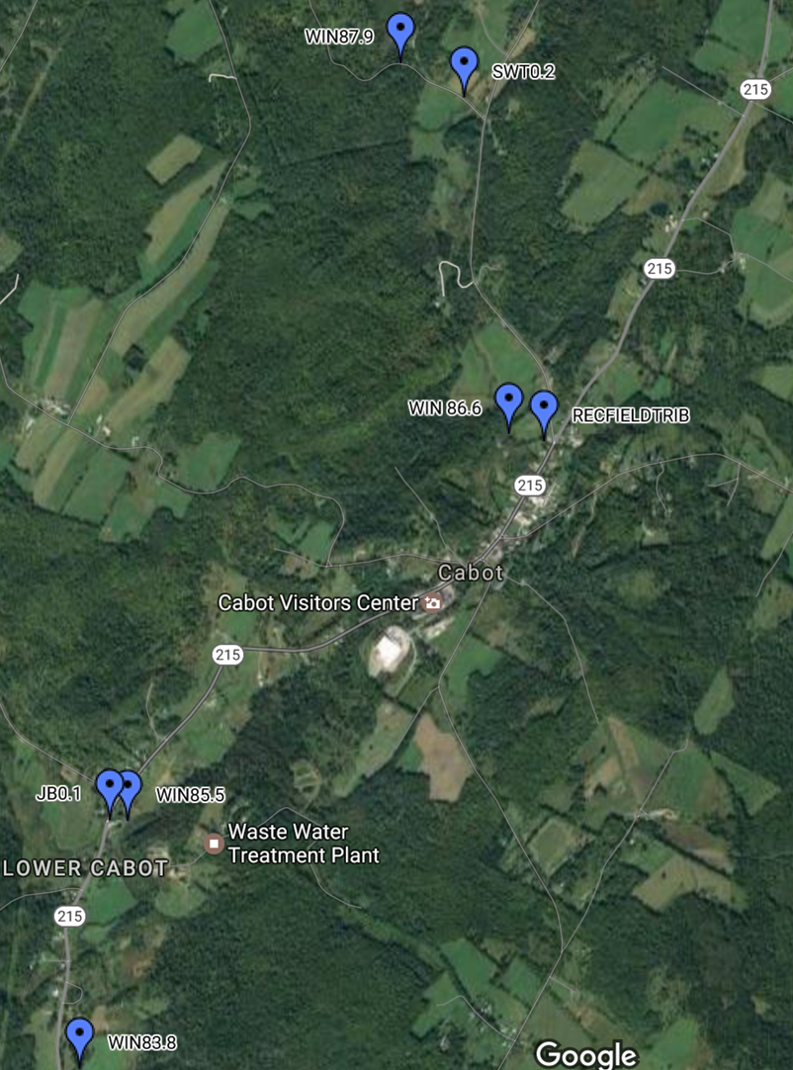

Headwaters Partnership Marshfield, VT Sampling Sites 2016
(the WIN 81.6 site, downstream of MAB0.1, is not labeled)
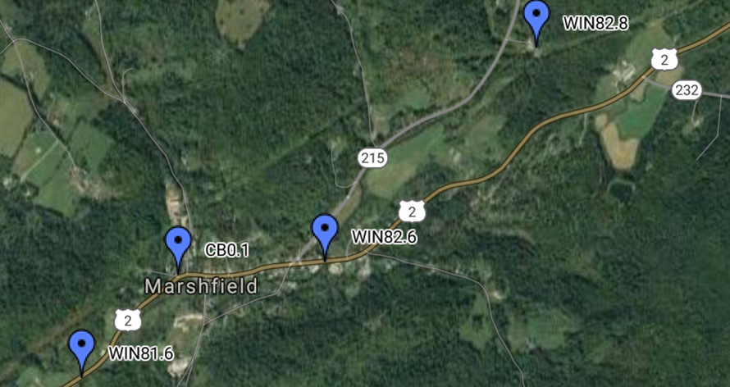
Headwaters Partnership Marshfield/Plainfield, VT Sampling Sites 2016 (GB0.1 is not labeled)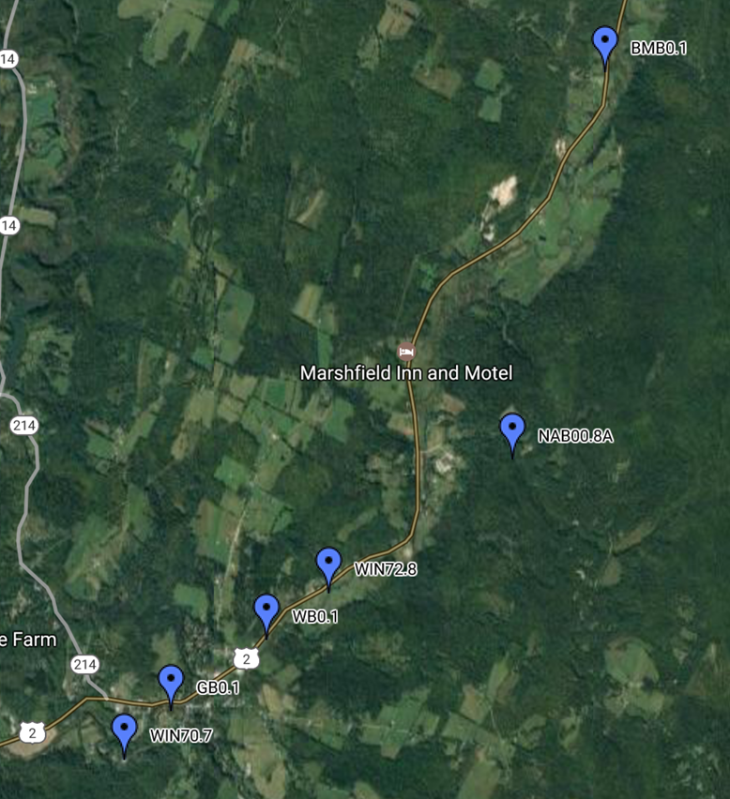
Appendix B:2017 E.coli concentration results for each site and date. RPD= relative percent difference between duplicate samples collected same date at a site. Data set includes 10% duplicates and Blank samples for quality control.
Sample Number | Location | Date | Results  E.coli mpn / 100ml | RPD
170471-09 | GB0.1 | 6/27/2017 | 56
170472-09 | GB0.1 | 7/11/2017 | 16
170912-10 | GB0.1 | 7/25/2017 | 120
171031-10 | GB0.1 | 8/8/2017 | 37
171158-11 | GB0.1 | 8/22/2017 | 411
171266-11 | GB0.1 | 9/5/2017 | 272
170912-12 | GFT0.1 | 7/25/2017 | 114
171031-12 | GFT0.1 | 8/8/2017 | 365
170471-07 | NAB0.8A | 6/27/2017 | 16
170472-07 | NAB0.8A | 7/11/2017 | 34
170912-08 | NAB0.8A | 7/25/2017 | 114
171031-06 | NAB0.8A | 8/8/2017 | 26
171158-07 | NAB0.8A | 8/22/2017 | 3
171266-07 | NAB0.8A | 9/5/2017 | 14
171031-07 | NAB0.8A-BLANK | 8/8/2017 | <1
171031-08 | NAB0.8A-DUP | 8/8/2017 | 21 | 19%
170471-10 | WIN70.7 | 6/27/2017 | 96
170472-10 | WIN70.7 | 7/11/2017 | 83
170912-11 | WIN70.7 | 7/25/2017 | 461
171031-11 | WIN70.7 | 8/8/2017 | 238
171158-12 | WIN70.7 | 8/22/2017 | 727
171266-12 | WIN70.7 | 9/5/2017 | 411
170471-08 | WIN72.8 | 6/27/2017 | 57
170472-08 | WIN72.8 | 7/11/2017 | 59
170912-09 | WIN72.8 | 7/25/2017 | 411
171031-09 | WIN72.8 | 8/8/2017 | 162
171158-08 | WIN72.8 | 8/22/2017 | 205
171266-08 | WIN72.8 | 9/5/2017 | 387
171158-09 | WIN72.8-BLANK | 8/22/2017 | <1
171266-09 | WIN72.8-BLANK | 9/5/2017 | <1
171158-10 | WIN72.8-DUP | 8/22/2017 | 308 | 40%
171266-10 | WIN72.8-DUP | 9/5/2017 | 345 | 12%
170471-06 | WIN81.6 | 6/27/2017 | 57
170472-06 | WIN81.6 | 7/11/2017 | 49
170912-07 | WIN81.6 | 7/25/2017 | 345
171031-05 | WIN81.6 | 8/8/2017 | 96
171158-06 | WIN81.6 | 8/22/2017 | 61
171266-06 | WIN81.6 | 9/5/2017 | 121
170471-11 | WIN82.6 | 6/27/2017 | 167
170472-11 | WIN82.6 | 7/11/2017 | 12
170912-04 | WIN82.6 | 7/25/2017 | 260
171031-04 | WIN82.6 | 8/8/2017 | 140
171158-05 | WIN82.6 | 8/22/2017 | 76
171266-05 | WIN82.6 | 9/5/2017 | 196
170912-05 | WIN82.6-BLANK | 7/25/2017 | <1
170912-06 | WIN82.6-DUP | 7/25/2017 | 344 | 28%
170471-05 | WIN82.8 | 6/27/2017 | 74
170472-05 | WIN82.8 | 7/11/2017 | 78
170912-03 | WIN82.8 | 7/25/2017 | 345
171031-03 | WIN82.8 | 8/8/2017 | 124
171158-04 | WIN82.8 | 8/22/2017 | 90
171266-04 | WIN82.8 | 9/5/2017 | 240
170471-04 | WIN83.8 | 6/27/2017 | 58
170472-02 | WIN83.8 | 7/11/2017 | 51
170912-02 | WIN83.8 | 7/25/2017 | 179
171031-02 | WIN83.8 | 8/8/2017 | 126
171158-03 | WIN83.8 | 8/22/2017 | 152
171266-03 | WIN83.8 | 9/5/2017 | 613
170472-03 | WIN83.8-BLANK | 7/11/2017 | <1
170472-04 | WIN83.8-DUP | 7/11/2017 | 51 | 0%
170471-01 | WIN85.5 | 6/27/2017 | 36
170472-01 | WIN85.5 | 7/11/2017 | 108
170912-01 | WIN85.5 | 7/25/2017 | 308
171031-01 | WIN85.5 | 8/8/2017 | 105
171158-02 | WIN85.5 | 8/22/2017 | 23
171266-02 | WIN85.5 | 9/5/2017 | 138
170471-02 | WIN85.5-BLANK | 6/27/2017 | <1
170471-03 | WIN85.5-DUP | 6/27/2017 | 54 | 39%
171158-01 | WIN86.9 | 8/22/2017 | 118
171266-01 | WIN86.9 | 9/5/2017 | 108
Average relative % difference |  |  |  | 23%

Appendix C. 2017 results for Total Nitrogen, Total Phosphorus, Turbidity, Alkalinity, and Chloride from the Upper Winooski Headwaters, and tributaries. Results include 10% duplicate and blank samples. RPD is the relative percent difference between a sample and the duplicate sample collected at same day and site.
Sample Number | Location | Date | Alklinity  (mg CaCO3/L) | Chloride (mg/L) | TN (mg-N/l) | TP (ug P/L) | Turbidity (NTU) | RPD, Alk | RPD, Chlor | RPD, TN | RPD, TP | RPD, Turb
171032-12 | BMB 0.1-BLANK | 8/8/2017 |  |  | < 0.1 | < 5 | < 0.2
171032-13 | BMB 0.1-DUP | 8/8/2017 |  |  | 0.28 | 15.1 | 1.51 |  |  | 3.51% | 8.25% | 4.75%
170470-14 | BMB0.1 | 6/27/2017 | 81 | < 2 | 0.15 | 10.9 | 1.4
170473-14 | BMB0.1 | 7/11/2017 |  |  | 0.18 | 12.2 | 1.14
170913-15 | BMB0.1 | 7/25/2017 |  |  | 0.24 | 19.9 | 3.21
171032-11 | BMB0.1 | 8/8/2017 |  |  | 0.29 | 16.4 | 1.44
171159-14 | BMB0.1 | 8/22/2017 |  |  | 0.31 | 10.3 | 0.71
171267-14 | BMB0.1 | 9/5/2017 |  |  | 0.22 | 10.1 | 1.27
170470-12 | CB0.1 | 6/27/2017 | 73 | 5.35 | 0.23 | 9.67 | 0.67
170473-12 | CB0.1 | 7/11/2017 |  |  | 0.31 | 11.9 | 0.62
170913-13 | CB0.1 | 7/25/2017 |  |  | 0.24 | 18.1 | 2.69
171032-09 | CB0.1 | 8/8/2017 |  |  | 0.35 | 13.7 | 0.86
171159-12 | CB0.1 | 8/22/2017 |  |  | 0.35 | 8.57 | 0.71
171267-12 | CB0.1 | 9/5/2017 |  |  | 0.31 | 13.7 | 0.64
170470-18 | GB0.1 | 6/27/2017 | 80 | 4.59 | 0.25 | 14.7 | 2.16
170473-18 | GB0.1 | 7/11/2017 |  |  | 0.32 | 7.35 | 0.75
170913-19 | GB0.1 | 7/25/2017 |  |  | 0.23 | 15 | 3.16
171032-19 | GB0.1 | 8/8/2017 |  |  | 0.44 | 10.1 | 1.38
171159-20 | GB0.1 | 8/22/2017 |  |  | 0.57 | 7.44 | 0.41
171267-18 | GB0.1 | 9/5/2017 |  |  | 0.44 | 8.19 | 0.62
170470-01 | GFT0.1 | 6/27/2017 | 173 | 6.08 | 0.43 | 29.8 | 1.02
170473-01 | GFT0.1 | 7/11/2017 |  |  | 0.18 | 11.2 | 1.21
170913-21 | GFT0.1 | 7/25/2017 |  |  | 0.37 | 33 | 0.98
171032-21 | GFT0.1 | 8/8/2017 |  |  | 0.51 | 39.2 | 0.5
171159-01 | GFT0.1 | 8/22/2017 |  |  | 0.36 | 13.4 | 0.46
171267-01 | GFT0.1 | 9/5/2017 |  |  | 0.38 | 35.6 | 0.28
170473-03 | GFT0.1-DUP | 7/11/2017 |  |  | 0.14 | 11.9 | 1.26 |  |  | 25.00% | 6.06% | 4.05%
170473-02 | GFT0.1-BLANK | 7/11/2017 |  |  | < 0.1 | < 5 | < 0.2
171159-03 | GFT0.1-DUP | 8/22/2017 |  |  | 0.37 | 13.4 | 0.5 |  |  | 2.74% | 0.00% | 8.33%
171159-02 | GFT0.1-BLANK | 8/22/2017 |  |  | < 0.1 | < 5 | < 0.2
170470-07 | JB0.1 | 6/27/2017 | 93 | < 2 | 0.14 | 9.38 | 0.79
170473-07 | JB0.1 | 7/11/2017 |  |  | 0.2 | 13.9 | 0.83
170913-07 | JB0.1 | 7/25/2017 |  |  | 0.21 | 12.1 | 1.25
171032-05 | JB0.1 | 8/8/2017 |  |  | 0.26 | 11.9 | 0.89
171159-08 | JB0.1 | 8/22/2017 |  |  | 0.28 | 8.88 | 0.48
171267-06 | JB0.1 | 9/5/2017 |  |  | 0.31 | 92.6 | 1.11
170470-15 | NAB0.8A | 6/27/2017 | 29 | < 2 | 0.16 | 14.9 | 1.11
170473-15 | NAB0.8A | 7/11/2017 |  |  | 0.21 | 14.1 | 0.44
170913-16 | NAB0.8A | 7/25/2017 |  |  | 0.21 | 17.6 | 1.86
171032-14 | NAB0.8A | 8/8/2017 |  |  | 0.28 | 16.3 | 0.48
171159-15 | NAB0.8A | 8/22/2017 |  |  | 0.34 | 13.7 | < 0.2
171267-15 | NAB0.8A | 9/5/2017 |  |  | 0.34 | 16 | 0.52
171032-15 | NAB0.8A-BLANK | 8/8/2017 |  |  | < 0.1 | 8.18 | < 0.2
171032-16 | NAB0.8A-DUP | 8/8/2017 |  |  | 0.28 | 15.4 | 0.59 |  |  | 0.00% | 5.68% | 20.56%
170470-03 | Rec Field Trib | 6/27/2017 | 96 | 10.3 | 0.31 | 19.7 | 1.87
170473-05 | Rec Field Trib | 7/11/2017 |  |  | 0.33 | 15.6 | 2.48
170913-05 | Rec Field Trib | 7/25/2017 |  |  | 1.69 | 179 | 10.1
171032-03 | Rec Field Trib | 8/8/2017 |  |  | 0.46 | 32.9 | 5.54
171159-06 | Rec Field Trib | 8/22/2017 |  |  | 0.5 | 19.7 | < 0.2
171267-04 | Rec Field Trib | 9/5/2017 |  |  | 0.3 | 18.4 | 4.38
170470-02 | SWT0.2 | 6/27/2017 | 154 | 40 | 0.11 | 8.13 | 0.26
170473-04 | SWT0.2 | 7/11/2017 |  |  | 0.41 | 29.6 | 0.48
170913-02 | SWT0.2 | 7/25/2017 |  |  | 0.19 | 12.9 | 2.16
171032-02 | SWT0.2 | 8/8/2017 |  |  | 0.19 | 14.1 | 4.07
171159-04 | SWT0.2 | 8/22/2017 |  |  | 0.33 | 18.1 | 2.37
171267-02 | SWT0.2 | 9/5/2017 |  |  | 0.23 | 10.1 | 0.77
170913-03 | SWT0.2-BLANK | 7/25/2017 |  |  | < 0.1 | < 5 | < 0.2
170913-04 | SWT0.2-DUP | 7/25/2017 |  |  | 0.19 | 13.3 | 2.35 |  |  | 0.00% | 3.05% | 8.43%
170470-16 | WB0.1 | 6/27/2017 | 95 | < 2 | 0.16 | 10.4 | 0.81
170473-16 | WB0.1 | 7/11/2017 |  |  | 0.16 | 9.82 | 0.49
170913-17 | WB0.1 | 7/25/2017 |  |  | 0.23 | 12.7 | 1.17
171032-17 | WB0.1 | 8/8/2017 |  |  | 0.27 | 11.8 | 0.47
171159-16 | WB0.1 | 8/22/2017 |  |  | 0.3 | 10.5 | < 0.2
171267-16 | WB0.1 | 9/5/2017 |  |  | 0.2 | 7.92 | 0.43
170470-19 | WIN70.7 | 6/27/2017 | 94 | 6.35 | 0.23 | 22.8 | 3.77
170473-19 | WIN70.7 | 7/11/2017 |  |  | 0.22 | 24.8 | 5.61
170913-20 | WIN70.7 | 7/25/2017 |  |  | 0.24 | 24.2 | 5.47
171032-20 | WIN70.7 | 8/8/2017 |  |  | 0.32 | 22.3 | 3.11
171159-21 | WIN70.7 | 8/22/2017 |  |  | 0.37 | 22 | 4.92
171267-19 | WIN70.7 | 9/5/2017 |  |  | 0.32 | 17.1 | 2.66
171267-20 | WIN70.7-BLANK | 9/5/2017 |  |  | < 0.1 | < 5 | < 0.2
171267-21 | WIN70.7-DUP | 9/5/2017 |  |  | 0.31 | 17.8 | 2.49 |  |  | 3.17% | 4.01% | 6.60%
170470-17 | WIN72.8 | 6/27/2017 | 45 | 5.95 | 0.2 | 24 | 3.49
170473-17 | WIN72.8 | 7/11/2017 |  |  | 0.26 | 36.2 | 7.66
170913-18 | WIN72.8 | 7/25/2017 |  |  | 0.27 | 24.1 | 4.87
171032-18 | WIN72.8 | 8/8/2017 |  |  |  | 18.4 | 2.81
171159-17 | WIN72.8 | 8/22/2017 |  |  | 0.31 | 17.3 | 2.62
171267-17 | WIN72.8 | 9/5/2017 |  |  | 0.3 | 15.5 | 2.38
171159-18 | WIN72.8-BLANK | 8/22/2017 |  |  | 0.14 | < 5 | < 0.2
171159-19 | WIN72.8-DUP | 8/22/2017 |  |  | 0.33 | 18.1 | 2.76 |  |  | 6.25% | 4.52% | 5.20%
170470-13 | WIN81.6 | 6/27/2017 | 86 | 12.5 | 0.24 | 14.7 | 1.99
170473-13 | WIN81.6 | 7/11/2017 |  |  | 0.23 | 20.9 | 2.48
170913-14 | WIN81.6 | 7/25/2017 |  |  | 0.33 | 35 | 5.97
171032-10 | WIN81.6 | 8/8/2017 |  |  | 0.4 | 15.9 | 1.08
171159-13 | WIN81.6 | 8/22/2017 |  |  | 0.42 | 14.5 | 0.66
171267-13 | WIN81.6 | 9/5/2017 |  |  | 0.29 | 18.7 | 1.52
170470-20 | WIN82.6 | 6/27/2017 | 86 | 12.4 | 0.27 | 15.4 | 2.73
170473-20 | WIN82.6 | 7/11/2017 |  |  | 0.21 | 20 | 2.2
170913-10 | WIN82.6 | 7/25/2017 |  |  | 0.26 | 20 | 2.58
171032-08 | WIN82.6 | 8/8/2017 |  |  | 0.4 | 14 | 1.36
171159-11 | WIN82.6 | 8/22/2017 |  |  | 0.35 | 11.3 | 0.96
171267-11 | WIN82.6 | 9/5/2017 |  |  | 0.32 | 13.6 | 1.84
170913-11 | WIN82.6-BLANK | 7/25/2017 |  |  | < 0.1 | < 5 | < 0.2
170913-12 | WIN82.6-DUP | 7/25/2017 |  |  | 0.27 | 21.1 | 2.73 |  |  | 3.77% | 5.35% | 5.65%
170470-11 | WIN82.8 | 6/27/2017 | 102 | 12.3 | 0.33 | 18.5 | 3
170473-11 | WIN82.8 | 7/11/2017 |  |  | 0.35 | 17.6 | 1.84
170913-09 | WIN82.8 | 7/25/2017 |  |  | 0.31 | 20.9 | 2.37
171032-07 | WIN82.8 | 8/8/2017 |  |  | 0.41 | 16 | 1.18
171159-10 | WIN82.8 | 8/22/2017 |  |  | 0.42 | 12.9 | 0.91
171267-10 | WIN82.8 | 9/5/2017 |  |  | 0.37 | 17.9 | 1.56
170470-09 | WIN82.8-BLANK | 6/27/2017 | < 1 | < 2 | < 0.1 | 19.1 | < 0.2
170470-10 | WIN82.8-DUP | 6/27/2017 | 98 | 12.3 | 0.35 | < 5 | 2.52 | 4.00% | 0.00% | 5.88% | 3.19% | 6.13%
170470-08 | WIN83.8 | 6/27/2017 | 101 | 11.2 | 0.48 | 14.5 | 1.87
170473-08 | WIN83.8 | 7/11/2017 |  |  | 0.28 | 13.1 | 1.05
170913-08 | WIN83.8 | 7/25/2017 |  |  | 0.39 | 31.1 | 2.2
171032-06 | WIN83.8 | 8/8/2017 |  |  | 0.4 | 13.8 | 1.05
171159-09 | WIN83.8 | 8/22/2017 |  |  | 0.36 | 9.99 | 0.83
171267-07 | WIN83.8 | 9/5/2017 |  |  | 0.26 | 11.7 | 1.3
170473-09 | WIN83.8-BLANK | 7/11/2017 |  |  | 0.28 | < 5 | < 0.2
170473-10 | WIN83.8-DUP | 7/11/2017 |  |  | 0.28 | 13.6 | 0.91 |  |  | 0.00% | 3.75% | 14.29%
171267-09 | WIN83.8-DUP | 9/5/2017 |  |  | 0.26 | 14.2 | 1.35 |  |  | 0.00% | 19.31% | 3.77%
171267-08 | WIN83.8-BLANK | 9/5/2017 |  |  | 0.26 | 11.5 | 1.06
170470-04 | WIN85.5 | 6/27/2017 | 108 | 16 | 0.3 | 15.1 | 1.62
170473-06 | WIN85.5 | 7/11/2017 |  |  | 0.35 | 15 | 1.36
170913-06 | WIN85.5 | 7/25/2017 |  |  | 0.48 | 39 | 3.44
171032-04 | WIN85.5 | 8/8/2017 |  |  | 0.42 | 14.3 | 1.07
171159-07 | WIN85.5 | 8/22/2017 |  |  | 0.46 | 11.6 | 0.64
171267-05 | WIN85.5 | 9/5/2017 |  |  | 0.29 | 13.3 | 1.53
170470-05 | WIN85.5-BLANK | 6/27/2017 | 1 | < 2 | < 0.1 | < 5 | < 0.2
170470-06 | WIN85.5-DUP | 6/27/2017 | 107 | 15.8 | 0.31 | 14.9 | 1.34 |  |  | 3.28% | 1.33% | 18.92%
170913-01 | WIN86.9 | 7/25/2017 |  |  | 0.32 | 15.8 | 2.29
171159-05 | WIN86.9 | 8/22/2017 |  |  | 0.45 | 19.5 | 2.71
171267-03 | WIN86.9 | 9/5/2017 |  |  | 0.32 | 17.5 | 0.69
171032-01 | WIN86.9 | 8/8/2017 |  |  | 0.45 | 25.4 | 0.88
 |  | AVERAGE RELATIVE PERCENT DIFFERENCE |  |  |  |  |  | 4.0% | 0.0% | 4.5% | 5.4% | 8.9%

