**Water Quality Monitoring in the Upper Winooski River Headwaters**

**2016**

***E. coli*, chloride, alkalinity, phosphorus, nitrogen, and turbidity levels in the streams of**

**Cabot-Marshfield-Plainfield**

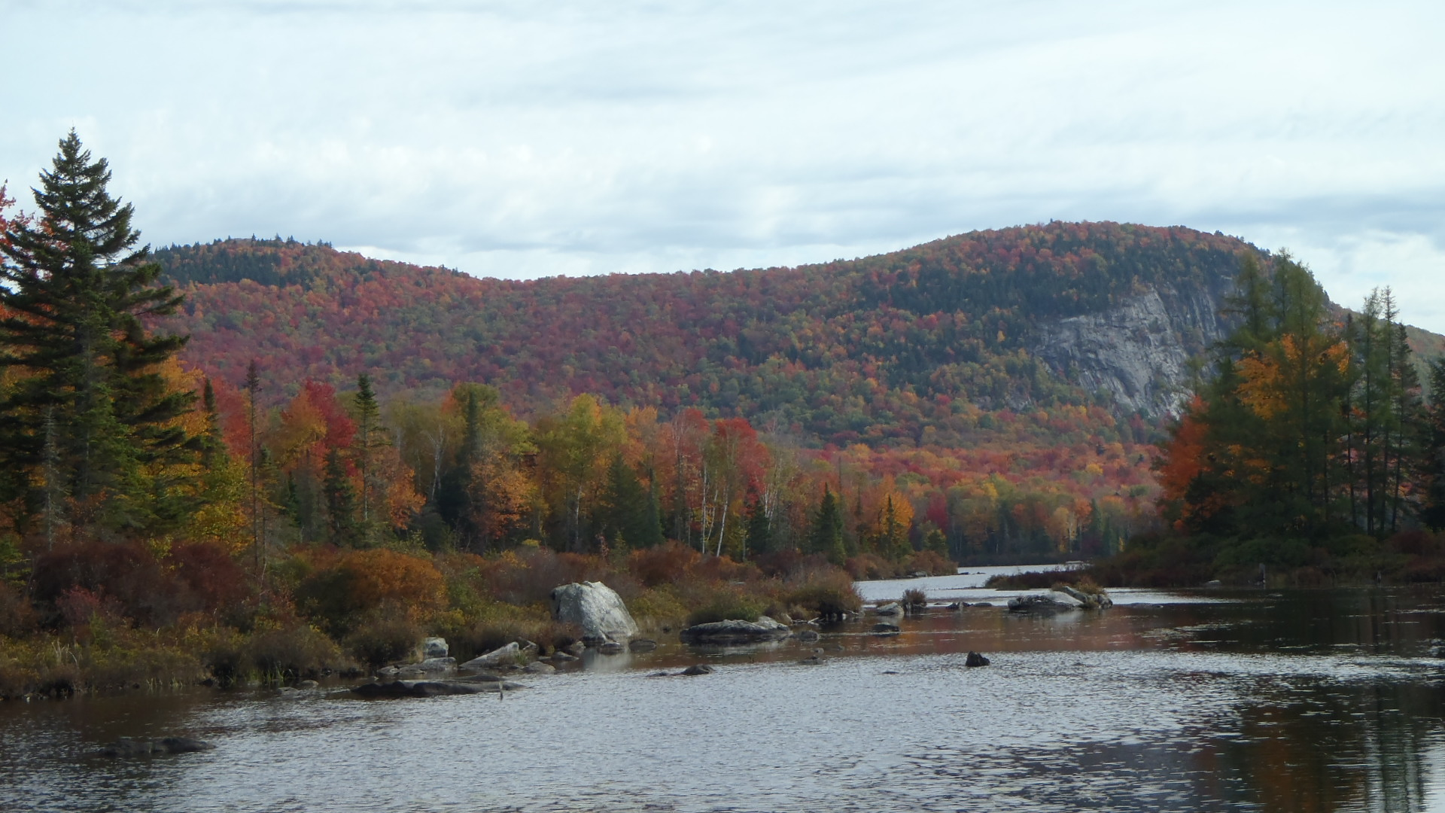

**Marshfield Cliffs in fall color 2016**

**The Friends of the Winooski River in Cooperation with**

**The Conservation Commissions of Cabot, Marshfield, and Plainfield**

**with support from the**

**R.A. LaRosa Grants Program**

**Prepared by Steve Fiske and Shawn White for**

**The Vermont Department of Environmental Conservation**

**January 2017**

**Water Quality Monitoring by the Winooski Headwaters Partnership**

The Winooski Headwaters Partnership is composed of the Conservation Commissions of Plainfield, Marshfield, and Cabot; the Friends of the Winooski River; and community members of Headwaters towns. The Headwaters Partnership has been conducting water quality monitoring of the Winooski River and several of its tributaries since 2007. Parameters of interest have included *E. coli,* total phosphorus, total nitrogen, turbidity, chloride, alkalinity, temperature, and pH. Monitoring sites have been chosen based on recreational contact, suspected pollutant sources, locations of waste water treatment plants, and a population of a Vermont listed threatened species.

The following report describes the results of the Headwaters Partnership 2016 monitoring. Samples were collected by Headwaters volunteers approximately biweekly on, July 5/6, July 19, Aug 2, August 17, and August 30. Descriptions and locations of the sampling sites sampled for bacteria (*Escherichia coli*) , and or for water quality parameters are shown in **Appendix A**. Despite the overall dry summer in 2016 our sampling dates only saw two dates during dry weather (base flows), these occurred on the first and last sampling dates. Event runoff (collected after a rain event) occurred on the three mid summer dates. Samples were analyzed at the Vermont Department of Environmental Conservation La Rosa laboratory by laboratory staff. Individual sample results are listed in **Appendices B** and **C**. Quality assurance measures (duplicate sample relative percent differences) and control blank results are shown in **Appendices D** and **E** and met target values in all cases except the *E. coli* duplicate pair taken at WIN85.5 on 7/19, which had a relative percent difference (RPD) of 91%; the turbidity duplicates taken at NAB2.8 on 7/19 and WIN81.6 on 8/17; and the phosphorus and nitrogen duplicates taken on 8/30 at GUB1.0. With the exception of the *E. coli* duplicates, the high RPD of these pairs was likely due to the parameter measurements being so low, so that any slight difference between the two measurements resulted in a large relative percent difference.

***E. coli* Background and Results**

Fecal coliform bacteria are a particular group of bacteria primarily found in human and animal intestines and feces. *Escherichia coli* (*E. coli*) is one of the fecal coliform bacteria widely used as an indicator organism to detect the presence of fecal material in water and the possible presence of pathogenic (disease-producing) organisms. When *E. coli* is found in waters, its presence is not the problem of concern itself (most strains of *E.coli* are not pathogenic), but is rather an indicator of the presence of other pathogens found in fecal matter from humans or animals. *E. coli* monitoring is commonly conducted to inform people the water is safe for swimmers and other contact recreational activities. A relationship can often be established between high bacteria concentrations and its sources such as rainfall runoff from urban streets, waterfowl or other wildlife congregations, pastured animals, pet waste, and untreated waste (septic or sewage) wastewater. Vermont’s *E.coli* criteria matches the EPA recommendations: “Not to exceed a *geometric mean of 126 organisms /100ml* obtained over a representative period of 60 days, and no more than *10% of samples above 235 organisms/100 ml”.* This equals to a *risk factor of about 36 illnesses/1,000 ingestions*. The EPA also provides an *E. coli* “Beach Action Value” (BAV) of 235 MPN/mL for single water samples. States can adopt this value and use it to close a recreational water site to the public when *E. coli* levels are above this standard.

Headwaters Partnership volunteers collected samples for *E. coli* testing at 18 locations on the Winooski River on an approximately biweekly basis for most sites starting July 5 or 6 to August 30, 2016. Site locations are presented as the River Mile (RM) of the river or stream up from its mouth. As such the highest RM, WIN86.6, is located above Cabot village, and the lowest at RM, WIN70.1 is below the Plainfield WWTF. All site descriptions are found in a table at the end of this report in **Appendix A**. Individual sample results are presented in **Appendix B**.

The results as the geometric mean of the two base flow sampling events collected at a location are presented in **Figure 1**. These results are representative of river conditions when swimming is most likely to occur. The *E. coli* levels within the main stem of the Winooski River were highest at WIN71.5, behind the co-op, and remain high thru the village of Plainfield down to WIN70.7, below the Plainfield WWTF. *E. coli* levels above the WQ standards also occurred at the Martin Bridge, just upstream of Plainfield village. In 2016 the only other reach that showed elevated levels was in the Cabot flats at RM 83.3. It should be noted, however, that this value is based on a single sample collected on the first collection date (no other sample was collected at this site).

**Figure 1**: *E. coli* levels in the upper Winooski River 2016 during baseflow conditions. The dotted black line indicates the VT standard for geometric mean *E. coli* levels (126 mpn/100 mL).



The Plainfield village reach of river has been high in *E. coli* for years (**Figure 2, and Table 1).** The reach, which is adjacent to the Plainfield Recreation Fields, should be considered as having a higher risk for contact recreation, and efforts should continue in identifying the source(s) of this contamination. In 2016 samples collected from behind the co-op and at Martin Bridge show the contamination is likely from multiple non-point sources. A second reach of river is also slightly above standards is the “Cabot Flats”. Historically the *E. coli* levels in this reach have been sporadically high in some years while lower in other years. In 2016 the reach of stream thru the village of Marshfield shows an improvement compared to past years, with no base flow samples above the WQ standards.

**Figure 2**: Showing E.coli levels over time at all locations from 2012-2016.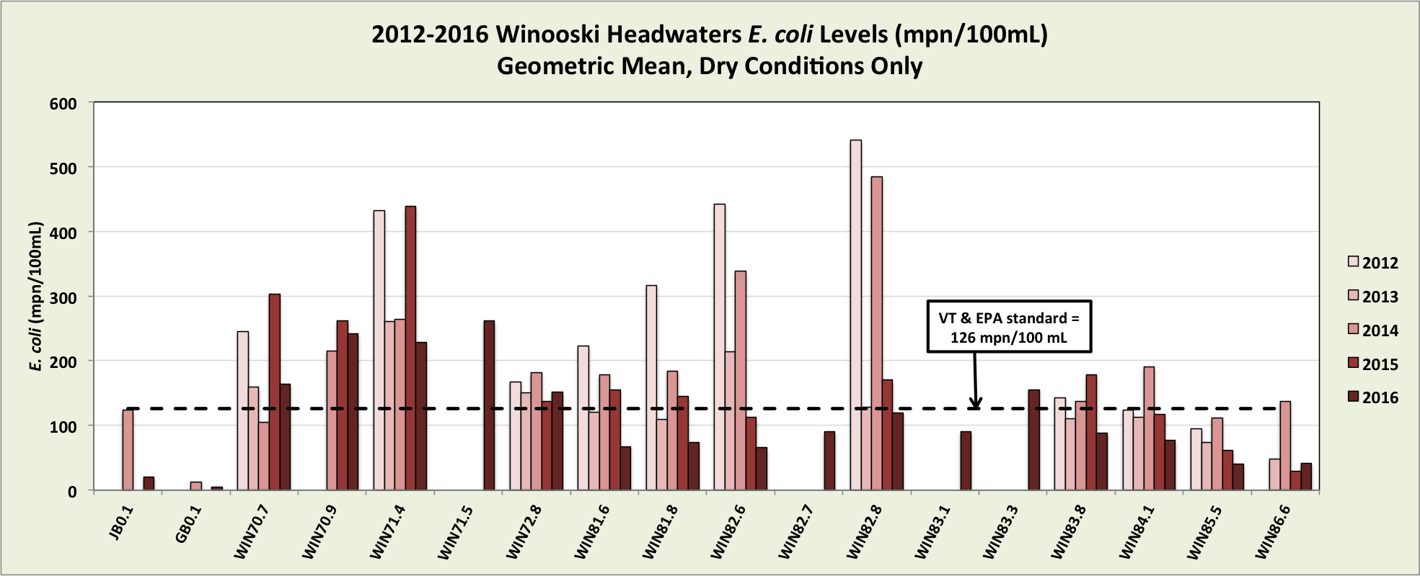

**Table 1**: Showing *E.coli* levels over time at all locations sampled in 2016 from 2007-2016.

|  |  |  |  |  |  |  |  |  |  |
| --- | --- | --- | --- | --- | --- | --- | --- | --- | --- |
|  | ***E. coli* Geometric Mean Under Dry Conditions** | | | | | | | | |
| **Site ID** | **2007** | **2008** | **2010** | **2011** | **2012** | **2013** | **2014** | **2015** | **2016** |
| JB0.1 |  |  | 67 |  |  |  | 123 |  | 20 |
| GB0.1 | 39 | 58 |  |  |  |  | 12 |  | 5 |
| WIN70.7 |  | 149 | 268 |  | 245 | 159 | 105 | 302 | 164 |
| WIN70.9 |  |  |  |  |  |  | 215 | 262 | 242 |
| WIN71.4 | 192 | 172 | 371 | 533 | 432 | 261 | 264 | 439 | 229 |
| WIN71.5 |  |  |  |  |  |  |  |  | 261 |
| WIN72.8 |  |  | 162 | 214 | 168 | 150 | 181 | 137 | 152 |
| WIN81.6 | 256 | 134 | 150 |  | 223 | 120 | 178 | 154 | 67 |
| WIN81.8 |  | 154 | 184 |  | 317 | 109 | 184 | 145 | 74 |
| WIN82.6 |  | 41 | 236 | 56 | 442 | 214 | 338 | 113 | 66 |
| WIN82.8 |  |  |  | 171 | 541 | 128 | 485 | 170 | 119 |
| WIN83.1 |  |  |  |  |  |  |  |  | 90 |
| WIN83.3 |  |  |  |  |  |  |  |  | 155 |
| WIN83.8 | 187 | 83 | 128 | 175 | 143 | 110 | 137 | 179 | 88 |
| WIN84.1 |  |  | 118 | 84 | 124 | 113 | 190 | 117 | 77 |
| WIN85.5 |  |  | 51 | 78 | 94 | 74 | 112 | 61 | 40 |
| WIN86.6 |  |  |  |  |  | 48 | 137 | 29 | 41 |
|  | Exceeds EPA standards for the annual geometric mean (126 mpn/ml) | | | | | | | | |

**Figure 3** shows the 2106 *E. coli* levels in the upper Winooski River, comparing dry baseflow and event runoff flow samples. The Vermont standard of is the geometric mean of 126 mpn/100 ml. The high levels in the river under event flows coincide with high turbidity levels (**Figure 4)** in the river, together indicating stormwater runoff, and/or re-suspended river sediments are contaminated with *E. coli.* It is therefore not recommended to swim in the Winooski river immediately following a rain event until the water clarity improves; because you are at a substantially higher risk of contracting a water-borne stomach illness. Turbidity is noticeable at about 10 NTU’s.

**Figure 3**: 2016 *E. coli* levels in the upper Winooski River, comparing dry baseflow and event runoff flow samples. VT standard for geometric mean *E. coli* levels is 126 mpn/100 ml under baseflow conditions.



**Figure 4**: Mean turbidity under base flow dry conditions vs freshet flow rain event conditions. 

Vermont’s phosphorus river water quality standards apply under base flow conditions during the summer/fall June-October growing season. It is under these hydrologic conditions, and warm summer/fall stream conditions that attached stream bed algae can become most prolific and potentially cause a detrimental effect on the aquatic life of a stream. The mean total phosphorus of the samples taken on the two dry-weather, base-flow sampling dates in 2016 is shown in **Figure 5**. At all but the WIN70.7 site, total phosphorus concentrations under base flow conditions were below or only slightly above the VT water quality standards for both the Small High Gradient (12ug/l) and Medium High Gradient (15ug/l) for Class B waters in 2016.

**Figure 5:** Mean total phosphorus levels in the Winooski Headwaters tributaries (JB0.1, MAB0.1, GUB0.9, NAB2.6, and GB0.1) and mainstem during dry low flow conditions in 2016.



Phosphorus concentrations are also higher under turbid event flow conditions and lower under baseflow conditions as seen in **Figure 6**.The higher total phosphorus concentrations found under event flows represent phosphorus export downstream from the headwaters area. While export loading toward Lake Champlain cannot be calculated without accurate flow measures it is clear that the upper headwaters does export a significant amount of phosphorus under event flows, and the phosphorus is primarily in the particulate form. The source of this phosphorus is likely both from non point stormwater runoff from back roads, agricultural areas, logging in the watershed, and eroding stream bank sediments. The phosphorus loading during event flows is highest in the Plainfield area in large part from Great Brook, which enters the Winooski River just above the WIN 70.9 station, above the WWTF in Plainfield, below the dam. The other tributary streams show relatively low turbidity and resulting phosphorus export under both base and event flows. Of these Jug Brook has the highest event flow turbidity and phosphorus.

**Figure 6**: 2016 mean total phosphorus concentrations in Winooski upper main stem and tributaries under both base and event flow river conditions.



Nitrogen concentrations under base flow conditions were low, less than 0.4 mg/l, with the exception of Great Brook, which had the highest total nitrogen recorded in 2016 of > 0.6 mg/l under base flow conditions (**Figure 7**). Great Brook has over the years had a higher total nitrogen level compared to other locations. During event flow sampling total nitrogen was higher but still relatively low at less than 0.6 mg/l at all locations. The current numerical VT WQ standard for Class B waters is not to exceed 5.0 mg/l as NO3-N at flows exceeding low median monthly flows, in Class B(1) and B(2) waters.

**Figure 7**: Total nitrogen (mg/l) from sampling locations in the upper Winooski watershed, under base flow and event flow conditions.



**Alkalinity and Chloride - Results**

Water Quality samples for alkalinity and Chloride were again collected once annually on 8/2/2016. The results of this sampling are presented below in **Table 3** and in **Appendix C**. Alkalinity is highest (near or over 100mg CaCO3/l) in the tributary streams Jug Brook and Guernsey Brook, as well as in the Winooski River in Marshfield and Cabot. Alkalinity was lowest (22mg/ CaCO3/l) in Marshfield Brook. The Winooski in the Plainfield area from Win 72.8 to 70.7 were in the moderate range (about 60 mg CaCO3/l). Alkalinity is a reflection of the bedrock and soils from these watersheds, with the low alkalinity streams draining granitic-based watersheds and high alkalinity streams draining watersheds with soils higher in calcium. Chloride was < 10mg/l in all tributaries and in the Winooski River in Plainfield. It was in the teens in the Winooski River in Marshfield and Cabot. Chloride does not become toxic to aquatic life until levels approach 230mg/l. The Vermont Water Quality standards chloride criteria is 230 mg/l chronic (daily mean over four day period), and 860 mg/l acute (one day mean). Overall, chloride was very low at all locations- indicating deicing materials such as road and sidewalk salting is not yet an issue in the upper Winooski River watershed.

**Table 3** : Alkalinity and Chloride concentrations at 12 locations in the upper Winooski River. 20016

|  |  |  |  |
| --- | --- | --- | --- |
| **Location** | **Date** | **Alkalinity**  **(mg CaCO3/L)** | **Chloride**  **(mg/L)** |
| **MAB 0.1** | 8/2/2016 | 22 | 3.3 |
| **NAB 2.6** | 8/2/2016 | 62 | <2.0 |
| **WIN 72.8** | 8/2/2016 | 63 | 7.8 |
| **WIN 70.7** | 8/2/2016 | 67 | 8.6 |
| **WIN 70.9** | 8/2/2016 | 68 | 8.8 |
| **WIN 81.6** | 8/2/2016 | 96 | 10.4 |
| **WIN 81.8** | 8/2/2016 | 98 | 11.0 |
| **GUB 1.0** | 8/2/2016 | 104 | <2.0 |
| **JB 0.1** | 8/2/2016 | 106 | <2.0 |
| **WIN 84.1** | 8/2/2016 | 114 | 10.5 |
| **WIN 83.8** | 8/2/2016 | 116 | 10.6 |
| **GB 0.1** | 8/2/2016 | 125 | 9.1 |

***Appendices***

**Appendix A.** Site Descriptions and Maps

***E. coli* testing sites (18 total)**

|  |  |  |
| --- | --- | --- |
| **Site ID** | **Lat/Long** | **Description** |
| WIN 86.6 | 44.4065 / -72.3104 | Above Cabot Plains Brook, adjacent to Cabot Rec Fields |
| WIN 85.5 | 44.3984 / -72.3244 | By Larry’s ballfield below Cabot village. |
| WIN 84.7 | 44.3906 / -72.3307 | Above sawmill road bridge at Cabot WWTF |
| WIN 83.8 | 44.3829 / -72.3325 | Durant cemetery below Cabot WWTF |
| WIN 83.3 | 44.3774 / -72.3342 | Below (south of) second drainage ditch below farm below Durant cemetery. |
| WIN 83.1 | 44.3651 / 72.3346 | Above Graham’s Green house |
| WIN 82.8 | 44.3604 / -72.3353 | Just above GMP generation station. |
| WIN 82.7 | 44.35666 / -72.34255 | Across from McCrillis Road, below GMP powerhouse about 0.4 mi. |
| WIN 82.6 | 44.3519 / -72.3470 | At Rt 2 bridge just above Marshfield Village |
| WIN 81.8 | 44.3511 / -72.3553 | Above Marshfield WWTP, below Creamery tributary |
| WIN 81.6 | 44.3472 / -72.3606 | Below Marshfield WWTF, above flower farm |
| WIN 72.8 | 44.2871 / -72.4090 | At Martin Bridge |
| WIN 71.5 | 44.2785/ -72.4228 | Behind Plainfield Co-op Above Plainfield dam |
| WIN 71.4 | 44.2775 / -72.4258 | Below dam Plainfield Village, above Great Brook |
| WIN 70.9 | 44.2758 / -72.4287 | Above discharge at Plainfield WWTF |
| WIN 70.7 | 44.2733 / -72.4322 | Below discharge at Plainfield WWTF |
| JB 0.1 | 44.3923 / -72.331 | Jug Brook at Route 215 in Lower Cabot |
| GB 0.1 | 44.2767 / -72.4267 | Great Brook just before confluence with the Winooski |

**Water quality monitoring sites (12 total)**

|  |  |  |
| --- | --- | --- |
| **Site ID** | **Lat/Long** | **Description** |
| JB 0.1 | 44.3923 / -72.331 | Jug Brook at Route 215 in Lower Cabot |
| MAB 0.1 | 44.3482 / -72.3582 | Marshfield Brook at confluence with the Winooski River |
| NAB 0.8 | 44.2981 / -72.38745 | Naismith Brook at Paradise swimming hole |
| NAB 2.6 | 44.2776 / -72.37728 | Naismith Brook at Maple Hill Road Bridge |
| GB 0.1 | 44.2767 / -72.4267 | Great Brook just before confluence with the Winooski |
| WIN 84.1 | 44.3906 / -72.3307 | Above sawmill road bridge at Cabot WWTF |
| WIN 83.8 | 44.3829 / -72.3325 | Durant cemetery below Cabot WWTF |
| WIN 81.8 | 44.3511 / -72.3553 | Above Marshfield WWTP, below Creamery tributary |
| WIN 81.6 | 44.3472 / -72.3606 | Below Marshfield WWTF, at flower farm |
| WIN 72.8 | 44.2871 / 72.4090 | Winooski River at Martin Bridge |
| WIN 70.9 | 44.2758 / -72.4287 | Above discharge at Plainfield WWTF |
| WIN 70.7 | 44.2733 / -72.4322 | Below discharge at Plainfield WWTF |

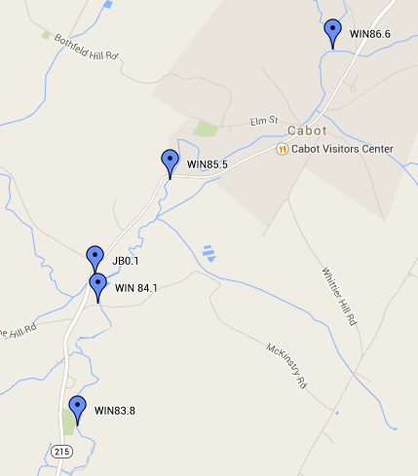

**Headwaters Partnership Cabot, VT Sampling Sites for 2016**



**Headwaters Partnership Marshfield, VT Sampling Sites 2016**

**(the WIN 81.6 site, downstream of MAB0.1, is not labeled)**

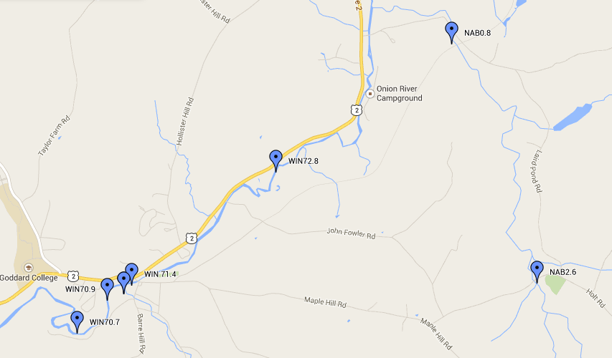**Headwaters Partnership Plainfield, VT Sampling Sites 2016 (GB0.1 is not labeled)**

**Appendix B.** 2016 *E.coli* results from the Upper Winooski Headwaters, and tributaries.

|  |  |  |
| --- | --- | --- |
| **Location** | **Date** | **Final E. Coli.(mpn/100ml)** |
| GB0.1 | 8/30/2016 | 5 |
| JB0.1 | 7/19/2016 | 291 |
| JB0.1 | 8/17/2016 | 2420 |
| JB0.1 | 8/2/2016 | 123 |
| JB0.1 | 8/30/2016 | 20 |
| WIN 70.7 | 7/5/2016 | 167 |
| WIN 70.7 | 7/19/2016 | 866 |
| WIN 70.7 | 8/2/2016 | 921 |
| WIN 70.7 | 8/17/2016 | 2420 |
| WIN 70.7 | 8/30/2016 | 161 |
| WIN 70.9 | 7/5/2016 | 248 |
| WIN 70.9 | 7/19/2016 | 687 |
| WIN 70.9 | 8/2/2016 | 579 |
| WIN 70.9 | 8/17/2016 | 1733 |
| WIN 70.9 | 8/30/2016 | 236 |
| WIN 71.4 | 7/5/2016 | 272 |
| WIN 71.4 | 7/19/2016 | 866 |
| WIN 71.4 | 8/2/2016 | 461 |
| WIN 71.4 | 8/17/2016 | 2420 |
| WIN 71.4 | 8/30/2016 | 192 |
| WIN 71.5 | 7/5/2016 | 276 |
| WIN 71.5 | 7/19/2016 | 687 |
| WIN 71.5 | 8/2/2016 | 411 |
| WIN 71.5 | 8/17/2016 | 2420 |
| WIN 71.5 | 8/30/2016 | 248 |
| WIN 72.8 | 7/5/2016 | 152 |
| WIN 72.8 | 7/19/2016 | 727 |
| WIN 72.8 | 8/2/2016 | 770 |
| WIN 72.8 | 8/17/2016 | 2420 |
| WIN 72.8-Blank | 8/17/2016 | 1 |
| WIN 72.8-Dup | 8/17/2016 | 2420 |
| WIN 81.6 | 7/6/2016 | 133 |
| WIN 81.6 | 7/19/2016 | 649 |
| WIN 81.6 | 8/2/2016 | 435 |
| WIN 81.6 | 8/17/2016 | 2420 |
| WIN 81.6 | 8/30/2016 | 34 |
| WIN 81.8 | 7/6/2016 | 112 |
| WIN 81.8 | 7/19/2016 | 770 |
| WIN 81.8 | 8/2/2016 | 291 |
| Win 81.8 | 8/17/2016 | 2420 |
| WIN 81.8 | 8/30/2016 | 49 |
| WIN 81.8-Blank | 8/30/2016 | 1 |
| WIN 81.8-Dup | 8/30/2016 | 49 |
| WIN 82.6 | 7/6/2016 | 73 |
| WIN 82.6 | 7/19/2016 | 727 |
| WIN 82.6 | 8/2/2016 | 435 |
| WIN 82.6 | 8/17/2016 | 2420 |
| WIN 82.6 | 8/30/2016 | 59 |
| WIN 82.7 | 7/6/2016 | 120 |
| WIN 82.7 | 7/19/2016 | 548 |
| WIN 82.7 | 8/2/2016 | 308 |
| WIN 82.7 | 8/17/2016 | 2420 |
| WIN 82.7 | 8/30/2016 | 68 |
| WIN 82.8 | 7/6/2016 | 308 |
| WIN 82.8 | 7/19/2016 | 649 |
| WIN 82.8 | 8/2/2016 | 435 |
| WIN 82.8-BLANK | 8/2/2016 | 1 |
| WIN 82.8-DUP | 8/2/2016 | 387 |
| WIN 82.8 | 8/17/2016 | 2420 |
| WIN 82.8 | 8/30/2016 | 46 |
| WIN 83.1 | 7/5/2016 | 193 |
| WIN 83.1 | 7/19/2016 | 687 |
| WIN 83.1 | 8/2/2016 | 261 |
| WIN 83.1 | 8/17/2016 | 2420 |
| WIN 83.1 | 8/30/2016 | 42 |
| WIN 83.3 | 7/5/2016 | 155 |
| WIN 83.8 | 7/5/2016 | 190 |
| WIN 83.8 | 7/19/2016 | 276 |
| WIN 83.8 | 8/2/2016 | 276 |
| WIN 83.8 | 8/17/2016 | 2420 |
| WIN 83.8 | 8/30/2016 | 41 |
| WIN 84.1 | 7/5/2016 | 166 |
| WIN 84.1 | 7/19/2016 | 225 |
| WIN 84.1 | 8/17/2016 | 2420 |
| WIN 84.1 | 8/30/2016 | 35 |
| WIN 85.5 | 7/5/2016 | 40 |
| Win 85.5 | 7/19/2016 | 411 |
| WIN 85.5-Blank | 7/19/2016 | 1 |
| WIN 85.5-Dup | 7/19/2016 | 153 |
| WIN 85.5 | 8/2/2016 | 161 |
| WIN 85.5 | 8/17/2016 | 2420 |
| WIN 85.5 | 8/30/2016 | 40 |
| WIN 86.6 | 7/5/2016 | 26 |
| WIN 86.6-Blank | 7/5/2016 | 1 |
| Win 86.6-DUP | 7/5/2016 | 28 |
| WIN 86.6 | 7/19/2016 | 365 |
| WIN 86.6 | 8/2/2016 | 156 |
| WIN 86.6 | 8/17/2016 | 2420 |
| WIN 86.6 | 8/30/2016 | 67 |

**Appendix C.** 2016 Winooski Headwaters Alkalinity, Chloride, Total Nitrogen (TN), Total Phosphorus (TP), and Turbidity results by parameter and site.

|  |  |  |  |  |  |  |
| --- | --- | --- | --- | --- | --- | --- |
| **Location** | **Date** | **Alkalinity (mg CaCO3/L)** | **Chloride (mg/L)** | **TN (mg-N/l)** | **TP(μg P/L)** | **Turbidity (NTU)** |
| GB 0.1 | 7/5/2016 |  |  | 0.54 | 8.9 | 1 |
| GB 0.1 | 7/19/2016 |  |  | 0.39 | 19.1 | 8 |
| GB 0.1 | 8/2/2016 | 125 | 9.1 | 0.57 | 7.9 | 1 |
| GB 0.1 | 8/17/2016 |  |  | 0.70 | 1600.0 | 492 |
| GB 0.1 | 8/30/2016 |  |  | 0.70 | 7.1 | 0 |
| GUB 1.0 | 7/5/2016 |  |  | 0.27 | 17.2 | 0 |
| GUB 1.0 | 7/19/2016 |  |  | 0.24 | 15.7 | 1 |
| GUB 1.0 | 8/2/2016 | 104 | 2.0 | 0.28 | 10.5 | 0 |
| GUB 1.0 | 8/17/2016 |  |  | 0.54 | 141.0 | 27 |
| GUB 1.0 | 8/30/2016 |  |  | 0.27 | 8.7 | 0 |
| GUB 1.0-Blank | 8/30/2016 |  |  | 0.10 | 7.1 | 0 |
| GUB 1.0-Dup | 8/30/2016 |  |  | 0.38 | 13.7 | 0 |
| JB 0.1 | 7/5/2016 |  |  | 0.24 | 9.6 | 1 |
| JB 0.1-Blank | 7/5/2016 |  |  | 0.10 | 6.4 | 0 |
| JB 0.1-Dup | 7/5/2016 |  |  | 0.24 | 11.2 | 1 |
| JB 0.1 | 7/19/2016 |  |  | 0.27 | 25.6 | 5 |
| JB 0.1 | 8/2/2016 | 106 | 2.0 | 0.24 | 9.3 | 1 |
| JB 0.1 | 8/17/2016 |  |  | 1.03 | 297.0 | 31 |
| JB 0.1 | 8/30/2016 |  |  | 0.26 | 9.6 | 0 |
| MAB 0.1 | 7/5/2016 |  |  | 0.34 | 13.6 | 1 |
| MAB 0.1 | 7/19/2016 |  |  | 0.32 | 13.1 | 1 |
| MAB 0.1 | 8/2/2016 | 22 | 3.3 | 0.36 | 11.0 | 1 |
| MAB 0.1 | 8/17/2016 |  |  | 0.57 | 41.8 | 5 |
| MAB 0.1 | 8/30/2016 |  |  | 0.40 | 11.6 | 1 |
| NAB 2.6 | 7/5/2016 |  |  | 0.26 | 24.0 | 0 |
| NAB 2.6 | 7/19/2016 |  |  | 0.26 | 16.2 | 1 |
| NAB 2.6-Blank | 7/19/2016 |  |  | 0.10 | 6.6 | 0 |
| NAB 2.6-Dup | 7/19/2016 |  |  | 0.25 | 17.1 | 1 |
| NAB 2.6 | 8/2/2016 | 62 | 2.0 | 0.64 |  | 0 |
| NAB 2.6 | 8/17/2016 |  |  | 0.73 | 95.9 | 17 |
| NAB 2.6 | 8/30/2016 |  |  | 0.24 | 13.5 | 0 |
| WIN 70.7 | 7/5/2016 |  |  | 0.26 | 23.4 | 5 |
| WIN 70.7 | 7/19/2016 |  |  | 0.28 | 48.4 | 12 |
| WIN 70.7 | 8/2/2016 | 67 | 8.6 | 0.34 | 24.0 | 7 |
| WIN 70.7 | 8/17/2016 |  |  | 0.88 | 914.0 | 324 |
| WIN 70.7 | 8/30/2016 |  |  | 0.28 | 15.2 | 2 |
| WIN 70.9 | 7/5/2016 |  |  | 0.27 | 22.3 | 5 |
| WIN 70.9 | 7/19/2016 |  |  | 0.26 | 34.7 | 10 |
| WIN 70.9 | 8/2/2016 | 68 | 8.8 | 0.32 | 22.6 | 5 |
| WIN 70.9 | 8/17/2016 |  |  | 0.72 | 1500.0 | 569 |
| WIN 70.9 | 8/30/2016 |  |  | 0.29 | 15.3 | 2 |
| WIN 72.8 | 7/5/2016 |  |  | 0.23 | 18.8 | 4 |
| WIN 72.8 | 7/19/2016 |  |  | 0.26 | 30.6 | 10 |
| WIN 72.8 | 8/2/2016 | 63 | 7.9 | 0.30 | 18.4 | 3 |
| WIN 72.8 | 8/17/2016 |  |  | 0.94 | 230.0 | 97 |
| WIN 72.8 | 8/30/2016 |  |  | 0.27 | 13.6 | 2 |
| WIN 81.6 | 7/5/2016 |  |  |  | 16.4 | 1 |
| WIN 81.6 | 7/19/2016 |  |  | 0.29 | 32.0 | 9 |
| WIN 81.6 | 8/2/2016 | 96 | 10.4 | 0.32 | 15.5 | 2 |
| WIN 81.6 | 8/17/2016 |  |  | 1.16 | 478.0 | 266 |
| WIN 81.6-Blank | 8/17/2016 |  |  | 0.10 | 5.0 | 0 |
| WIN 81.6-Dup | 8/17/2016 |  |  | 1.15 | 467.0 | 203 |
| WIN 81.6 | 8/30/2016 |  |  | 0.39 | 16.4 | 1 |
| WIN 81.8 | 7/5/2016 |  |  | 0.34 | 11.7 | 1 |
| WIN 81.8 | 7/19/2016 |  |  | 0.31 | 30.9 | 9 |
| WIN 81.8 | 8/2/2016 | 98 | 11.0 | 0.30 | 13.6 | 2 |
| WIN 81.8 | 8/17/2016 |  |  | 1.08 | 505.0 | 237 |
| WIN 81.8 | 8/30/2016 |  |  | 0.39 | 10.3 | 1 |
| WIN 83.8 | 7/5/2016 |  |  | 0.32 | 14.1 | 1 |
| WIN 83.8 | 7/19/2016 |  |  | 0.30 | 29.5 | 8 |
| WIN 83.8 | 8/2/2016 | 116 | 10.6 | 0.38 | 14.0 | 2 |
| WIN 83.8 | 8/17/2016 |  |  | 0.94 | 295.8 | 71 |
| WIN 83.8 | 8/30/2016 |  |  | 0.32 | 9.9 | 1 |
| WIN 84.1 | 7/5/2016 |  |  | 0.30 | 13.3 | 2 |
| WIN 84.1 | 7/19/2016 |  |  | 0.30 |  | 11 |
| WIN 84.1 | 8/2/2016 | 114 | 10.5 | 0.29 | 16.5 | 2 |
| WIN 84.1-BLANK | 8/2/2016 | 1 | 2.0 | 0.10 | 5.0 | 0 |
| WIN 84.1-DUP | 8/2/2016 | 114 | 10.3 | 0.29 | 15.6 | 2 |
| WIN 84.1 | 8/17/2016 |  |  | 0.91 | 345.0 | 68 |
| WIN 84.1 | 8/30/2016 |  |  | 0.32 | 10.6 | 1 |

**Appendix D. Quality assurance measures for *E. coli*, phosphorous, nitrogen, and turbidity sampling in 2016**

|  |  |  |  |  |  |  |  |
| --- | --- | --- | --- | --- | --- | --- | --- |
| **Location** | **Date** | **RPD, Alkalinity** | **RPD, Chloride** | **RPD, *E. coli*** | **RPD, TN** | **RPD, TP** | **RPD, Turbidity** |
| WIN86.6 | 7/5/2106 |  |  | 8% |  |  |  |
| WIN85.5 | 7/19/2016 |  |  | 91% |  |  |  |
| WIN82.8 | 8/2/2016 |  |  | 12% |  |  |  |
| WIN72.8 | 8/17/2016 |  |  | 0% |  |  |  |
| WIN81.8 | 8/30/2016 |  |  | 0% |  |  |  |
| GUB 1.0 | 8/30/2016 |  |  |  | 34% | 44% | 5% |
| JB 0.1 | 7/5/2016 |  |  |  | 0% | 15% | 8% |
| NAB 2.6 | 7/19/2016 |  |  |  | 4% | 5% | 21% |
| WIN 81.6 | 8/17/2016 |  |  |  | 1% | 2% | 27% |
| WIN 84.1 | 8/2/2016 | 0% | 2% |  | 0% | 6% | 10% |
| **Mean RPD** | **2016** | **0%** | **2%** | **22%** | **8%** | **15%** | **8%** |

Note: The mean relative percent difference value for the duplicates is high due to the high RPD between the turbidity samples taken at Naismith Brook and WIN 81.6, and the nitrogen and phosphorus samples taken at GUB1.0. The levels in these samples were very low, which caused the RPD to be unusually large and the mean RPD for turbidity to exceed the target value.

Target RPD for duplicate field samples:

Alkalinity <15% ( for values > 20 mg/l)

Chloride ≤ 5%

*E. coli* ≤ 50%

Nitrogen ≤ 50%

Phosphorus ≤ 30%

Turbidity ≤ 15%

**Appendix E.** Results from field blanks.

|  |  |  |  |  |  |  |
| --- | --- | --- | --- | --- | --- | --- |
| **Sample Number** | **Location** | **Date** | **Parameter** | **Units** | **Symbol** | **Result** |
| 160952-08 | WIN 84.1-BLANK | 8/2/16 | Alkalinity | mg/l | < | 1 |
| 160952-08 | WIN 84.1-BLANK | 8/2/16 | Chloride | mg/l | < | 2 |
| 160782-03 | WIN 86.6-Blank | 7/5/16 | *E. coli* | mpn/100ml | < | 1 |
| 160783-04 | WIN 85.5-Blank | 7/19/16 | *E. coli* | mpn/100ml | < | 1 |
| 160951-09 | WIN 82.8-BLANK | 8/2/16 | *E. coli* | mpn/100ml | < | 1 |
| 161090-14 | WIN 72.8-Blank | 8/17/16 | *E. coli* | mpn/100ml | < | 1 |
| 161232-11 | WIN 81.8-Blank | 8/30/16 | *E. coli* | mpn/100ml | < | 1 |
| 160784-03 | JB 0.1-Blank | 7/5/16 | Total N | mg/l | < | 0.1 |
| 160785-06 | NAB 2.6-Blank | 7/19/16 | Total N | mg/l | < | 0.1 |
| 160952-08 | WIN 84.1-BLANK | 8/2/16 | Total N | mg/l | < | 0.1 |
| 161091-11 | WIN 81.6-Blank | 8/17/16 | Total N | mg/l | < | 0.1 |
| 161233-05 | GUB 1.0-Blank | 8/30/16 | Total N | mg/l | < | 0.1 |
| 160784-03 | JB 0.1-Blank | 7/5/16 | Total P | μg/l |  | 6.38 |
| 160785-06 | NAB 2.6-Blank | 7/19/16 | Total P | μg/l |  | 6.6 |
| 160952-08 | WIN 84.1-BLANK | 8/2/16 | Total P | μg/l | < | 5 |
| 161091-11 | WIN 81.6-Blank | 8/17/16 | Total P | μg/l | < | 5 |
| 161233-05 | GUB 1.0-Blank | 8/30/16 | Total P | μg/l |  | 7.12 |
| 160784-03 | JB 0.1-Blank | 7/5/16 | Turbidity | NTU | < | 0.2 |
| 160785-06 | NAB 2.6-Blank | 7/19/16 | Turbidity | NTU | < | 0.2 |
| 160952-08 | WIN 84.1-BLANK | 8/2/16 | Turbidity | NTU | < | 0.2 |
| 161091-11 | WIN 81.6-Blank | 8/17/16 | Turbidity | NTU | < | 0.2 |
| 161233-05 | GUB 1.0-Blank | 8/30/16 | Turbidity | NTU | < | 0.2 |
| 160782-03 | WIN 86.6-Blank | 7/5/16 | *E. coli* | mpn/100ml | < | 1 |
| 160783-04 | WIN 85.5-Blank | 7/19/16 | *E. coli* | mpn/100ml | < | 1 |
| 160951-09 | WIN 82.8-BLANK | 8/2/16 | *E. coli* | mpn/100ml | < | 1 |
| 161090-14 | WIN 72.8-Blank | 8/17/16 | *E. coli* | mpn/100ml | < | 1 |
| 161232-11 | WIN 81.8-Blank | 8/30/16 | *E. coli* | mpn/100ml | < | 1 |